Ventilation and Gas Exchange
- What is the difference between ventilation and breathing?
- What is the difference between breathing and respiration?
- Why do we breathe?
- We breathe in air. Which gases are present in air?
- What are the formulae of these gases?
- Which one is useful to us?
- Air is a mixture. Explain what is meant by mixture.
- Complete the diagram:
Alveoli
Trachea

- Above each arrow, write which gas is moving
- What is the function (job) of the alveoli?
- List the ways in which the alveoli are suited to their job
- What does the word exchange mean?
- What do scientists mean when they talk about gas exchange?
- Why is it important that there is a good blood supply to the alveoli?
- What type of respiration do cells have to do if there is not enough oxygen?
- A person has a disease which means that only one of their lungs works. Write a paragraph to explain why this makes it difficult for them to exercise.
- Explain what is happening in the respiratory system to cause the changes seen between diagram 1 and diagram 2 in both pairs
2
1
1
2
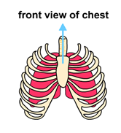
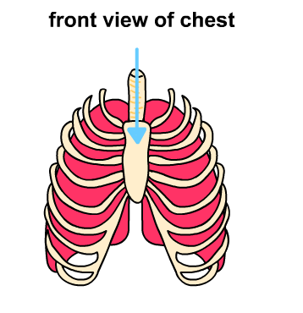

- Complete the table below to show what happens to each part of your respiratory system as you breathe. .
 | Inhalation | Exhalation
Ribs
Diaphragm
Intercostal Muscles
Volume of Thorax
Pressure
Air

- A student has been asked to write a description of what happens in the respiratory system during inhalation and how this leads to an increased amount of oxygen being carried in the blood. Below is her answer:
‘When we breathe in through the thorax the oxygen is able to come through the bronchioles to get to the alveoli. This is because the ribs get smaller and so our lungs get bigger to hold more air. Pressure inside the lungs in lower so all of the air goes into the blood.’
- How does air get into our lungs?
- List the order of structures in the respiratory system through which oxygen travels to get to the blood.
- What happens to the diaphragm and the size of the lungs as we inhale?
- How does the body make this happen?
- In your books, try to answer the same question that the student was asked to answer in question 19 above.

