Required Practicals Mastery Booklet: Chemistry
For the double science GCSE there are six practicals that you must be familiar with. There are a further two for triple science. This booklet will outline the practicals and provide you with explanations and questions to best prepare you for the exam. It is designed to be used once you have studied the relevant units. Many of the questions will contain ideas related to the required practicals.
Videos for all practicals can be found here:
https://www.youtube.com/channel/UC-TM-z1-tmX1iK_H4SxVhww/videos
More detailed practical instructions can be found here:
http://www.rsc.org/learn-chemistry/resource/res00002217/gcse-science-specification-guide#!cmpid=CMP00007527
You should watch the video for each practical before attempting the questions.

Required practical activity 1: Preparation of a pure, dry sample of a soluble salt from an insoluble oxide or carbonate, using a Bunsen burner to heat dilute acid and a water bath or electric heater to evaporate the solution.
Recap questions:
- What is a salt?
- What is a soluble salt?
- What is a dilute acid?
- What is a base?
- What does evaporation mean?
- Give the products for the reaction between copper oxide and sulphuric acid. Refer to your notes on the reactions of acids if necessary.
- Write a word equation for this reaction.
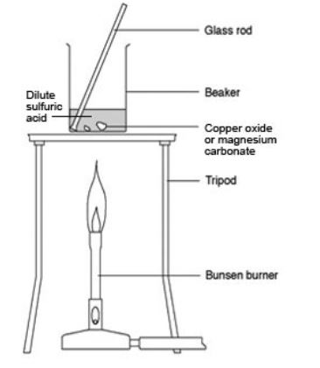
- Challenge: write a symbol equation for this reaction
Method
The first step is to put on goggles for safety and then measure out dilute sulphuric acid using a measuring cylinder. Measuring cylinders are more precise than beakers. The acid is then poured into a beaker which is then warmed on a Bunsen burner.
- Why is it important to wear goggles when using acid?
- Why is a measuring cylinder used to measure out the acid?
- Why is the acid warmed?
- When warming the acid, it is important not to heat it too much. Why?
An excess of copper oxide is added. This means that more than is needed is added and is needed to remove all the acid. A small amount is added to start with and stirred. This results in a clear blue solution. More copper oxide is added until no more can react. Copper oxide is a black powder so when no more can react a black powder can be seen at the bottom of the beaker.
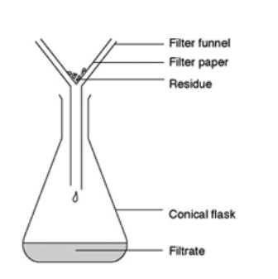
- Why is the mixture stirred?
- Once it has reacted, the copper oxide can no longer be seen. Why is this?
- What is an excess?
The excess copper oxide must now be removed by filtration with filter paper.
- What is filtration?
- What types of mixtures can filtration be used to separate?
- Explain why filtration cannot separate salt from sea water.
- What is the residue in this practical?
- What would the residue look like?
- What is the filtrate in this practical?
The clear blue solution is poured into an evaporating basin. The basin is then heated gently over a water bath to prevent breakdown of copper sulphate crystals.
- What is the name for this process?
- Where does the water go?
- Why is it important to stop the temperature getting too hot?
Summarised method
In your exam, you will asked to replicate this method from memory and answer questions based upon it. A summarised method could be:
- Measure out a volume of dilute sulphuric acid using a measuring cylinder
- Warm dilute sulphuric acid in a beaker with a Bunsen burner
- Add copper oxide one spatula at a time
- Add copper oxide until it is in excess - when you can see unreacted copper oxide
- Filter the mixture using a funnel and filter paper
- Pour the filtrate into an evaporating basin
- Warm on a water bath until crystals form
Summary questions
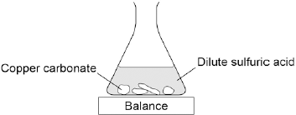
- Cover up the method above and attempt to replicate it from memory. Once you have finished, uncover the method, correct your method and then try again with a blank piece of paper.
- A student investigated the reaction of copper carbonate with dilute sulfuric acid. Using the equipment shown.
Complete the state symbols in the equation:
CuCO₃ (___) + H₂SO₄ (aq) → CuSO₄ (aq) + H₂O (___) + CO₂ (g)
- Why did the balance reading decrease during the reaction? Choose one answer from the below.
  - The copper carbonate broke down.
  - A salt was produced in the reaction.
  - A gas was lost from the flask.
  - Water was produced in the reaction.
- Describe a safe method for making pure crystals of copper sulfate from copper carbonate and dilute sulfuric acid. Use the information in the figure above to help you. In your method you should name all of the apparatus you will use.
- Rock salt is a mixture of sand and salt. Salt dissolves in water. Sand does not dissolve in water. Some students separated rock salt. This is the method used:
1. Place the rock salt in a beaker.
2. Add 100 cm3 of cold water.
3. Allow the sand to settle to the bottom of the beaker.
4. Carefully pour the salty water into an evaporating dish.
5. Heat the contents of the evaporating dish with a Bunsen burner until salt crystals start to form.
Suggest one improvement to step 2 to make sure all the salt is dissolved in the water.
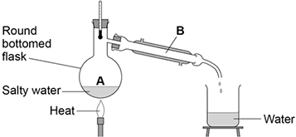
- The salty water in step 4 still contained very small grains of sand. Suggest one improvement to step 4 to remove all the sand.
- Suggest one safety precaution the students should take in step 5.
- Another student removed water from salty water using the apparatus in the figure to the right. Describe how this technique works by referring to the processes at A and B.
- What is the reading on the thermometer during this process?
- Calcium chloride (CaCl₂) is a soluble salt. Calcium chloride can be made by reacting dilute hydrochloric acid with either solid calcium oxide or solid calcium carbonate. Name the type of reaction that takes place when dilute hydrochloric acid reacts with calcium oxide.
- Write a balanced symbol equation for the reaction of dilute hydrochloric acid with calcium oxide.
- A student added solid calcium oxide to dilute hydrochloric acid in a beaker. The student added solid calcium carbonate to dilute hydrochloric acid in another beaker. Describe one difference between the two reactions that the student would see.
- Describe how crystals of calcium chloride can be made from calcium carbonate and dilute hydrochloric acid.

Required practical activity 3: Investigate what happens when aqueous solutions are electrolysed using inert electrodes. This should be an investigation involving developing a hypothesis.
Recap questions:
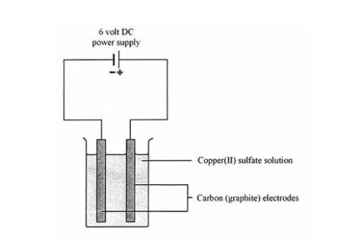
- What is electrolysis?
- Why is electrolysis used to extract certain metals?
- What are electrodes?
- What is an anode and what is a cathode?
- To which electrode are positive ions attracted?
- To which electrode are negative ions attracted?
- To which electrode are metal ions attracted?
- To which electrode are non-metal ions attracted?
- When performing electrolysis on a solution, hydrogen is often formed instead of a metal. Explain why.
- When the non-metal in electrolysis of a solution is not a halogen, which element is always formed?
- The electrodes must be inert. What does inert mean?
- What substances do we often use for electrodes?
- Give an equation to show how water can break down into OH⁻(aq) ions and H⁺(aq) ions. Refer back to your electrolysis mastery booklet if you need to.
- Give an equation to show how OH⁻ ions can be oxidised at the anode.
- Give an equation to show how H⁺ ions can be reduced at the cathode.
Method:
First step is to half fill a beaker with your chosen solution. The electrodes must then be submerged in the solution and connected to a power pack. It is important that the crocodile clips are not submerged in the solution as they may react with it.
- A student decides to use copper (II) chloride solution. What is the formula for this solution?
- What is a solution?
- Outline a method for how a student could obtain solid copper chloride from copper chloride solution.
- A student uses crocodile clips that are made of iron. Explain why submerging these crocodile clips in copper chloride will ruin the practical. (hint – look back at your notes on the reactivity series)
- Why will the practical not work if solid copper chloride is used? Explain your answer with reference to ions.
Second step is to turn on the power pack. Bubbles will slowly begin to form at the electrodes. Any gas produced can then be tested. Any solid metal produced will form on the cathode.
- What are the tests for chlorine and oxygen gas?
- What is the test for hydrogen gas?
- In what cases will hydrogen form?
- At which electrode will hydrogen form?
- Complete the table below. The first one has been done for you.
Solution | Formula | Forms at anode | Forms at cathode
Copper (II) chloride | CuCl₂ | Cl₂(g) | Cu(s)
Copper (II) sulphate
Potassium chloride
Sodium chloride
Potassium sulphate
Lithium hydroxide
Copper hydroxide
Zinc sulphate
Iron (II) chloride
Iron (III) sulphate
- Challenge: for each of the above, write half equations for what occurs at the anode and at the cathode
- Give equations to show how hydrogen and oxygen can be produced in the electrolysis of sodium hydroxide.
Often, you will be expected to describe how the gases produced can be collected, in which case you can use a diagram like the below. This shows how inverted (upside down) test tubes can be used to collect the gas.
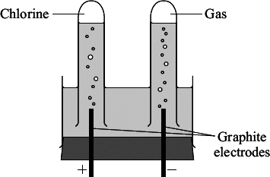
If measuring cylinders are used instead of test tubes, you can measure the volume of gas produced. Note that you must use the word “volume” and not “amount.”
Summarised method
You will normally be given a particular solution and be asked to outline a method for its electrolysis. You will often be given the opportunity to draw a diagram (like the ones above) which should be labelled. You must mention which tests are going to be used.
Summary questions
- A student makes a hypothesis: ‘When different salt solutions are electrolysed with inert electrodes, the product at the negative electrode is always a metal’. Describe how you would test this hypothesis in the laboratory. You should:
- draw a labelled diagram of the apparatus
- give the independent variable
- describe what you would see at the negative electrode if the hypothesis is true.
- The student’s hypothesis is only partially correct. Explain why the product at the negative electrode is not always a metal.
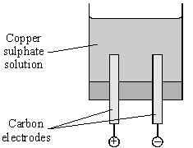
- Predict the product at the positive electrode in the electrolysis of:
sodium chloride solution
copper sulfate solution.
- An investigation into the electrolyte copper sulphate solution was carried out as shown. What does electrolyte mean?
- These were the observations:
Negative electrode: solid formed
Positive electrode: gas given off
Name the solid formed.
- Name the gas given off.
- How could a sample of gas be collected at the positive electrode?
- Suggest why the blue colour of copper sulphate becomes paler during the investigation.

Required practical activity 4: Investigate the variables that affect temperature changes in reacting solutions such as, eg acid plus metals, acid plus carbonates, neutralisations, displacement of metals.
Recap questions
- A reaction is conducted between zinc and copper sulphate solution. How can the temperature change of this reaction be measured?
- If the temperature increases, what can be said of the reaction?
- If the temperature decreases, what can be said of the reaction?
- Draw a fully labelled reaction profile for an exothermic reaction.
- Draw a fully labelled reaction profile for an endothermic reaction.
- A student wishes to add samples of iron and magnesium to acid and see which one changes temperature by the greatest amount. Which variables will the student have to control?
- Why must these variables be controlled?
- What is the independent variable in this experiment?
- What is the dependent variable in this experiment?
- Predict which metal will give the greatest temperature change. Explain your answer.
Method for reactions of solutions with other solutions or solids:
The method will vary depending on exactly what reaction you are going to be investigating. Often, you will be using a solid and a solution or two solutions. The first step is therefore to measure out a precise volume of solution and mass of solid.
- What piece of equipment is used to measure mass?
- What piece of equipment is used to measure volume?
- Explain why these pieces of equipment are used.
- Why is it important to precisely measure the volume of acid or mass of solid?
A simple calorimeter is set up. This usually involves a polystyrene cup placed in a beaker with a lid on top. A thermometer is pushed through the lid.
- Why is a polystyrene cup used?
- Why is a lid used?
- Why is the cup placed in a beaker?
The first solution is poured into the cup and left for a couple of minutes. Its temperature is then recorded. The second solution (or solid) is added to the cup, and the lid quickly placed on the cup. The reaction can then be stirred gently. You can then record the temperature every minute or just record the highest temperature reached.
- Why should the lid be returned quickly?
- What is the advantage of taking the temperature every minute?
- Why is stirring a potential source of error?
- An automatic stirrer can be placed inside the cup. How can this eliminate the error in question 92?
- What is the largest source of error in this reaction?
Summary method:
- Precisely measure out your reactants (solutions with measuring cylinder, solids with balance)
- Place a polystyrene cup in a beaker
- Prepare a lid with a thermometer
- Add reactant 1 to cup and record temperature
- Add reactant 2 to cup
- Quickly place lid on cup
- Stir gently
- Record highest temperature reached
Summary questions
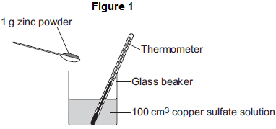
- A student wishes to investigate the temperature change when different volumes of sulphuric acid are added to sodium hydroxide solution. From memory, outline a method to carry out this investigation.
- Predict how the volume of sulphuric acid will affect the temperature change.
- Discuss the sources of error in this practical, and how the method could be improved.
- A student investigates the energy released when zinc powder reacts with copper sulfate solution. The student uses the apparatus shown in Figure 1. The student:
- measures 100 cm3 copper sulfate solution into a beaker
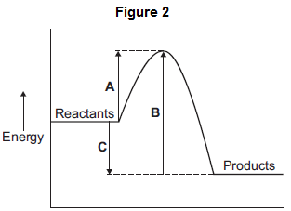
- measures the temperature of the copper sulfate solution
- puts 1 g zinc powder into the beaker
- stirs the mixture with a thermometer
- measures the highest temperature.
The student’s results were:
Starting temperature = 21 °C
Highest temperature = 32 °C
Calculate the change in temperature.
- The reaction of zinc with copper sulfate is exothermic. How can you tell from the student’s results that the reaction is exothermic?
- The energy diagram for the reaction is shown in Figure 2. How can you tell from the energy diagram that the reaction is exothermic?
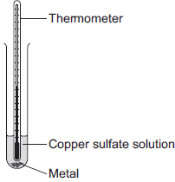
- Which arrow shows the activation energy in Figure 2?
- A student investigated displacement reactions of metals. The student added different metals to copper sulfate solution and measured the temperature change. The more reactive the metal is compared with copper, the bigger the temperature change. The apparatus the student used is shown.
State three variables that the student must control to make his investigation a fair test.
- Figure 2 shows the thermometer in one experiment before and after the student added a metal to the copper sulfate solution. Use Figure 2 to complete Table 1.
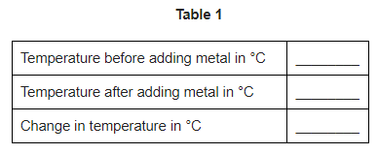
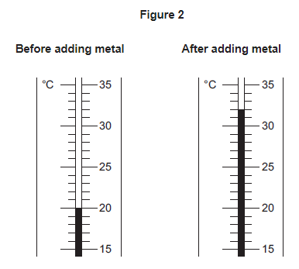

- The student repeated the experiment three times with each metal. The table shows the mean temperature change for each metal.

Metal | Mean temperature change in °C
Cobalt | 4.5
Gold | 0.0
Magnesium | 10.0
Nickel | 3.0
Silver | 0.0
Tin | 1.5

Why is a line graph not a suitable way of showing the results?
- Use the results to work out which metal is the most reactive. Give a reason for your answer.
- Explain why there was no temperature change when silver metal was added to the copper sulfate solution.
- It is not possible to put all six metals in order of reactivity using these results. Suggest how you could change the experiment to be able to put all six metals into order of reactivity.

Handling data and interpreting results
We have now covered three practicals and know enough content to be able to look at data handling and interpreting results. There are a number of concepts to be aware of here which are summarised in the table below.
Concept | Definition | Example
Variable | Something which can be changed in a practical | Mass of substance, volume of solution, temperature
Independent variable | The variable which is changed by the person carrying out the practical | Mass of zinc added to copper sulphate when investigating temperature change
Dependent variable | The variable which is the “result” of the practical | The temperature change when zinc is added to copper sulphate
Repeatability | Whether you repeating the experiment under the same conditions gets the same results | If you add the same mass of zinc to a fresh sample of copper sulphate, do you get the same result?
Reproducibility | Whether someone else repeating the experiment under the same conditions gets the same results | If your classmate does the same practical and gets the same results
Accuracy | If your results are close to the true value | If using a pH probe to measure pH, if the probe has not been calibrated properly it will not give you an accurate result
Precision | Whether measurements “cluster closely” | When applied to equipment usually refers to how closely you can measure, e.g. a measuring cylinder is more precise than a beaker. When applied to results usually means if your repeats are close to each other.
Random error | Issues affecting measurement that cannot be predicted. Take repeats and calculate means to eliminate this error. | A draft in a room may cool down an experiment, giving you different readings.
Systematic error | An issue affecting your measurement by the same amount each time | If there is a problem with a balance that causes it to read 5g over the true value each time (someone may have left some powder on it)
Anomalies | Individual results which do not fit with the others. These should be ignored. | If you repeat and experiment and get 10g, 11g, and 25g, it is likely that your last result is an anomaly.
Trend | How one variable affects another | “As you add a greater mass of metal, the temperature change increases”
Directly proportional | If you plot your graph and the line of best fit is straight. It means that as x increases by a set amount, y also increases by a set amount | Results like:  x 1 2 3 4 5 6 7  y 2 4 6 8 10 12 14
Uncertainty | How sure you are that your result is correct | The range of your measurements is a good way to establish your uncertainty. If your results are 4,4,4 that is more certain than 3,5,4, despite the mean being the same for both.

- A student investigates how the mass of iron added to copper sulphate affects the temperature change. What are the dependent and independent variables?
- Which variables must be controlled?
- The student chooses to use the masses 1g, 2g, 3g, 4g and 5g. Explain why the student should repeat the experiment for each mass.
- Why is it important for the student to compare their results with other students’ results?
- After the experiment, the student realised that the thermometer was giving readings that were “out” by 6°C each time. What type of error is this?
- Why is it important that the student uses a measuring cylinder and not a beaker to measure the volume of solution used?
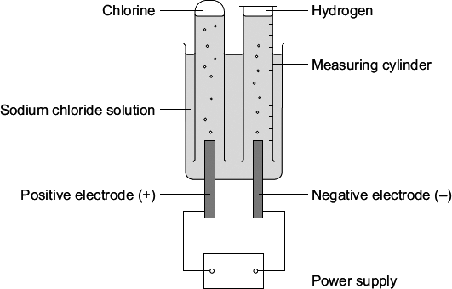
- A student investigated the electrolysis of sodium chloride solution. Five sodium chloride solutions were made. Each solution had a different concentration. To make each solution the student:
- weighed the amount of sodium chloride needed
- dissolved it in water
- added more water until the total volume was one cubic decimetre (1 dm3).
The solutions were placed one at a time in the apparatus shown. The student measured the volume of hydrogen gas produced in ten minutes. The results are shown on the graph below. Draw a line of best fit on the graph.
- The result for one concentration is anomalous. Which result is anomalous?
- Suggest two possible causes of this anomalous result.
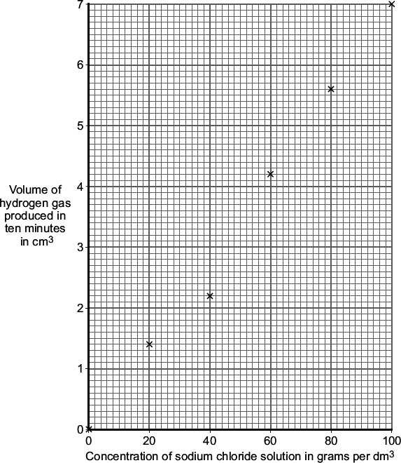
- Suggest how the student could check the repeatability of this experiment.
- Suggest how the student could check the reproducibility of this experiment.
- How did an increase in the concentration of the sodium chloride solution affect the volume of hydrogen gas produced in ten minutes?
- Are these results directly proportional? Explain your answer.
- Why is it important that the student records the volume produced in ten minutes exactly each time?
- At the end of the experiment, the student notices that the stopwatch being used has a delay between the button being pushed and the stopwatch starting. What type of error is this?
- In this case, what should the student do?
- Sodium chloride does not conduct electricity when it is solid. Explain, in terms of ions, why sodium chloride solution conducts electricity.
- Chlorine is produced at the positive electrode. Why are chloride ions attracted to the positive electrode?
- The solution left at the end of each experiment contains sodium hydroxide. Draw a ring around one number which could be the pH of this solution.
2 5 7 13
- A student investigated the conductivity of different concentrations of sodium chloride solution. The student set the apparatus up as shown in Figure 1.
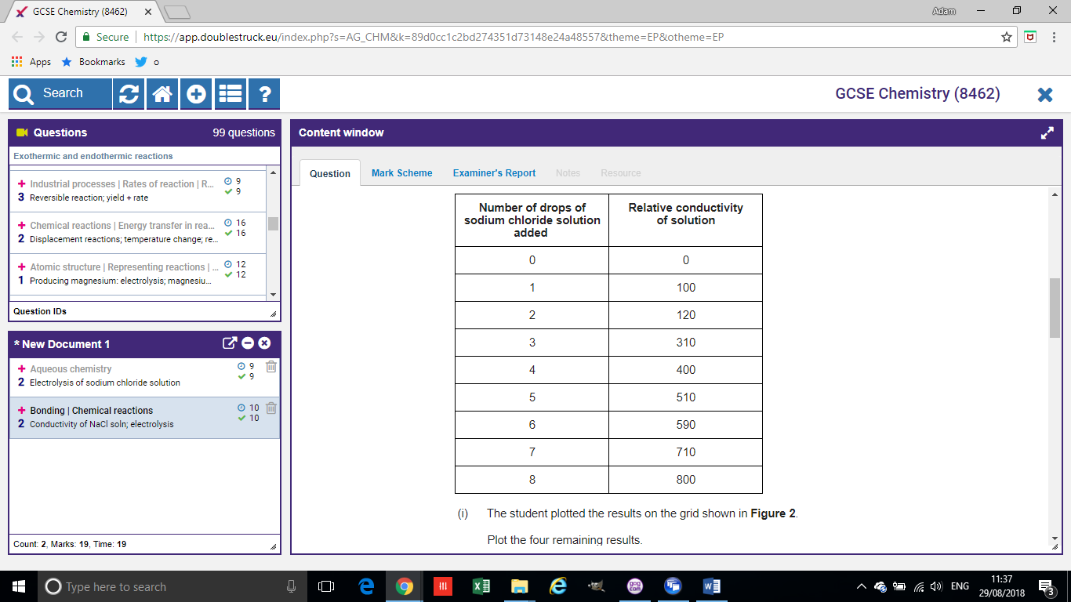
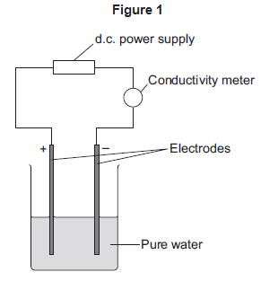
The student measured the conductivity of the pure water with a conductivity meter. The reading on the conductivity meter was zero.
The student:
  - added sodium chloride solution one drop at a time
  - stirred the solution
  - recorded the reading on the conductivity meter.
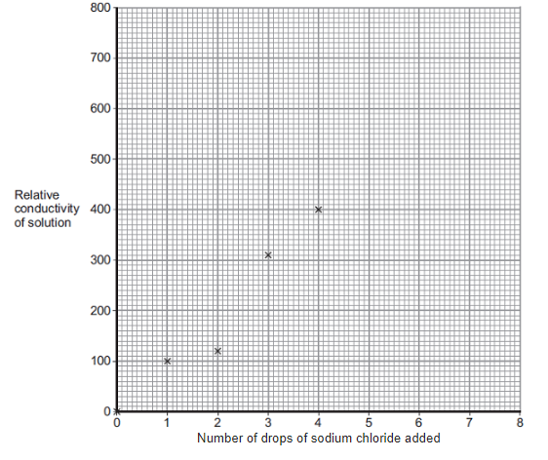
What were the dependent and independent variables in this experiment?
- The student’s results are shown in the table above. The student plotted the results on the grid shown.
Plot the four remaining results.
- Draw a line of best fit, ignoring the anomalous result.
- One of the points is anomalous. Suggest one error that the student may have made to cause the anomalous result. (hint – your answer must explain why the anomaly is less than you would expect, and you cannot write “wrong number of drops” as we assume that this was correct!)
- Is this anomaly caused by a random or systemic error?
- The student wanted to compare the conductivity of sodium chloride solution with the conductivity of potassium chloride solution. State one variable he should keep constant when measuring the conductivity of the two solutions.
- Are these results directly proportional? Explain your answer.
- The student used a conductivity meter but could have used a light bulb instead. The more a solution conducts, the brighter the bulb. Explain why using a bulb would not be an improvement to this method.
- How can the student ensure these results are repeatable and reproducible?
- Explain, in terms of bonding, why pure water does not conduct electricity.
- Some students investigated the energy changes occurring in the reaction between potassium hydrogencarbonate and hydrochloric acid. The equation for the reaction is:

KHCO₃(s) + HCl(aq) ⟶ KCl(aq) + CO₂(g) + H₂O(l)

This is the method used:

1. Measure 50 cm³ hydrochloric acid into a glass beaker.

2. Measure the temperature of the hydrochloric acid.

3. Measure a given mass of potassium hydrogencarbonate.

4. Add the potassium hydrogencarbonate to the hydrochloric acid.

5. Stir until all the potassium hydrogencarbonate has reacted.

6. Record the lowest temperature reached.

7. Repeat three more times, using the same mass of potassium hydrogencarbonate.

Each student used a different mass of potassium hydrogencarbonate.

The method described will not give very accurate results. Suggest one change to the apparatus that would improve the accuracy of the results. Give a reason for your answer.
- What type of error is solved by your change?
- The method described does not lead to precise measurements. Suggest one change to the apparatus that would improve the precision of the measurements taken.
- The students controlled the volume of the hydrochloric acid. Give one other control variable the students should use.
- The table shows one student’s results.

 | Trial 1 | Trial 2 | Trial 3 | Trial 4
Initial temperature in °C | 21.2 | 21.1 | 21.0 | 21.1
Final temperature in °C | 15.6 | 15.4 | 15.6 | 16.6
Temperature decrease in °C | 5.6 | 5.7 | 5.4 | 4.5

Calculate the mean temperature decrease for the results shown in the table above. Ignore any anomalous results. Give your answer to 1 decimal place. Give the uncertainty in your answer.
Mean = __________ °C ± __________ °C
- The graph below shows the students’ results.

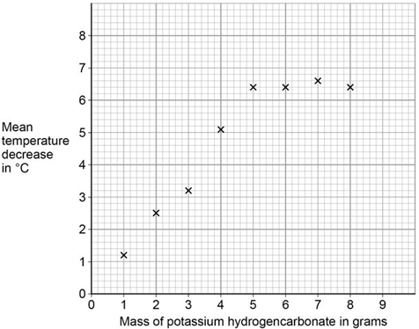

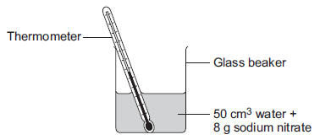
Draw two intersecting straight lines of best fit on the graph above.
- Explain why the graph has this shape. Use data from the graph.
- Suggest a possible reason for the anomalous points. Do not include errors in measuring.
- This question is about temperature changes. A student investigated the temperature change when 8 g of sodium nitrate dissolves in 50 cm³ of water. The diagram shows the apparatus the student used.
The student did the experiment five times. The table below shows the results.
Experiment | Decrease in temperature of water in °C
1 | 5.9
2 | 5.7
3 | 7.2
4 | 5.6
5 | 5.8
Calculate the mean decrease in temperature. Do not use the anomalous result in your calculation.
- Suggest one source of error in the apparatus and one change in the apparatus in the diagram above which would improve the accuracy of the results. Give a reason for your answer.
- The student investigated the temperature change when different masses of sodium carbonate were added to 50 cm³ of water at 20 °C. The table below shows the results.
Mass of sodium carbonate in g | Final temperature of solution in °C
2.0 | 21.5
4.0 | 23.0
6.0 | 24.5
8.0 | 26.0
10.0 | 26.6
12.0 | 26.6
14.0 | 26.6
Describe the relationship between the mass of sodium carbonate added and the final temperature of the solution. Use values from the table in your answer.

Required practical activity 5: Investigate how changes in concentration affect the rates of reactions by a method involving measuring the volume of a gas produced and a method involving a change in colour or turbidity. This should be an investigation involving developing a hypothesis.
Recap questions:
- State and explain the effect of increasing temperature on the rate of reaction.
- State and explain the effect of using larger lumps of solid on the rate of reaction.
- In a reaction involving an acid, state and explain the effect of increasing the concentration of the acid on the rate of reaction.
- In a reaction involving gases, state and explain the effect of increasing the pressure on the rate of reaction.
- State and explain the effect of adding a catalyst on the rate of reaction.
Method
There are a number of different methods for measuring the rate of reaction and a number of different variables that can be changed. Please watch the video here https://www.youtube.com/watch?v=mgDXMfKRYAc or here https://www.youtube.com/watch?v=Gl6LVl7oAlU to familiarise yourself with the different methods. Below is a model example of a response to a GCSE question on the topic.
A student investigated the reaction between magnesium and hydrochloric acid. The student investigated how the rate of this reaction changed when the concentration of hydrochloric acid was changed.
Write a plan the student could use. In your plan you should:
- describe how you would carry out the investigation and make it a fair test
- describe the measurements you would make.
Poor answer:
First, take a small piece of magnesium. Add it to some hydrochloric acid and count the number of bubbles. See how long it takes for there to be 100 bubbles. You can then change the amount of acid and do it again, but keep the piece of magnesium the same each time. Put your results in a table and then in a graph. Make sure you wear goggles and a labcoat too.
Model answer
- The student should measure out 20cm³ of 0.1moldm⁻³ hydrochloric acid using a measuring cylinder and pour in a conical flask
- The student should measure out 3g of magnesium using a balance
- The student should add the magnesium to the acid and attach the flask to a gas syringe
- The student should measure how much gas is produced in one minute
- The student should repeat this with the same volume of hydrochloric acid and the same mass of magnesium, but increase the concentration to 0.2moldm⁻³
- The student should repeat this with 0.3, 0.4 and 0.5moldm⁻³ concentrations

- A student wishes to investigate how the temperature affects the rate of a reaction between calcium carbonate and hydrochloric acid. Which variables will need to be controlled?
- What measurements could the student take? How would they take this?
- Identify the independent and dependent variables.
- How could the student ensure that their results are repeatable?
- How could the student ensure that their results are reproducible?
- The student is not sure whether to stir the reaction mixture. Give an advantage and a disadvantage of stirring the reaction mixture.
- The student uses a gas syringe which doesn’t close properly and can only go down to 7cm³. What type of error will this cause?
- The student decides to use a measuring cylinder but realises afterwards that the tubing was not connected properly, and some gas was escaping, but we cannot know how much each time. What type of error is this?
- A student wishes to investigate the effect of surface area on the rate of reaction in the reaction between calcium carbonate and sulphuric acid. From memory, write a method for the student that would result in accurate measurements. Include information about safety, which measurements should be made and how the student can ensure it will be a fair test.
- A student conducts a reaction and collects the gas using a measuring cylinder underwater as shown in the image. They first measure out the lithium carbonate on a balance and record the mass. They then measure out a fixed volume of dilute hydrochloric acid using a measuring cylinder.
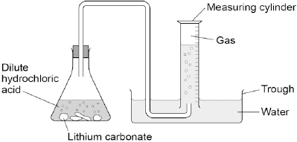
The student obtained results with an anomaly. The student suggests the reasons below to explain the anomalous result, but only two are potentially correct. Identify which two.
Too much lithium carbonate was added.
The bung was not pushed in firmly enough.
There was too much water in the trough.
The measuring cylinder was not completely over the delivery
The conical flask was too small.
- Explain why the other options are incorrect.
- When sodium thiosulfate solution reacts with dilute hydrochloric acid, the solution becomes cloudy. The equation for the reaction is:
Na₂S₂O₃(aq) + 2 HCl(aq) ⟶ 2 NaCl(aq) + SO₂(g) + H₂O(l) + S(s)
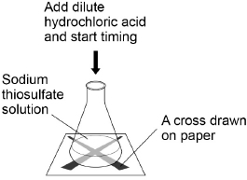
Why does the solution become cloudy?
- Some students used this reaction to investigate the effect of concentration on rate of reaction. The diagram shows the apparatus used.
This is the method used.
1. Measure 25 cm³ sodium thiosulfate solution into a conical flask.
2. Stand the conical flask on a cross drawn on paper.
3. Add 10 cm³ of dilute hydrochloric acid.
4. Time how long it takes the cross to become no longer visible.
5. Repeat steps 1–4 with sodium thiosulfate solutions of different concentrations.
- Name one control variable the students should use in this investigation.
- The table shows the students’ results.
Concentration of sodium thiosulfate solution in mol / dm³ | Time for cross to become no longer visible in s
0.020 | 170
0.040 | 90
0.060 | 82
0.080 | 42
0.100 | 34
0.120 | 30
0.140 | 28
Plot the data from the table above on the graph below. Draw a line of best fit.
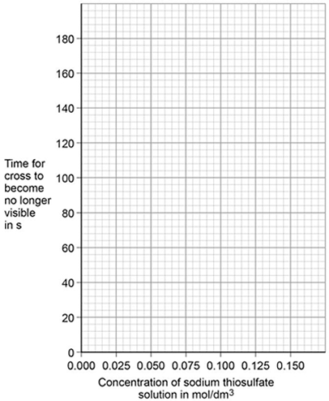
- Are these results directly proportional?
- The students repeated the reading at 0.060 and recorded times of 78s, 80s, and 81s as well as the original reading. Calculate the mean of these results and give an estimate for the uncertainty.
- The students repeated the investigation two more times. They obtained similar results each time. What word describes an investigation by the same students which gives similar results each time?
- What word describes a similar investigation carried out by other students which gives similar results?
- Describe how the students can use their results to improve the accuracy of the investigation.
- The students analysed their results to give a conclusion and an explanation for their investigation.
Conclusion: ‘The higher the concentration, the lower the rate of reaction.’
Explanation: ‘At higher concentrations, the particles have more energy, so they are moving faster. Therefore the collisions are more energetic.’
The students are not correct. Give a correct conclusion and explanation for the results of the investigation.
- A solution containing 0.18 g of sodium thiosulfate reacts with dilute hydrochloric acid in 2 minutes. Calculate the mean rate of reaction in g / s. Give your answer in standard form.

Required practical activity 6 Investigate how paper chromatography can be used to separate and tell the difference between coloured substances. Students should calculate Rf values.
Paper chromatography is a method for separating mixtures.
Recap questions:
- What is a mixture?
- What is a solution?
- What is a solvent?
- What is a solute?
- What is solubility?
- What is a physical property?
Method for paper chromatography
You can use the videos linked at the start of this document or here https://www.youtube.com/watch?v=pdZwGrhKa_k
Draw a pencil line about a 1cm from the bottom of the piece of paper. Carefully add a small ink spot on the pencil line, leave a space, and then add your next ink spot which should be a different colour.
- Why must the line be drawn in pencil?
Carefully pour your solvent into a beaker. It should have a height lower than the height of your pencil line. Carefully place the paper in the solvent and leave to stand. Sometimes the paper can be hung from the top, and sometimes there will be a lid.
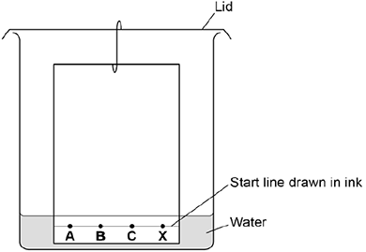
- Why must the pencil line be higher than top of the solvent?
Figure 1: for Q 183
As the solvent rises up the paper, the ink dissolves into it and is carried up. The different colours in the ink are attracted both to the paper and the solvent. The paper slows them down as they travel up the paper. If they are more attracted to the solvent than the paper, they will travel further. If they are more attracted to the paper than the solvent, they will travel less far.
- In the experiment in the diagram, the student has made two mistakes. Explain what these mistakes are and what effect they will have on the results.
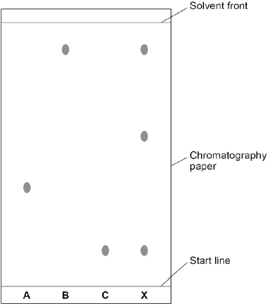
- A student has a complete chromatogram (the piece of paper after it has been through chromatography. How many different colours is X made of?
- Does X have any colours in common with C or B?
- Explain how you know your answer to question 185
- A student concludes that “A is only made of one colour as it did not separate in chromatography.” Is the student’s conclusion correct?
- A student labels the top spot for X as 1 and the middle spot for X as 2. Assuming that both spots were as attracted to the paper as each other, which one was more attracted to the solvent? Explain your answer.
- The student labels the bottom spot of X as 3. The student knows that 2 and 3 are as attracted to the paper as each other. Which one is less attracted to the paper?
- The student drew their start line in pencil. Why is it important that they did not use ink?
- The student had very shaky hands on the day of the experiment. What kind of error could this introduce?
- Professional chemists often use chromatography to find out which chemicals are in food and if they are safe or not. Why is it important for other chemists to do chromatography to the sae foods?

R_{f} values
The R_{f} value of a substance is a ratio of how far up the paper it moved compared to the solvent. It is calculated by:
$$\frac{distance travelled by substance}{distance travelled by solvent}$$
- Using a ruler, measure how far the spot at B has travelled from the start line
- Using a ruler, measure how far the solvent has moved from the start line
- Divide 193 by 194. Your answer should be approximately 0.8.
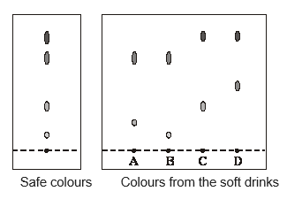
- Calculate the R_{f} values for each of the spots at X
Exam practice
- Chromatography was carried out on a sample of soft drinks to check that they contained only colours that were safe. This is the result.
What conclusions about the safety of the colours in the soft drinks A, B, C and D can be made from the results shown by chromatography?
- Calculate the R_{f} value for each spot on C, measuring from the middle of the spot and assuming that the solvent front is the top of the paper
- Some farmed salmon have a coloured additive in the food that they are given. This is a permitted additive that improves the colour of the fish meat. A sample of the colour is extracted from a salmon. Explain how paper chromatography could be used to confirm that this is the permitted additive. Read the article:

Problem food colourings
Scientists say they have evidence that some
food colourings cause hyperactive behaviour in
young children.
These food colourings are added to some sweets.

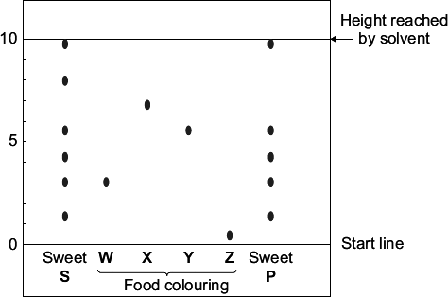
W, X, Y and Z are food colourings that may cause hyperactive behaviour in young children. A scientist used chromatography to see if these food colourings were used in two sweets, S and P.

The results are shown on the chromatogram.
- Food colourings, such as W, X, Y and Z, are added to some sweets. Suggest one reason why. Use the scale on the chromatogram to help you to answer this question. Which food colouring, W, X, Y or Z, has an R_{f} value of 0.7?
- From the chromatogram, what conclusions can the scientist make about the colourings in sweets S and P?

Required practical activity 8: Analysis and purification of water samples from different sources, including pH, dissolved solids and distillation.
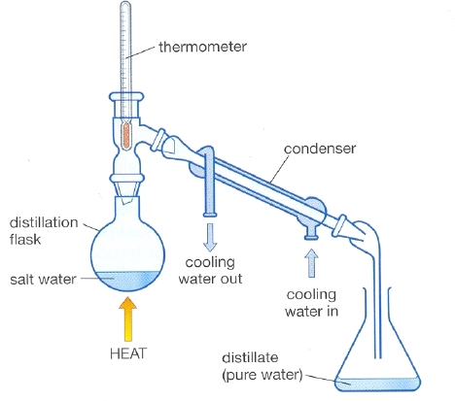
Make sure to watch the video from page 1 of this document before attempting the questions.
Recap questions:
- What is potable water?
- What is the difference between potable and pure water?
- What is the boiling point of pure water?
- How can the boiling point of a sample of water be used to test its purity?
- What is distillation?
- Outline the process that take place in the distillation of salty water. Include all changes of state.

Distillation is usually set up as per the diagram:

You can test the boiling point of a liquid by heating it gently with a thermometer fully submerged in it. Pure substances have a fixed boiling point, impure substances tend to have a range.

Questions:
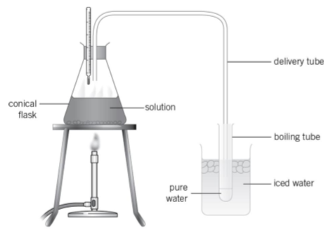
- A student sets up a simple distillation as on the right with tap water in the conical flask. Explain why the temperature shown on the thermometer is not 100°C.
- Why is the boiling point kept in iced water?
- How can the student check that the distillate is pure water?
- A student checks the distillate and finds its pH is 7. Does this confirm that it is pure water?
- What safety considerations must be taken in this practical?
- The student heats the solution until only a little is left and then leaves the flask on a window sill until all the water has evaporated. The student weighed the conical flask before adding the tap water starting the practical. Will the flask weigh more or less once the water has evaporated? Explain your answer.
- A student has a mixture of water and ethanol. What technique will be used to separate the water and ethanol?
- Ethanol is flammable. Explain why it is better to heat the mixture with an electric heater than a Bunsen burner.
- Why is distillation expensive?
- Normally before water is purified it is filtered. Explain the purpose of filtration.
- A student wishes to know the boiling point of a solution. Outline a method that the student could use.
- A solution of salty water has the formula NaCl(aq). Explain what the (aq) means.
- Which ions are present in this solution?
- Why can the NaCl not be separated from the solution by filtration?
- Which separation technique can be used if a student wants to keep the NaCl and lose the water?
- A student tests this solution and finds that it starts boiling at 98°C and stops at 104°C. In what two ways does this prove that the solution is not pure water?
- The student decides to distil the solution. In this case, what will the distillate be?
- Why is it important to use a condenser?
- Before distillation the solution weighed 12.3g. The student stops the distillation after five minutes. The distillate weighs 4.8g. What would you expect the mass of the solution left in the flask to be?
- Explain your answer.
- When the student weighs the flask, she finds that it is less than would be expected. Suggest how this may have occurred and which type of error is responsible.
- Suggest a possible improvement to the method to prevent this occurring
- How could the student test the purity of the distillate?
- Why is distillation an in inefficient method for producing potable water?

GCSE Questions
- Potable water is water that is safe to drink. Seawater can be changed into potable water by desalination.
  - Name the substance removed from seawater by desalination. (1)
  - Desalination requires large amounts of energy. Desalination is only used when there is no other source of potable water. Give one reason why. (1)
  - Water from lakes and rivers can be treated to make it potable. The first stage is to filter the water from lakes and rivers. Why is the water filtered? (1)
  - Chlorine gas is then added to the filtered water.Why is chlorine gas used to treat water? (1)
  - Describe a test for chlorine gas. Give the result of the test if chlorine is present. (2)
  - Some students investigated different water samples. The table shows some of their results.

Water | pH | Mass of dissolved solid in g / dm3
Tap water | 6.5 | 0.5
Seawater | 8.1 | 35.0

Pure water

Complete the table above to show the expected results for pure water. (2)
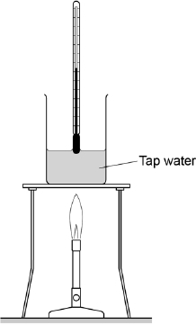
  - What mass of dissolved solid is present in 100 cm ³ of the sample of tap water? (1)
  - Boiling points can be used to show whether substances are pure. The diagram shows the apparatus the students used to find the boiling point of tap water. The students made a mistake setting up the apparatus. What mistake did the students make? (1)
- Water from a lake in the UK is used to produce drinking water.
  - What are the two main steps used to treat water from lakes? Give a reason for each step. (2)
  - Explain why it is more difficult to produce drinking water from waste water than from water in lakes. (3)
  - Some countries make drinking water from sea water. Complete the figure below to show how you can distil salt solution to produce and collect pure water. Label the following: pure water salt solution (3)
  - How could the water be tested to show it is pure? Give the expected result of the test for pure water.(2)
  - Why is producing drinking water from sea water expensive? (1)
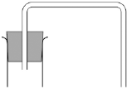

TRIPLE ONLY: Use of chemical tests to identify the ions in unknown single ionic compounds covering the ions from sections Flame tests through to Sulfates.

Recap questions:
- Outline the steps involved in a flame test
- Which colours are formed from ions of: lithium, sodium, potassium, calcium, copper?
- Why can you not use a flame test to identify metal ions in a mixture containing more than one metal ion?
- Complete the table:
Ion | Change on addition of sodium hydroxide | Ionic equation and state symbols
Aluminium | Forms a white precipitate | Al³⁺(aq) + 3OH⁻(aq) Al(OH)₃(s)
Calcium
Magnesium
Copper (II)
Iron (II)
Iron (III)
- How can aluminium, calcium and magnesium be distinguished by adding more sodium hydroxide?
- What is the test for carbonates?
- Calcium carbonate is added to sulphuric acid. Write a word and symbol equation for this reaction
- Explain why the mass of a flask containing calcium carbonate and sulphuric acid will decrease
- Outline the test for halogens
- Give the colours of the different silver halide precipitates
- Halide ions in solution react with silver ions to produce silver (I) halide precipitates. Write ionic equations for this process for chloride, bromide and iodide ions. Include state symbols.
- Nitric acid is used to remove impurities. Explain why hydrochloric acid should not be used
- What is the test for sulphate ions?
- Write an ionic equation for the reaction between sulphate ions and barium ions to produce an insoluble precipitate. Include state symbols.

GCSE Questions
- Burgundy Mixture is a formulation used to kill fungi on grapevines. It is made by mixing two compounds, A and B. The ratio by mass of A : B in the mixture is 1 : 8
  - Calculate the mass of A needed in a mixture containing 125 g of B. (2)
Scientists test a solution of compound A. The table shows their results.
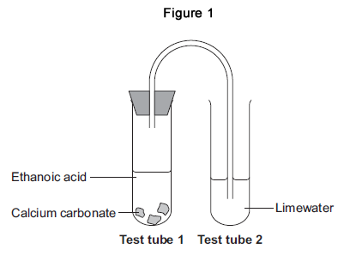
Test | Result
Add sodium hydroxide solution | Blue precipitate
Add dilute hydrochloric acid and barium chloride solution | White precipitate
  - Which two ions are in compound A? (2)
  - The scientists think that compound B is sodium carbonate. Describe how the scientists can test a solution of B to see if sodium ions are present. Give the result of the test if sodium ions are present. (2)
  - Describe how the scientists can test a solution of B to see if carbonate ions are present. Give the result of the test if carbonate ions are present. (3)
- This question is about reactions of ethanoic acid and the analysis of salts.
  - Figure 1 shows the apparatus used to investigate the reaction of ethanoic acid with calcium carbonate.
    - Describe a change that would be seen in each test tube. Give a reason for each change.(4)
    - Complete the displayed structure of ethanoic acid.
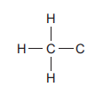 (1)
    - Ethanoic acid is a carboxylic acid. Complete the sentence.
Carboxylic acids react with alcohols in the presence of an ____________ catalyst to produce pleasant-smelling compounds called ______________ . (2)
  - Figure 2 shows four test tubes containing three different salt solutions and water.
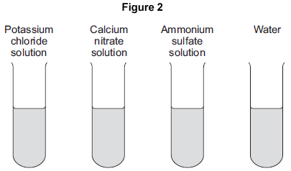
Each solution and the water was tested with:
• silver nitrate in the presence of dilute nitric acid
• barium chloride in the presence of dilute hydrochloric acid.
Complete the table of results.

 | Potassium chloride solution | Calcium nitrate solution | Ammonium sulfate solution | Water
Test with silver nitrate in the presence of dilute nitric acid |  |  | no change | no change
Test with barium chloride in the presence of dilute hydrochloric acid |  | no change | white precipitate
(2)
(c) Flame tests can be used to identify metal ions.
(i) Complete the following sentences.
The flame colour for potassium ions is ____________ .
The flame colour for calcium ions is ____________ . (2)
(ii) Give one reason why a flame test would not show the presence of both potassium ions and calcium ions in a mixture. (1)
- The colours of fireworks are produced by chemicals.

  - Information about four chemicals is given in the table.Complete the table below.

Chemical | Colour produced in  firework
barium chloride | green
_____________ carbonate | crimson
sodium nitrate | _____________
calcium sulfate | red
(2)
(b) Describe a test to show that barium chloride solution contains chloride ions. Give the result of the test. (2)
(c) A student did two tests on a solution of compound X.
Test 1
Sodium hydroxide solution was added.
A blue precipitate was formed.
Test 2
Dilute hydrochloric acid was added.
Barium chloride solution was then added.
A white precipitate was formed.
The student concluded that compound X is iron(II) sulfate. Is the student’s conclusion correct? Explain your answer. (3)

- In this question you will be assessed on using good English, organising information clearly and using specialist terms where appropriate. A group of students had four different colourless solutions in beakers 1, 2, 3 and 4, shown in the figure below.
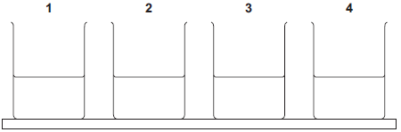
The students knew that the solutions were
• sodium chloride
• sodium iodide
• sodium carbonate
• potassium carbonate
but did not know which solution was in each beaker. The teacher asked the class to plan a method that could be used to identify each solution. She gave the students the following reagents to use:
• dilute nitric acid
• silver nitrate solution.
The teacher suggested using a flame test to identify the positive ions. Outline a method the students could use to identify the four solutions. You should include the results of the tests you describe. (6)

- This question is about chemical analysis.
  - A student has solutions of three compounds, X, Y and Z. The student uses tests to identify the ions in the three compounds. The student records the results of the tests in the table.

 | Test
Compound | Flame test | Add sodium hydroxide solution | Add hydrochloric acid and barium chloride solution | Add nitric acid and silver nitrate solution
X | no colour | green precipitate | white precipitate | no reaction
Y | yellow flame | no reaction | no reaction | yellow precipitate
Z | no colour | brown precipitate | no reaction | cream precipitate
Identify the two ions present in each compound, X, Y and Z. (3)
  - A chemist needs to find the concentration of a solution of barium hydroxide.
Barium hydroxide solution is an alkali. The chemist could find the concentration of the barium hydroxide solution using two different methods.
Method 1
• An excess of sodium sulfate solution is added to 25 cm³ of the barium hydroxide solution. A precipitate of barium sulfate is formed.
• The precipitate of barium sulfate is filtered, dried and weighed.
• The concentration of the barium hydroxide solution is calculated from the mass of barium sulfate produced.
Method 2
• 25 cm³ of the barium hydroxide solution is titrated with hydrochloric acid of known concentration.
• The concentration of the barium hydroxide solution is calculated from the result of the titration.
Compare the advantages and disadvantages of the two methods. (5)

TRIPLE ONLY: determination of the reacting volumes of solutions of a strong acid and a strong alkali by titration. Determination of the concentration of one of the solutions in mol/dm³ and g/dm³ from the reacting volumes and the known concentration of the other solution.
The key aspect to this practical is about the use of burettes and pipettes as “appropriate” apparatus. These are both “accurate” and “precise.” You will also need to be able to use data from a titration to determine the concentration of one of the solutions.
Recap questions:
- How many cm³ are in:

  - 2dm³
  - 7dm³
  - 0.8dm³
  - 100dm³

- Express the volumes below in dm³:

  - 1000cm³
  - 100cm³
  - 280cm³
  - 86cm³

- A solution has 3 moles of X dissolved in 350cm³ of water. What is its concentration?
- A solution is 340cm³ and has a concentration of 1.2moldm³. How many moles of solute are present?
- A solution is 12.2dm³ and has a concentration of 0.08moldm³. How many moles of solute are present?
- What volume of water will need to be added to 5.3 moles of solute to make a solution of concentration 0.05moldm³?
- What volume of water will need to be added to 5.3 moles of solute to make a solution twice as concentrated as the one in the question above?
- A solution has 76g of X dissolved in 0.8dm³ of water. What is its concentration?
- Another 250cm³ of water is added to the same solution. What is its concentration now?
- Define strong acid
- Give a word equation for the reaction between sodium hydroxide and hydrochloric acid
- Give a symbol equation for the same reaction
- Derive an ionic equation for this reaction
- Repeat the three questions above for the reaction between sodium hydroxide and sulphuric acid
Method
A sample method is shown below. Read it and answer the questions.
- Collect some hydrochloric acid in a beaker and label it.
- Rinse your burette with distilled water and then with some of the hydrochloric acid.
- Fill a burette with the hydrochloric acid beyond the zero mark and then let the solution run out until the bottom of the meniscus is exactly on the zero mark. All bubbles should be removed from the jet.
- Collect some sodium hydroxide in another beaker and label it.
- Rinse the 25.0 cm³ pipette with distilled water and then with the sodium hydroxide.
- Use the pipette and the pipette filler to transfer 25.0 cm³ of the sodium hydroxide into a clean dry conical flask.
- Add three to four drops of phenolphthalein indicator into the flask and swirl. Place the conical flask on the white tile directly below the burette.
- Record the initial burette reading in the table below (this should be 0.00 cm3).
- Carry out a rough titration by adding the acid to the alkali in small amounts at a time. Swirl the flask after every addition and continue until the indicator changes from pink to colourless. Note the final burette reading and record it in the table. Your teacher will show you how to read the burette.
- Repeat the titration accurately by adding the acid drop-wise near the end point. Make sure you record the initial and final burette readings in the appropriate column in the table.
- Repeat the accurate titrations until you have two concordant results (within 0.10 cm³ of each other).
Questions
- Why is the burette first rinsed with distilled water?
- Why is the burette then rinsed with hydrochloric acid?
- Why do bubbles need to be removed from the jet?
- Why is it important to label the beakers?
- Why does the pipette also need to be rinsed?
- Why must the conical flask be clean and dry?
- What is an indicator?
- Why is it important to use a white tile?
- Why must the flask be swirled after each addition of acid?
- What is an “end point”?
- Why is adding the acid “drop-wise” more accurate than adding it in “small amounts at a time”?
- Comment on the precision of a burette compared to a beaker or a measuring cylinder.
- Making reference to uncertainty, explain why it is important to receive concordant results
- In terms of how they measure volumes, explain the difference between a pipette and a burette
Summarised method:
            - Fill burette with solution of known concentration
            - Measure out 25.0cm³ of solution with unknown concentration with a pipette
            - Add unknown solution into a conical flask and place on a white tile
            - Add an indicator (usually phenolphthalein which is pink in alkali and colourless in acid/neutral)
            - Add known solution slowly to the unknown solution
            - Swirl regularly
            - Add dropwise close to the end point
GCSE Questions
- Sodium hydroxide neutralises sulfuric acid. The equation for the reaction is:
2NaOH + H₂SO₄ → Na₂SO₄ + 2H₂O
  - Sulfuric acid is a strong acid. What is meant by a strong acid? (2)
  - Write the ionic equation for this neutralisation reaction. Include state symbols. (2)
  - A student used a pipette to add 25.0 cm³ of sodium hydroxide of unknown concentration to a conical flask. The student carried out a titration to find out the volume of 0.100 mol / dm³ sulfuric acid needed to neutralise the sodium hydroxide. Describe how the student would complete the titration. You should name a suitable indicator and give the colour change that would be seen. (Try and do this from memory first!) (4)
  - The student carried out five titrations. Her results are shown in the table below.
 | Titration 1 | Titration 2 | Titration 3 | Titration 4 | Titration 5
Volume of 0.100 mol / dm³ sulfuric acid in cm³ | 27.40 | 28.15 | 27.05 | 27.15 | 27.15
Use the student’s concordant results to work out the mean volume of 0.100 mol / dm³ sulfuric acid added. (2)
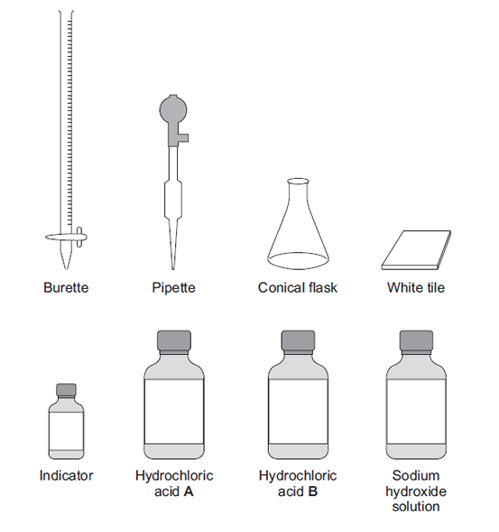
  - The equation for the reaction is:
2NaOH + H₂SO₄ → Na₂SO₄ + 2H₂O
Calculate the concentration of the sodium hydroxide. Give your answer to three significant figures. (4)
  - The student did another experiment using 20 cm³ of sodium hydroxide solution with a concentration of 0.18 mol / dm³. Relative formula mass (M_{r}) of NaOH = 40 Calculate the mass of sodium hydroxide in 20 cm³ of this solution. (2)
- In this question you will be assessed on using good English, organising information clearly and using specialist terms where appropriate. A student has to check if two samples of hydrochloric acid, A and B, are the same concentration. Describe how the student could use the apparatus and the solutions in the diagram to the right to carry out titrations. (Total 6 marks)
- An oven cleaner solution contained sodium hydroxide. A 25.0 cm³ sample of the oven cleaner solution was placed in a flask. The sample was titrated with hydrochloric acid containing 73 g/dm³ of hydrogen chloride, HCI.
  - Describe how this titration is carried out. (3)
  - Calculate the concentration of the hydrochloric acid in mol/dm³. (2)
  - 10.0 cm³ of hydrochloric acid were required to neutralise the 25.0 cm³ of oven cleaner solution.
    - Calculate the number of moles of hydrochloric acid reacting. (2)
    - Calculate the concentration of sodium hydroxide in the oven cleaner solution in mol/dm³. (2)
- Citric acid is a weak acid.
  - Explain what is meant by a weak acid. (2)
A student titrated citric acid with sodium hydroxide solution. This is the method used:
1. Pipette 25.0 cm³ of sodium hydroxide solution into a conical flask.
2. Add a few drops of thymol blue indicator to the sodium hydroxide solution. Thymol blue is blue in alkali and yellow in acid.
3. Add citric acid solution from a burette until the end-point was reached.
  - Explain what would happen at the end-point of this titration. Refer to the acid, the alkali and the indicator in your answer. (3)
  - Explain why a pipette is used to measure the sodium hydroxide solution but a burette is used to measure the citric acid solution (2)
  - The table shows the student’s results:
 | Titration 1 | Titration 2 | Titration 3 | Titration 4 | Titration 5
Volume of citric acid solution in cm³ | 13.50 | 12.10 | 11.10 | 12.15 | 12.15
The equation for the reaction is:
C₆H₈O₇ + 3 NaOH ⟶ C₆H₅O₇Na₃ + 3 H₂O
The concentration of the sodium hydroxide was 0.102 mol / dm ³. Calculate the concentration of the citric acid in mol/dm ³ (5)
- Dilute nitric acid reacts with potassium hydroxide solution. The equation for the reaction is:
HNO₃ + KOH KNO₃ + H₂O
A student investigated the temperature change in this reaction. This is the method the student used.
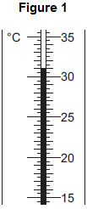
Step 1 Put 25 cm³ of dilute nitric acid in a polystyrene cup.
Step 2 Use a thermometer to measure the temperature of the dilute nitric acid.
Step 3 Use a burette to add 4 cm³ of potassium hydroxide solution to the dilute nitric acid and stir the mixture.
Step 4 Use a thermometer to measure the highest temperature of the mixture.
Step 5 Repeat steps 3 and 4 until 40 cm³ of potassium hydroxide solution have been added.
The dilute nitric acid and the potassium hydroxide solution were both at room temperature.
  - Figure 1 shows part of the thermometer after some potassium hydroxide solution had been added to the dilute nitric acid. What is the temperature shown on the thermometer? (1)
  - Errors are possible in this experiment.
    - Suggest two causes of random error in the experiment. (2)
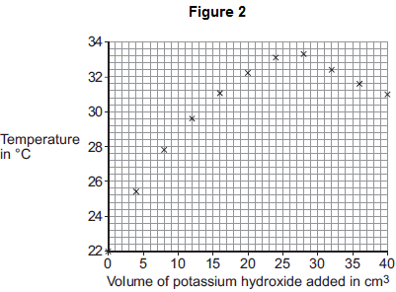
    - Another student used a glass beaker instead of a polystyrene cup. This caused a systematic error. Why does using a glass beaker instead of a polystyrene cup cause a systematic error? (1)
  - The results of the student using the polystyrene cup are shown in Figure 2.
    - How do the results in Figure 2 show that the reaction between dilute nitric acid and potassium hydroxide solution is exothermic? (1)
    - Explain why the temperature readings decrease between 28 cm³ and 40 cm³ of potassium hydroxide solution added. (2)
    - It is difficult to use the data in Figure 2 to find the exact volume of potassium hydroxide solution that would give the maximum temperature. Suggest further experimental work that the student should do to make it easier to find the exact volume of potassium hydroxide solution that would give the maximum temperature. (2)
  - The student did further experimental work and found that 31.0 cm³ of potassium hydroxide solution neutralised 25.0 cm³ of dilute nitric acid. The concentration of the dilute nitric acid was 2.0 moles per dm³.
HNO₃ + KOH KNO₃ + H₂O
Calculate the concentration of the potassium hydroxide solution in moles per dm³. (3)
  - The student repeated the original experiment using 25 cm³ of dilute nitric acid in a polystyrene cup and potassium hydroxide solution that was twice the original concentration. She found that:
• a smaller volume of potassium hydroxide solution was required to reach the maximum temperature
• the maximum temperature recorded was higher.
Explain why the maximum temperature recorded was higher. (2)

Q28 Level 3 (5–6 marks):
A coherent method is described with relevant detail, and in correct sequence which demonstrates a broad understanding of the relevant scientific techniques and procedures. The steps in the method are logically ordered. The method would lead to the production of valid results.
Level 2 (3–4 marks):
The bulk of the method is described with mostly relevant detail, which demonstrates a reasonable understanding of the relevant scientific techniques and procedures. The method may not be in a completely logical sequence and may be missing some detail.
Level 1 (1–2 marks):
Simple statements are made which demonstrate some understanding of some of the relevant scientific techniques and procedures. The response may lack a logical structure and would not lead to the production of valid results.
0 marks:
No relevant content.
Indicative content
• sulfuric acid in beaker (or similar)
• add copper carbonate one spatula at a time
• until copper carbonate is in excess or until no more effervescence occurs *
• filter using filter paper and funnel
• filter excess copper carbonate
• pour solution into evaporating basin / dish
• heat using Bunsen burner
• leave to crystallise / leave for water to evaporate / boil off water
• decant solution
• pat dry (using filter paper)
• wear safety spectacles / goggles
*Students. may choose to use a named indicator until it turns a neutral colour, record the number of spatulas of copper carbonate added then repeat without the indicator.

Q29-33

(a) any one from:

• heat

• stir

1

(b) filter

accept use a centrifuge

accept leave longer (to settle)

1

(c) any one from:

• wear safety spectacles

• wear an apron

1

(d) evaporation at A

1

condensation at B

1

(e) 100

1

[6]

Q34-37

(a) neutralisation

ignore reference to exothermic or endothermic

1

(b) 2 HCl + CaO ➔ CaCl₂ + H₂O

accept multiples and fractions

formulae

ignore state symbols

1

balancing (dependent on first mark)

1

(c) (the carbonate has) fizzing / bubbles / effervescence

ignore dissolving

ignore gas produced

1

(d) add excess calcium carbonate to acid (and stir) / add CaCO₃ until fizzing stops

ignore heating the acid

accept answer using calcium oxide in place of calcium carbonate

1

(remove excess calcium carbonate by) filter(ing)

1

warm until a saturated solution forms / point of crystallisation / crystals start to form

do not accept heat until all water gone

1

leave to cool

dependent on previous mark

If solution not heated allow leave to evaporate (1)

until crystals form (1)

1

Q65-67

(a) (diagram)

complete circuit with power supply

1

test solution in beaker or other appropriate apparatus

1

electrodes

allow carbon, platinum or inert electrodes

1

(independent variable)

salt solutions (with different metal ions)

1

(observation)

solid / metal deposit on the negative electrode

1

(b) (sometimes) hydrogen is produced

1

(because) the metal is more reactive than hydrogen

1

(c) chlorine

1

oxygen

1
Q68-72

(a) substance brokendown / separates / splits into elements

by electric current / electricity

ions free to move e.g. when molten / in solution

allow 1 mark for “a substance that conducts electricity”

max 2

(b) (i) copper / Cu

1

(ii) oxygen /O₂

allow CO₂

1

(c) tube over electrode

full of CuSO₄(aq) / water

allow sulphuric acid / sensible electrolyte

not any other liquid / using a syringe

2

(d) Cu²⁺ ions removed / less Cu²⁺

not copper sulphate removed

allow 1 mark for “copper removed / less copper”

2
Q98-101

(a) (i) 11

1

(ii) 4620 (J)

correct answer gains 2 marks with or without working

allow 4.62kJ for 2 marks

if answer is incorrect:

100 × 4.2 × 11 gains 1 mark

or

100 × 4.2 × (their temp. rise) gains 1 mark

or

100 × 4.2 × (their temp. rise) correctly calculated gains 2 marks

2

(b) the temperature increases

allow gets hotter

allow heat / energy is given off

1

(c) (i) (energy of) products lower than (energy of) reactants

allow converse

allow arrow C points downwards

1

(ii) A

1

[6]
Q102-107

(a) any three from:

• concentration of (salt) solution

• volume of (salt) solution

ignore amount of solution

• initial temperature (of the solution)

ignore room temperature

• surface area / form of metal

• moles of metal

allow mass / amount

ignore time

ignore size of tube

3

(b) 20

1

32

1

12

allow ecf

1

(c) (i) four bars of correct height

tolerance is + / - half square

3 correct for 1 mark

2

bars labelled

1

(ii) one variable is non-continuous / categoric

accept qualitative or discrete

accept no values between the metals

1

(iii) magnesium

1

because biggest temperature change

accept gives out most energy

ignore rate of reaction

dependent on first mark

1

(iv) does not react / silver cannot displace copper

1

because silver not more reactive (than copper) or silver below copper in reactivity series

do not accept silver is less reactive than copper sulfate

1

(v) replace the copper sulfate

could be implied

1

with any compound of a named metal less reactive than copper

allow students to score even if use an insoluble salt

1

Q114-126 (messed around with order and added my own Qs)

(a) the ions can move / travel / flow /are free

accept particles / they for ions

allow delocalised ions

or

ignore delocalised / free electrons

ignore references to collisions

accept converse with reference to solid

the ions carry the charge / current

ignore ions carry electricity

1

(b) any one from:

• because they are negative / anion

allow Cl–

ignore chlorine

• opposite charges / attract

1

(c) 13

1

(d) (i) reasonable attempt at straight line which misses the anomalous point

must touch all five crosses

do not allow multiple lines

1

(ii) 40

ignore 2.2

1

(iii) any two sensible errors from:

ignore systematic / human / apparatus / zero /experimental / random / measurement / reading errors unless qualified

• gas escapes

• weighing error

allow NaCl not measured correctly

• error in measuring (volume / amount) of hydrogen

• error in measuring (volume / amount) of water

allow error in measuring volume / scale for 1 mark if neither hydrogen or water mentioned

• incorrect concentration

allow NaCl not fully dissolved or spilled or impure

• timing error

• change in voltage / current

allow faulty power supply

• change in temperature

• recording / plotting error

2

(iv) any one from:

ignore ‘do more tests’

• repeat the experiment

• results compared with results from /other students / other groups / other laboratories / internet / literature.

• results compared with another method

1

(v) increases owtte

allow directly proportional or positive correlation

allow rate / it is faster / quicker

1
Q127-136

(a) (i) points correctly plotted ( ± ½ small square)

four points = 2 marks

three points = 1 mark

Max 2

straight line of best fit using full range of points from 0,0

1

(ii) any one from:

must explain why the point is below the line

• the solution may not have been properly stirred

• the electrodes may have been a larger distance apart

• the drop of sodium chloride may have been a smaller volume / smaller

allow not enough sodium chloride added

allow smaller amount of sodium chloride

do not allow too few drops added

ignore the student may have misread the conductivity meter

1

(iii) any one from:

• the volume of pure water

allow amount

• the concentration (of the solutions added)

• the volume (of the drops) of solution added

ignore number of drops

• the distance between the electrodes

• the same electrodes or electrodes made of the same material

• same depth or surface area of electrodes in the water

• constant power supply

ignore current

• stirred

1

(b) (i) because (pure) water is covalent / molecular (simple) or contains molecules

1

therefore (pure) water has no free / mobile electrons or ions

molecules do not have a charge or molecules do not contain ions gains 2 marks

1

(ii) because there are ions in sodium chloride

allow Na⁺ and / or Cl–(ions) or ionic bonding.

Ignore particles other than ions for MP1.

1

which can move or carry the current / charge

MP2 must be linked to ions only.

1

(iii) Hydrogen

allow H₂ / H

1
Q137-143

(a) use a polystyrene cup instead of a (glass) beaker

allow insulate the beaker

allow use a lid

1

minimises energy transfer from the surroundings

or

for better insulation

1

(b) concentration of hydrochloric acid

1

(c) 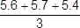

1

= 5.6 (°C)

1

± 0.2

1

(d) straight line from origin to (5.0, 6.4)

must not deviate to anomalous point

1

horizontal line from (5.0, 6.4) to (8.0, 6.4)

must not deviate to anomalous point

1

(e) as mass (of potassium hydrogencarbonate) increases, temperature decrease / change increases

1

until 5 g (to 8 g) (of potassium hydrogencarbonate has been added)

allow ecf from lines of best fit

1

(because) the reaction has finished

or

(because) all the acid has reacted

or

(because) no more solid can react

or

(because) the solid is in excess

1

(f) not stirred correctly

1
Q164-174

(a) sulfur

1

precipitate

allow solid

1

(b) any one from:

• (volumetric) pipette

• burette

1

(c) any one from:

• concentration of hydrochloric acid

• volume of hydrochloric acid

• volume of sodium thiosulfate solution

• temperature (of solution)

• darkness of cross

allow same cross

• same stirring / swirling

1

(d) 7 points plotted correctly

allow tolerance of ± half a small square

allow 5 or 6 points plotted correctly for 1 mark

2

line of best fit

must avoid anomalous point

1

(e) repeatable

do not accept reproducible

1

(f) discard any anomalous results

1

calculate a mean

1

(g) conclusion:

the higher the concentration, the higher the rate of reaction

1

explanation:

(at higher concentrations) there are more particles in a fixed volume

1

(therefore the) collisions are more frequent

1

allow converse

(h) 120 (s)

1

0.18 / 120

allow 0.0015

1

= 1.5 × 10⁻³ (g / s)

an answer of 9 × 10⁻² scores 2 marks

allow an answer of 0.09 for 1 mark

1

an answer of 1.5 × 10⁻³ (g / s) scores 3 marks
Q199-201

drinks / colours B and C are safe

1

drinks / colours A and D are not safe

accept a pair of one safe colour and one not safe colour identified for 1 mark

accept A, B, C and D all contain one safe colour for 1 mark

ignore references to shading

(a) (improve) appearance

allow add colour

allow these food colourings have not been proven to cause hyperactive behaviour in young children

do not accept taste / flavour / preservatives

ignore reference to E-numbers

1

(b) X

1

(c) any three from:

• S contains six / 6 colourings

• P contains five / 5 colourings

if neither of first 2 bullet points given allow 1 mark for S contains more colours than P or converse

• both S and P contain the same

five / 5 colourings

• both contain W and Y

• both sweets (may) cause hyperactivity

ignore unsafe

• neither contain X and Z

3

Questions 248-252
Q1.
(a)
1
= 15.6(25) (g)
1
an answer of 15.6(25) (g) scores 2 marks
(b) copper (ions)
allow in either order
1
sulfate (ions)
1
(c) flame test
1
yellow (flame)
1
(d) add dilute acid
allow named acid
1
(bubble gas produced through) limewater
1
(turns) cloudy / milky
allow forms white precipitate
1
[9]
Q2.
(a) (i) fizz / effervescence / bubbles
allow calcium carbonate decreases in size or dissolves
1
because carbon dioxide produced / released
allow because gas produced / released
1
limewater turns cloudy / milky / white
1
because (a precipitate of or solid) calcium carbonate forms
allow because of carbon dioxide if not already credited
1
(ii) 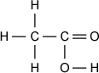
allow -OH
do not allow lower case ‘h’
1
(iii) acid
must be in this order
ignore any name of an acid
1
ester(s)
1
(b) white (precipitate) no change
no change no change
all four correct 2 marks
any two correct 1 mark
2
(c) (i) lilac
allow purple
1
red
1
must be in this order
(ii) colours are masked / changed by each flame colour
1
[12]
Q3.
(a) lithium
allow Li⁺ / Li
1
yellow
allow orange
1
(b) silver nitrate (solution)
incorrect test = 0 marks
ignore (nitric) acid
do not allow other named acids
1
white precipitate
1
(c) blue precipitate (with sodium hydroxide) indicates copper ions
allow Cu²⁺
1
and white precipitate (with barium chloride) indicates sulfate ions
allow SO₄²⁻
accept compound X is copper sulfate / CuSO₄ for 1 mark
1
but iron(II) ions produce a green precipitate (with sodium hydroxide)
1
[7]
Q4.
Marks awarded for this answer will be determined by the Quality of Communication (QC) as well as the standard of the scientific response. Examiners should also apply a ‘best-fit’ approach to the marking.
0 marks
No relevant content
Level 1 (1 – 2 marks)
Any description of a method used and / or a result given
Level 2 (3 – 4 marks)
Description of workable methods used, with results to identify positive or negative ions
Level 3 (5 – 6 marks)
Description of methods used to identify both positive and negative ions, with relevant results
examples of the points made in the response
extra information
Test: add (platinum / nichrome) wire (for the flame test)
accept any method of introducing the solution into the flame, eg a splint soaked in the solution or sprayed from a bottle
Result: the sodium compounds result in a yellow / orange / gold flame or the potassium compound results in a lilac / purple / mauve flame
student could state that potassium carbonate gives a different colour to the three sodium compounds as long as it is clear that the flame test colour comes from Na⁺ or K⁺
Test: add dilute nitric acid to all four solutions
allow any acid
Result: sodium carbonate and potassium carbonate will effervesce or sodium chloride and sodium iodide will not effervesce
Test: add dilute nitric acid followed by silver nitrate
Result: sodium chloride and sodium iodide produce a precipitate or sodium chloride produces a white precipitate and sodium iodide produces a yellow precipitate
accept sodium carbonate and potassium carbonate do not produce a precipitate
[6]
Q5.
(a) X:
Fe²⁺ / iron(II), SO₄²⁻ / sulfate
allow iron(II) sulfate
or FeSO₄
1
Y:
Na⁺ / sodium, I⁻ / iodide
allow sodium iodide
or NaI
1
Z:
Fe³⁺ / iron(III), Br⁻ / bromide
allow iron(III) bromide
or FeBr₃
correct identification of any two ions = one mark
correct identification of any four ions = two marks
1
(b) any five from:
allow converse arguments
method 1
• weighing is accurate
• not all barium sulfate may be precipitated
• precipitate may be lost
• precipitate may not be dry
• takes longer
• requires energy
allow not all the barium hydroxide has reacted
method 2
• accurate
• works for low concentrations
allow reliable / precise
5

Questions 281-285
Q1.
(a) (sulfuric acid is) completely / fully ionised
1
In aqueous solution or when dissolved in water
1
(b) H⁺(aq) + OH⁻(aq) → H₂O(l)
allow multiples
1 mark for equation
1 mark for state symbols
2
(c) adds indicator, eg phenolpthalein / methyl orange / litmus added to the sodium hydroxide
(in the conical flask)
do not accept universal indicator
1
(adds the acid from a) burette
1
with swirling or dropwise towards the end point or until the indicator just changes colour
1
until the indicator changes from pink to colourless (for phenolphthalein) or yellow to red
(for methyl orange) or blue to red (for litmus)
1
(d) titrations 3, 4 and 5
or
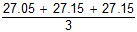
1
27.12 cm³
accept 27.12 with no working shown for 2 marks
1
allow 27.1166 with no working shown for 2 marks
(e) Moles H₂SO₄ = conc × vol = 0.00271
allow ecf from 8.4
1
Ratio H₂SO₄:NaOH is 1:2
or
Moles NaOH = Moles H₂SO₄ × 2 = 0.00542
1
Concentration NaOH = mol / vol = 0.00542 / 0.025 = 0.2168
1
0.217 (mol / dm³)
accept 0.217 with no working for 4 marks
1
accept 0.2168 with no working for 3 marks
(f) × 0.18 = no of moles
or
0.15 × 40 g
1
0.144 (g)
1
accept 0.144g with no working for 2 marks
[16]
Q2.
Marks awarded for this answer will be determined by the Quality of Written Communication (QWC) as well as the standard of the scientific response. Examiners should also apply a ‘best-fit’ approach to the marking.
Level 3 (5 – 6 marks)
There is a description of titrations that would allow a comparison to be made between the two solutions of hydrochloric acid.
Level 2 (3 – 4 marks)
There is a description of an experimental method including addition of acid to alkali which may include an indicator or colour change and may include a measurement of volume.
Level 1 (1 – 2 marks)
There is a simple description of using some of the apparatus.
0 marks
No relevant content.
examples of chemistry points made in the response could include:
• acid in burette or flask
• alkali/sodium hydroxide or acid in burette or flask
• volume of acid or alkali measured using the pipette
• indicator in flask
• white tile under the flask
• slow addition
• swirling/mixing
• colour change of indicator
• burette volume measured
[6]
Q3.
(a) hydrochloric acid in burette
1
indicator
1
note volume at end / neutralisation point
titre must be HC1
1
(b) 1 mole HCl = 36.5g /36.5
1
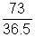 = 2 moles / dm³
2 for correct answer
1
(c) (i) 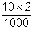
allow e.c.f. ie their (b) × 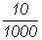
2 for correct answer
1
= 0.02 moles
1
(ii) 0.02 × 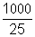 = 0.8 mol / dm³
1
allow e.c.f. ie their (c)(i) × 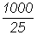
1
[9]
Q4.
(a) produces H⁺ / hydrogen ions in aqueous solution
1
(but is) only partially / slightly ionised
1
(b) indicator changes colour
1
from blue to yellow
allow from blue to green
1
(when) the acid and alkali are (exactly) neutralised
or
(when) no excess of either acid or alkali
1
(c) pipette measures one fixed volume (accurately)
1
(but) burette measures variable volumes (accurately)
1
(d) 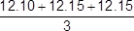
1
(mean titre =) 12.13(3) (cm ³)
1
(moles NaOH = conc × vol) = 0.00255
1
(moles citric acid = moles NaOH) = 0.00085
1
(conc acid = moles / vol) = 0.0701 (mol / dm ³)
allow ecf from steps 1, 2, 3 and / or 4
allow an answer of 0.0701 (mol / dm ³) without working for 1 mark only
1
[12]
Q5.
(a) 31
1
(b) (i) any two from:
• incorrect reading of thermometer / temperature
• incorrect measurement of volume of acid
• incorrect measurement of volume of alkali (burette).
2
(ii) glass is a (heat) conductor or polystyrene is a (heat) insulator
answer needs to convey idea that heat lost using glass or not lost using polystyrene
accept answers based on greater thermal capacity of glass (such as “glass absorbs more heat than polystyrene”)
1
(c) (i) temperature increases
1
(ii) no reaction takes place or all acid used up or potassium hydroxide in excess
1
cool / colder potassium hydroxide absorbs energy or lowers temperature
ignore idea of heat energy being lost to surroundings
1
(iii) take more readings
ignore just “repeat”
1
around the turning point or between 20 cm³ and 32 cm³
accept smaller ranges as long as no lower than 20 cm³ and no higher than 32 cm³
1
(d) 1.61 or 1.6(12903)
correct answer with or without working scores 3
if answer incorrect, allow a maximum of two from:
moles nitric acid = (2 × 25 / 1000) = 0.05 for 1 mark
moles KOH = (moles nitric acid) = 0.05 for 1 mark
concentration KOH = 0.05 / 0.031
answer must be correctly rounded (1.62 is incorrect)
3
(e) same amount of energy given out
1
which is used to heat a smaller total volume or mixture has lower thermal capacity
or
number of moles reacting is the same
but the total volume / thermal capacity is less
if no other marks awarded award 1 mark for idea of reacting faster
1
[14]

