Required Practicals Mastery Booklet: Chemistry
For the triple science GCSE there are eight practicals that you must be familiar with. This booklet will outline the practicals and provide you with explanations and questions to best prepare you for the exam. It is designed to be used once you have studied the relevant units. Many of the questions will contain ideas related to the required practicals.
Videos for all practicals can be found here:
https://www.youtube.com/channel/UC-TM-z1-tmX1iK_H4SxVhww/videos
More detailed practical instructions can be found here:
http://www.rsc.org/learn-chemistry/resource/res00002217/gcse-science-specification-guide#!cmpid=CMP00007527
You should watch the video for each practical before attempting the questions.
Contents:
p2. 1: Crystallisation Required Practical
p4. 2:Neutralisation Required Practical
p6. 3: Electrolysis Required Practical
p9. 4: Temperature Changes Required Practical
p12. Handling data and interpreting results
p18. 5: Rates Required Practical
p22. 6: Chromatography Required Practical
p24. 7: Identifying Ions Required Practical
p28. 8: Analysis and Purification of Water Required practical
p30, Answers to questions

Required Practical 1: Preparation of a pure, dry sample of a soluble salt from an insoluble oxide or carbonate, using a Bunsen burner to heat dilute acid and a water bath or electric heater to evaporate the solution.
https://www.youtube.com/watch?v=qIOMlwBoe_4
Recap questions:
- What is a salt?
- What is a soluble salt?
- What is a dilute acid?
- What is a base?
- What does evaporation mean?
- Give the products for the reaction between copper oxide and sulphuric acid. Refer to your notes on the reactions of acids if necessary.
- Write a word equation for this reaction.
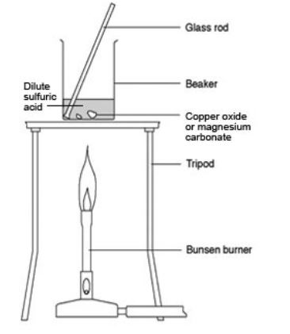
- Challenge: write a symbol equation for this reaction
Method
The first step is to put on goggles for safety and then measure out dilute sulphuric acid using a measuring cylinder. Measuring cylinders are more precise than beakers. The acid is then poured into a beaker which is then warmed on a Bunsen burner.
- Why is it important to wear goggles when using acid?
- Why is a measuring cylinder used to measure out the acid?
- Why is the acid warmed?
- When warming the acid, it is important not to heat it too much. Why?
An excess of copper oxide is added. This means that more than is needed is added and is needed to neutralise all the acid. A small amount is added to start with and stirred. This results in a clear blue solution. More copper oxide is added until no more can react. Copper oxide is a black powder so when no more can react a black powder can be seen at the bottom of the beaker.
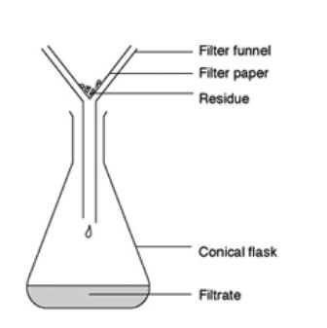
- Why is the mixture stirred?
- Once it has reacted, the copper oxide can no longer be seen. Why is this?
- What is an excess?
The excess copper oxide must now be removed by filtration with filter paper.
- What is filtration?
- What types of mixtures can filtration be used to separate?
- Explain why filtration cannot separate salt from sea water.
- What is the residue in this practical?
- What would the residue look like?
- What is the filtrate in this practical?
The clear blue solution is poured into an evaporating basin. The basin is then heated gently over a water bath to prevent breakdown of copper sulphate crystals.
- What is the name for this process?
- Where does the water go?
- Why is it important to stop the temperature getting too hot?

Summarised method
In your exam, you will asked to replicate this method from memory and answer questions based upon it. A summarised method could be:
- Measure out a volume of dilute sulphuric acid using a measuring cylinder
- Warm dilute sulphuric acid in a beaker with a Bunsen burner
- Add copper oxide one spatula at a time
- Add copper oxide until it is in excess - when you can see unreacted copper oxide
- Filter the mixture using a funnel and filter paper
- Pour the filtrate into an evaporating basin
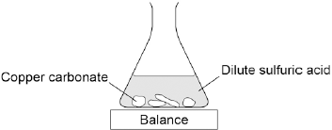
- Warm on a water bath until crystals form
Summary questions
- Cover up the method above and attempt to replicate it from memory. Once you have finished, uncover the method, correct your method and then try again with a blank piece of paper.
- A student investigated the reaction of copper carbonate with dilute sulfuric acid. Using the equipment shown.
Complete the state symbols in the equation:
CuCO₃ (___) + H₂SO₄ (aq) → CuSO₄ (___) + H₂O (___) + CO₂ (g)
- Why did the balance reading decrease during the reaction? Choose one answer from the below.
  - The copper carbonate broke down.
  - A salt was produced in the reaction.
  - A gas was lost from the flask.
  - Water was produced in the reaction.
- Describe a safe method for making pure crystals of copper sulfate from copper carbonate and dilute sulfuric acid. Use the information in the figure above to help you. In your method you should name all of the apparatus you will use.
- Rock salt is a mixture of sand and salt. Salt dissolves in water. Sand does not dissolve in water. Some students separated rock salt. This is the method used:
1. Place the rock salt in a beaker.
2. Add 100 cm³ of cold water.
3. Allow the sand to settle to the bottom of the beaker.
4. Carefully pour the salty water into an evaporating dish.
5. Heat the contents of the evaporating dish with a Bunsen burner until salt crystals start to form.
Suggest one improvement to step 2 to make sure all the salt is dissolved in the water.
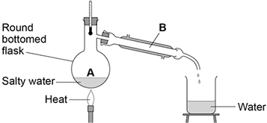
- The salty water in step 4 still contained very small grains of sand. Suggest one improvement to step 4 to remove all the sand.
- Suggest one safety precaution the students should take in step 5.
- Another student removed water from salty water using the apparatus in the figure to the right. Describe how this technique works by referring to the processes at A and B.
- What is the reading on the thermometer during this process?
- Calcium chloride (CaCl₂) is a soluble salt. Calcium chloride can be made by reacting dilute hydrochloric acid with either solid calcium oxide or solid calcium carbonate. Name the type of reaction that takes place when dilute hydrochloric acid reacts with calcium oxide.
- Write a balanced symbol equation for the reaction of dilute hydrochloric acid with calcium oxide.
- A student added solid calcium oxide to dilute hydrochloric acid in a beaker. The student added solid calcium carbonate to dilute hydrochloric acid in another beaker. Describe one difference between the two reactions that the student would see.
- Describe how crystals of calcium chloride can be made from calcium carbonate and dilute hydrochloric acid.
Required Practical 2: Investigation to find the concentration of a dilute sulfuric acid solution using a sodium hydroxide solution of known concentration.
https://www.youtube.com/watch?v=8yHYoENtCEY
Recap questions:
- What does concentration mean?
- What does “hydroxide” in the name of a chemical tell you about it?
- What is a dilute acid?
- What is an alkali?
- What does neutralisation mean?
- Give the products for the reaction sodium hydroxide and sulfuric acid. Refer to your notes on the reactions of acids if necessary.
- Write a word equation for this reaction.
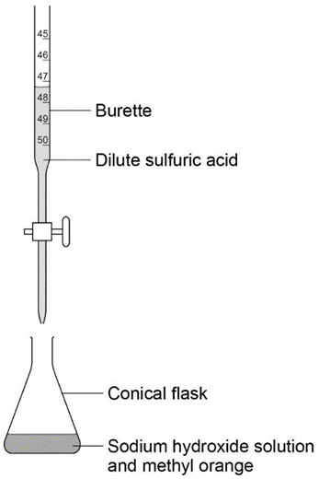
- Challenge: write a symbol equation for this reaction
Method
The first step is to put on goggles for safety as sodium
hydroxide is corrosive and sulfuric acid irritant.
Measure out sodium hydroxide solution using a pipette
and pipette filler and place in a conical flask. Pipettes
are more precise than measuring cylinders.
The acid is then poured into a burette using a funnel.
A few drops of methyl orange indicator are added to the
sodium hydroxide and the conical flask is placed on a white tile.
The volume of acid in the burette is recorded and the tap
of the burette opened to allow acid to enter the conical flask.
The flask is swirled until the indicator changes colour. The tap is closed
And the final volume of the burette is recorded. This enables the titre
value of the added acid to be calculated. This is the rough titration.
The process is repeated but this time with the acid added dropwise
near the end point to give an accurate titration. The experiment is
repeated again and the accurate values for the two accurate titrations
used to calculate an average volume of acid added.

- Why is it important to wear goggles when using an alkali?
- Why is a pipette used to measure out the alkali?
- Why is the conical flask used?
- Why is the conical flask placed on a white tile?
- Why is methyl orange indicator used rather than universal indicator?
Summarised method
In your exam, you will asked to replicate this method from memory and answer questions based upon it. A summarised method could be:
- Measure out 25cm³ of alkali using a pipette and pipette filler
- Place the alkali in a conical flask
- Add an indicator to the alkali and place on top of white tile
- Fill a burette with acid and record the starting volume
- Add the acid to the conical flask and swirl to mix
- Close the tap on the burette when the indicator changes colour
- Record the final volume of acid on the burette and calculate the rough titre
- Rinse out the conical flask with distilled water
- Repeat the process but this time add the acid dropwise near the endpoint for accuracy
- Repeat again and calculate the mean titre from the two average values.
Summary questions
- Cover up the method above and attempt to replicate it from memory. Once you have finished, uncover the method, correct your method and then try again with a blank piece of paper.
- Why is a conical flask used?
- Why is the substance placed in the conical flask measured out using a pipette and pipette filler?
- Why is a burette used to add the neutralising chemical?
- Why is an indicator used?
- What is the end-point?
- Why is the neutralising agent added dropwise near the endpoint
- Why is the conical flask rinsed with distilled water between titrations?

- Sodium hydroxide reacts with hydrochloric acid.
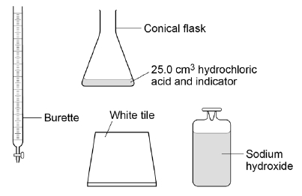
The diagram shows apparatus that can be used to find the volume of sodium hydroxide reacting with 25.0 cm ³ hydrochloric acid.
Describe a method to find the exact volume of sodium hydroxide that reacts with 25.0 cm ³ of hydrochloric acid. (6 marks)

- The reaction produces a solution of sodium chloride.
A student wants to obtain sodium chloride crystals from the sodium chloride solution.
This is the method used.
1. Add solid charcoal to the sodium chloride solution to remove the indicator colour.
2. Remove the solid charcoal.
3. Evaporate the solution to dryness over a Bunsen burner.
Charcoal is not soluble in water.
Suggest a method the student could use to remove the solid charcoal in Step 2.)

- The student obtains a powdery white solid. Suggest how the student could improve Step 3 of the method to obtain larger crystals instead of powder.
- The student found that 31.0 cm³ of sodium hydroxide solution neutralised 25.0 cm³ of dilute hydrochlroric acid.
The concentration of the dilute nitric acid was 2.0 moles per dm³.
HCl + NaOH →NaCl + H₂O
Calculate the concentration of the sodium hydroxide solution in moles per dm³.
- Calculate the concentration of the sodium hydroxide solution in grams per dm³.

Required practical activity 3: Investigate what happens when aqueous solutions are electrolysed using inert electrodes. This should be an investigation involving developing a hypothesis.
https://www.youtube.com/watch?v=tCHE_7QeRUc
Recap questions:
- What is electrolysis?
- Why is electrolysis used to extract certain metals?
- What are electrodes?
- What is an anode and what is a cathode?
- To which electrode are positive ions attracted?
- To which electrode are negative ions attracted?
- To which electrode are metal ions attracted?
- To which electrode are non-metal ions attracted?
- When performing electrolysis on a solution, hydrogen is often formed instead of a metal. Explain why.
- When the non-metal in electrolysis of a solution is not a halogen, which element is always formed?
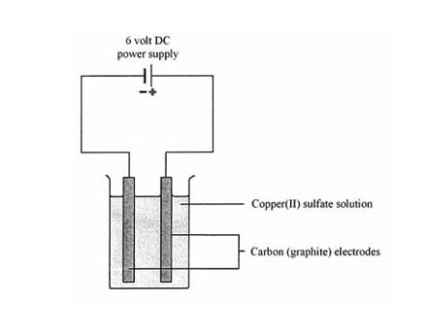
- The electrodes must be inert. What does inert mean?
- What substances do we often use for electrodes?
- Give an equation to show how water can break down into OH⁻(aq) ions and H⁺(aq) ions. Refer back to your electrolysis mastery booklet if you need to.
- Give an equation to show how OH⁻ ions can be oxidised at the anode.
- Give an equation to show how H⁺ ions can be reduced at the cathode.
Method:
First step is to half fill a beaker with your chosen solution. The electrodes must then be submerged in the solution and connected to a power pack. It is important that the crocodile clips are not submerged in the solution as they may react with it.
- A student decides to use copper (II) chloride solution. What is the formula for this solution?
- What is a solution?
- Outline a method for how a student could obtain solid copper chloride from copper chloride solution.
- A student uses crocodile clips that are made of iron. Explain why submerging these crocodile clips in copper chloride will ruin the practical. (hint – look back at your notes on the reactivity series)
- Why will the practical not work if solid copper chloride is used? Explain your answer with reference to ions.
Second step is to turn on the power pack. Bubbles will slowly begin to form at the electrodes. Any gas produced can then be tested. Any solid metal produced will form on the cathode.
- What are the tests for chlorine and oxygen gas?
- What is the test for hydrogen gas?
- In what cases will hydrogen form?
- At which electrode will hydrogen form?

- Complete the table below. The first one has been done for you.
Solution | Formula | Forms at anode | Forms at cathode
Copper (II) chloride | CuCl₂ | Cl₂(g) | Cu(s)
Copper (II) sulphate
Potassium chloride
Sodium chloride
Potassium sulphate
Lithium hydroxide
Copper hydroxide
Zinc sulphate
Iron (II) chloride
Iron (III) sulphate
- Challenge: for each of the above, write half equations for what occurs at the anode and at the cathode
- Give equations to show how hydrogen and oxygen can be produced in the electrolysis of sodium hydroxide.
Often, you will be expected to describe how the gases produced can be collected, in which case you can use a diagram like the below. This shows how inverted (upside down) test tubes can be used to collect the gas.
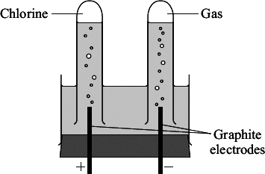
If measuring cylinders are used instead of test tubes, you can measure the volume of gas produced. Note that you must use the word “volume” and not “amount.”
Summarised method
You will normally be given a particular solution and be asked to outline a method for its electrolysis. You will often be given the opportunity to draw a diagram (like the ones above) which should be labelled. You must mention which tests are going to be used.
Summary questions
- A student makes a hypothesis: ‘When different salt solutions are electrolysed with inert electrodes, the product at the negative electrode is always a metal’. Describe how you would test this hypothesis in the laboratory. You should:
- draw a labelled diagram of the apparatus
- give the independent variable
- describe what you would see at the negative electrode if the hypothesis is true.
- The student’s hypothesis is only partially correct. Explain why the product at the negative electrode is not always a metal.
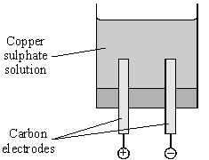
- Predict the product at the positive electrode in the electrolysis of:
sodium chloride solution
copper sulfate solution.
- An investigation into the electrolyte copper sulphate solution was carried out as shown. What does electrolyte mean?
- These were the observations:
Negative electrode: solid formed
Positive electrode: gas given off
Name the solid formed.
- Name the gas given off.
- How could a sample of gas be collected at the positive electrode?
- Suggest why the blue colour of copper sulphate becomes paler during the investigation.

Required practical activity 4 Investigate the variables that affect temperature changes in reacting solutions such as, e.g. acid plus metals, acid plus carbonates, neutralisations, displacement of metals.
https://www.youtube.com/watch?v=tKxcQYZ2YH8
Recap questions
- A reaction is conducted between zinc and copper sulphate solution. How can the temperature change of this reaction be measured?
- If the temperature increases, what can be said of the reaction?
- If the temperature decreases, what can be said of the reaction?
- Draw a fully labelled reaction profile for an exothermic reaction.
- Draw a fully labelled reaction profile for an endothermic reaction.
- A student wishes to add samples of iron and magnesium to acid and see which one changes
temperature by the greatest amount. Which variables will the student have to control?
- Why must these variables be controlled?
- What is the independent variable in this experiment?
- What is the dependent variable in this experiment?
- Predict which metal will give the greatest temperature change. Explain your answer.
Method for reactions of solutions with other solutions or solids:
The method will vary depending on exactly what reaction you are going to be investigating. Often, you will be using a solid and a solution or two solutions. The first step is therefore to measure out a precise volume of solution and mass of solid.
- What piece of equipment is used to measure mass?
- What piece of equipment is used to measure volume?
- Explain why these pieces of equipment are used.
- Why is it important to precisely measure the volume of acid or mass of solid?
A simple calorimeter is set up. This usually involves a polystyrene cup placed in a beaker with a lid on top. A thermometer is pushed through the lid.
- Why is a polystyrene cup used?
- Why is a lid used?
- Why is the cup placed in a beaker?
The first solution is poured into the cup and left for a couple of minutes. Its temperature is then recorded. The second solution (or solid) is added to the cup, and the lid quickly placed on the cup. The reaction can then be stirred gently. You can then record the temperature every minute or just record the highest temperature reached.
- Why should the lid be returned quickly?
- What is the advantage of taking the temperature every minute?
- Why is stirring a potential source of error?
- An automatic stirrer can be placed inside the cup. How can this eliminate the error in question 92?
- What is the largest source of error in this reaction?
Summary method:
- Precisely measure out your reactants (solutions with measuring cylinder, solids with balance)
- Place a polystyrene cup in a beaker
- Prepare a lid with a thermometer
- Add reactant 1 to cup and record temperature
- Add reactant 2 to cup
- Quickly place lid on cup
- Stir gently
- Record highest temperature reached

Summary questions
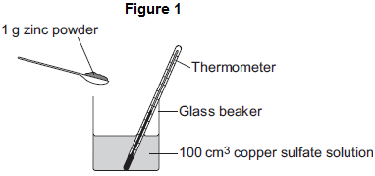
- A student wishes to investigate the temperature change when different volumes of sulphuric acid are added to sodium hydroxide solution. From memory, outline a method to carry out this investigation.
- Predict how the volume of sulphuric acid will affect the temperature change.
- Discuss the sources of error in this practical, and how the method could be improved.
- A student investigates the energy released when zinc powder reacts with copper sulfate solution. The student uses the apparatus shown in Figure 1. The student:
- measures 100 cm³ copper sulfate solution into a beaker
- measures the temperature of the copper sulfate solution
- puts 1 g zinc powder into the beaker
- stirs the mixture with a thermometer
- measures the highest temperature.
The student’s results were:
Starting temperature = 21 °C
Highest temperature = 32 °C
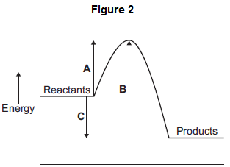
Calculate the change in temperature.
- The reaction of zinc with copper sulfate is exothermic. How can you tell from the student’s results that the reaction is exothermic?
- The energy diagram for the reaction is shown in Figure 2. How can you tell from the energy diagram that the reaction is exothermic?
- Which arrow shows the activation energy in Figure 2?

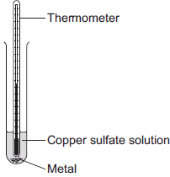
- A student investigated displacement reactions of metals. The student added different metals to copper sulfate solution and measured the temperature change. The more reactive the metal is compared with copper, the bigger the temperature change. The apparatus the student used is shown.
State three variables that the student must control to make his investigation a fair test.

Figure 2 shows the thermometer in one experiment before and after the student added a metal to the copper sulfate solution. Use Figure 2 to complete Table 1.
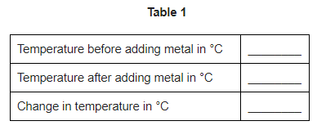
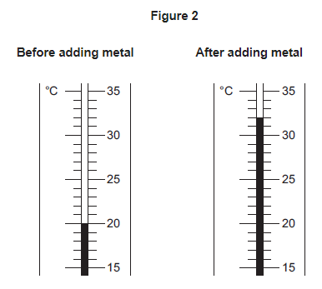

- The student repeated the experiment three times with each metal. The table below shows the mean temperature change for each metal.

Metal | Mean temperature change in °C
Cobalt | 4.5
Gold | 0.0
Magnesium | 10.0
Nickel | 3.0
Silver | 0.0
Tin | 1.5

Why is a line graph not a suitable way of showing the results?
- Use the results to work out which metal is the most reactive. Give a reason for your answer.
- Explain why there was no temperature change when silver metal was added to the copper sulfate solution.
- It is not possible to put all six metals in order of reactivity using these results. Suggest how you could change the experiment to be able to put all six metals into order of reactivity.

Handling data and interpreting results
We have now covered three practicals and know enough content to be able to look at data handling and interpreting results. There are a number of concepts to be aware of here which are summarised in the table below.
Concept | Definition | Example
Variable | Something which can be changed in a practical | Mass of substance, volume of solution, temperature
Independent variable | The variable which is changed by the person carrying out the practical | Mass of zinc added to copper sulphate when investigating temperature change
Dependent variable | The variable which is the “result” of the practical | The temperature change when zinc is added to copper sulphate
Repeatability | Whether you repeating the experiment under the same conditions gets the same results | If you add the same mass of zinc to a fresh sample of copper sulphate, do you get the same result?
Reproducibility | Whether someone else repeating the experiment under the same conditions gets the same results | If your classmate does the same practical and gets the same results
Accuracy | If your results are close to the true value | If using a pH probe to measure pH, if the probe has not been calibrated properly it will not give you an accurate result
Precision | Whether measurements “cluster closely” | When applied to equipment usually refers to how closely you can measure, e.g. a measuring cylinder is more precise than a beaker. When applied to results usually means if your repeats are close to each other.
Random error | Issues affecting measurement that cannot be predicted. Take repeats and calculate means to eliminate this error. | A draft in a room may cool down an experiment, giving you different readings.
Systematic error | An issue affecting your measurement by the same amount each time | If there is a problem with a balance that causes it to read 5g over the true value each time (someone may have left some powder on it)
Anomalies | Individual results which do not fit with the others. These should be ignored. | If you repeat and experiment and get 10g, 11g, and 25g, it is likely that your last result is an anomaly.
Trend | How one variable affects another | “As you add a greater mass of metal, the temperature change increases”
Directly proportional | If you plot your graph and the line of best fit is straight. It means that as x increases by a set amount, y also increases by a set amount | Results like:  x 1 2 3 4 5 6 7  y 2 4 6 8 10 12 14
Uncertainty | How sure you are that your result is correct | The range of your measurements is a good way to establish your uncertainty. If your results are 4,4,4 that is more certain than 3,5,4, despite the mean being the same for both.

- A student investigates how the mass of iron added to copper sulphate affects the temperature change. What are the dependent and independent variables?
- Which variables must be controlled?
- The student chooses to use the masses 1g, 2g, 3g, 4g and 5g. Explain why the student should repeat the experiment for each mass.
- Why is it important for the student to compare their results with other students’ results?
- After the experiment, the student realised that the thermometer was giving readings that were “out” by 6°C each time. What type of error is this?
- Why is it important that the student uses a measuring cylinder and not a beaker to measure the volume of solution used?
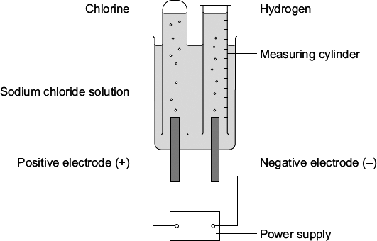
- A student investigated the electrolysis of sodium chloride solution. Five sodium chloride solutions were made. Each solution had a different concentration. To make each solution the student:
- weighed the amount of sodium chloride needed
- dissolved it in water
- added more water until the total volume was one cubic decimetre (1 dm³).
The solutions were placed one at a time in the apparatus shown. The student measured the volume of hydrogen gas produced in ten minutes. The results are shown on the graph below. Draw a line of best fit on the graph.
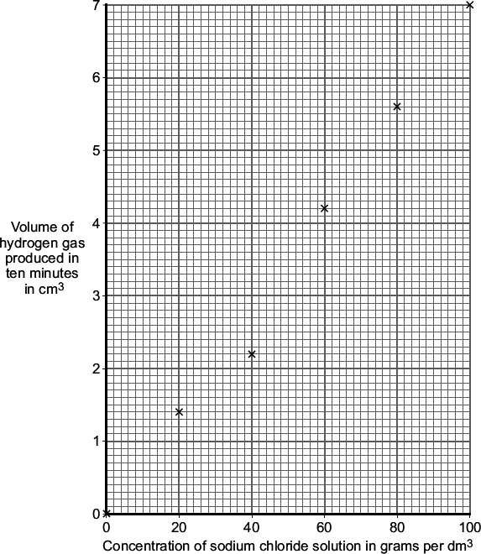
- The result for one concentration is anomalous. Which result is anomalous?
- Suggest two possible causes of this anomalous result.
- Suggest how the student could check the repeatability of this experiment.
- Suggest how the student could check the reproducibility of this experiment.
- How did an increase in the concentration of the sodium chloride solution affect the volume of hydrogen gas produced in ten minutes?
- Are these results directly proportional? Explain your answer.
- Why is it important that the student records the volume produced in ten minutes exactly each time?
- At the end of the experiment, the student notices that the stopwatch being used has a delay between the button being pushed and the stopwatch starting. What type of error is this?
- In this case, what should the student do?
- Sodium chloride does not conduct electricity when it is solid. Explain, in terms of ions, why sodium chloride solution conducts electricity.
- Chlorine is produced at the positive electrode. Why are chloride ions attracted to the positive electrode?
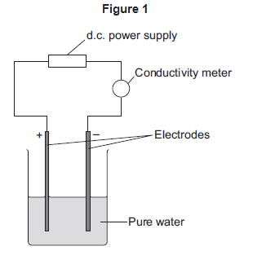
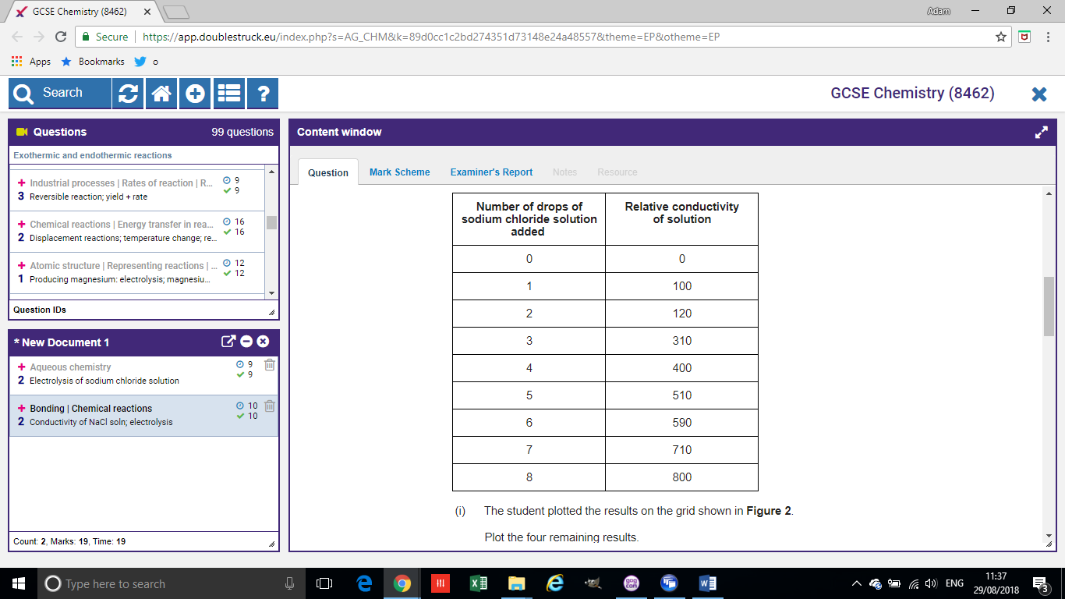
- The solution left at the end of each experiment contains sodium hydroxide. Draw a ring around one number which could be the pH of this solution.
2 5 7 13
- A student investigated the conductivity of different concentrations of sodium chloride solution. The student set the apparatus up as shown in Figure 1.
The student measured the conductivity of the pure water with a conductivity meter. The reading on the conductivity meter was zero.
The student:
  - added sodium chloride solution one drop at a time
  - stirred the solution
  - recorded the reading on the conductivity meter.
What were the dependent and independent variables in this experiment?
- The student’s results are shown in the table above. The student plotted the results on the grid shown.
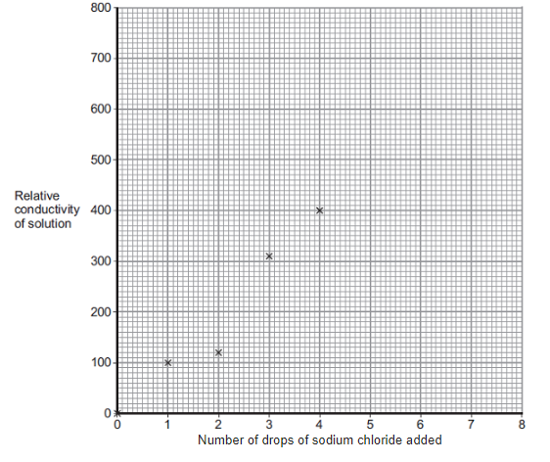
Plot the four remaining results.
- Draw a line of best fit, ignoring the anomalous result.
- One of the points is anomalous. Suggest one error that the student may have made to cause the anomalous result. (hint – your answer must explain why the anomaly is less than you would expect, and you cannot write “wrong number of drops” as we assume that this was correct!)
- Is this anomaly caused by a random or systemic error?
- The student wanted to compare the conductivity of sodium chloride solution with the conductivity of potassium chloride solution. State one variable he should keep constant when measuring the conductivity of the two solutions.
- Are these results directly proportional? Explain your answer.
- The student used a conductivity meter but could have used a light bulb instead. The more a solution conducts, the brighter the bulb. Explain why using a bulb would not be an improvement to this method.
- How can the student ensure these results are repeatable and reproducible?
- Explain, in terms of bonding, why pure water does not conduct electricity.
- Some students investigated the energy changes occurring in the reaction between potassium hydrogencarbonate and hydrochloric acid. The equation for the reaction is:

KHCO₃(s) + HCl(aq) ⟶ KCl(aq) + CO₂(g) + H₂O(l)

This is the method used:

1. Measure 50 cm³ hydrochloric acid into a glass beaker.

2. Measure the temperature of the hydrochloric acid.

3. Measure a given mass of potassium hydrogencarbonate.

4. Add the potassium hydrogencarbonate to the hydrochloric acid.

5. Stir until all the potassium hydrogencarbonate has reacted.

6. Record the lowest temperature reached.

7. Repeat three more times, using the same mass of potassium hydrogencarbonate.

Each student used a different mass of potassium hydrogencarbonate.

The method described will not give very accurate results. Suggest one change to the apparatus that would improve the accuracy of the results. Give a reason for your answer.
- What type of error is solved by your change?
- The method described does not lead to precise measurements. Suggest one change to the apparatus that would improve the precision of the measurements taken.
- The students controlled the volume of the hydrochloric acid. Give one other control variable the students should use.
- The table shows one student’s results.

 | Trial 1 | Trial 2 | Trial 3 | Trial 4
Initial temperature in °C | 21.2 | 21.1 | 21.0 | 21.1
Final temperature in °C | 15.6 | 15.4 | 15.6 | 16.6
Temperature decrease in °C | 5.6 | 5.7 | 5.4 | 4.5

Calculate the mean temperature decrease for the results shown in the table above. Ignore any anomalous results. Give your answer to 1 decimal place. Give the uncertainty in your answer.
Mean = __________ °C ± __________ °C

- The graph below shows the students’ results.

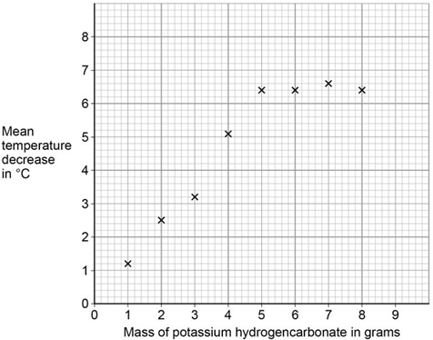

Draw two intersecting straight lines of best fit on the graph above.
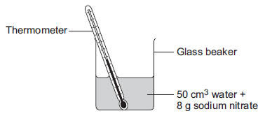
- Explain why the graph has this shape. Use data from the graph.
- Suggest a possible reason for the anomalous points. Do not include errors in measuring.
- This question is about temperature changes. A student investigated the temperature change when 8 g of sodium nitrate dissolves in 50 cm³ of water. The diagram shows the apparatus the student used.
The student did the experiment five times. The table below shows the results.
Experiment | Decrease in temperature of water in °C
1 | 5.9
2 | 5.7
3 | 7.2
4 | 5.6
5 | 5.8
Calculate the mean decrease in temperature. Do not use the anomalous result in your calculation.
- Suggest one source of error in the apparatus and one change in the apparatus in the diagram above which would improve the accuracy of the results. Give a reason for your answer.

- The student investigated the temperature change when different masses of sodium carbonate were added to 50 cm³ of water at 20 °C. The table below shows the results.
Mass of sodium carbonate in g | Final temperature of solution in °C
2.0 | 21.5
4.0 | 23.0
6.0 | 24.5
8.0 | 26.0
10.0 | 26.6
12.0 | 26.6
14.0 | 26.6
Describe the relationship between the mass of sodium carbonate added and the final temperature of the solution. Use values from the table in your answer.

Required practical activity 5: Investigate how changes in concentration affect the rates of reactions by a method involving measuring the volume of a gas produced and a method involving a change in colour or turbidity. This should be an investigation involving developing a hypothesis.
https://www.youtube.com/watch?v=Gl6LVl7oAlU
https://www.youtube.com/watch?v=ssa3wh3RNt0
Recap questions:
- State and explain the effect of increasing temperature on the rate of reaction.
- State and explain the effect of using larger lumps of solid on the rate of reaction.
- In a reaction involving an acid, state and explain the effect of increasing the concentration of the acid on the rate of reaction.
- In a reaction involving gases, state and explain the effect of increasing the pressure on the rate of reaction.
- State and explain the effect of adding a catalyst on the rate of reaction.
Method
There are a number of different methods for measuring the rate of reaction and a number of different variables that can be changed. Please watch the video here https://www.youtube.com/watch?v=mgDXMfKRYAc or here https://www.youtube.com/watch?v=Gl6LVl7oAlU to familiarise yourself with the different methods. Below is a model example of a response to a GCSE question on the topic.
A student investigated the reaction between magnesium and hydrochloric acid. The student investigated how the rate of this reaction changed when the concentration of hydrochloric acid was changed.
Write a plan the student could use. In your plan you should:
- describe how you would carry out the investigation and make it a fair test
- describe the measurements you would make.
Poor answer:
First, take a small piece of magnesium. Add it to some hydrochloric acid and count the number of bubbles. See how long it takes for there to be 100 bubbles. You can then change the amount of acid and do it again, but keep the piece of magnesium the same each time. Put your results in a table and then in a graph. Make sure you wear goggles and a labcoat too.
Model answer
- The student should measure out 20cm³ of 0.1moldm⁻³ hydrochloric acid using a measuring cylinder and pour in a conical flask
- The student should measure out 1g of magnesium using a balance
- The student should add the magnesium to the acid and attach the flask to a gas syringe
- The student should measure how much gas is produced in one minute
- The student should repeat this with the same volume of hydrochloric acid and the same mass of magnesium, but increase the concentration to 0.2moldm⁻³
- The student should repeat this with 0.3, 0.4 and 0.5moldm⁻³ concentrations
- A student wishes to investigate how the temperature affects the rate of a reaction between calcium carbonate and hydrochloric acid. Which variables will need to be controlled?
- What measurements could the student take? How would they take this?
- Identify the independent and dependent variables.
- How could the student ensure that their results are repeatable?
- How could the student ensure that their results are reproducible?
- The student is not sure whether to stir the reaction mixture. Give an advantage and a disadvantage of stirring the reaction mixture.
- The student uses a gas syringe which doesn’t close properly and can only go down to 7cm³. What type of error will this cause?
- The student decides to use a measuring cylinder but realises afterwards that the tubing was not connected properly, and some gas was escaping, but we cannot know how much each time. What type of error is this?
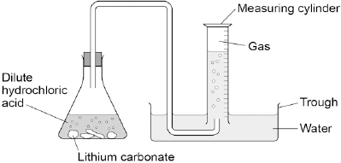
- A student wishes to investigate the effect of surface area on the rate of reaction in the reaction between calcium carbonate and sulphuric acid. From memory, write a method for the student that would result in accurate measurements. Include information about safety, which measurements should be made and how the student can ensure it will be a fair test.
- A student conducts a reaction and collects the gas using a measuring cylinder underwater as shown in the image. They first measure out the lithium carbonate on a balance and record the mass. They then measure out a fixed volume of dilute hydrochloric acid using a measuring cylinder.
The student obtained results with an anomaly. The student suggests the reasons below to explain the anomalous result, but only two are potentially correct. Identify which two.
Too much lithium carbonate was added.
The bung was not pushed in firmly enough.
There was too much water in the trough.
The measuring cylinder was not completely over the delivery
The conical flask was too small.
- Explain why the other options are incorrect.
- When sodium thiosulfate solution reacts with dilute hydrochloric acid, the solution becomes cloudy. The equation for the reaction is:
Na₂S₂O₃(aq) + 2 HCl(aq) ⟶ 2 NaCl(aq) + SO₂(g) + H₂O(l) + S(s)
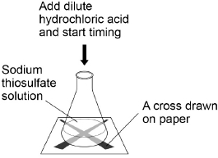
Why does the solution become cloudy?
- Some students used this reaction to investigate the effect of concentration on rate of reaction. The diagram shows the apparatus used.
This is the method used.
1. Measure 25 cm³ sodium thiosulfate solution into a conical flask.
2. Stand the conical flask on a cross drawn on paper.
3. Add 10 cm³ of dilute hydrochloric acid.
4. Time how long it takes the cross to become no longer visible.
5. Repeat steps 1–4 with sodium thiosulfate solutions of different concentrations.
- Name one control variable the students should use in this investigation.

- The table shows the students’ results.
Concentration of sodium thiosulfate solution in mol / dm³ | Time for cross to become no longer visible in s
0.020 | 170
0.040 | 90
0.060 | 82
0.080 | 42
0.100 | 34
0.120 | 30
0.140 | 28
Plot the data from the table above on the graph below. Draw a line of best fit.
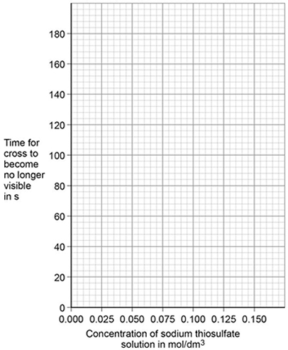
- Are these results directly proportional?
- The students repeated the reading at 0.060 and recorded times of 78s, 80s, and 81s as well as the original reading. Calculate the mean of these results and give an estimate for the uncertainty.
- The students repeated the investigation two more times. They obtained similar results each time. What word describes an investigation by the same students which gives similar results each time?
- What word describes a similar investigation carried out by other students which gives similar results?
- Describe how the students can use their results to improve the accuracy of the investigation.
- The students analysed their results to give a conclusion and an explanation for their investigation.
Conclusion: ‘The higher the concentration, the lower the rate of reaction.’
Explanation: ‘At higher concentrations, the particles have more energy, so they are moving faster. Therefore the collisions are more energetic.’
The students are not correct. Give a correct conclusion and explanation for the results of the investigation.
- A solution containing 0.18 g of sodium thiosulfate reacts with dilute hydrochloric acid in 2 minutes. Calculate the mean rate of reaction in g / s. Give your answer in standard form.

Required practical activity 6 Investigate how paper chromatography can be used to separate and tell the difference between coloured substances. Students should calculate Rf values.
Paper chromatography is a method for separating mixtures.
https://www.youtube.com/watch?v=pnTGNAfu6GE
Recap questions:
- What is a mixture?
- What is a solution?
- What is a solvent?
- What is a solute?
- What is solubility?
- What is a physical property?
Method for paper chromatography
Draw a pencil line about a 1cm from the bottom of the piece of paper. Carefully add a small ink spot on the pencil line, leave a space, and then add your next ink spot which should be a different colour.
- Why must the line be drawn in pencil?
Carefully pour your solvent into a beaker. It should have a height lower than the height of your pencil line. Carefully place the paper in the solvent and leave to stand. Sometimes the paper can be hung from the top, and sometimes there will be a lid.
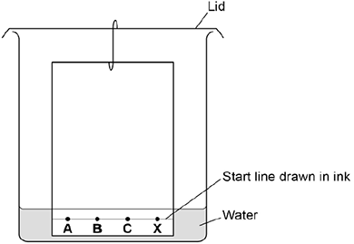
- Why must the pencil line be higher than top of the solvent?
Figure 1: for Q 183
As the solvent rises up the paper, the ink dissolves into it and is carried up. The different colours in the ink are attracted both to the paper and the solvent. The paper slows them down as they travel up the paper. If they are more attracted to the solvent than the paper, they will travel further. If they are more attracted to the paper than the solvent, they will travel less far.
- In the experiment in the diagram, the student has made two mistakes. Explain what these mistakes are and what effect they will have on the results.
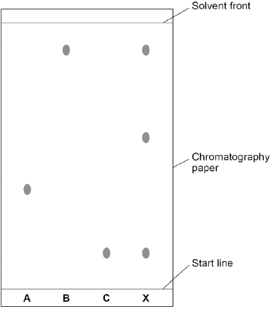
- A student has a complete chromatogram (the piece of paper after it has been through chromatography. How many different colours is X made of?
- Does X have any colours in common with C or B?
- Explain how you know your answer to question 211
- A student concludes that “A is only made of one colour as it did not separate in chromatography.” Is the student’s conclusion correct?
- A student labels the top spot for X as 1 and the middle spot for X as 2. Assuming that both spots were as attracted to the paper as each other, which one was more attracted to the solvent? Explain your answer.
- The student labels the bottom spot of X as 3. The student knows that 2 and 3 are as attracted to the paper as each other. Which one is less attracted to the paper?
- The student drew their start line in pencil. Why is it important that they did not use ink?
- The student had very shaky hands on the day of the experiment. What kind of error could this introduce?
- Professional chemists often use chromatography to find out which chemicals are in food and if they are safe or not. Why is it important for other chemists to do chromatography to the safe foods?
R_{f} values
The R_{f} value of a substance is a ratio of how far up the paper it moved compared to the solvent. It is calculated by:
$$\frac{distance travelled by substance}{distance travelled by solvent}$$
- Using a ruler, measure how far the spot at B has travelled from the start line
- Using a ruler, measure how far the solvent has moved from the start line
- Divide 219 by 220. Your answer should be approximately 0.8.
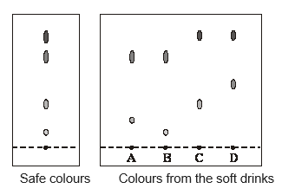
- Calculate the R_{f} values for each of the spots at X
Exam practice
- Chromatography was carried out on a sample of soft drinks to check that they contained only colours that were safe. This is the result.
What conclusions about the safety of the colours in the soft drinks A, B, C and D can be made from the results shown by chromatography?
- Calculate the R_{f} value for each spot on C, measuring from the middle of the spot and assuming that the solvent front is the top of the paper
- Some farmed salmon have a coloured additive in the food that they are given. This is a permitted additive that improves the colour of the fish meat. A sample of the colour is extracted from a salmon. Explain how paper chromatography could be used to confirm that this is the permitted additive.

Read the article.

Problem food colourings
Scientists say they have evidence that some
food colourings cause hyperactive behaviour in
young children.
These food colourings are added to some sweets.

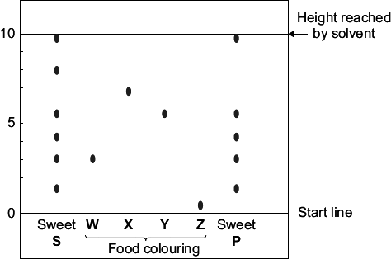
W, X, Y and Z are food colourings that may cause hyperactive behaviour in young children. A scientist used chromatography to see if these food colourings were used in two sweets, S and P.

The results are shown on the chromatogram.

Food colourings, such as W, X, Y and Z, are added to some sweets. Suggest one reason why. Use the scale on the chromatogram to help you to answer this question. Which food colouring, W, X, Y or Z, has an R_{f} value of 0.7?
- From the chromatogram, what conclusions can the scientist make about the colourings in sweets S and P?

Required practical activity 7 – Identifying Ions
Chemical and flame tests can be used to identify ions in ionic compounds
https://www.youtube.com/watch?v=fCZztwJmAl0
Recap questions:
- What is an ion?
- What is an anion?
- What is a cation?
- What is a halide?
- What is a precipitate?
- How can we test for carbon dioxide?
Method:
Flame Tests
- Dip a nichrome wire or damp splint into the first solution. Then hold the tip of the wire / splint in a blue Bunsen burner flame.
- Clean the wire carefully or use a fresh damp splint before testing another sample to prevent contamination..

Carbonate Test
- Add a few drops of dilute hydrochloric acid to each solution. If it fizzes, add the collected gas to limewater.
Sulfate Test
- If the sample from the carbonate test does not fizz, then add 1 cm depth of barium chloride solution.
Halide test
- Add a few drops of dilute nitric acid to each solution. Then add 1 cm depth of silver nitrate solution.

- Complete the table:

Metal ion | Lithium | Sodium | Potassium | Calcium | Copper
Flame colour

- Complete the table:

Non-metal ion | Carbonate | Sulfate | Chloride | Bromide | Iodide
Carbonate test
Sulfate test
Halide test

- Write the chemical reagents needed and the observation that would be expected in a positive test for (a) carbonate ions; (b) sulfate ions; (c) chloride, bromide and iodide ions
- Write a word equation for the reaction between sodium carbonate and hydrochloric acid
- Write a formula equation with state symbols for the reaction of sodium carbonate solution and hydrochloric acid
- Explain why hydrochloric acid is added to an unknown sample before the sulfate test is completed
- Write a word equation for the reaction of copper sulfate solution with barium chloride solution
- Write a formula equation with state symbols for the reaction of copper sulfate solution with barium chloride solution
- Challenge: Write an ionic equation for the reaction in Q240
- Explain why nitric acid is added to an unknown sample before the halide test is completed
- Write a word equation for the reaction of copper chloride solution with silver nitrate solution
- Write a formula equation with state symbols for the reaction of copper chloride solution with silver nitrate solution
- Challenge: Write an ionic equation for the reaction in Q244
GCSE Questions
- (a) The colours of fireworks are produced by chemicals.
Three of these chemicals are lithium sulfate, potassium chloride and sodium nitrate.
(i) A student wants to carry out flame tests on these three chemicals.
Describe how to carry out a flame test.
______________________________________________________________
______________________________________________________________
______________________________________________________________
______________________________________________________________
(2)

(ii) Draw one line from each chemical to the correct flame colour.
The first one has been done for you.

Chemical |  | Flame colour
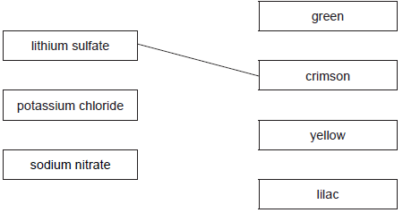
(2)
(iii) Dilute nitric acid and silver nitrate solution are added to solutions of the three chemicals.
A white precipitate forms in one of the solutions.
Which chemical produces the white precipitate?
______________________________________________________________
(1)

(b) The student tests a fourth chemical, X.
(i) The student adds sodium hydroxide solution to a solution of chemical X.
A blue precipitate is formed.
Which metal ion is in chemical X?
______________________________________________________________
(1)
(ii) The student adds dilute hydrochloric acid to a solution of chemical X and then adds barium chloride solution.
A white precipitate is formed.
Which negative ion is in chemical X?
Draw a ring around the correct answer.

chloride | nitrate | sulfate
(1)
(Total 7 marks)

- Alums are salts. They have been used since ancient times in dyeing and medicine and still have
many uses today.
Three alums are shown in the table:

Name | Ions present
Ammonium alum | NH₄⁺ Al³⁺ SO₄²⁻
Potassium alum | K⁺ Al³⁺ SO₄²⁻
Sodium alum | Na⁺ Al³⁺ SO₄²⁻
(a) These alums contain sulfate ions (SO₄²⁻).
Describe and give the result of a chemical test to show this.
Test _______________________________________________________________
___________________________________________________________________
Result _____________________________________________________________
___________________________________________________________________
(2)
(b) These alums contain aluminium ions (Al³⁺).
Describe how sodium hydroxide solution can be used to show this.
___________________________________________________________________
___________________________________________________________________
___________________________________________________________________
___________________________________________________________________ (2)
(c) Aluminium ions do not give a colour in flame tests. However, flame tests can be used to distinguish between these three alums.
Explain how these three alums could be identified from the results of flame tests.
___________________________________________________________________
___________________________________________________________________
___________________________________________________________________
___________________________________________________________________
___________________________________________________________________
(2)
(Total 6 marks)

Required practical activity 8 Analysis and purification of water samples from different sources, including pH, dissolved solids and distillation.
https://www.youtube.com/watch?v=_UGHsbTEBvA
Recap questions:
- What is potable water?
- What is pure water?
- What is the pH of pure water?
- Does pure water conduct electricity? Explain your answer.
- What is the boiling point of pure water?
- How does the boiling point of an impure substance differ from the boiling point of an impure substance?
- What is distillation?
- Put the labels below in order to explain what occurs during distillation:
  - Water is collected as distillate
  - Solution boils
  - Steam is cooled in the condenser
  - Steam condenses into water
  - Steam rises into the condenser
  - Water flows down the condenser
Method outline
There are a number of different techniques involved in analysis and purification of water samples. Analysis includes testing the boiling point and pH. Pure water will have a pH of 7 and a boiling point of exactly 100°C.
Purification involves distillation. We use simple distillation when we want to collect the solvent from a solution. We use fractional distillation when we want to collect different liquids separately from a mixture.
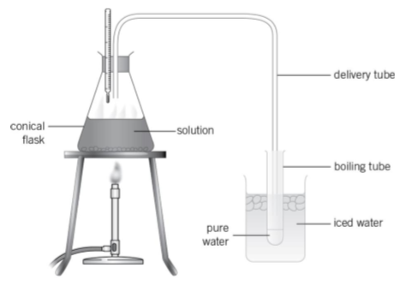
- A student sets up a simple distillation as above with tap water in the conical flask. Explain why the temperature shown on the thermometer is not 100°C.
- Why is the collection tube kept in iced water?
- How can the student check that the distillate is pure water?
- A student checks the distillate and finds its pH is 7. Does this confirm that it is pure water?
- What safety considerations must be taken in this practical?
- The student heats the solution until only a little is left and then leaves the flask on a window sill until all the water has evaporated. The student weighed the conical flask before adding the tap water starting the practical. Will the flask weigh more or less once the water has evaporated? Explain your answer.
- A student has a mixture of water and ethanol. What technique will be used to separate the water and ethanol?
- Ethanol is flammable. Explain why it is better to heat the mixture with an electric heater than a Bunsen burner.
- Why is distillation expensive?
- Normally before water is purified it is filtered. Explain the purpose of filtration.
GCSE questions
- Potable water is water that is safe to drink. Seawater can be changed into potable water by desalination. Name the substance removed from seawater by desalination.
- Desalination requires large amounts of energy. Desalination is only used when there is no other source of potable water. Give one reason why.
- Water from lakes and rivers can be treated to make it potable. The first stage is to filter the water from lakes and rivers. Why is the water filtered?
- Chlorine gas is then added to the filtered water. Why is chlorine gas used to treat water?
- Describe a test for chlorine gas. Give the result of the test if chlorine is present.
- Some students investigated different water samples. The table shows some of their results.
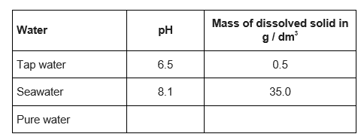
Complete the table above to show the expected results for pure water.
- What mass of dissolved solid is present in 100 cm 3 of the sample of tap water?
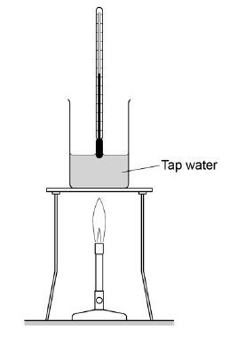
- Boiling points can be used to show whether substances are pure.
- The diagram shows the apparatus the students used to find the boiling point of tap water. The students made a mistake setting up the apparatus. What mistake did the students make?

Answers to questions
- A salt is an ionic compound formed when an acid is neutralised by a base
- A soluble salt is a salt that dissolves in water to form a solution.
- A dilute acid is a substance with a pH below 7 but that has a large amount of water present, making it less concentrated.
- A base is a substance that can neutralise an acid, forming a salt and water. It is usually a metal oxide, insoluble metal hydroxide or carbonate.
- Evaporation is the removal of water by gentle heating.
- base + acid → water + salt , so the products are water + copper sulfate
- copper oxide + sulfuric acid → water + copper sulfate
- CuO_{(s)} + H₂SO_{4(aq)} → H₂O_{(l)} + CuSO_{4(aq)}
- Hot acid is corrosive and would damage the eyes.
- A measuring cylinder is more precise than a beaker with a higher resolution scale.
- The acid is warmed to increase the rate of reaction because copper oxide is insoluble.
- If the acid is heated too strongly the reaction can froth up and escape from the beaker which is dangerous.
- The mixture stirred to ensure that all of the acid has reacted.
- The black copper oxide can’t be seen because it reacts to form a blue solution of copper sulfate
- An excess is when more than enough of a substance is used to make sure the other reactant is used up completely.
- Filtration is the separation of a solid from a mixture. The solid particles are too large to pass through holes in the paper whereas water and solution particles can.
- Mixtures can separate suspensions – mixtures of solids and solutions/liquids.
- Filtration cannot separate salt from sea water because the salt particles are dissolved in the water and are small enough to pass through the holes in the paper along with the water.
- The residue in this practical is the excess copper oxide.
- The residue is a black solid.
- The filtrate in this practical is copper sulfate solution, CuSO_{4(aq)}
- The process is called evaporation and crystallization.
- The water evaporates into the atmosphere.
- If the temperature gets too hot, too much water is lost and a dry white powder (anhydrous copper sulfate) is produced, not blue crystals.
- Put on safety spectacles.
Measure out sulfuric acid in a measuring cylinder
Pour it into a beaker and heat with a Bunsen burner until just boiling.
Remove from heat and add a spatula of copper oxide and stir.
If all the copper oxide reacts, add more until an excess of the black solid remains.
Filter the mixture, collecting the blue filtrate.
Pour the filtrate into an evaporating basin and warm gently with a Bunsen burner.
Remove from heat and place by a window to allow crystallization to take place.

- CuCO₃ (s) + H₂SO₄ (aq) → CuSO₄ (aq) + H₂O (l) + CO₂ (g)
- A gas was lost from the flask.
Q28 Level 3 (5–6 marks):
A coherent method is described with relevant detail, and in correct sequence which demonstrates a broad understanding of the relevant scientific techniques and procedures. The steps in the method are logically ordered. The method would lead to the production of valid results.
Level 2 (3–4 marks):
The bulk of the method is described with mostly relevant detail, which demonstrates a reasonable understanding of the relevant scientific techniques and procedures. The method may not be in a completely logical sequence and may be missing some detail.
Level 1 (1–2 marks):
Simple statements are made which demonstrate some understanding of some of the relevant scientific techniques and procedures. The response may lack a logical structure and would not lead to the production of valid results.
0 marks:
No relevant content.
Indicative content
• sulfuric acid in beaker (or similar)
• add copper carbonate one spatula at a time
• until copper carbonate is in excess or until no more effervescence occurs *
• filter using filter paper and funnel
• filter excess copper carbonate
• pour solution into evaporating basin / dish
• heat using Bunsen burner
• leave to crystallise / leave for water to evaporate / boil off water
• decant solution
• pat dry (using filter paper)
• wear safety spectacles / goggles
*Students. may choose to use a named indicator until it turns a neutral colour, record the number of spatulas of copper carbonate added then repeat without the indicator.

Q29-33

(a) any one from:

• heat

• stir

1

(b) filter

accept use a centrifuge

accept leave longer (to settle)

1

(c) any one from:

• wear safety spectacles

• wear an apron

1

(d) evaporation at A

1

condensation at B

1

(e) 100

1

[6]
Q34-37

(a) neutralisation

ignore reference to exothermic or endothermic

1

(b) 2 HCl + CaO ➔ CaCl₂ + H₂O

accept multiples and fractions

formulae

ignore state symbols

1

balancing (dependent on first mark)

1

(c) (the carbonate has) fizzing / bubbles / effervescence

ignore dissolving

ignore gas produced

1

(d) add excess calcium carbonate to acid (and stir) / add CaCO₃ until fizzing stops

ignore heating the acid

accept answer using calcium oxide in place of calcium carbonate

1

(remove excess calcium carbonate by) filter(ing)

1

+crystallisation / crystals start to form

do not accept heat until all water gone

1

leave to cool

dependent on previous mark

If solution not heated allow leave to evaporate (1)

until crystals form (1)

1
38) Concentration is the amount of a solute (in moles) or mass of a solute (in grams) dissolved per dm³ (litre) of solution. The more concentrated the substance the more of the solute there is to react.
39) Hydroxide tells you that the substance is a base and will neutralise an acid.
40) A dilute acid is one that has a low concentration as it is dissolved in lots of water.
41) An alkali is a soluble base, i.e. it dissolves in water to give a solution with a pH above 7.
42) Neutralisation is when an acid reacts with a base or when an alkali reacts with an acid.
43) sodium sulfate + water
- sodium hydroxide + sulfuric acid →sodium sulfate + water
- 2NaOH(aq) + H₂SO₄(aq) → Na₂SO₄(aq) + 2H₂O(l)
- The alkali is corrosive
- A pipette gives a more accurate volume than a measuring cylinder
- The conical flask can be swirled to mix the reaction mixture without spilling the chemicals
- The white tile makes the change of colour of the indicator at the endpoint easier to see.
- Methyl orange indicator changes from one colour to another, making the endpoint easier to see
than universal indicator which changes through a range of different shades of lots of colours
- fill burette with acid
measure alkali with a pipette and filler
add to a conical flask
add an indicator
place conical flask on white tile
add acid from the burette to the alkali and indicator
swirl
stop adding acid when the indicator changes colour
measure volume used from burette
repeat more accurately by adding dropwise near the endpoint
repeat accurate titration and calculate the mean titre added from the accurate titrations
- A conical flask enables swirling without spillage
- A pipette is more accurate than a measuring cylider
- The burette delivers an accurate value because it has a higher resolution scale
- An indicator shows when the solution has been neutralised
- The change of colour when the solution has been neutralised
- To improve accuracy
- To remove any excess acid or alkali which would make the next titration inaccurate

      - fill burette with sodium hydroxide 1
add sodium hydroxide from the burette to the hydrochloric acid and indicator 1
stop when colour changes 1
measure volume used from burette 1
plus any two from: •stand flask on white tile
• swirl
• add dropwise near the endpoint
• repeat
60) filtration 1
61) evaporate some of the solution and leave to cool or heat with an electric heater 1
[8]
62) 1.61 or 1.6(12903)
correct answer with or without working scores 3
if answer incorrect, allow a maximum of two from:
moles acid = (2 × 25 / 1000) = 0.05 for 1 mark
moles NaOH = (moles acid) = 0.05 for 1 mark
concentration NaOH = 0.05 / 0.031
answer must be correctly rounded (1.62 is incorrect)
3

63) Calculate the concentration of the sodium hydroxide solution in grams per dm³.

Concentration in g/dm³ = concentration in mol/dm³ x M_{r}
= 1.61 x (23 + 16 + 1) = 64.4g/dm³

64) The splitting of ionic compounds into elements using electricity
65) Because they are higher than carbon in the reactivity series
66) Electrodes are solid electrical conductors dipped into the electrolyte (ionic liquid or solid)
67) The anode is the positive electrode and the cathode is the negative electrode (PANIC)
68) Positive ions are attracted to the negative electrode
69) Negative ions are attracted to the positive electrode.
70) Metal ions are positive, so attracted to the negative electrode.
71) Non-metal ions are attracted to the positive electrode except hydrogen.
72) Hydrogen is often formed instead of a metal because H⁺ ions are formed from water and easier to discharge because hydrogen is less reactive than many metals.
73) Oxygen is always formed at the positive electrode if a non-halide solution is used.
74) Inert means unreactive.
75) Electrodes are often made of graphite (carbon)
76) H₂O ⇌ OH⁻_{(aq)} + H⁺_{(aq)}
77) 4OH⁻ (aq) → 2H₂O (l) + O_{2 (g)} + 4e⁻
78) 2H⁺(aq) + 2e⁻→ H_{2(g)}
79) copper (II) chloride solution is CuCl_{2(aq)}
80) A solution is a mixture where a substance (solute) is dissolved in a solvent (usually water)
81) Pour copper chloride solution into an evaporating basin. Warm over a water bath to evaporate some of the water until crystals appear around the edge. Leave the solution to crystallise.
82) Iron is more reactive than copper so there will be a reaction and iron will displace the copper:
iron + copper chloride → iron chloride + copper
83) Solid copper chloride has the ions in fixed positions in an ionic lattice so the ions are not free to move.
84) Chlorine bleaches indicator paper and oxygen rekindles a glowing splint.
85) Hydrogen gas is tested with a lit splint and produces a squeaky pop.
86) Hydrogen will form if the metal in the ionic solution is above hydrogen in the reactivity series.
87) Hydrogen forms at the negative electrode because the H⁺ ion is positively charged.

88)
Solution | Formula | Forms at anode | Forms at cathode
Copper (II) chloride | CuCl₂ | Cl₂(g) | Cu(s)
Copper (II) sulphate | CuSO₄ | O_{2(g)} | Cu(s)
Potassium chloride | KCl | Cl₂(g) | H_{2(g)}
Sodium chloride | NaCl | Cl₂(g) | H_{2(g)}
Potassium sulphate | K₂SO₄ | O_{2(g)} | H_{2(g)}
Lithium hydroxide | LiOH | O_{2(g)} | H_{2(g)}
Copper hydroxide | Cu(OH)₂ | O_{2(g)} | Cu(s)
Zinc sulphate | ZnSO₄ | O_{2(g)} | H_{2(g)}
Iron (II) chloride | FeCl₂ | Cl₂(g) | H_{2(g)}
Iron (III) sulphate | Fe₂ (SO₄) ₃ | O_{2(g)} | H_{2(g)}
89) and 90)
Solution | Anode | Cathode
Copper (II) chloride | 2Cl⁻(aq) → Cl_{2(g)} + 2e- | Cu²⁺(aq) + 2e- →Cu(s)
Copper (II) sulphate | 4OH⁻ (aq) → 2H₂O (l) + O_{2 (g)} + 4e⁻ | Cu²⁺(aq) + 2e- →Cu(s
Potassium chloride | 2Cl⁻(aq) → Cl_{2(g)} + 2e- | 2H⁺(aq) + 2e- → H_{2(g)}
Sodium chloride | 2Cl⁻(aq) → Cl_{2(g)} + 2e- | 2H⁺(aq) + 2e- → H_{2(g)}
Potassium sulphate | 4OH⁻ (aq) → 2H₂O (l) + O_{2 (g)} + 4e⁻ | 2H⁺(aq) + 2e- → H_{2(g)}
Lithium hydroxide | 4OH⁻ (aq) → 2H₂O (l) + O_{2 (g)} + 4e⁻ | 2H⁺(aq) + 2e- → H_{2(g)}
Copper hydroxide | 4OH⁻ (aq) → 2H₂O (l) + O_{2 (g)} + 4e⁻ | Cu²⁺(aq) + 2e- →Cu(s
Zinc sulphate | 4OH⁻ (aq) → 2H₂O (l) + O_{2 (g)} + 4e⁻ | 2H⁺(aq) + 2e- → H_{2(g)}
Iron (II) chloride | 2Cl⁻(aq) → Cl_{2(g)} + 2e- | 2H⁺(aq) + 2e- → H_{2(g)}
Iron (III) sulphate | 4OH⁻ (aq) → 2H₂O (l) + O_{2 (g)} + 4e⁻ | 2H⁺(aq) + 2e- → H_{2(g)}

90)
Water (very partially) dissociates: H₂O ⇌ OH⁻_{(aq)} + H⁺_{(aq)}
At cathode: 2H⁺(aq) + 2e- → H_{2(g)}
At anode: 4OH⁻ (aq) → 2H₂O (l) + O_{2 (g)} + 4e⁻

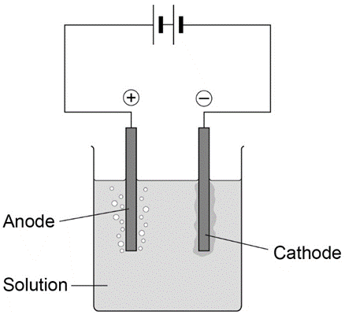
Q91-93
        - (diagram)

complete circuit with power supply

1

test solution in beaker or other appropriate apparatus

1

electrodes

allow carbon, platinum or inert electrodes

1

(independent variable)

salt solutions (with different metal ions)

1

(observation)

solid / metal deposit on the negative electrode

1

(b) (sometimes) hydrogen is produced

1

(because) the metal is more reactive than hydrogen

1

(c) chlorine

1

oxygen

1
Q94-98

(a) substance broken down / separates / splits into elements

by electric current / electricity

ions free to move e.g. when molten / in solution

allow 1 mark for “a substance that conducts electricity”

max 2

(b) (i) copper / Cu

1

(ii) oxygen /O₂

allow CO₂

1

(c) tube over electrode

full of CuSO₄(aq) / water

allow sulphuric acid / sensible electrolyte

not any other liquid / using a syringe

2

(d) Cu²⁺ ions removed / less Cu²⁺

not copper sulphate removed

allow 1 mark for “copper removed / less copper”

2

99) By measuring out the volume of the solution with a measuring cylinder. Pour the solution into a polystyrene cup and record the starting temperature. Add the zinc and stir. Record the maximum temperature reached and calculate the temperature rise.
100) It is exothermic
101) Is it is endothermic
102)
activation energy
reactants
Energy
energy change
products

Reaction Progress

103)

activation energy
products
Energy
energy change
reactants

Reaction Progress

104) The volume and concentration of the acid. The mass or moles of the metal added.
105) Each control variable would affect the value of the temperature change calculated, so it would be impossible to determine how changing the metal affects the temperature change.
106) The metal reacting.
107) The temperature rise.
108) Magnesium because it is higher in the reactivity series (the difference in reactivity between magnesium and hydrogen is larger than the difference between that of iron and hydrogen).
109) A balance with resolution 0.01g
110) A measuring cylinder
111) They have high resolution and so deliver an accurate mass and volume respectively.
112) A change in mass or volume could affect the temperature rise for the reaction.
113) To minimise heat loss because polystyrene is a thermal insulator.
114) To minimise heat loss by convection.
115) To prevent the cup falling over and to provide further thermal insulation by trapping a layer of air.
116) To minimise heat loss.
117) It increases the chance of recording the maximum temperature rise.
118) If the two reactants don’t come into contact the reaction will be incomplete and the temperature change smaller than it should be.
119) The automatic stirrer enables efficient mixing enabling all of the reactants to react.
120) Heat loss

121)
- Measure 25cm³ of 0.5mol/dm³ sodium hydroxide with a measuring cylinder and pour into a polystyrene cup calorimeter
- Measure and record the starting temperature
- Measure out 25cm³ of 0.5mol/dm³ sulfuric acid in a separate measuring cylinder
- Add the acid to the alkali and stir
- Record the highest temperature reached.
- Pour away the reaction mixture and wash out the calorimeter.
- Measure 25cm³ of 0.5mol/dm³ sodium hydroxide with a measuring cylinder and pour into a polystyrene cup calorimeter
- Measure out 20cm³ of 0.5mol/dm³ sulfuric acid in a separate measuring cylinder and make up the volume with distilled water.
- Repeat steps 4-7
- Measure out 15cm³ of 0.5mol/dm³ sulfuric acid in a separate measuring cylinder and make up the volume with distilled water.
- Repeat steps 4-7
- Measure out 10cm³ of 0.5mol/dm³ sulfuric acid in a separate measuring cylinder and make up the volume with distilled water.
- Repeat steps 4-7
- Measure out 5cm³ of 0.5mol/dm³ sulfuric acid in a separate measuring cylinder and make up the volume with distilled water.
- Repeat steps 4-6

122) Increasing the volume of sulphuric acid will increase the temperature change.
123) Heat loss – insulate the calorimeter with a lid; measuring errors – use a balance with more decimal places, use a pipette and pipette filler to measure the acid rather than a measuring cylinder
124) Change in temperature =32 - 21 = 11ºC.
125) The temperature of the reaction mixture increases.
126) The energy level of the products is lower than that of the reactants.
127) The activation energy is arrow A

Q128

The mass (or moles of the metal). The volume of the solution. The concentration of the solution.

(a) (i) 11

1

(ii) 4620 (J)

correct answer gains 2 marks with or without working

allow 4.62kJ for 2 marks

if answer is incorrect:

100 × 4.2 × 11 gains 1 mark

or

100 × 4.2 × (their temp. rise) gains 1 mark

or

100 × 4.2 × (their temp. rise) correctly calculated gains 2 marks

2

(b) the temperature increases

allow gets hotter

allow heat / energy is given off

1

(c) (i) (energy of) products lower than (energy of) reactants

allow converse

allow arrow C points downwards

1

(ii) A

1

[6]
Q129-133

(a) any three from:

• concentration of (salt) solution

• volume of (salt) solution

ignore amount of solution

• initial temperature (of the solution)

ignore room temperature

• surface area / form of metal

• moles of metal

allow mass / amount

ignore time

ignore size of tube

3

(b) 20

1

32

1

12

allow ecf

1

(c) (i) four bars of correct height

tolerance is + / - half square

3 correct for 1 mark

2

bars labelled

1

(ii) one variable is non-continuous / categoric

accept qualitative or discrete

accept no values between the metals

1

(iii) magnesium

1

because biggest temperature change

accept gives out most energy

ignore rate of reaction

dependent on first mark

1

(iv) does not react / silver cannot displace copper

1

because silver not more reactive (than copper) or silver below copper in reactivity series

do not accept silver is less reactive than copper sulfate

1

(v) replace the copper sulfate

could be implied

1

with any compound of a named metal less reactive than copper

allow students to score even if use an insoluble salt

1

134) Dependent – temperature change ; independent - metal
135) Volume and concentration of solution
136) To improve accuracy by identifying anomalies and by enabling a mean temperature rise to be calculated for each mass value.
137) To check to see if they are reproducible.
138) Systematic error.
139) The measuring cylinder has a higher resolution scale and so a more accurate volume is delivered.

140)

Anomalous point ignored when
drawing line.

Line should go through the origin and
all other points

Line should be drawn in
ordinary erasable pencil

141) Anomalous point for 40g/dm³
142) Incorrect concentration of solution, gas escaped from apparatus
143) Carry out the experiment for the same concentrations and compare with their first set of data.
144) Compare their results with other students doing the same type of experiment.
145) As the concentration of the sodium chloride solution increases the volume of hydrogen gas produced in ten minutes increases.
146) Yes, the line of best-fit is a straight line that passes through the origin. Increasing the concentration by a factor of 4 increases the volume by a similar factor, e.g. 20g/dm³ produces 1.4cm³ of gas, and 80g/dm³ produces 5.6cm³.
147) The time that the gas volume is recorded is a control variable, changing it will affect the result.
148) This is a systematic error.
149) The student could subtract the delay time from each value.

Q150

(a) the ions can move / travel / flow /are free

accept particles / they for ions

allow delocalised ions

or

ignore delocalised / free electrons

ignore references to collisions

accept converse with reference to solid

the ions carry the charge / current

ignore ions carry electricity

1

(b) any one from:

• because they are negative / anion

allow Cl–

ignore chlorine

• opposite charges / attract

1

(c) 13

1

(d) (i) reasonable attempt at straight line which misses the anomalous point

must touch all five crosses

do not allow multiple lines

1

(ii) 40

ignore 2.2

1

(iii) any two sensible errors from:

ignore systematic / human / apparatus / zero /experimental / random / measurement / reading errors unless qualified

• gas escapes

• weighing error

allow NaCl not measured correctly

• error in measuring (volume / amount) of hydrogen

• error in measuring (volume / amount) of water

allow error in measuring volume / scale for 1 mark if neither hydrogen or water mentioned

• incorrect concentration

allow NaCl not fully dissolved or spilled or impure

• timing error

• change in voltage / current

allow faulty power supply

• change in temperature

• recording / plotting error

2

(iv) any one from:

ignore ‘do more tests’

• repeat the experiment

• results compared with results from /other students / other groups / other laboratories / internet / literature.

• results compared with another method

1

(v) increases owtte

allow directly proportional or positive correlation

allow rate / it is faster / quicker

1
Q127-136

(a) (i) points correctly plotted ( ± ½ small square)

four points = 2 marks

three points = 1 mark

Max 2

straight line of best fit using full range of points from 0,0

1

(ii) any one from:

must explain why the point is below the line

• the solution may not have been properly stirred

• the electrodes may have been a larger distance apart

• the drop of sodium chloride may have been a smaller volume / smaller

allow not enough sodium chloride added

allow smaller amount of sodium chloride

do not allow too few drops added

ignore the student may have misread the conductivity meter

1

(iii) any one from:

• the volume of pure water

allow amount

• the concentration (of the solutions added)

• the volume (of the drops) of solution added

ignore number of drops

• the distance between the electrodes

• the same electrodes or electrodes made of the same material

• same depth or surface area of electrodes in the water

• constant power supply

ignore current

• stirred

1

(b) (i) because (pure) water is covalent / molecular (simple) or contains molecules

1

therefore (pure) water has no free / mobile electrons or ions

molecules do not have a charge or molecules do not contain ions gains 2 marks

1

(ii) because there are ions in sodium chloride

allow Na⁺ and / or Cl–(ions) or ionic bonding.

Ignore particles other than ions for MP1.

1

which can move or carry the current / charge

MP2 must be linked to ions only.

1

(iii) Hydrogen

allow H₂ / H

1
Q137-143

(a) use a polystyrene cup instead of a (glass) beaker

allow insulate the beaker

allow use a lid

1

minimises energy transfer from the surroundings

or

for better insulation

1

(b) concentration of hydrochloric acid

1

(c) 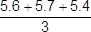

1

= 5.6 (°C)

1

± 0.2

1

(d) straight line from origin to (5.0, 6.4)

must not deviate to anomalous point

1

horizontal line from (5.0, 6.4) to (8.0, 6.4)

must not deviate to anomalous point

1

(e) as mass (of potassium hydrogencarbonate) increases, temperature decrease / change increases

1

until 5 g (to 8 g) (of potassium hydrogencarbonate has been added)

allow ecf from lines of best fit

1

(because) the reaction has finished

or

(because) all the acid has reacted

or

(because) no more solid can react

or

(because) the solid is in excess

1

(f) not stirred correctly

1

174) Increases. Particles have higher kinetic energy, move faster and collide more frequently.
175) Decreases. There is a smaller surface area, so less frequent collisions.
176) Increases. There are more particles in the same volume so there are more frequent collisions.
177) Increases. There are more particles in the same volume so there are more frequent collisions.
178) Increases. It provides an alternative reaction pathway with a lower activation energy, so more collisions are successful.
179) The mass (or moles) of calcium carbonate, the surface area of the pieces of calcium carbonate, the volume and concentration of acid.
180) The time. The volume of gas produced in a certain time or the mass lost from the apparatus in a certain time.
181) The volume of gas collected in a certain time or the mass lost in a certain time.
182) Repeat the experiment and compare their results with their previous data set.
183) Compare their results with other students carrying out a similar investigation.
184) Stirring will increase the chance of the reaction being complete. Stirring will increase the chance of gas leakage if collecting gas or spillage/alteration of the mass measurement if using the mass loss method.
185) Zero error / systematic error.
186) Random error.
187)
The experiment is made fair test by using the same mass of calcium carbonate, using the same volume of acid and the same concentration of acid. All experiments should be carried out at the same temperature/ These are the control variables. The independent variable is the surface area of the particles (small particles have a large surface area, medium particles have a medium surface area, large particles have a small surface area) and the dependent variable is the mass lost.

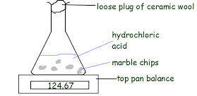
- Wear a pair of safety spectacles in case of acid splashes.
- Weigh out 3 samples of 10g of calcium carbonate with different sized particles, e.g. small, medium and large into three separate weighing boats.
- Measure out 50cm³ of 1 mol/dm³ of sulfuric acid with a measuring cylinder
- Pour the acid into a conical flask.
- Place the conical flask on a weighing balance along with a piece of ceramic wool and the weighing boat containing small particles.
- Pour the calcium carbonate into the acid, start the stop clock and place the weighing boat back on the balance and the piece of cotton wool in the neck of the flask to stop splashes escaping.
- Record the mass lost every 15 seconds for 3 minutes.
- Repeat steps 3-7 for the medium pieces and then for the large pieces

188)
Too much lithium carbonate was added. X this could lead to a greater volume if the acid is in excess
The bung was not pushed in firmly enough.
There was too much water in the trough. X It would cause a water spill but not change the volume of gas collected
The measuring cylinder was not completely over the delivery tube
The conical flask was too small. X the air inside will be displaced regardless of the volume of the flask

190)

(a) sulfur

1

precipitate

allow solid

1

(b) any one from:

• (volumetric) pipette

• burette

1

(c) any one from:

• concentration of hydrochloric acid

• volume of hydrochloric acid

• volume of sodium thiosulfate solution

• temperature (of solution)

• darkness of cross

allow same cross

• same stirring / swirling

1

(d) 7 points plotted correctly

allow tolerance of ± half a small square

allow 5 or 6 points plotted correctly for 1 mark

2

line of best fit

must avoid anomalous point

1

(e) repeatable

do not accept reproducible

1

(f) discard any anomalous results

1

calculate a mean

1

(g) conclusion:

the higher the concentration, the higher the rate of reaction

1

explanation:

(at higher concentrations) there are more particles in a fixed volume

1

(therefore the) collisions are more frequent

1

allow converse

(h) 120 (s)

1

0.18 / 120

allow 0.0015

1

= 1.5 × 10⁻³ (g / s)

an answer of 9 × 10⁻² scores 2 marks

allow an answer of 0.09 for 1 mark

1

an answer of 1.5 × 10⁻³ (g / s) scores 3 marks

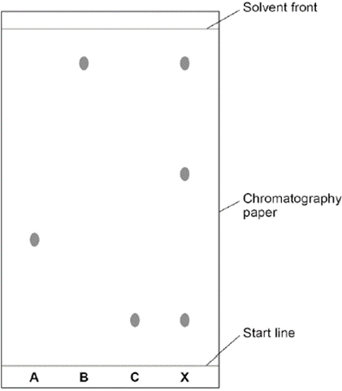
201) A mixture is a substance made from more than one element or compound where the elements or compounds are not chemically bonded.
202) A solution is a mixture of a solvent and a solute.
203) A solvent is a substance that dissolves another, e.g. water in sea water
204) A solute is a substance that is dissolved in another, e.g. salt in sea water
205) Solubility is a measure of how well a substance dissolves in a solvent.
206) A physical property is something that can be measured without chemically altering the substance that is being measured, e.g. density or electrical conductivity.
207) The line be drawn in pencil because it is insoluble. Ink might dissolve and the ink would be carried up the chromatogram obscuring the results.
208) The samples on the chromatogram should be above the solvent or they will dissolve into the solvent rather than running up the chromatogram.
209) The line has been drawn in ink which can run up the chromatogram obscuring the results. The spots are submerged in the solvent so will dissolve into it rather than running up the chromatogram.
210) X is made from 3 dyes as it has three spots
211) X has one colour in common with B and one in common with C and one that is different from the colours in either B or C.
212) The spot from B lines up with the top spot for X, the spot from C lines up with the bottom spot for X. The middle spot for X has a different migration distance compared with any spot for B and C.
213) It seems likely as there is only one spot but another solvent might enable separation.
214) 1 - The one that is more attracted to the solvent is the one that migrates furthest
215) 2 - The one that is less attracted to the paper is the one that migrates furthest
216) Ink might dissolve and run up the chromatogram, obscuring the results.
217) Random error
218) So that there are unbiased scientists checking their results
219) spot at B has travelled mm from the start line
220) the solvent has moved mm from the start line
221) /. = 0.8.
222) R_{f} values for spot 1 = , spot 2 = spot3 =

Exam practice
223) Chromatography was carried out on a sample of soft drinks to check that they contained only colours that were safe. This is the result.
What conclusions about the safety of the colours in the soft drinks A, B, C and D can be made from the results shown by chromatography?
224) Calculate the Rf value for each spot on C, measuring from the middle of the spot and assuming that

Q226

drinks / colours B and C are safe

1

drinks / colours A and D are not safe

accept a pair of one safe colour and one not safe colour identified for 1 mark

accept A, B, C and D all contain one safe colour for 1 mark

ignore references to shading

(a) (improve) appearance

allow add colour

allow these food colourings have not been proven to cause hyperactive behaviour in young children

do not accept taste / flavour / preservatives

ignore reference to E-numbers

1

(b) X

1

(c) any three from:

• S contains six / 6 colourings

• P contains five / 5 colourings

if neither of first 2 bullet points given allow 1 mark for S contains more colours than P or converse

• both S and P contain the same

five / 5 colourings

• both contain W and Y

• both sweets (may) cause hyperactivity

ignore unsafe

• neither contain X and Z

3

227) An ion is a charged atom that has lost or gained electrons.
228) An anion is a negative ion that is attracted to the positive anode.
229) A cation is a positive ion that is attracted to the negative cathode.
230) A halide is a salt compound that contains an ion formed by a halogen
231) A precipitate is a solid formed when two solutions are mixed.
232) Carbon dioxide produces a white precipitate when passed through limewater.
233)
Metal ion Lithium Sodium Potassium Calcium Copper
Flame colour Crimson Yellow Lilac Orange/red Green

234)

Non-metal ion Carbonate Sulfate Chloride Bromide Iodide
Carbonate test bubbles no reaction no reaction no reaction no reaction
Sulfate test white ppte white ppte no reaction no reaction no reaction
Halide test no reaction no reaction white ppte cream ppte yellow ppte

235) (a) carbonate ions – hydrochloric acid – bubbles of gas
(b) sulfate ions – hydrochloric acid and barium chloride solution – white precipitate
(c) chloride, bromide and iodide ions – nitric acid and silver nitrate solution- white, cream and yellow precipitates respectively
236) sodium carbonate + hydrochloric acid → water + sodium chloride+ carbon dioxide
237) Na₂CO₃(aq) + 2HCl(aq) → H₂O(l) + 2NaCl + CO₂(g)
238) A carbonate or hydroxide would also give a “false positive” of a white precipitate, the acid reacts with these.
239) copper sulfate + barium chloride → copper chloride + barium sulfate
240) CuSO₄(aq) + BaCl₂ (aq) → CuCl₂ (aq)+ BaSO₄(s)
241) Ba²⁺(aq) + SO₄²⁻ (aq) + → BaSO₄(s)
242) A carbonate or hydroxide would also give a “false positive” of a white precipitate, the acid reacts with these
243) copper chloride + silver nitrate → copper nitrate + silver chloride
244) CuCl₂(aq) + 2AgNO₃ (aq) → Cu(NO₃)₂(aq) + 2AgCl(aq)
245) Ag⁺(aq) + Cl⁻ (aq) + → AgCl(s)

246) (a)(i) Clean a nichrome wire with concentrated acid to clean it
Dip the wire in a solution or solid and then hold it just above the cone of a roaring flame
(ii)
Chemical Flame colour
Potassium nitrate lilac
Sodium chloride yellow

(iii) Sodium chloride

(b)(i) Cu²⁺ ion
(ii) sulfate

247) Test add nitric acid followed by barium nitrate solution
Result a white precipitate forms
(b) Adding a few drops of sodium hydroxide solution produces a white precipitate that dissolves when an excess of sodium hydroxide is added.
(c) Sodium ions give a yellow flame, potassium ions a lilac flame whereas the ammonium ion gives no flame colour.

248) Potable water is water that is fit to drink
249) Pure water is water that only contains water molecules
250) The pH of pure water is pH7 at room temperature
251) Pure water does not conduct electricity because it has no charge carriers to enable a current to flow.
252) The boiling point of pure water is 100ºC at sea level.
253) The boiling point of an impure substance is lower than a pure substance and its boiling point will be less sharp.
254) Distillation is a separation technique that involves evaporation and condensation.
255)

1.Solution boils
2.Steam is cooled in the condenser
4
3. Steam condenses into water
4. Steam rises into the condenser
1
5. Water flows down the condenser
2,3,5
6. Water is collected as distillate

6

256) Tap water I impure as it contains dissolved minerals
257) To condense the steam
258) Test the freezing and boiling point and evaporate the liquid and check for residue.
259) No, other substances have a pH value of 7
260) Safety spectacles. The steam will scald, so make sure the delivery tube is below the level of the iced-water
261) The flask will be heavier as the solute won’t evaporate.
262) Distillation.
263) To prevent a fire.
264) It requires large amounts of energy to heat up the water so it evapoartes.
265) Filtration removes insoluble materials, e.g. leaves and worms.

Q266

(a) sodium chloride or salt

allow dissolved salts

1

(b) expensive

1

(c) to remove solids

1

(d) to sterilise the water

allow to kill microorganisms

1

(e) test: (damp) litmus paper

1

result: bleached

or

turns white

1

(f) pH: 7.0

1

mass of dissolved solid: 0.0 (g)

1

(g) 0.05 g

1

(h) did not immerse the thermometer (bulb)

1

