Bonding Mastery Booklet
Your course looks at three types of chemical bond: ionic, covalent and metallic. We will cover them in that order.
Atoms into ions
- State the charge on a proton, neutron and electrons
- Complete the blanks:
In an a_____________ there are equal numbers of p______________ and e_______________. This means that overall there is no c________ as they cancel each other out.
- Draw an atom of fluorine in your exercise book including all electrons
- How many protons does an atom of fluorine have?
- What is the overall charge on an atom of fluorine?
- Explain your answer to question 5.
You cannot change the number of protons that an atom has. You can change the number of electrons it has through a chemical reaction. But, if it gains or loses electrons then the number of protons and electrons will no longer be the same.
Example: lithium has three protons and three electrons. It has no overall charge because each proton is +1 and each electron is -1
 | Protons | Electrons
 | +1 | -1
 | +1 | -1
 | +1 | -1
Total charge on each side: | +3 | -3
 | Overall: +3 + (-3) = 0
However, if it loses one electron, then the charges become imbalanced:
 | Protons | Electrons
 | +1 | -1
 | +1 | -1
 | +1
Total charge on each side: | +3 | -2
 | Overall: +3 + (-2) = +1
So if a lithium atom loses an electron, it becomes a positive ion. The opposite happens if it gains an electron:
 | Protons | Electrons
 | +1 | -1
 | +1 | -1
 | +1 | -1
 |  | -1
Total charge on each side: | +3 | -4
 | Overall: +3 + (-4) = -1
If an atom gains electrons, it becomes a negative ion.
If an atom loses electrons, it becomes a positive ion.
- An atom has 9 protons. How many electrons does it have?
- Explain your answer.
- The atom from question 7 loses an electron. Explain why it is now called an ion not an atom.
- What charge does this ion have?
- The atom loses another electron. What charge does it have now?
- An atom has 17 protons. It gains one electron. What is its charge?
- It gains another 4 electrons. What is its charge now?
- Explain why taking away electrons increases the charge.
- An ion has a charge of +1 and 15 protons. How many electrons does it have?
- How many electrons did it have when it was an atom?
- An ion has a charge of -1 and 10 electrons. How many protons does it have?
- An ion has a charge of +3 and has 51 electrons. How many protons does it have?
- What is the difference between an element and a compound?
- What is the difference between the plum pudding model and the nuclear model?
- Balance the equation:
Li(s) + Cl₂(g) LiCl(s)
- What do the state symbols stand for?
- Cl₂ is a molecular substance but Li is a giant one. What are the differences between them?
- Challenge: outline the similarities and differences, in terms of subatomic particles, between atoms, isotopes and ions.
Full outer shells
In your books, draw the full atomic structures of sodium, fluorine and oxygen.
The different atoms have different numbers of electrons on their outer shell. In order to have a full outer shell, they can either lose electrons or gain electrons. So sodium will lose one electron to become a 1+ ion. Oxygen will gain two electrons to become a -2 ion, and fluorine will gain one electron to become a 1- ion.
- If the atom is in group 1, it will lose an electron to become a 1+ ion
- If the atom is in group 2, it will lose two electrons to become a 2+ ion
- If the atom is in group 3, it will lose three electrons to become a 3+ ion
- If the atom is in group 5, it will gain three electrons to become a 3- ion
- If the atom is in group 6, it will gain two electrons to become a 2- ion
- If the atom is in group 7, it will gain an electron to become a 1- ion
- Group 0 does not form ions as the atoms have full outer shells already
We write the charge on an ion as a superscript, a small number above the symbol e.g. Na⁺ or O²⁻. Notice that chemists normally put the number and then the charge so 2- not -2.
- Complete the table below
Element name and symbol | Group | Number of electrons in outer shell | Will it lose or gain electrons? How many? | Charge on ion
Lithium, Li | 1 | 1 | Will lose one | Li⁺
Beryllium, Be |  |  |  | Be²⁺
Oxygen, ____ | 6 | 6 | Gain two | O²⁻
_________, N
Boron, B
Fluorine, _______
 |  |  |  | P³⁻
 |  |  |  | Rb⁺
Drawing Ions
We draw ions in square brackets with the charge in the top right. For example:
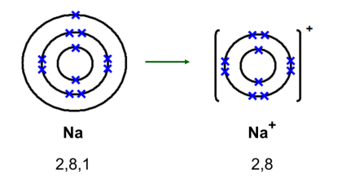
Oxygen forms ions as below:
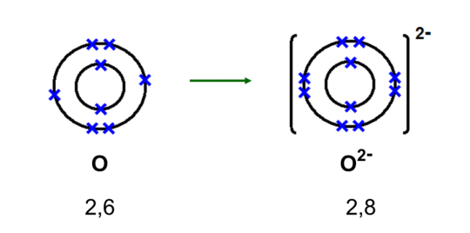
- Draw the ions of:

  - Lithium
  - Chlorine
  - Beryllium
  - Sulphur
  - Aluminium
  - Nitrogen
  - Magnesium
  - Potassium

- Which element forms this ion?
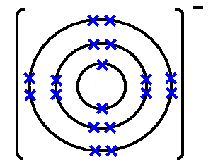
- Which element forms this ion?
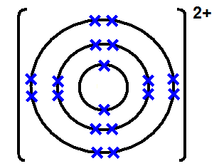

- Draw and label a diagram of the plum pudding model and explain its main differences to the electron shell model
- Potassium exists in three isotopes, K-39, K-40 and K-41. Making reference to the number of protons, neutrons and electrons in each, explain why they are called isotopes.
- How did Chadwick contribute to our understanding of isotopes?
- A sample of potassium is composed of 23% K-39, 48% K-40 and the remainder K-41. Calculate the average mass of the sample.
- With reference to the number of protons and electrons, explain why potassium ions have a 1+ charge.
- Explain why potassium atoms have no charge.
Ionic bonding
In order for atoms to gain a full outer shell, they need to either transfer their electrons to another atom, or to receive electrons from another atom. In the space below, copy the sodium chloride example from the board into your exercise book.
Sometimes, more than one electron is transferred. Copy the magnesium oxide from the board.
Sometimes, the number of electrons transferred depends on the atoms present. Copy the magnesium fluoride example from the board, as well as its formula.
Once you have two (or more ions) they are attracted to each other because they have opposite charges. The force that draws them together is called the electrostatic force of attraction.
- Draw diagrams to show how electrons are transferred when:
  - Lithium reacts with fluorine to form lithium fluoride
  - Potassium reacts with oxygen to form potassium oxide
  - Aluminium reacts with chlorine to form aluminium chloride
  - Na₂O is formed
  - AlN is formed
  - Challenge: aluminium reacts with oxygen to form aluminium oxide
- Check all your answers to question 29 clearly show electrons from one atom as a cross and the other as a dot. If not, correct them.
- Explain why fluorine cannot form an ionic bond with chlorine
- Explain why sodium cannot form an ionic bond with magnesium
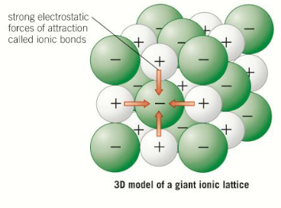
- Why is there no electrostatic force of attraction between lithium and calcium ions?
- In words, describe what occurs when sodium reacts with chlorine to form sodium chloride.
- Challenge: which substance do you think has stronger bonds: calcium oxide or sodium chloride? Explain your answer (hint – you may want to draw out the ions first)
Giant Ionic Lattices
When we carry out a chemical reaction, we do not just use one or two atoms. We use billions. Because the electrostatic force works in all directions, once they form oppositely charged ions, all these billions of atoms can be attracted to each other. We have learnt that this kind of a substance is called a giant substance.
When ions form a giant structure, it is called a giant ionic lattice.
Exam question: Describe the structure and bonding of sodium chloride (4)
Excellent answer:
Sodium chloride is a giant ionic lattice made of positive sodium ions (Na⁺) and negative chloride ions (Cl⁻). Because these ions are oppositely charged they are held together by the electrostatic force of attraction. Because this force acts in all directions, you can form a giant lattice of alternating positive and negative ions.
Poor answer:
Sodium and chlorine form ions and are stuck together by bonds in a large structure
This answer does not say what type of ions, does not mention the electrostatic force of attraction, and does not mention that there is a giant ionic lattice.
- Describe the structure and bonding in sodium fluoride. Give the formulae of the ions involved.
- Describe, in terms of electrons, what happens when sodium reacts with chlorine
- Describe, in terms of electrons, what happens when aluminium reacts with chlorine
- Describe the structure and bonding in aluminium chloride. Give the formulae of the ions involved.
- GCSE Past paper questions:
  - Magnesium chloride contains magnesium ions (Mg²⁺⁾ and chloride ions (Cl⁻). Describe, in terms of electrons, what happens when a magnesium atom reacts with chlorine atoms to produce magnesium chloride. (4)
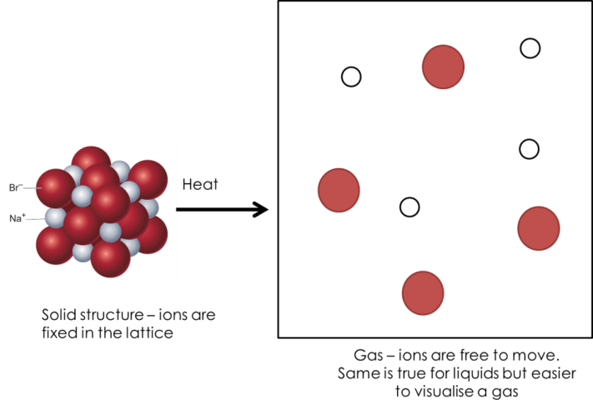
  - Potassium forms an ionic compound with sulfur. Describe what happens when two atoms of potassium react with one atom of sulfur. Give your answer in terms of electron transfer. Give the formulae of the ions formed. (5)
Properties of Ionic Substances
Ionic substances have two properties that you need to know. You must know these properties and explain why they come about:
High Melting and Boiling Points
In order to melt or boil an ionic compound you need to break lots of very strong ionic bonds. This requires a lot of energy and therefore ionic compounds have a high melting and boiling point.
Conducting electricity when liquid or in solution
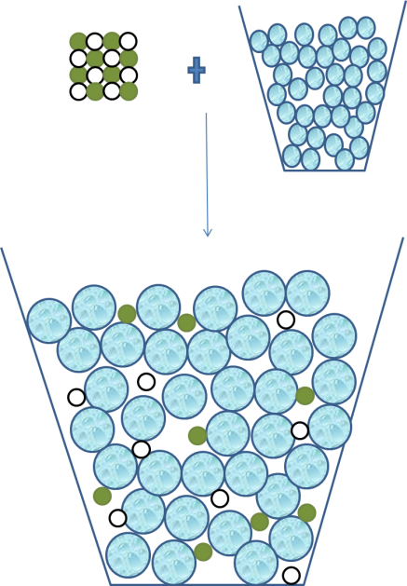
In order for a material to conduct electricity, there need to be charged particles that are free to move. Ionic compounds are made of charged particles (ions), but they are not free to move because of the strong bonds holding the lattice together.
If you melt the substance, then the ions become free to move and carry charge. If you dissolve it in water, then the ions are also free to move and carry charge. Therefore, ionic compounds conduct electricity when melted or dissolved.
- Use the labels below to label the diagram on the right:
Na⁺ ions, electrical insulator, giant ionic lattice, water, liquid, free ions, solution, electrical conductor
- Using the diagram, discuss the differences between NaCl(s) and NaCl(aq)
- Why does NaCl have a high melting point?
- In terms of electrons, how has NaCl formed?
- Potassium fluoride has a high melting and boiling point. Making full reference to its structure and bonding, explain why.
Summary questions:
Potassium oxide is an ionic compound. Answer the questions below about potassium oxide.
- How many protons are in potassium?
- How many neutrons are in oxygen?
- Explain why oxygen ions take a 2- charge in terms of protons and electrons.
- Draw a set of diagrams to explain, in terms of electrons, what occurs when potassium and oxygen react together.
- What is the formula for potassium oxide?(don’t worry if you aren’t sure we will do this in detail later)
- Why are potassium and oxygen ions attracted to each other?
- What is the name for potassium oxide’s structure?
- Give two properties of potassium oxide.
- Explain why solid potassium oxide does not conduct electricity.
- Explain why potassium oxide has a high melting point.
Challenge: explain why aluminium nitride has a higher melting and boiling point than potassium oxide
Covalent Bonding
Ionic bonds occur between metals and non-metals. Electrons are transferred.
Covalent bonds occur between non-metals and non-metals. Electrons are shared.
Drawing covalent bonds
Copy the worked examples from the board.
Use the step by step below to answer the questions.
Step 1: Write down the chemical formula
Step 2: Write down what atoms you need and how many of them
Step 3: Draw those atoms (just outer shell)
Step 4: Work out the number of electrons which would need to be shared (same as the number of electrons which are missing)
Step 5: Share the electrons!
Step 6: Count to make sure you got it right

- Draw covalent bonding diagrams for:
  - Fluorine (F₂)
  - Hydrogen fluoride (HF) (hint – remember Hydrogen only needs one more electron for a full shell!)
  - Hydrogen Chloride (HCl)
  - Water (H₂O) (Hint – each hydrogen can only form one bond! Try putting the oxygen in the middle…)
  - Ammonia gas (NH₃)
  - Methane (CH₄)
  - Nitrogen gas (N₂) (Hint – remember the difference between the covalent bond in chlorine and the covalent bond in oxygen…)
  - Carbon dioxide (CO₂)
- Draw an ionic bonding diagram for lithium fluoride
- Explain why lithium fluoride forms ionic bonds
- Give two properties of lithium fluoride
- Will lithium ever form covalent bonds?
- Give an example of an element that fluorine will form a covalent bond with
- A sample of fluorine contains isotopes with different masses; F-19 and F-18. In the sample 94% of the atoms are F-19. Calculate the relative mass of the sample.
- Fluorine (F₂) reacts with hydrogen (H₂) to make hydrogen fluoride (formula above).
- Write a word equation for this reaction
- Write a balanced symbol equation for this reaction
- Challenge: draw covalent bonding diagrams of each of the below.
    - Hydrogen peroxide (H₂O₂)
    - Propane (C₃H₈)
    - Ethene (C₂H₄)
    - Super challenge: Sulphur (S₈)
Covalent Structures
When ions come together into a larger structure it is called a giant ionic lattice. In covalent bonding, when the atoms (remember they have no charge so aren’t ions) come together they can either form a giant covalent substance or a simple molecular substance.
Giant Covalent Substances
Giant covalent substances have billions of atoms all joined up together by covalent bonds. Two examples are diamond (left) and silicon dioxide (right):
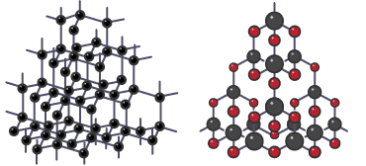
Because covalent bonds are so strong, these substances are hard. Because a lot of energy is required to break the bonds, they also have high melting and boiling points.
There are no free electrons or charged particles in these structures. Therefore they never conduct electricity.
- Silicon dioxide has a giant covalent structure. What would you expect its properties to be?
- Silicon dioxide is used to make moulds for pouring liquid metal into. Explain why silicon dioxide is used for this.
- Silicon carbide is a giant covalent substance. Explain why it has a high melting and boiling point.
- Aluminium iodide has a giant structure. Will it have a giant ionic or covalent structure?
- Explain your answer.
- State the conditions under which an ionic compound will conduct electricity.
- How many electrons does silicon have in its outer shell?
- How many neutrons does silicon have?
- What is the relative mass and charge on an electron?
- How did scientists prove that the plum pudding model of the atom must be incorrect?
- A student has a sample of two substances. One has a giant ionic lattice and the other is giant covalent.
- Why can the student not use their melting points to work out which is which?
- How could the student work out which one is which?
- What other differences are there between giant ionic and covalent structures.
Graphite: the exception
Graphite is a giant covalent structure made entirely of carbon atoms like diamond. However, its atoms are arranged differently meaning it has different properties.
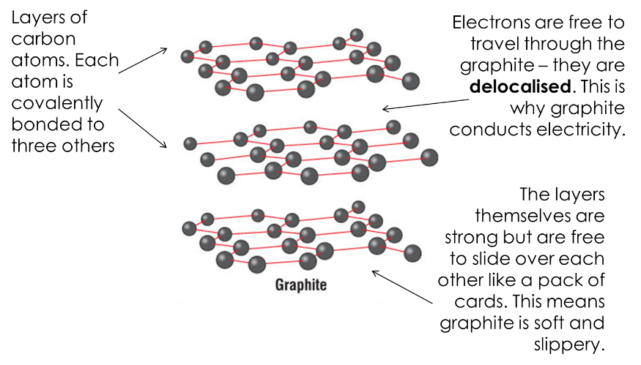
- In what ways are graphite and diamond similar?
- State two differences between diamond and graphite
- Explain why graphite can conduct electricity
- What is the difference between an element and a compound?
- A student has a sample of two substances. One is graphite and the other is sodium chloride.
- Other than appearance, how could the student identify which is which?
- In terms of charged particles, what is the difference in electrical conductivity between graphite and an ionic substance?
- How can you tell from the elements sodium chloride is made of that it will be ionic?
- Draw a dot and cross bonding diagram for sodium chloride
- Explain why sodium chloride has a high melting and boiling point
Simple Molecular Substances
When we first looked at covalent bonding we drew molecules like methane (CH₄).
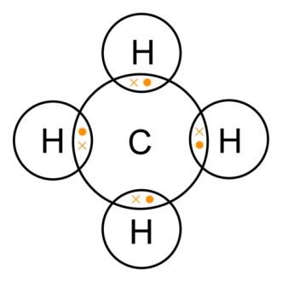
Because all the atoms now have full outer shells, no more atoms can be chemically bonded to this molecule. However, if I add another molecule of CH₄, it will be attracted to this molecule through a weak intermolecular force.
Because this force is weak, in order to separate the molecules a lot of energy is not required. When I separate the molecules, I have a liquid or a gas. Because I can separate the molecules without breaking the covalent bonds, I do not need to use a lot of energy to turn it into a liquid or gas.
Therefore, simple molecular substances have low melting and boiling points.
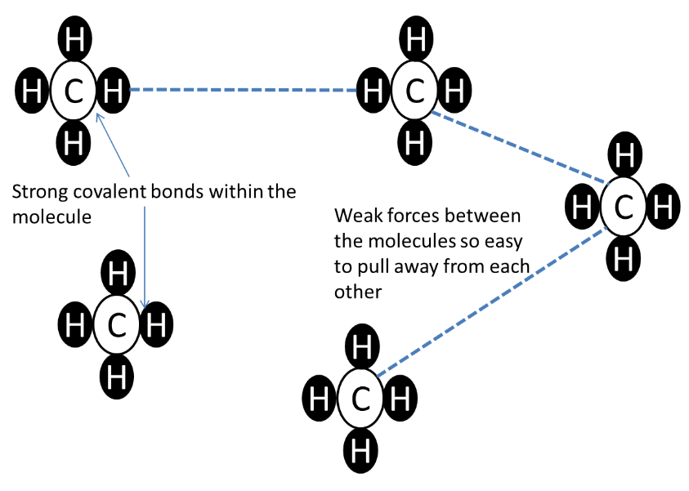
As before, they also cannot conduct electricity. Even though their particles are free to move they have no electric charge.
- Draw a dot and cross diagram of water
- Explain why it is difficult to separate the hydrogen atoms from the oxygen atoms
- Water is a simple molecular substance. What would you expect its properties to be?
- Our atmosphere is a mixture of elements and compounds, which are mainly made up of single atoms or small molecules. In the molecules, the atoms are held together by covalent bonds.
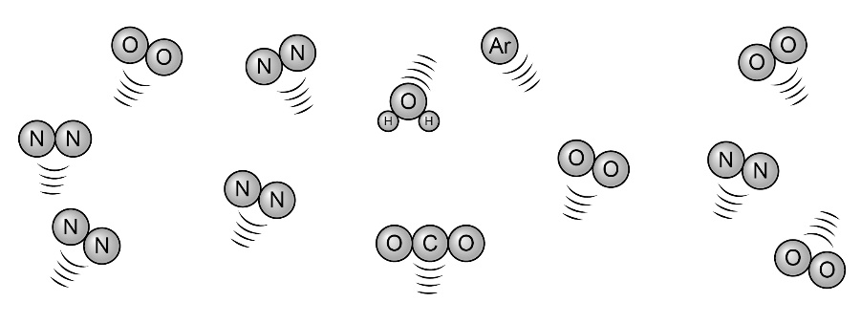
- Write a sentence to explain or describe each of the terms in bold in the above passage.
- Name and give the formula of each of the substances in our atmosphere shown above.
- Choose one chemical in our atmosphere that fits each of the descriptions below.
- An element
- A compound
- Made of single atoms
- Made of molecules
- State all the properties of giant ionic substances. Making reference to the structure and bonding, explain how these properties come about.
Polymers
Polymers are very long molecules with atoms held together by covalent bonds. The molecules are held together by intermolecular forces. The strength of the force increases with the size of the molecule, so they have higher melting and boiling points than simple molecular substances. They are normally solids at room temperature.
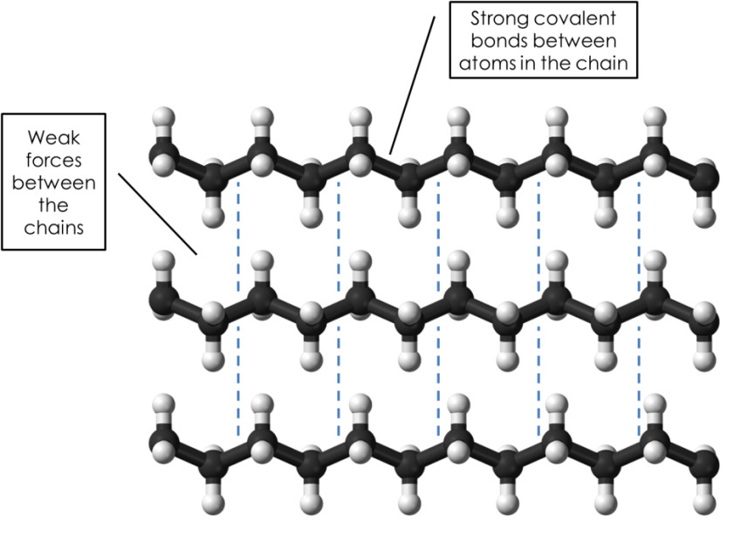
- Polyethane is made of carbon and hydrogen only. Methane is also made of carbon and hydrogen only. Why does polyethane have a much higher melting point than methane?
- Ammonia (NH₃) is a simple molecular substance. Explain why it has a low melting and boiling point
- Explain why ammonia cannot conduct electricity
- What is the main difference between simple molecular substances and giant covalent substances?
- Polymers do not conduct electricity. Explain why not.
- Challenge: Look at the graph below
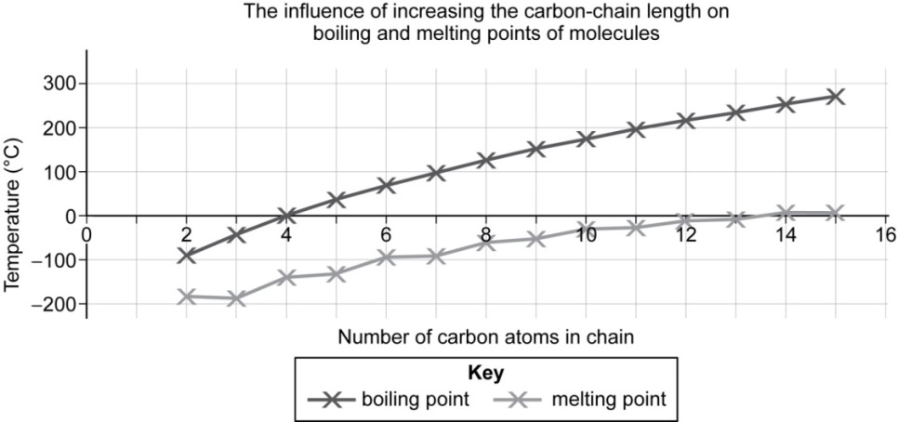

- Describe the pattern seen for the melting and boiling points.
- Explain these patterns using your knowledge of structure, bonding and forces.
Graphene, Fullerenes and Carbon Nanotubes
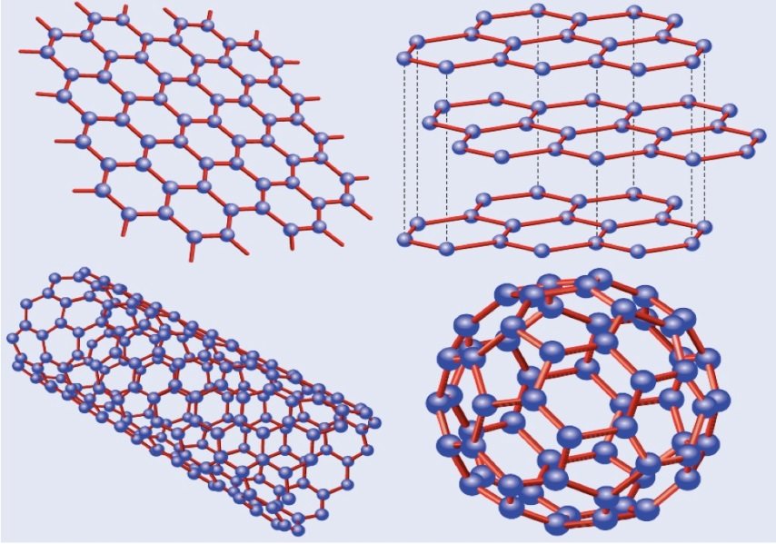
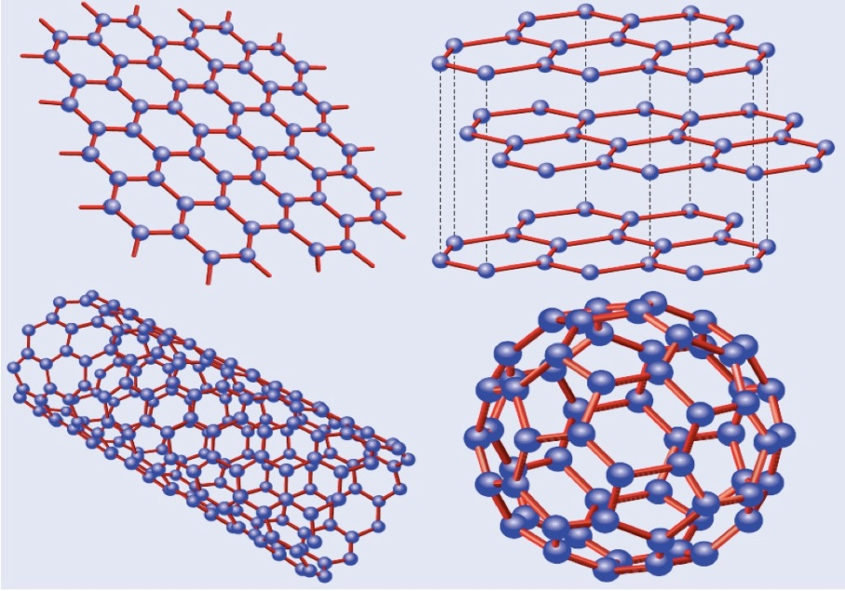
The diagram from left to right shows graphene, a fullerene and a carbon nanotube. These are all modern discoveries and have exciting potential uses.
 | Graphene | Fullerene | Nanotube
Structure | One layer of graphite | A hollow cage of carbon atoms | A hollow tube of carbon atoms
Uses | Electronics: very effective conductor of electricity due to free electrons  Very strong so useful in advanced materials (composites) | Drug delivery for medical applications  Lubricants (weak forces between cages so easy for cages to slip over each other)  Catalysts | High tensile strength so can be used in composite materials e.g. tennis rackets  High electrical conductivity

Summary Questions (all from GCSE papers)
- (a) This part of the question is about graphene. Choose the correct answer to complete each sentence.
(i) The bonds between the atoms in graphene are .............................................(1)
(ii) Graphene is made of .................................................... atoms. (1)
(iii) In graphene each atom bonds to ...................... other atoms. (1)
(b) This part of the question is about graphite. Graphite is used in pencils. Explain why (2)
88. Graphite is a non-metal. Explain why graphite conducts electricity. (3)
89. Lightweight handlebars for bicycles are made from materials containing carbon nanotubes. Carbon nanotubes are lightweight but very strong.
(a) Complete each sentence.
(i) Carbon nanotubes are similar to graphite because each carbon atom is joined to ________ other carbon atoms.
(ii) The carbon atoms are joined by ______ bonds
(iii) Carbon nanotubes are very strong because the ________________ are hard to break
(b) An airplane contains many miles of electrical wiring made from copper. This adds to the mass of the airplane. It has been suggested that the electrical wiring made from copper could be replaced by lighter carbon nanotubes.
(i) What does the term ‘nano’ tell you about the carbon nanotubes? (1)
(ii) Like graphite, each carbon atom is joined to three other carbon atoms. Explain why the carbon nanotube can conduct electricity. (2)
Metals
Metals want to lose their electrons to form a full outer shell. The electrons in the outer shell become delocalised, which means they are free to move leaving a positive ion behind. The positive ions are then attracted to the delocalised electrons by the electrostatic force of attraction.
- Draw a diagram of a metal based on the one on the board. Add the labels:
metal ions, delocalised electrons, layers, giant structure, electrostatic attraction between ions and delocalised electrons
- For each of the elements below, state which type of bond would be formed. The first two have been done for you.
Element 1 | Element 2 | Type of bond
Sodium | Sodium | Metallic
Carbon | Silicon | Covalent
Carbon | Carbon
Oxygen | Lithium
Silver | Fluorine
Magnesium | Chlorine
Magnesium | Calcium
Beryllium | Nitrogen
Phosphorous | Oxygen

- Explain how the particles are held together in a metal
Properties of metals
Metals have four properties which you need to be aware of.
Metals have high melting and boiling points because the electrostatic force between the delocalised electrons and metal ions is strong
Metals are malleable (easy to bend and shape) because the layers of ions can slide over each other.
Metals are good conductors of electricity because the delocalised electrons carry electrical charge through the metal.
Metals are good conductors of thermal energy because energy is transferred by the delocalised electrons.
- Explain why metals have high melting and boiling points
- Copper is used to make wires for household circuits. Give two reasons why.
- Explain why graphite can conduct electricity
- Explain why most covalent substances do not conduct electricity
- State the conditions under which an ionic substance will conduct electricity
- Define malleable
- Explain why sodium atoms and potassium atoms cannot form ionic bonds
- Challenge: which of sodium or magnesium do you think has the highest melting point? Explain your answer.

Alloys
Pure metals are very soft because the layers can slide over each other easily. If you add an atom of a different element into the layer, it will have a different size and disturb the layers.
- Explain how electricity is conducted in a metal. To gain full marks you must include a description of the structure and bonding of a metal. (4)
- Describe how the structure of an alloy is different from the structure of a pure metal. (2)
- Suggest one reason why coins are not made of pure copper. Do not give cost as a reason. (1)
- Iron is used (as steel) to make the body panels for cars. Explain how the structure and bonding of iron:
  - allows the body panels to conduct electricity;
  - allows the body panels to be bent into shape;
  - gives the body panels strength.
- Complete the table below
Complete the table:  Substance | Melting point (°C) | Boiling point (°C) | Conductor of electricity when: |  |  | Type of structure and bonding (simple molecular, giant covalent, giant ionic lattice, metallic)
Complete the table:  Substance | Melting point (°C) | Boiling point (°C) | solid | liquid | in solution
A | 1083 | 2567 | yes | yes | insoluble
B | –107 | 13 | no | no | no
C | 2300 | 4000 | no | no | insoluble
D | 605 | 1350 | no | yes | yes
E | 6 | 80 | no | no | insoluble
- Identify which of the substances in the table below could be:
i sodium chloride (NaCl) ii aluminium metal (Al)
iii diamond (C) iv carbon chloride (CCl₄).
Substance | Melting point (°C) | Boiling point (°C) | Electrical conductor as…
Substance | Melting point (°C) | Boiling point (°C) | solid (s) | liquid (l) | solution (aq)
A | 660 | 2467 | yes | yes | insoluble
B | –23 | 77 | no | no | insoluble
C | 801 | 1413 | no | yes | yes
D | 3550 | 4827 | no | no | insoluble

- Challenge: Explain why metals are good conductors of electricity and suggest why this conductivity increases across the periodic table from sodium to magnesium to aluminium. (4)

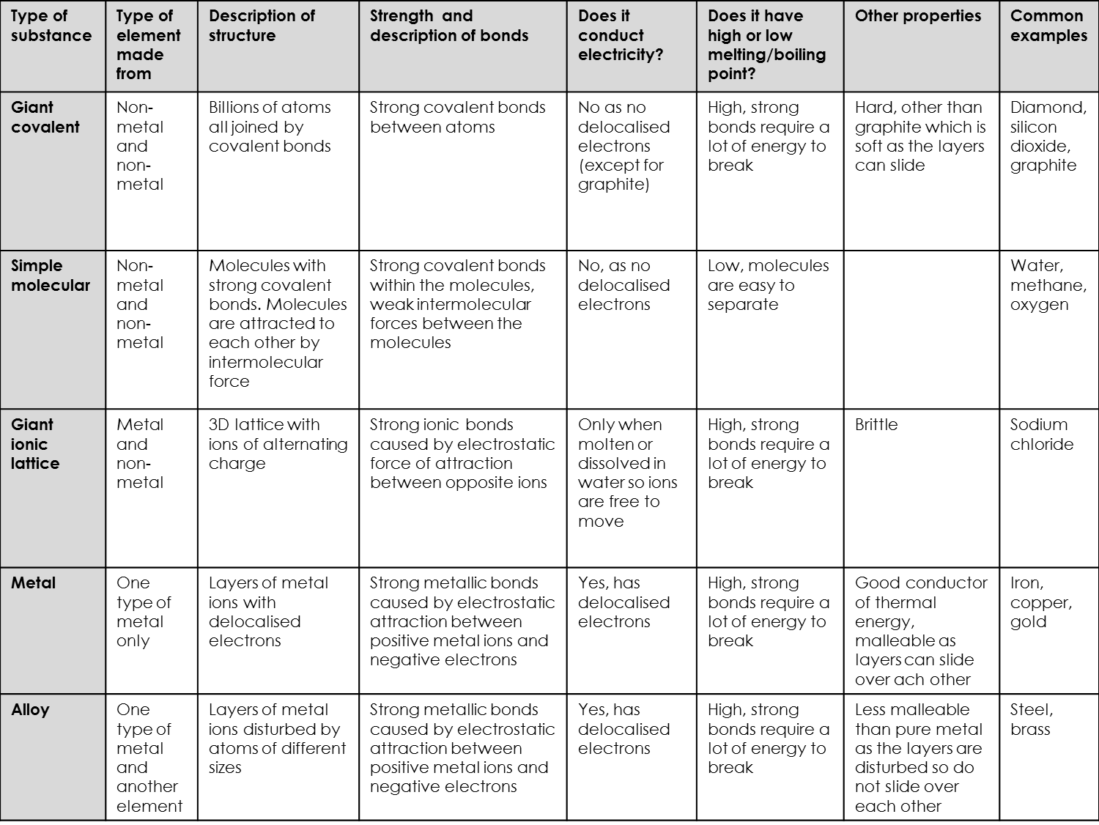

Bonding Summary Activity
Use the table on page 12 to help you answer the questions below. The first two have been done for you as a model. At first, use the table but as you get further into the questions you should start trying to answer from memory as much as possible.
- A student has a substance which conducts electricity when solid but is very hard. What type of structure does it have?
The only types of structure in the table which conduct electricity when solid are metals and graphite. Graphite and pure metals are soft, so it must be an alloy.
Answer: alloy
- Given an example of a substance which has a high melting and boiling point and never conducts electricity.
Giant covalent, giant ionic and metallic substances all have high melting and boiling points. Out of those, ionic conducts electricity under certain conditions and metallic can always conduct electricity, therefore it must be giant covalent so it could be graphite, diamond or silicon dioxide. Out of those, graphite conducts electricity so either diamond or silicon dioxide.
Answer: diamond or silicon dioxide
You do not need to write a whole paragraph in your answers, just the final answer.
- A substance has a high melting point and conducts electricity. What type of structure could it have?
- Explain your answer to c
- How would you be able to tell the difference between a metal and an alloy?
- A student has two white substances. One is giant ionic and the other is giant covalent. How could they tell which is which?
- A substance is a liquid at room temperature. What type of structure does it have?
- Would you expect it to conduct electricity? Explain your answer.
- From memory, try and name all five types of structure.
- Look at the table and correct your answer to i
- Both graphite and pure metals are soft. Explain why.
- A substance is dissolved in water and can conduct electricity. What type of structure would the substance have had?
- Why do simple molecular structures have low melting and boiling points?
- What is the difference between a metal and an alloy?
- Explain why alloys are harder than pure metals
- Silicon dioxide is used to make coatings for fire fighters’ uniforms. Explain why.
- Explain why graphite conducts electricity but diamond does not
- Under what conditions will simple molecular substances conduct electricity?
- Graphite and metals both conduct electricity. Explain what they have in common in terms of how they conduct electricity.
- Methane molecules are made of one carbon atom joined to four hydrogen atoms. These bonds are very strong. Explain why methane has a low melting point.
- Compare the structure and bonding in sodium chloride to the structure and bonding in sodium. Explain your answer fully and include similarities and differences.
- When sodium chloride conducts electricity, the way it does so is different to how graphite conducts electricity. Explain how.
- TiCl₄ is a liquid at room temperature. Explain why this is surprising and what this tells you about its structure.
- Sucrose is a molecular substance but is solid at room temperature. Explain why this is surprising and suggest why it is solid at room temperature.

Groups In The Periodic Table
We have previously learnt that the periodic table was originally organised by atomic weights. Mendeleev put elements together based on their chemical properties. Nowadays, the periodic table has elements in order of their atomic number and organised according to properties.
We now know that the reason why elements in a group have similar properties is because they have the same number of electrons in the outer shell.
Groups are the columns and periods are the rows.
- Why is the Periodic Table referred to as the Periodic Table of Elements?
- What does the group and the period that an element is in tell you about its electrons?
- Draw an atom of lithium
- What charge will lithium take when it becomes an ion?
- Two different elements chemically react together. What word can be used to describe the products?
- Why is it only recently that we could explain why elements in the same group have similar properties?
- Potassium reacts with chlorine. What type of bond will be fond?
- Describe what occurs in terms of electrons.
- Potassium is a metal. Suggest four properties of potassium.
- Chlorine is a simple molecular substance. State two of its properties.
- Rubidium reacts with water. Would you expect potassium to react with water? Explain your answer.
Group 1 reactions
The group 1 metals are known as the alkali metals. The group 1 metals all react with:
- Oxygen to form oxides
- Chlorine to form chlorides
- Water to form hydroxides
For example, for sodium:
Sodium + oxygen sodium oxide
4Na(s) + O₂(g) 2Na₂O(s)
Sodium + chlorine sodium chloride
2Na(s) + Cl₂(g) 2NaCl(s)
Sodium + water sodium hydroxide + hydrogen
2Na(s) + 2H₂O(l) 2NaOH(aq) + H₂(g)
- Write a word and symbol equation for the reaction between potassium and:
  - Oxygen
  - Chlorine
  - Water
- Explain what the different state symbols in your equations stand for
- A student drops 2g of lithium into 150g of water in a beaker. Explain why the mass of the beaker weighs less than 152g at the end.
- This question is about the reaction below:
2Li(s) + Cl₂(g) 2LiCl(s)
- Identify the type of bonding in each of the substances above
- Explain why chlorine is a gas at room temperature
- Under what conditions will lithium chloride conduct electricity?
- Why does lithium conduct electricity?

Group 1 reactivity
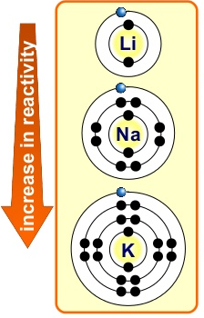
Reactivity means how reactive something is. All the group 1 metals are reactive, but they get more reactive as you go down the group, so potassium is more reactive than sodium, which is more reactive than lithium. This can be explained by looking at the electronic structure of the atoms:
In order to react, the metal needs to lose an electron. The easier it is to lose, the more reactive it will be.
The ease with which the electron is lost depends on the strength of the electrostatic attraction between the positive nucleus and the negative electrons.
This is affected by the distance from the nucleus and the number of shells. Greater distance decreases the attraction. More shells decreases the attraction as the inner electrons shield the one on the outer shell.
- Give two reasons why potassium is more reactive than sodium.
- Give two reasons why lithium is less reactive than sodium.
- Explain why group 1 metals need to be stored in oil.
- Schools are not allowed samples of caesium. Explain why.
- Explain how the reactivity of a group 1 metal depends on its outer electron.
- Write a word and symbol equation for the reaction between lithium and water.
- Draw a dot and cross diagram of water.
- Challenge: Suggest why calcium is more reactive than magnesium.
- Super challenge: explain why potassium is softer (easier to cut) than sodium.
Group 7 properties
Group 7 elements are called the halogens. They are reactive non-metals that form as diatomic (two atoms joined together).
Down the group, the melting point and boiling point of the halogens increase, but their reactivity decreases:
Element | Formula and state at room temperature | Reactivity
Fluorine | F₂(g) | Most reactive
Chlorine | Cl₂(g)
Bromine | Br₂(l)
Iodine | I₂(s) | Least reactive

- How many electrons do the halogens have in their outer shell?
- What type of bond exists between the two atoms in a halogen?
- Draw an atom of chlorine.
- Draw a dot and cross diagram of Br₂. Outer shells only are necessary.
- Explain why fluorine has a low melting and boiling point.
- Challenge: why does the boiling point increase down the group? Think about intermolecular forces and what we learned when we looked at polymers.
Group 7 reactivity
The reactivity of the halogens increases up the group (the opposite to group1).
In order to react, the halogen needs to gain an electron. The easier it is to gain, the more reactive it will be.
The ease with which the electron is gained depends on the strength of the electrostatic attraction between the positive nucleus and the negative electrons.
This is affected by the distance from the nucleus and the number of shells. Smaller distance increases the attraction. More shells increases the attraction as the inner electrons do not shield the one on the outer shell.
- Explain why fluorine is more reactive than chlorine.
- Explain why bromine is less reactive than chlorine.
- Explain why potassium is more reactive than lithium.
- Write a symbol equation for the reaction between lithium and chlorine.
Displacement reactions
In some chemical reactions, a more reactive element can take the place of a less reactive element in a compound:
Potassium chloride + fluorine potassium fluroide + chlorine
2KCl + F₂ 2KF + Cl₂
In this reaction, because fluorine is more reactive than chlorine, it takes its place in the compound and potassium chloride becomes potassium fluoride. This is called a displacement reaction.
- Write a word and symbol equation for the reaction between bromine and lithium iodide.
- In the reaction above, identify the two elements and the two compounds.
- What kind of substance is potassium fluoride?
- Explain why potassium fluoride has a higher melting point than fluorine.
- Explain why iodine is less reactive than bromine.
- Explain why chlorine does not conduct electricity.
Group 0 elements
The Group 0 elements are also called the Noble gases. They have full outer shells which means they do not need to gain or lose electrons. For this reason they do not react with other elements and form chemical bonds. Unlike other gases, they exist naturally as single atoms, not as molecules.
As you go down the group, the boiling points of the Noble gases increase.

Summary task:

The electronic structure of the atoms of five elements are shown in the figure below. The letters are not the symbols of the elements.

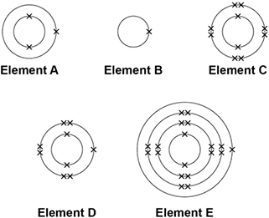

Choose the element to answer the question. Each element can be used once, more than once or not at all.

- Which element is hydrogen?
- Which element is a halogen?
- Which element is a metal in the same group of the periodic table as element A?
- Which element exists as single atoms?
- There are two isotopes of element A. Information about the two isotopes is shown in the table below.

 | Mass number of the isotope | 6 | 7
 | Percentage abundance | 92.5 | 7.5

Use the information in the table above to calculate the relative atomic mass of element A. Give your answer to 2 decimal places.
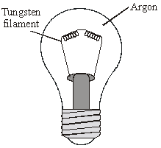
- Explain why the reactivity of the elements increases going down Group 1 from lithium to rubidium but decreases going down Group 7 from fluorine to iodine. (4)
- Explain why fluorine will react with every element on the periodic table other than helium.
- The diagram shows an electric light bulb.

When electricity is passed through the tungsten filament it gets very hot and gives out light. State why argon is used in the light bulb. Explain your answer in terms of the electronic structure of an argon atom.

