Energy Changes Mastery Booklet
In all chemical reactions, energy is either taken in from the surroundings or released to the surroundings.
If energy is released to the surroundings, the temperature of the surroundings will increase. We call these reactions exothermic.
If energy is taken in from the surroundings, the temperature of the surroundings will decrease. We call these reactions endothermic.
Remember that the thermometer counts as the surroundings. So if the temperature on the thermometer decreases, the reaction is endothermic. If the temperature on the thermometer increases, the reaction is exothermic.
 | Exothermic | Endothermic
Energy | Released to surroundings | Taken in from surroundings
Temperature of surroundings | Increases | Decreases
Examples | Combustion, respiration, self-heating cans, hand warmers | Thermal decomposition, citric acid and sodium hydrogen carbonate, sports related cold-packs

- The following experiment was used to compare how much heat energy three different fuels gave out when they were burnt.
Thermometer
Metal can

Fuel burner
100g water

Here are the results when 1.0 g of each fuel was burnt.
fuel | temperature of water at start | temperature of water at end
ethanol | 19ºC | 36ºC
paraffin | 20ºC | 47ºC
white spirit | 18ºC | 41ºC

Are the reactions exothermic or endothermic?
- Explain how you know your answer to Q1.
- What was the temperature change when 1.0 g of ethanol was burnt?
- Which fuel released the most energy when it was burnt?
- Why it is important to burn 1.0 g of each fuel in each experiment?
- The temperatures of reactions of zinc, magnesium and nickel with hydrochloric acid were measured.
The results are shown in the table.
metal | Temp at start ºC | Highest temp reached ºC | Temp change  ºC
nickel | 19 | 24 | 5
calcium | 19 | 57
zinc | 19 | 30 | 11
  - Calculate the temperature change for the calcium reaction.
  - Magnesium is more reactive than zinc but less reactive than calcium. Predict the temperature change for a reaction between magnesium and hydrochloric acid.
  - What name is given to reactions which give out heat?
- What temperature change will be observed for an endothermic reaction?
- Suggest another reaction which would give out heat.

Measuring the temperature change
In order to measure the temperature change of a reaction, we can use a range of different apparatus. The most common will be either to mix a solid with a solution, or to use the reaction to heat up water. You could use a fuel burner for this (like the diagram on the first page) or any other substance, including food. The change in temperature allows you to work out if the reaction was endo or exothermic.
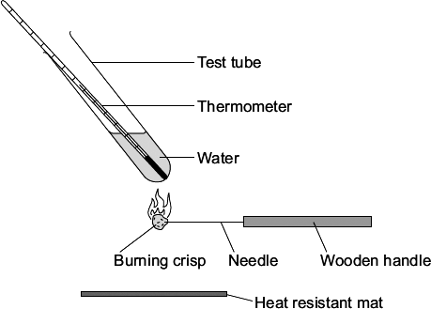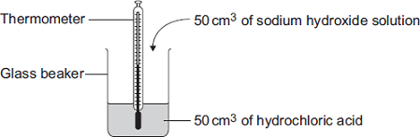
In each of the reactions energy is transferred from the reaction to the thermometer (or the reverse). To improve these you must make sure that no heat can escape to the environment so use a better insulator than a glass beaker or tube and put a lid on it.
- A student investigated the reaction of magnesium with hydrochloric acid. A piece of magnesium was dropped into the hydrochloric acid. Use your notes from when we studied acids to write a word equation for this reaction.
  - Extension: write a symbol equation for this reaction. Remember that you need to look at the charges of the ions to work out the formula of magnesium chloride
- In your answer to question 9, indicate which substances are reactants and which are products.
- In your answer to question 9, indicate which substances are elements and which are compounds
- Why does the mass of the substances decrease as the reaction goes on?
- The reaction is exothermic. Which two measurements would the student make to show that the reaction is exothermic? (hint – look at the table in question 6. Which two measurements have been taken?)
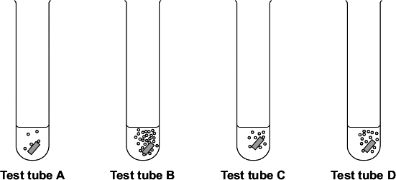
- How would the measurements from Q13 show that the reaction is exothermic?
- The student investigated how changing the concentration of the hydrochloric acid affects this reaction. Each test tube contained a different concentration of hydrochloric acid. The diagrams show the results of this experiment. Suggest one control variable in this investigation.
- Which test tube, A, B, C or D, contained the greatest concentration of hydrochloric acid?
- Explain your answer.
- Which test tube would show the smallest temperature change?
- How could the student improve the experiment’s design?
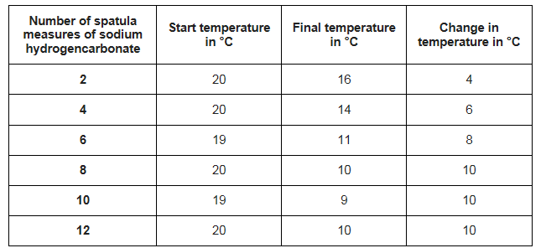
- Some students did an experiment to find the temperature change when hydrochloric acid reacts with sodium hydrogencarbonate. The results are in the table.
  - Describe, as fully as you can, the trends shown in the students’ results.
  - State the type of energy transfer for this reaction.
- Sodium hydrogencarbonate is used as baking powder for making cakes. When the cake mixture is baked the sodium hydrogencarbonate decomposes. The equation for the reaction is:
NaHCO₃(s) Na₂CO₃(s) + H₂O(g) + CO₂(g)
- Balance the equation.
- Write a word equation for this reaction.
- The cake mixture rises when baked. Use the equation to suggest why
- Sodium hydrogen carbonate is an ionic compound. Give two properties of sodium hydrogen carbonate.
- Explain why carbon dioxide is a gas at room temperature by making reference to its bonding and structure.
Reaction profiles
A reaction profile shows you the relative energy difference between the reactants and the products in a chemical reaction.
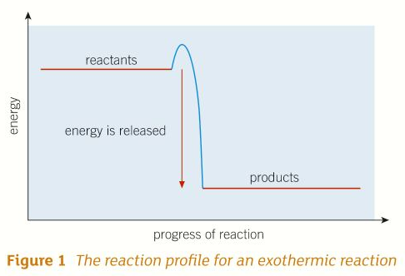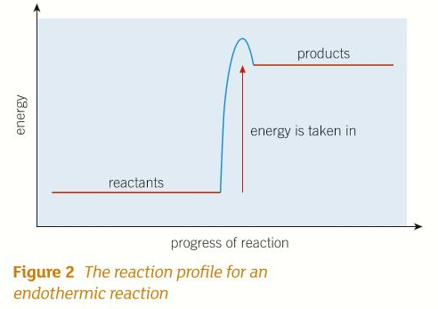
- For each of the reactions below, draw a reaction profile and state whether the reaction is exo or endothermic:
Reaction | Temp. at start (°C) | Temp. at end (°C)
zinc + sulfuric acid → zinc (II) sulfate + hydrogen | 21 | 51
nitric acid + sodium hydroxide → sodium nitrate + water | 22 | 28
potassium hydrogencarbonate + hydrochloric acid → potassium chloride + water + carbon dioxide | 21 | 9
silver (I) nitrate + copper → silver + copper (II) nitrate | 20 | 25

Recap questions
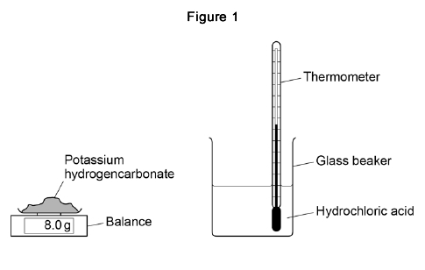
A student investigated the energy change occurring in the endothermic reaction between potassium hydrogencarbonate and hydrochloric acid. Figure 1 shows the apparatus used. This is the method used.
1. Measure 50 cm3 hydrochloric acid into a glass beaker.
2. Measure 1.0 g of potassium hydrogencarbonate.
3. Add the potassium hydrogencarbonate to the hydrochloric acid.
4. Stir until all the potassium hydrogencarbonate has reacted.
5. Record the lowest temperature reached.
6. Repeat steps 1‒5 two more times.
7. Repeat steps 1‒6 with different masses of potassium hydrogencarbonate.
(a) Which is the most suitable apparatus to use to measure 50 cm3 of hydrochloric acid? Circle one answer.
Balance Conical flask Gas syringe Measuring cylinder
(b) The student used a glass beaker for the reaction. Suggest one change to the apparatus that would improve the accuracy of the results. Give a reason for your answer.
(c) Which two variables should the student keep the same to make this a fair test? Circle two answers.
Mass of potassium hydrogencarbonate Same balance Same thermometer
Starting temperature of hydrochloric acid Volume of hydrochloric acid
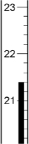
(d) The diagram on the right shows part of the thermometer used to measure the temperature. What is the temperature reading on the thermometer?
The table shows a set of results.
 | Test 1 | Test 2 | Test 3
Lowest temperature in °C | 16.1 | 15.8 | 15.9

(e) What is the range of the lowest temperature?
From _________ °C to _________ °C
(f) Calculate the mean lowest temperature. Use the table above.
(g) How do the results show that the reaction is endothermic?
The graph shows the student’s results.
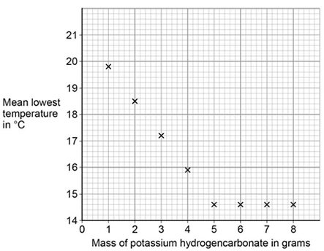
(h) Draw two straight lines of best fit on the graph above.
(i) Describe how the lowest temperature changes as the mass of potassium hydrogencarbonate added increases.

