The Atmosphere
Name: _____________
Use the diagram below to help you answer the questions
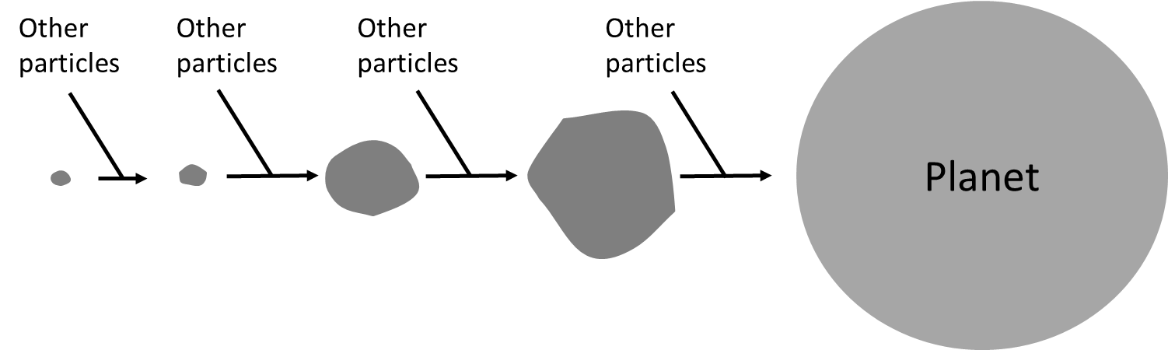
- When were the smallest particles formed?
- What caused the particles to be attracted to each other?
- When the particles are moving in space, which store do they have energy in?
- A small particle is pulled towards a large lump of rock. Draw a free body diagram showing any forces acting on the small particle.
- Challenge – come back to this at the end: A large particle is pulling on a small particle with a force of 10,000N. With what force is the small particle pulling on the large particle? Explain your answer.
- When planets first form they are extremely hot. Explain why.
- The Earth’s early atmosphere was mostly carbon dioxide. Where did this carbon dioxide come from?
- Venus and Mars both have atmospheres mostly consisting (made up) of carbon dioxide. Explain why life has not formed there.
- Challenge: why do you think scientists are not 100% sure what the Earth’s early atmosphere was like?
Fill in the blanks:
- Because the Earth was formed ________________ of years ago, it is difficult for scientists to know what it was like then. This is why we often use the phrase “scientists believe”; scientists have t_____________ based on e______________, but at this point in time they cannot be sure.
- Complete the sentence stems below in your exercise book.
The Earth’s early atmosphere was formed by…
The Earth’s early atmosphere consisted of…
Scientists cannot know for sure what the early atmosphere was like because…
Scientists cannot know for sure what the early atmosphere was like but…
Scientists cannot know for sure what the early atmosphere was like therefore…
Water
- The early atmosphere contained a small amount of water vapour. Where did this water vapour come from?
- What does condense mean?
- Why did the water vapour condense?
- Is there a chemical difference between liquid water and water vapour?
- The surface temperature on Venus is over 400°C. Why does Venus not have any oceans?
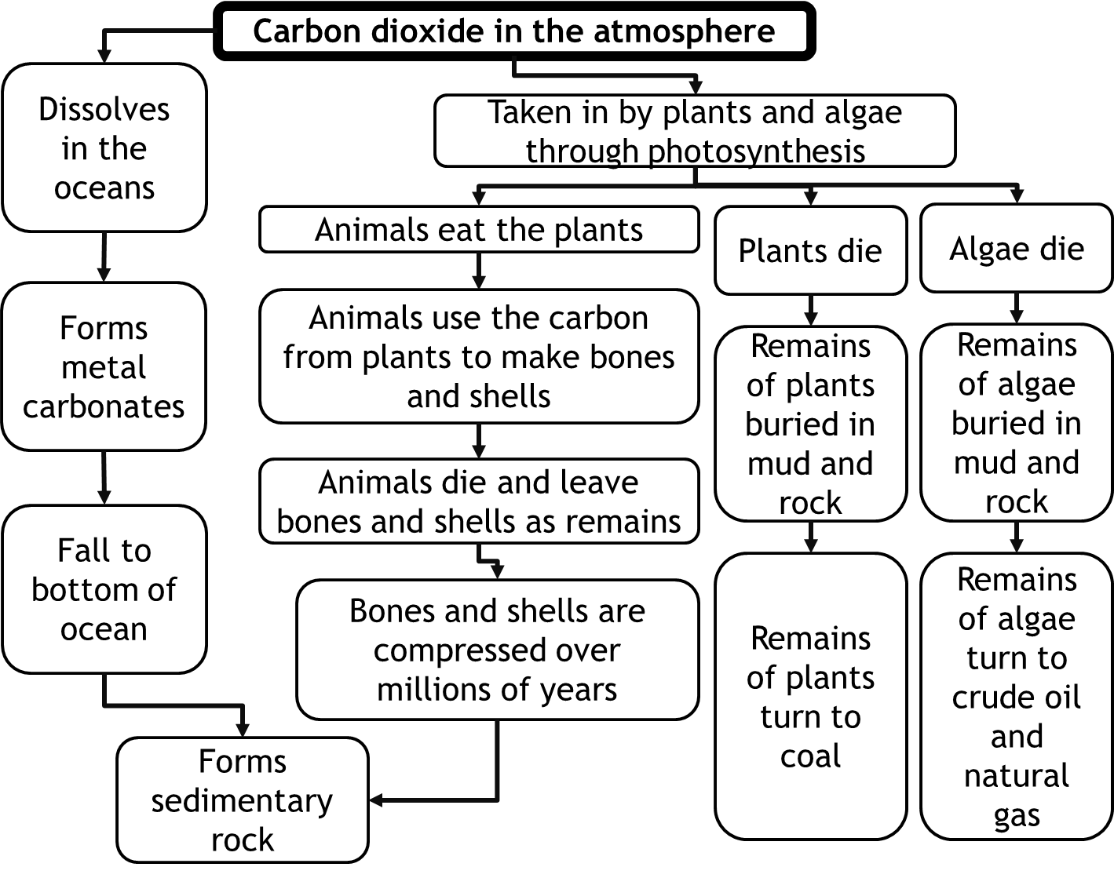
- Mars also does not have any liquid water on the surface. Why is this?
Life
- Why can scientists not be sure exactly when life came into being?
- Give the word equation for photosynthesis
- If you could look at algae under a microscope, which organelles would you expect to see? Explain your answer.
- After algae came into being, how would the composition of the early atmosphere change?
- Challenge: The Earth was formed 4.5 billion years ago. Why did life not come into being until 2.7 billion years ago?
Carbon dioxide – where did it all go?
- Give a word equation for photosynthesis
- Complete the passage below:
In the Earth’s e_________ a____________ there was a large percentage of c___________ d____________. Over time, that percentage has d____________. A lot of it d____________ in the o______________ and formed m_____________ c____________. It is not easy for the c_________ in a m__________ c___________ to be released back to the atmosphere so it is called l_____________ u___.
- Write a passage of your own similar to the one above to explain why the carbon in bones and shells is called “locked up” carbon
- How is sedimentary rock formed from bones and shells?
- Name three fossil fuels
- Explain how each fossil fuel is formed
- Explain why each fossil fuel has “locked up” carbon in it
- Animals use plants to obtain glucose, which they use for respiration. Give a word equation for respiration.
- Explain why the carbon contained in glucose is not called “locked up”
- Where did the carbon dioxide in the Earth’s early atmosphere come from?
- Why can scientists not be sure about the exact percentage of carbon dioxide in the Earth’s early atmosphere?
- Using as much detail as you can, explain why the percentage of carbon dioxide in the atmosphere did not decrease until the oceans started to form.
Nitrogen
- Give the formula for nitrogen gas
- Explain why under normal circumstances nitrogen will not react with oxygen
- What does “persist” mean?
- Nitrogen is a molecular substance. Give examples of five other molecular substances
- Explain what is meant by molecular substance
- Volcanoes can produce ammonia, which reacts to form nitrogen:
NH₃ + O₂ N₂ + H₂O
Copy the equation and balance it
- Explain why this reaction could not take place until 2.7 billion years ago
- The H₂O is produced as steam but cools down to form liquid water. What is the name for this process?
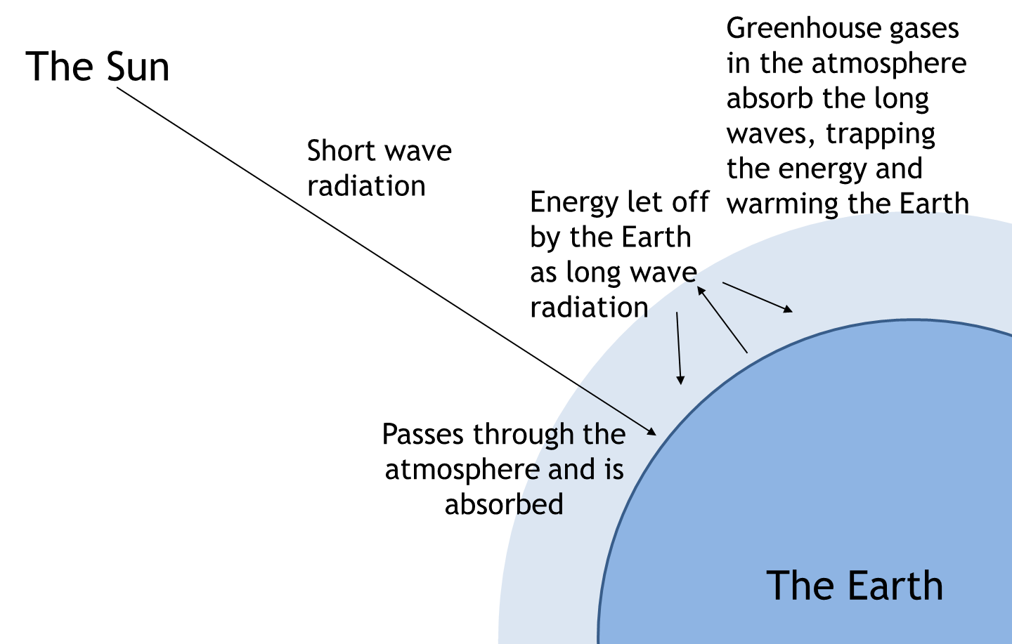
- Why was there lots of steam (water vapour) in the Earth’s early atmosphere, but very little today?
Greenhouse gases
There are three main greenhouse gases: carbon dioxide, methane and water vapour.
- How is energy transferred from the Sun to the Earth?
- How is the radiation that comes to the Earth different to the radiation that leaves the Earth?
- Not all the energy from the Sun reaches the Earth, some of it is reflected by the atmosphere. If 250J of energy from the Sun hits the atmosphere at a certain place, but only 128J makes it to the surface of the Earth, how much energy is reflected by the atmosphere?
- Justify your answer.
- Venus has an extremely thick atmosphere made up mostly of carbon dioxide. Explain why this is part of the reason that Venus has a surface temperature above 400°C.
- Use a paragraph to explain how greenhouse gases cause the Earth to warm up
Humans are adding greenhouse gases to the atmosphere in a number of ways:

- Burning fossil fuels releases carbon dioxide
- Deforestation results in fewer trees to take in carbon dioxide through photosynthesis
- Rice fields release methane
- Grazing cattle release methane

- Explain why greenhouse gases can increase the temperature of the Earth
- Give the symbol formulae for carbon dioxide and methane
- A farmer wishes to buy a forest which they can cut down and use the land for cattle. How could this affect the environment?
- Give a word equation for the combustion of a fuel
- Give a balanced symbol equation for the combustion of methane
- Challenge: a student says that combusting methane does not change the amount of greenhouse gases in the atmosphere. We start with methane (which is a greenhouse gas) and we finish with carbon dioxide (which is a greenhouse gas). In terms of “locked up” carbon, explain why the student is wrong.
It is important to note that the amount of carbon dioxide over the last 3 billion years has decreased from being the majority of the atmosphere to being around 0.04% today. Recent additions of CO₂ only increase it by a tiny amount. That amount is significant, and has effects as below, but it is nowhere near where it used to be. A question about the change in amounts of CO₂ throughout the Earth’s history is therefore very different to one about the last 200 years or so.
- Describe and explain the changes in the amount of CO₂ from 2.7 billion years ago until recently.
- Describe how human activity has changed the amount of CO₂ in the atmosphere.
Evidence for global warming
- Most scientists believe that as we i_____________ the percentage of c____________ d____________ in the atmosphere, the global t______________ will increase. They have two main sources of evidence:
1. In the past, whenever the t____________ of the E___________ has been high, the percentage of c______________ d_____________ has also been high.
2. Scientists can run experiments where they prove that g____________ g___________ like methane and c___________ d____________ trap energy.
- In a debate between two students, the first students says:
“In the past, the temperature of the Earth has changed naturally. Even though it’s true the Earth’s current temperature is high, this is a natural process and the temperature will decrease naturally”
The second student disagrees and says:
“It is true that the temperature of the Earth has changed naturally, but the change normally takes many hundreds of years and is very slow. This time, the change has happened very quickly since the 19th century and is a very large change too.”
  - According to student 2 what occurred in the 19th century that caused the temperature to increase?
  - As well as combustion of fossil fuels, what could the affect the percentage of carbon dioxide in the atmosphere?
  - The data below is taken from a station that monitors the amount of carbon dioxide in the atmosphere. What is the general trend (pattern) in the readings?
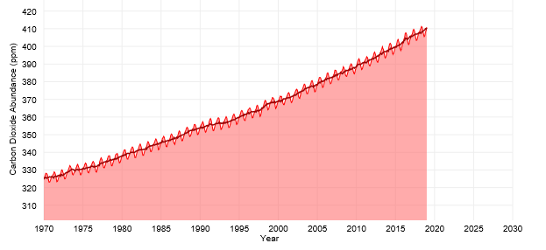
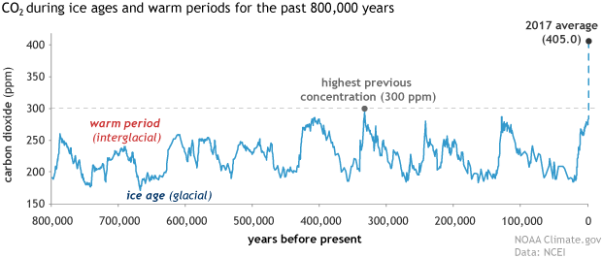
  - Why does the line go up and down? (hint – think about how the amount of carbon dioxide changes in one year with the seasons)
  - The data to the right shows how the amount of carbon dioxide in the atmosphere has changed over time. In words, describe how the amount of carbon dioxide has changed over time.
  - The graph below shows the Earth’s temperature over the last 800,000 years. In words, describe how the temperature has changed over time. 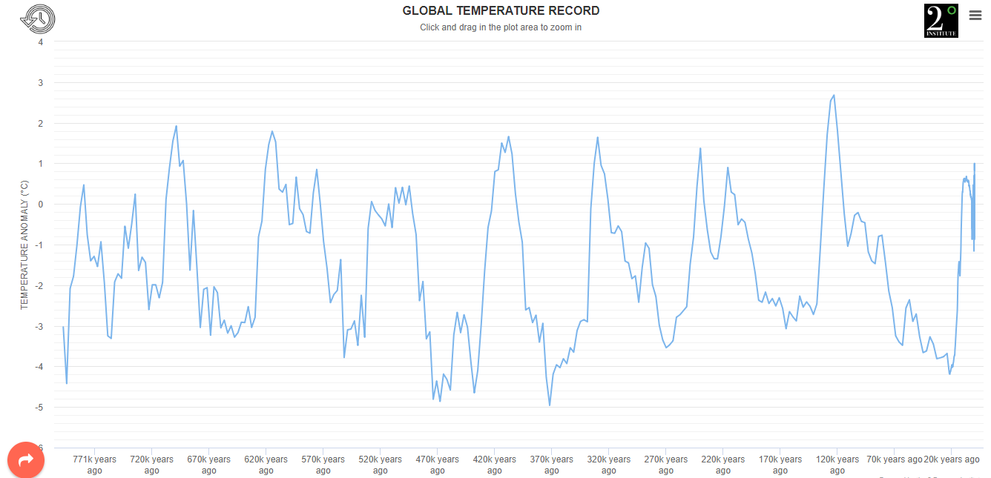
  - Based on the graphs presented so far, which student is correct?
  - In the graph above, there are time periods when the temperature increased by 5°C in 12,000 years. In the last 150 years, the temperature has increased by 1.5°C. Does this change your answer to question g?
Climate change
Scientists predict that the Earth’s increasing temperature will lead to climate change. There are many effects of climate change, with just a few mentioned below:

Event | Leads to… | Effects…
Melting ice caps | Habitat loss. Land based ice loss can result in rising sea levels. | Puts animals and ecosystems under stress, sea levels see below.
Extreme weather events | Damage to crops and plants, interferes with animal breeding patterns/migratory/behavioural patterns | Widespread damage to animal numbers and diversity, potential for food shortages
Changes in the amount and time of rainfall | Damage to crops and plants, interferes with animal breeding patterns/migratory/behavioural patterns | Widespread damage to animal numbers and diversity, potential for food shortages
Sea levels rising | Caused by increase temperature of water and land based ice melting, leads to low lying areas of land being submerged | Human and animal colonies becoming uninhabitable.
- How could climate change result in their being less food available for humans?
- How could climate change cause humans to have to leave their homes in large numbers?
- Why are sea levels rising?
- How could this affect polar bear populations?
- A student took data for the temperature in December over five years. She noticed that the temperature was decreasing over time. Explain why she would be incorrect to claim that “global warming is a myth”
Carbon footprint
The carbon footprint of a product is the total amount of carbon dioxide and greenhouse gases released by that product through its full life cycle. The life cycle includes the greenhouse gases released in manufacture and disposal. The carbon footprint of a product can be reduced by:
- Using renewable sources of energy e.g. solar and wind
- Using products less frequently (e.g. walking instead of driving)
- Building more efficient products that waste less energy e.g. more efficient engines or home insulation
- Taxing emissions and allowing companies to not pay them if they plant trees instead
- Using biofuels which are “carbon neutral”
Reducing carbon emissions globally requires international cooperation. However, not all countries agree that climate change is occurring. For others, taking some of the measures above would reduce their economic productivity.
- When does the life cycle of a car start?
- When buying a car, what things should be considered in terms of its carbon footprint?
- A country whose citizens have limited access to electricity is unlikely to agree to international measures to reduce carbon emissions. Why?
- In terms of climate change, why is it better to take public transport to school than to get a lift?
- Why is it important for homes to be properly insulated?
- Complete the sentence stems below:
It is important to reduce our carbon footprint because…
It is important to reduce our carbon footprint but…
It is important to reduce our carbon footprint therefore…
- Give three ways that you could reduce carbon emissions in your own life
Atmospheric Pollutants
Until now we have looked at how human activity influences the amount of greenhouse gas in the atmosphere. Human activity also causes other changes to the atmosphere which have nothing to do with global warming and climate change.
Burning fuels results in the pollutants below being released:
Pollutant | Origin | Effect
Carbon monoxide | Incomplete combustion of fuels | Colourless and odourless but toxic gas
Particulates (soot and unburned hydrocarbons) | Incomplete combustion of fuels especially in diesel engines | Global dimming and respiratory problems and potential to cause cancer
Sulphur dioxide | Sulphur impurities in the fuel reacting with oxygen | Acid rain and respiratory problems
Oxides of nitrogen | Nitrogen from the air being heated near an engine and reacting with oxygen | Acid rain and respiratory problems
- The government collects data on the amount of particulates in different places. Explain why this is important.
- Most houses have carbon monoxide detectors. Explain why this is important.
- State the difference between complete and incomplete combustion.
- A new engine is invented which allows much more oxygen to react with the fuel than before. Explain why this is important.
- Ethane is combusted (reacted with oxygen) to produce carbon monoxide and water. Write a balanced symbol equation for this reaction at room temperature.
- A factory does not allow gases to escape before passing them through a base. Explain why this is important.
- The factory uses calcium carbonate powder for this. Explain why this is better than big lumps.
- Natural gas contains fewer impurities than other fossil fuels. Explain why this is important.
- People living in large cities can be more prone to certain health problems. Explain why.

Summary task
Below are a number of key words and phrases from this unit connected by lines. Above each line write a sentence containing the words from each en
Rainfall
Crop production
Global warming
The atmosphere today contains only very small amounts of carbon dioxide, but human activity is increasing this amount.
Carbon footprint
When oxides of nitrogen are released into the atmosphere they can cause acid rain
Methane is a greenhouse gas. It can contribute to global warming and climate change which leads to severe weather events
Respiration
Acid rain
Oxides of nitrogen
Severe weather events
Photosynthesis
Methane
Carbon dioxide
The Atmosphere
Sulphur impurities
Greenhouse gas
Climate change
Oxygen
Early atmosphere
Algae

