Further Organic Chemistry (triple only)
Alkenes
See your notes from class to help you answer the questions
- Draw a molecule of butane next to a molecule of butene
  - In terms of the type of atoms, how are the two molecules similar?
  - In terms of the number of atoms, how are the two molecules similar?
  - In terms of the number of atoms, how are the two molecules different?
  - In terms of the word hydrocarbon, how are the two molecules similar?
  - In terms of the bonds, how are the two molecules similar?
  - In terms of the bonds, how are the two molecules different?
  - Which molecule is saturated and which is unsaturated? Explain your answer.
- The alkenes have the general formula C_{n}H_{2n}. So if a molecule has 4 carbons, it will have 2x4 hydrogens.
  - How many hydrogens are in the first four alkenes? (remember that the first alkene has two carbons)
  - How many hydrogens are in an alkene with 8 carbons?
  - How many hydrogens are in an alkene with 14 carbons?
  - How many carbons are in an alkene with 62 hydrogens?
  - Explain why an alkene cannot have an odd number of hydrogen atoms.
  - How many more carbons does an alkene with 84 hydrogens have than an alkane with 32 hydrogens?
- Alkenes have low melting and boiling points. Making reference to their bonding, explain why.
Reactions of alkenes: combustion
- Write a word and symbol equation for the complete combustion of propene and butane
- Use your notes (and page 118) to calculate the energy change on the complete combustion of propane and the complete combustion of propene. The C=O bond in carbon dioxide is 799kJ/mol. The C=C bond is 614kJ/mol
- Challenge: Use this to explain why alkenes are not used as fuels
Reactions of alkenes: addition with halogen
- Write symbol equations for:
  - Reaction of propene with chlorine
  - Reaction of ethene with bromine
  - Reaction of pentene with fluorine
  - Reaction of butene with iodine
- Explain why fluorine is more reactive than chlorine
- An alkene has 21 carbons. Write a symbol equation for its reaction with bromine.
- What would you expect to see in that reaction?
- Challenge: work out the energy change when propene reacts with chlorine compared to when it reacts with fluorine. C-F: 485kJ/mol, F-F: 155kJ/mol
Reactions of alkenes: addition with hydrogen
- Write symbol equations for the reaction of each of the first four alkenes with hydrogen
- What is the role of the catalyst?
- Use page 159 to state what this reaction is used for
- What temperature does this reaction take place at?
- The reaction between pentene and hydrogen takes place at 60°C. What would be the effect of increasing the temperature on the rate of reaction?
- Explain your answer.
- Challenge: An alkene has twice the number of carbons as an alkane with 12 hydrogens. What is its formula?
Reactions of alkenes: addition with water
- Write a word and symbol equation for the reactions of ethene, propene and butene with steam
- Calculate the energy change in the reaction between ethene and steam. Use page 160 to find the structure of the product
- Is this endo or exothermic?
- What effect will increasing the temperature have on the equilibrium?
- Explain your answer.
- All substances in this reaction are gases. What effect will increasing the pressure have on the rate of reaction?
- Explain your answer.
- What effect will increasing the pressure have on the equilibrium?
Alcohols
- Use your textbook to draw and name the first four alcohols
- Write the structural formula of each of these alcohols
- Use page 161 to explain why chemists use structural formula
- State what is meant by homologous series
- On complete combustion, alcohols form carbon dioxide and water. Write a word and symbol equation for the complete combustion of each of the first four alcohols.
- Calculate the energy of combustion of ethane, ethene and ethanol. Which would be the most effective fuel?
Reactions of alcohols with sodium
- Write a word and balanced symbol equation for the reaction of propanol with sodium
- What would you expect to see as part of this reaction?
- Ethan-1,1-diol has two –OH groups attached to one of its carbons. Draw out this molecule
- This molecule can be written as CH₃CH(OH)₂ Write a symbol equation for the reaction between this molecule and sodium
- An alkane with 12 carbons is cracked to form an alkane with 6 carbons and two identical alkenes.
  - Write a balanced symbol equation for this process
  - State two ways in which this cracking can be carried out
  - Why is cracking beneficial?
  - How would you separate the products from each other?
  - How could you tell the difference between the alkane and the alkene?
  - Give a word and symbol equation for the reaction which would turn the alkene product into an alcohol
Carboxylic acids
- Draw and name the first four carboxylic acids
- Write a symbol equation for the reaction of butanol and an oxidising agent
- Write a word and symbol equation for the reaction of propanoic acid and sodium carbonate
- Write a word and symbol equation for the reaction of butanoic acid with sodium hrdoxide
- When carboxylic acids combust completely, they form carbon dioxide and water. Write a word and symbol equation for the complete combustion of vinegar
- Write a word equation for the reaction between magnesium and ethanoic acid
- Carboxylic acids are weak acids. Explain what is meant by weak acid
- Challenge: why would you expect the symbol formula for sodium ethanoate to not be analagous to calcium ethanoate?
Formation of esters
- Write the word and symbol equation for the reaction between ethanol and ethanoic acid to form ethyl ethanoate
- Draw the displayed formula of each substance in the reaction
- This reaction is reversible. In terms of the substances involved, explain what reversible means.
- This reaction reaches equilibrium. What does equilibrium mean?
- The reaction requires an acid catalyst. What is the usual role of a catalyst?
- In this reaction, the catalyst also serves to remove water from the reaction mixture. How does this affect the equilibrium?
- Calculate the energy change for this reaction.
- What effect will increasing the temperature have on the equilibrium?
- 40g of ethanoic acid is dissolved in 250cm³ of water. What is the concentration of acid in g/dm³ and mol/dm³?
- How many molecules of ethanoic acid are there in 25cm³ of this solution?
- Each molecule of ethanoic acid can release one H⁺ ion, but only 35% of them do so. How many moles of H⁺ are present?
- The solution has a pH of 5. How many more H⁺ ions will be required for a pH of 4?
- Challenge: NaOH completely dissociates into its ions. What mass of NaOH will need to be dissolved into 75cm³ of water to fully neutralise the 250cm³ solution of ethanoic acid prepared above?
Polymers
Polymers are very large molecules consisting of atoms held together by strong covalent bonds. The intermolecular forces in-between the molecules are relatively strong, so polymers are solid at room temperature.
Polymers which are man-made are called synthetic, e.g. PVC, Nylon.
There are also natural polymers like DNA, proteins and starch
Addition polymerisation
The simplest way to make a polymer is to start with an alkene like ethene. Many molecules of ethene join together to form a long chain. The ethene molecules are called monomers.
Copy the diagrams from the board into your exercise book
- Explain why polymers have relatively high melting and boiling points
- Why does poly(propene) have a higher melting point than propene?
- What does the “n” in the diagrams above signify?
- Draw addition polymerisation schemes for each of the below:
a | b | c | d
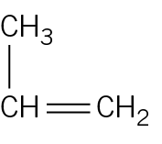 | 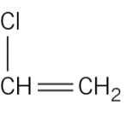 | 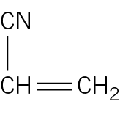 | 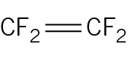
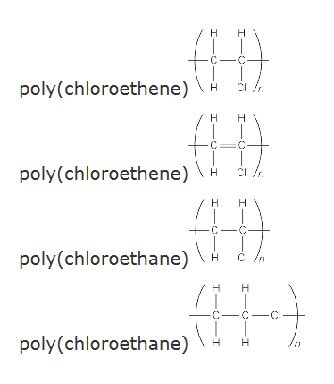
- Which monomer is the below polymer made of?
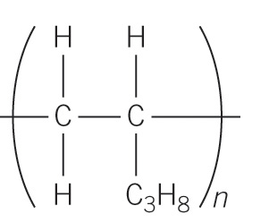
- State the differences you would expect to find between propane and pentane
- Draw an equation to show how three propene molecules join together to form poly(propene).
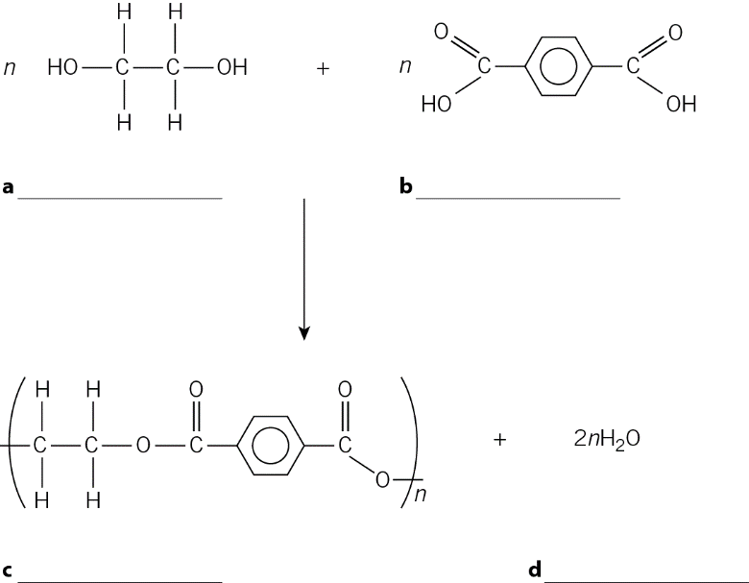
- Only one of the diagrams to the right correctly represents the polymer formed from chloroethane. Identify the correct answer and explain why each of the others are incorrect.
Condensation Polymerisation
A condensation reaction is one where two or more molecules join together and in the process lose a small molecule such as water.
Copy the diagram from the board showing the formation of a polyester from ethanediol and propanedioc acid into your book
- PET is used to make plastic drinks bottles. It is made by joining many individual units together. Write the labels below onto the diagram in the correct places, to show how PET is made.
water dicarboxylic acid diol condensation polymer
- Why is PET referred to as a polyester?
- Describe similarities and differences between addition polymerisation and condensation polymerisation.
- Methanediol and butanedioic acid react together to form a polyester. Draw diagrams to represent this process.

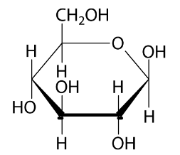
Starch and Cellulose
Glucose is a simple sugar molecule called a monosaccharide. Molecules of glucose can be joined together to make polysaccharides. One polysaccharide made from glucose is starch, and another is cellulose.
Glucose links together to form polysaccharides
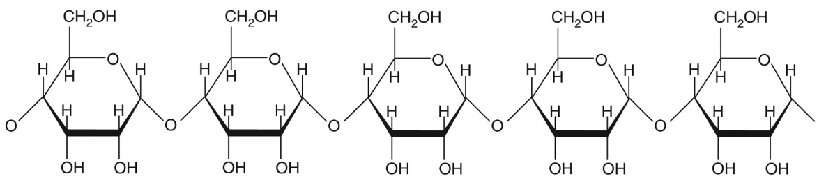
In starch the glucose molecules are arranged in branched chains. In cellulose they are arranged in straight chains which can line up neatly next to each other.
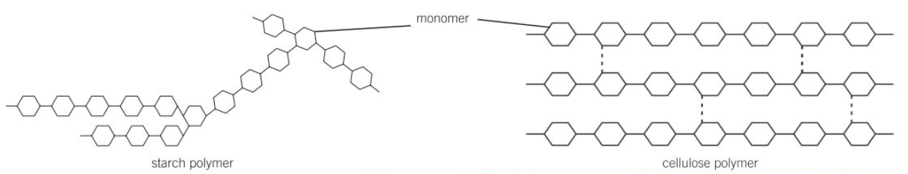
- Explain where plants get glucose from.
- Glucose molecules can react together via a condensation reaction. What is a condensation reaction?
- Explain why this reaction can be thought of as a polymerisation reaction
- Draw the disaccharide formed from two molecules of glucose reacting together.
- What is the second product of this reaction?
- In what ways are starch and cellulose different? In which ways are they the same?
Amino Acids
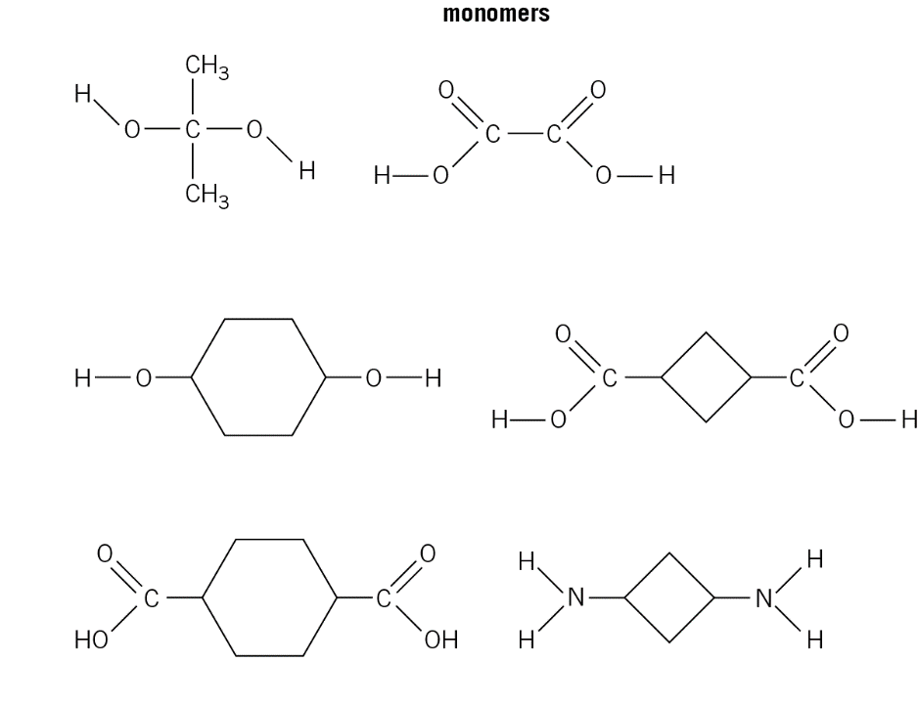
Amino acids have two functional groups, an amine and an acid. These molecules can react together via condensation polymerisation to produce polypeptides. When different amino acids join together, the result is a polypeptide called a protein.
Copy the diagram from the board which shows the polypeptide formed from glycine.
- Each of the monomers on the right is paired up with the monomer next to it. Draw the polymer that results when they react together.
- The amino acid serine is shown below. When only two amino acids react together they form a dipeptide. Draw the dipeptide made from two serine molecules.
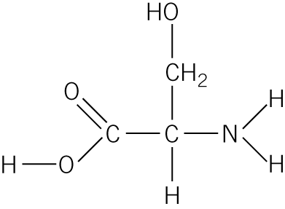
- Draw the tripeptide formed from three serine molecules.
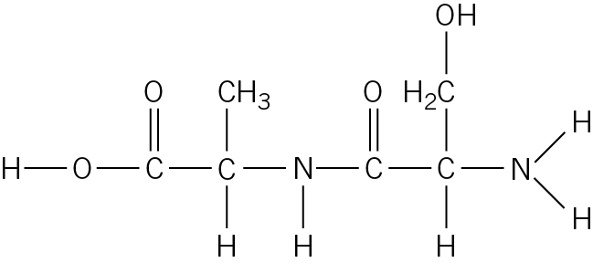
- Draw the formula of the two different monomers that have formed the molecule to the right:
DNA
Deoxyribonucleic acid (DNA) is a large molecule that contains genetic information. It is made of two chains of nucleotides held together in a double helix structure. There are four types of nucleotides which can polymerise to form the chains. They are called G, C, A and T. The order in which they join up determines the genetic information which they hold.
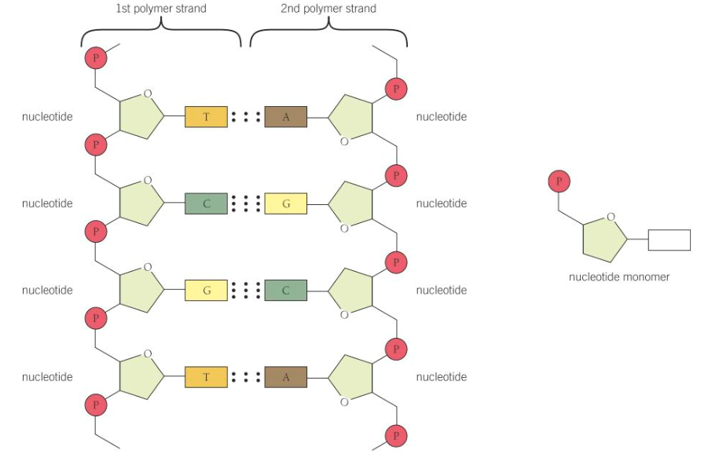
The dots in the diagram represent intermolecular forces.
- What is a nucleotide?
- When nucleotides react together a molecule of water is lost. Via which type of reaction do nucleotides join together?
- How many different nucleotides are there?
- What is a double helix structure?
- Challenge: when the cell uses DNA to gather genetic information, the two strands in the helix separate from each other. Explain why this is as an easier process than separating the nucleotides within a chain from each other.

