Chemistry Unit 1 Mastery Booklet
Atoms
Chemistry is the study of atoms and how they interact. Atoms are too small to see with a microscope and throughout history scientists have had different opinions of what atoms are and what they are made of. Those opinions were based on experimental evidence.
Charge
- Following class discussion, fill in the gaps.
All particles have c_____________. This is a property that can be p_______________, n______________e or n________________. P_______________ charges attract n________________e ones and repel p__________________ ones. N______________ charges are not attracted or repelled.
The discovery of c______________ allowed scientists to develop their model of the a_______________. A m________________ is a theory that scientists use to describe things which cannot be observed directly.
History of the Atom Summary
Dalton’s model | Atoms are tiny spheres that cannot be broken down.
Plum pudding model | The atom is a ball of spread out positive charge with negative electrons studded into it
Nuclear model | An atom has a nucleus with a positive charge. Electrons orbit the nucleus. Between the nucleus and the electrons is empty space.
Electron shell model (Bohr model) | Electrons orbit the nucleus at a fixed energy level
Protons and neutrons | The nucleus consists of protons which have a positive charge and neutrons which have no charge
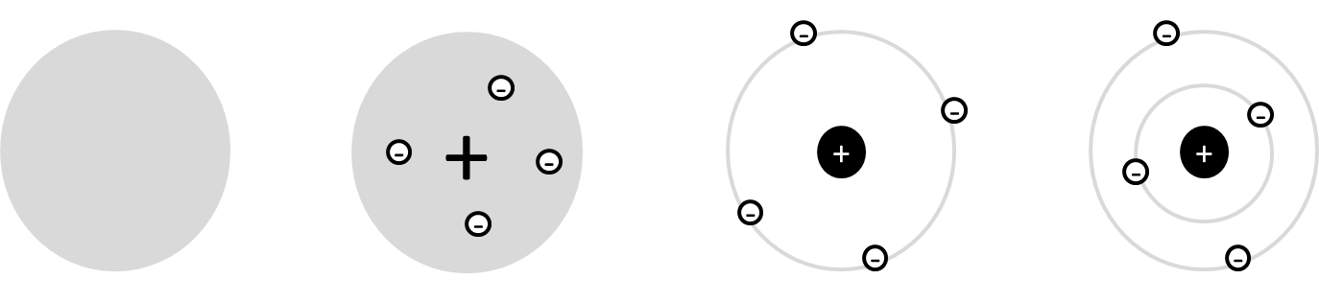

- Use the keywords and phrases to label the diagrams above. Some can be used more than once.
Nuclear model, negative charges studded in, negatively charged electrons, ball of spread out positive charge, hard sphere, positive nucleus, fixed energy level, electron shell model, protons and neutrons, empty space
- What type of evidence led scientists to change their model of the atom?
- State two differences between Dalton’s model and the Plum Pudding model.
- State three differences between the Plum Pudding model and the nuclear model.
Challenge: read through page 7 and summarise Thomson’s experiment.
Rutherford Scattering
This experiment proved that atoms have a nucleus. Scientists took a very thin strip of gold foil. They fired particles with positive charges at it (alpha particles).
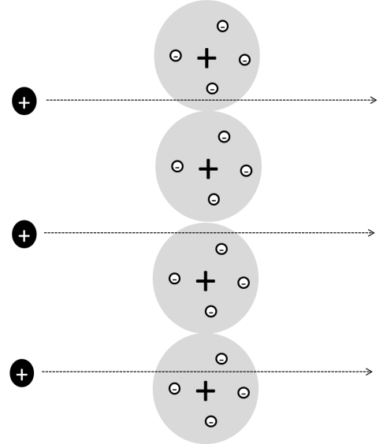
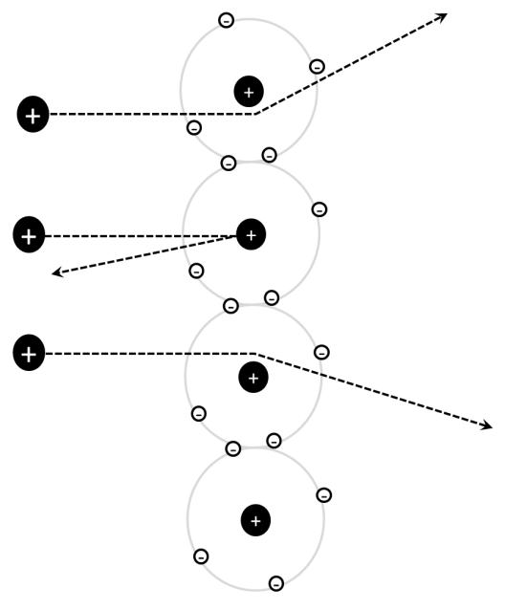
If the Plum Pudding Model were true most of the positive charges would go straight through the atoms as the positive charge was so spread out it would not be big enough to repel them.
However, this is not what happened. The atoms’ paths were straight through but deflected and bent, with some bouncing right back. This meant that there had to be an area of dense positive charge which would be strong enough to cause the particles to bounce back. This is why scientists decided the nuclear model must be true.
- Label the diagrams with the labels below. Some labels should be used more than once.
nucleus with dense positive charge, negative electrons orbiting nucleus, negative electrons studded in, alpha particles, expected to travel straight through, spread out positive charge, deflected path, then layer of atoms
- Describe the plum pudding model of the atom.
- Outline the Rutherford Scattering experiment.
- Explain what conclusion could be drawn from the Rutherford Scattering experiment.
Challenge: read through page 13 in the textbook and summarise why Bohr had to change Rutherford’s nuclear model of the atom.
Modern Structure of the Atom
The current model has atoms being made of three subatomic particles: protons, neutrons and electrons. Bohr’s experiments provided evidence that the electrons were in fixed orbits called shells.
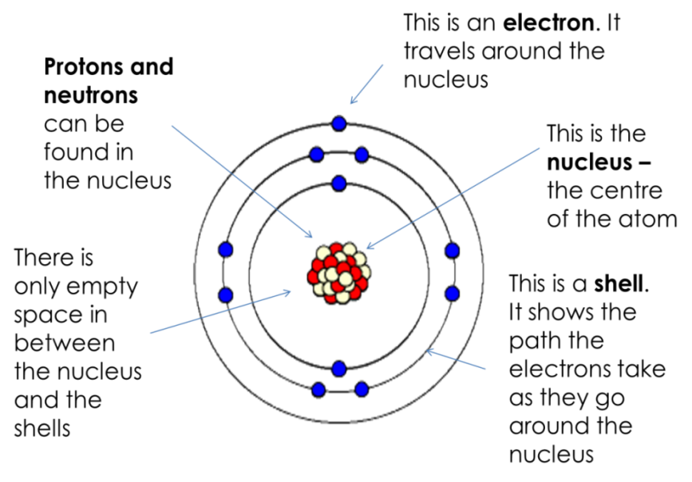
- Below is a diagram of an atom. Use the notes from the board to fill in the labels
- What is smaller, an atom or a proton?
- What is between the electrons?
- What is the charge on an electron?
- A student draws an atom and labels the centre “nucleus with electrons.” Explain why the student is wrong.
- What label should the student use?
- What is the charge on a proton?
- What leads scientists to change their scientific models?
Challenge: how do you think that atoms could be different from each other?

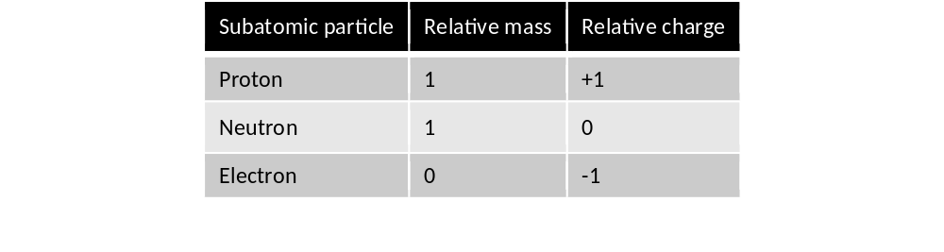
Protons, neutrons and electrons
As well as having different charges, the subatomic particles have different masses. These masses are incredibly tiny, so we use relative mass to represent their masses.

Different atoms
- Fill in the blanks
There are about 100 different types of a_____. They differ in their numbers of p_______, n______ and e______. If a s_________ is made of one type of atom, it is called an e__________. The different atoms and the name of the elements they make up are found in the p_______ t______ of e______ and are represented by a symbol (e.g. Na = _____________).
- If an atom has 7 protons, what would its relative mass be?
Each proton has a relative mass of 1, so this atom’s relative mass must be 7x1=7
- If an atom has 9 protons and no neutrons, what would its relative mass be?
- Give two differences between the plum pudding and the nuclear model of the atom
- If an atom has 12 neutrons only, what would its relative mass be?
- An atom has 14 neutrons and 8 protons. What would its relative mass be?
- An atom has 21 neutrons, 20 protons and 20 electrons. What is its relative mass?
Challenge: an atom has a relative mass of 39. It has twice as many neutrons as protons, but the same number of electrons as protons. It has a prime number of electrons. How many protons, neutrons and electrons does it have?
Atomic number and mass number
On the periodic table, each element has two numbers:
Atomic number: the small number
This tells you the total number of protons in an atom
It also tells you the number of electrons. This is because an atom must have the same number of positive charges and negative charges so it does not have an overall charge – the protons and electrons cancel each other out.
Mass number: the big number
This tells you the total number of protons +neutrons in an atom
To work out number of neutrons: mass number – atomic number
- Complete the table:
Element | Symbol | Atomic number | Neutrons | Mass number
Hydrogen | H | 1 | 0 | 1
Nitrogen |  | 7 | 7 | 14
Carbon | C | 6
 | Fe | 26
Gold |  |  | 118 | 197
 | Ge |  | 41
Tellurium |  |  |  | 128
Copper |  | 29 | 35 | 64
 | Co
 |  |  | 161
- An atom has 6 protons. How many electrons will it have? (hint – read the paragraphs at the beginning of this section again)
- How can you tell from the periodic table how many electrons an atom has?
Challenge: the periodic table has the elements organised by their atomic number not their atomic mass. Use the periodic table to explain why.
Isotopes
If two atoms have the same number of protons, they are the same element. If they have a different number of protons, they are different elements.
However, two atoms can have the same number of protons but different numbers of neutrons. These atoms are called isotopes. Their atomic number will be the same but their mass number will be different. Chadwick was the scientist who discovered the neutron. This allowed other scientists to understand that it was possible for atoms of the same element to have different masses (as they had different numbers of neutrons).
Look at chlorine on the periodic table. Its mass number is 35.5 and its atomic number is 17. How many neutrons does it have?
Number of neutrons = mass number – atomic number
Number of neutrons = 35.5 -17 = 18.5
This cannot be correct as you cannot have half a neutron. Instead, it represents the average mass of all the atoms of chlorine in the universe.
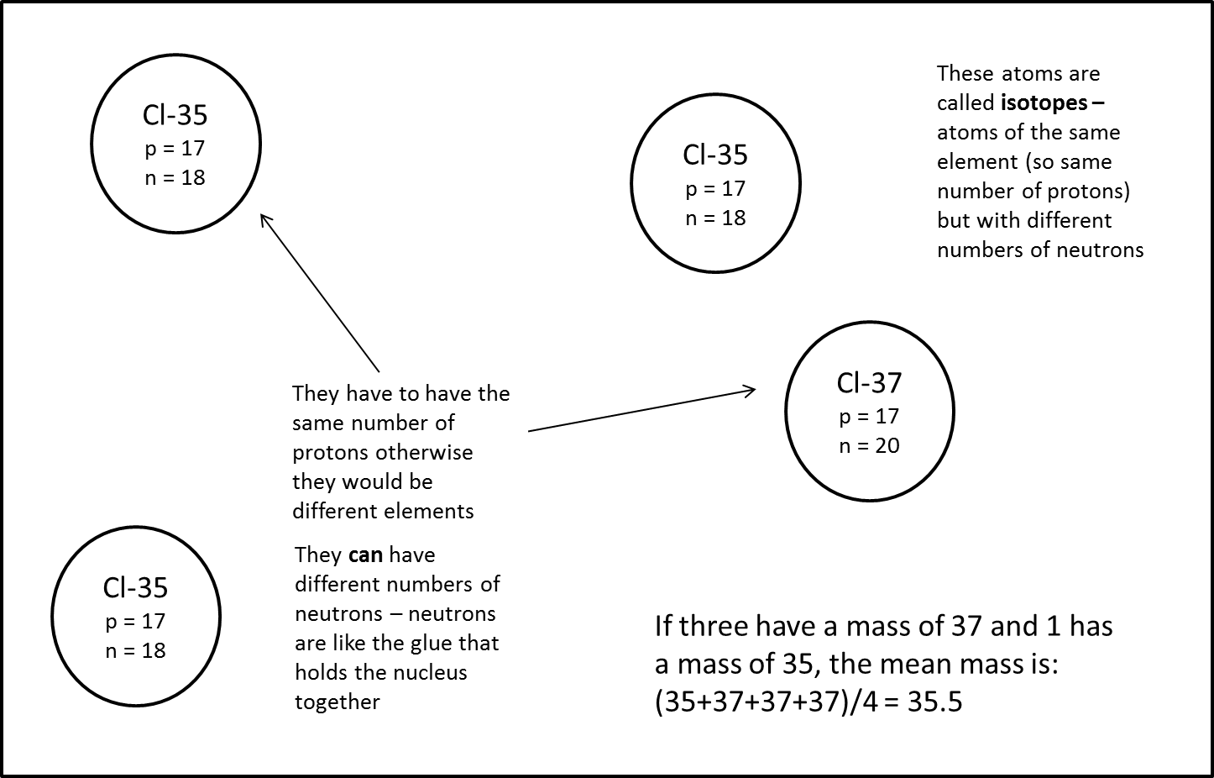
Scientists have discovered that 75% of the atoms of chlorine in the universe have a mass of 35 (so 18 neutrons)
25% have a mass of 37 (so 20 neutrons)
The percentage is called the abundance
When we work out the mean mass we call it the relative atomic mass
$$\frac{\left(abundance of isotope 1 ×mass of isotope 1\right)+(abundance of isotope 2 ×mass of isotope 2)}{100}$$
So for chlorine:
Relative atomic mass = $\frac{\left(75 ×35\right)+(25 ×37)}{100}$= 35.5

Worked example – copper:
Copper has two isotopes. 69% is Cu-63 and 31% is Cu-65. What is the relative atomic mass?
We know that the equation for relative atomic mass is:
$$\frac{\left(abundance of isotope 1 ×mass of isotope 1\right)+(abundance of isotope 2 ×mass of isotope 2)}{100}$$
Here, isotope 1 has an abundance of 69 and a mass of 63. Isotope 2 has an abundance of 31 and a mass of 65.
$$\frac{(69 × 63) + (31 × 65)}{100}=63.62$$
Calculate the relative atomic mass of the following mixtures of isotopes. Give your answers to 1 decimal place.
- 90.5% Ne and 9.5% Ne (remember that the mass number is the larger number
- 7.6% Li and 92.4% Li
- 5.9% Fe, 91.8% Fe and 2.3% Fe
- 92.2% Si, 4.7% Si and 3.1% Si
- The table shows the natural relative abundance of the main isotopes of mercury, Hg.
Mass number | 198 | 199 | 200 | 201 | 202 | 204
% Abundance | 10.0 | 16.9 | 23.1 | 13.2 | 29.9 | 6.9
  - Calculate the relative atomic mass of mercury. Give your answer to 1 decimal place.
  - Explain why the relative atomic mass of mercury is shown as 201 in the periodic table.
Electronic structure
The electrons that an atom has determines how it reacts. We have seen already that the number of electrons is the same as the atomic number of an atom.
- How many electrons are in atoms of:
  - Iron
  - Molybdenum
  - Technetium
  - Platinum
  - Potassium
  - Chlorine
  - Helium
  - Xenon
- How are electrons arranged in an atom?
- In terms of electrons, what is the difference between the plum pudding and the nuclear model?
Challenge: Start reading through page 18
Electrons orbit atoms in fixed energy levels (often called shells). Two electrons can fit on the first shell. 8 electrons can fit on the next shells. The first shell needs to be filled before the second and the second before the third.
- In your exercise book, draw diagrams for the first 20 atoms. Include the number notation.
- Challenge: in the periodic table, the columns are labelled groups and the rows labelled periods. What does the group and period of an element tell you about its electronic structure?

Elements, Compounds and Structure
In our previous lessons we have been looking at the atom and how scientists have modelled it over time. In this booklet we will be looking at how those atoms combine to form elements or compounds.
Elements and compounds
Atoms can be joined together by chemical bonds. If atoms of the same type are joined together, the substance is called an element. If different types are joined together, the substance is called a compound. The names of the elements can be found on the periodic table. Compounds are not found on the periodic table.
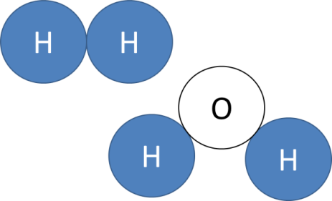
- A substance is made of three different types of atom. Is it an element or a compound?
- A substance is made of three of the same type of atom. Is it an element or a compound?
- What is the main difference between elements and compounds?
- What can elements and compounds have in common?
- What are the names of the three subatomic particles?
- Draw a labelled diagram of the plum pudding model of the atom.
- Over time, why have scientists changed their ideas about the atom?
- What are isotopes?
- There are five sentences below. Two are true and three are false. In the space below, say which three are false.
  - If you want to know the name of a compound, you should look it up on the periodic table
  - A lump of iron is an example of an element
  - Table salt is made of sodium and chlorine atoms joined by chemical bonds and is therefore a compound
  - If you want to make an element you need to take different types of atom and chemically bond them together
  - A piece of tellurium is an example of a compound
Challenge: explain why they are false
Molecules
- Which of the definitions below is best for the word molecule?
  - Atoms of different elements chemically joined together
  - More than one atom chemically joined together
  - A type of compound
  - More than one atom of the same type chemically joined together
  - A group of atoms together
- Explain why the other options are worse.
- Draw the electronic structure of sodium and of fluorine.
- How would you make molecules of fluorine?
- Is sodium fluoride an element or compound?
- Explain your answer to Q14
Molecular Substances and Chemical Formulae
- Fill in the blanks following class discussion.
M___________ s____________ are made of many m_________________ which are not c______________ b_______________ to each other. Each m_______________ is made of atoms which are c______________ b_______________ to each other, but the molecules are not bonded to each other.
The c____________ f_______________ of a molecular substance tells you which atoms, and how many of them, are present.
Remember that when you have different substances together that are not chemically bonded it is called a mixture.
We will be learning about six different molecular substances:
- Hydrogen, H₂
- Oxygen, O₂
- Nitrogen, N₂
- Water, H₂O
- Methane, CH₄
- Carbon dioxide, CO₂
- For each of the molecular substances above, write out which atoms they have in them and how many of them there are.
Example: H₂ has two hydrogen atoms in it
- Identify which of the substances above are compounds and which are elements.
- Name each of the substances represented by the diagrams below.
Oxygen
Hydrogen
Carbon

- In total, how many electrons are present in a molecule of water?
- In total, how many electrons are present in two molecules of water?
- How many neutrons are there in a molecule of methane?
- What are the relative masses and charges of protons, neutrons and electrons?
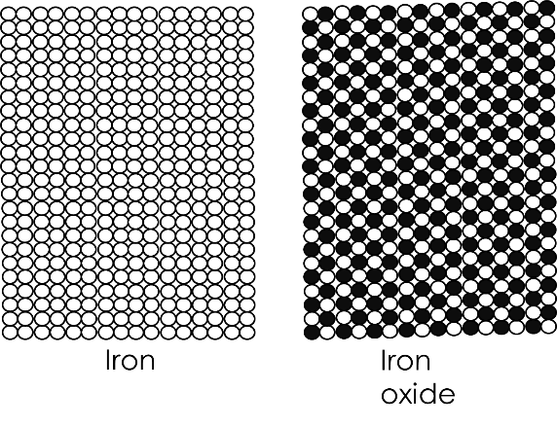
- Draw diagrams like the ones above for:
  - A mixture of hydrogen and oxygen
  - A mixture of oxygen and water
  - A mixture of compounds
Giant structures
- Fill in the gaps:
Unlike molecular substances, g____________ s________________ are made of billions of a_________ which are all c_____________ b_______________ together. Like molecular substances, g_________________ s___________________ can be e________________ or c___________________.
- Which of the diagrams above represents an element, and which represents a compound?
- How do you know?
- How can you tell by looking at the diagrams that they are giant substances and not molecular ones?
- What is the chemical symbol for iron?
- How many protons, neutrons and electrons are there in iron?
- X-45 and X-49 are isotopes. X-45 has an abundance of 42% and X-49 has an abundance of 58%. What is the relative mass of X?
- Connect the sentences:
Atoms are made of |  | How many atoms are in that substance and what those atoms are
Atoms can be joined together by |  | Molecular substance
When a small group of atoms are joined together we call this a |  | Elements or compounds
A substance made of lots of molecules is a |  | Giant substance
A substance made of billions of atoms all joined together is a |  | Molecule
Molecular and giant substances can be |  | Chemical bonds
The chemical formula of a substance tells you |  | Protons neutrons and electrons

Challenge: sand is made of small grains. Do you think it is a giant or molecular substance? Explain your answer.
Chemical Equations
A chemical equation is a way of showing what occurs in a chemical reaction. The substances that you start with are called reactants and the ones that you finish with are called products. For example:
Hydrogen + oxygen water
In this case, hydrogen and oxygen are reactants and water is the product. The equation above is a word equation: an equation which uses the names of substances to represent a chemical reaction.
- When nitrogen and hydrogen react together they produce a compound called ammonia. Write a word equation for this reaction.
- What are the reactants?
- What is the product?
- Ethanol reacts with oxygen to form carbon dioxide and water. Write a word equation for this reaction.
- Identify the reactants and products in this reaction.
- Oxygen is an element. What does this mean?
- Oxygen is molecular substance. What does this mean?
- How many protons, neutrons and electrons are present in an atom of oxygen?
Challenge: a sample of oxygen atoms contains 73% O-18, 12% O-19 and 15% O-21. What is the relative atomic mass of this sample?
Chemical formulae
In previous lessons, we looked at how every element has a symbol to represent it. Compound have a chemical formula which represents how many atoms they have in them and what those atoms are. For example NaF, sodium fluoride, has one atom of sodium and one atom of fluorine. However, Na₂O, sodium oxide, has two atoms of sodium and two of oxygen.
- Which atoms, and how many of them, are present in:
  - CaO
One atom of calcium and one of oxygen
  - CaBr₂
  - Mg₃N₂
  - C₆H₁₂O₆
  - CO₂
  - C₇H₅N₃O₆
If symbols are in brackets, then you must multiply everything in the brackets by the little number that follows them. For example:
Mg(OH)₂ has one magnesium atom. The O and H are in brackets so must be multiplied by 2.
Therefore this compound has one magnesium atom, two oxygen atoms and two hydrogen atoms.
- Which atoms, and how many of them, are present in:

- Ca(OH)₂
- Li₂SO₄
- Al₂(SO₄)₃
- CaCO₃
- Mg(NO₃)₂
- Ga(NO₃)₂

Conservation of mass
In any chemical reaction, the atoms are neither created nor destroyed. It does not matter whether the reaction is hot or cold, the atoms cannot be created or destroyed. But they are rearranged. For example, in a reaction between a carbon atom and an oxygen molecule, the atoms rearrange to form carbon dioxide.
Carbon + oxygen carbon dioxide
O
O
C
O
O
C

You can see that the atoms on the left have all rearranged themselves to produce a new substance. This is called the conservation of mass; that atoms cannot be created or destroyed as a result of a chemical reaction.
Below is a particle diagram for a reaction:
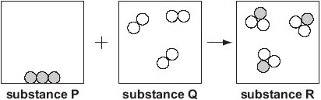
- Which substances are elements?
- Which substance is a compound?
- Identify the reactants and the products
- In terms of atoms and rearrangement, how can you tell that a chemical reaction has taken place?
- How many atoms of P are on the left?
- How many atoms of Q are on the left?
- How many atoms of P are on the right?
- How many atoms of Q are on the right?
- How do your answers prove that mass has been conserved in this reaction?

Symbol equations
Because all substances can be represented by symbols and formulae, we can write an equation with the symbols and formulae instead of just words. For example:
Carbon + oxygen carbon dioxide word equation
C + O₂ CO₂ symbol equation
But because mass is conserved, we can run into a problem with symbol equations. For example, hydrogen and oxygen react together to form water as below:
Hydrogen + oxygen water word equation
H₂ + O₂ H₂O symbol equation
H
H
O
O
H
H
O

But if you look carefully you will see a problem. There are two atoms of hydrogen in the reactants, and two in the products. This shows that no hydrogen atoms have been created or destroyed.
However, if you look at oxygen, you will see two atoms on the left, but only one on the right. This shows that an atom of oxygen has been destroyed, which is impossible.
An easy way to solve this would be to change the H₂O into H₂O₂. However, this would be incorrect as H₂O₂ is not water; it is a completely different compound!
In fact, we cannot touch the small numbers at this point. All we can do is change the number of molecules that we have to start with:
H
H
O
H
H
O
H
H
O
H
H
O

Now you can see that all the atoms in the reactants are present in the product. We can write this in an equation like so:
2H₂ + O₂ 2H₂O
This is called a balanced equation.
Worked example: sodium reacting with fluorine
In your exercise book, copy out the equations below and balance them:

- Na + Cl₂ NaCl
- Li + F₂ LiF
- Mg + O₂ MgO
- Ca + O₂ CaO
- P₄ + O₂ P₂O₅
- Al + Cl₂ Al₂Cl₃
- S + F₂ SF₆
- K + H₂O KOH + H₂
- S₈ + O₂ SO₃
- MgCO₃ + Ca CaCO₃ + Mg
- Li₂SO₄ + K K₂SO₄ + Li
- Mg(OH)₂ + K KOH + Mg
- CH₄ + O₂ CO₂ + H₂O

Summary questions
In a reaction, copper sulphate and sodium hydroxide react together to form copper hydroxide and sodium sulphate.
- Write a word equation for this reaction.
- What are the reactants and what are the products?
- The formula for copper sulphate is CuSO₄. Which atoms are present in it?
- Explain why copper sulphate is a compound.
- Sodium hydroxide is NaOH, copper hydroxide is Cu(OH)₂ and sodium sulphate is Na₂SO₄. Write a balanced symbol equation for this reaction.
In a reaction, marble powder is mixed with hydrochloric acid
- The formula for marble powder is CaCO₃ and its name is calcium carbonate. Which atoms are present in calcium carbonate?
- Is calcium carbonate an element or a compound? Explain your answer.
- Calcium carbonate is made of billions of atoms all chemically bonded together. What type of substance is it?
- Below is a symbol equation for the reaction.
CaCO₃ + HCl CaCl₂ + CO₂ + H₂O
Copy the equation into your exercise book and balance it
Magnesium can be heated in the air to react with oxygen
- Magnesium is a giant structure. What does this mean?
- The magnesium and oxygen form magnesium oxide. Write a word equation for this reaction. Identify the reactants and the product.
- Magnesium oxide has a formula MgO. Use this information to write a symbol equation for this reaction.
- Balance the symbol equation.
- The diagrams below show what is occurring during the reaction. White circles are atoms of oxygen, and grey ones are atoms of magnesium.

  - Label two elements in the diagrams
  - Label a compound in the diagrams
  - Name all the elements and compounds
  - Use the number of particles to prove that mass has been conserved in this reaction
  - Use the number of particles to explain why the mass of the product is greater than the mass of the initial magnesium

The structure of the periodic table
The modern periodic table lists approximately 100 elements, but has changed a lot over time as scientists have organised the elements differently. The changes are summarised below:
 | First lists of elements | Mendeleev’s periodic table | Modern periodic table
Elements placed in order by: | Atomic mass | Normally atomic mass, but some elements were swapped around | Atomic number
Completion: | Showed no gaps | Left gaps for undiscovered elements (Mendeleev made predictions about the properties of these elements) | No gaps (all elements up to a certain atomic number have been discovered)
Grouping: | Elements were not grouped | Elements grouped according to chemical properties | Elements grouped according to number of electrons in outer shells
Metals and non-metals: | No clear distinction | No clear distinction | Metals to the left, non-metals to the right
Use the table above and the modern periodic table to help you answer the questions below.
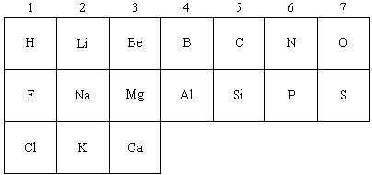
- The idea of a periodic table of the elements was started by John Newlands about 140 years ago. He wrote down the elements he knew about in order, starting with the lightest atoms. Then he arranged them into seven groups, like this:
(a) Write down three differences between the groups in Newlands’ periodic table and the groups in the modern periodic table (up to the element Ca, which is calcium). (3)
(b) Suggest one reason why this part of Newlands’ table was different from the modern one. (1)
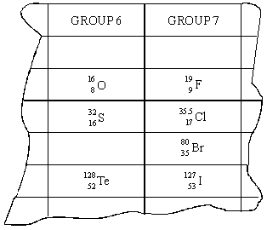
(c) Dimitri Mendeléev later developed the periodic table of the elements. He arranged the elements according to their properties and their relative atomic masses. The diagram shows where Mendeléev put tellurium (Te) and iodine (I) in his table because of their properties. (The diagram uses present day symbols and the atomic numbers of the elements have been added to Mendeléev’s table.)
(i) What is wrong with this arrangement of tellurium and iodine in terms of their relative atomic masses?
(ii) Explain why this is not a problem in the modern periodic table.
- John Newland produced another periodic table in 1866. The 21 elements in his table are shown in the diagram.
 |  |  | Column
1 | 2 | 3 | 4 | 5 | 6 | 7
H | Li | Be | B | C | N | O
F | Na | Mg | Al | Si | P | S
Cl | K | Ca | Cr | Ti | Mn | Fe
(a) In which two columns of Newland’s periodic table do all the elements have similar properties?
(b) The modern periodic table is arranged in a different order to Newland’s table.
(i) What order is used in the modern periodic table?
(ii) Argon has a higher relative atomic mass than potassium. Explain why.
(iii) Describe the changes in the number of electrons in the atoms of elements in the period which begins with potassium and ends with krypton.
- The electronic structures of five elements, V, W, X, Y and Z are shown below.
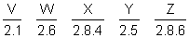
(a) (i) Write the letters of the two elements which belong to the same group in the Periodic Table
(ii) To which group do they belong?
(b) Write the letters of two elements that are gases
- (a) Arsenic has two isotopes, As-75 and As-77. Explain the difference between these isotopes in terms of subatomic particles.
(b) The relative of abundance of As-75 is 88.3%. Calculate the relative atomic mass of arsenic.
Summary problem
- Over time, scientists have changed their ideas about the periodic table due to experimental evidence. Describe the alpha particle experiment.
- If the plum pudding model of the atom were true, what would the outcome of the alpha particle experiment have been?
- How did the alpha particle prove that there must be a nucleus?
- How did Bohr add to the nuclear model of the atom?
- What did Chadwick discover?
- Explain how Chadwick’s discovery allowed scientists to explain the existence of isotopes
- There are two isotopes of Bromine: Br-79 and Br-81. Making full reference to the number of subatomic particles in each isotope, describe the differences between them.
- A sample of bromine is found to be 35% Br-79 and 65% Br-81. Calculate the relative atomic mass of this sample.
- H₂O is a molecular substance. Explain what a molecule is.
- Describe the structure of a molecular substance.
- Both H₂O and O₂ are molecular substances. Describe their similarities and their differences.
- Sodium chloride is a giant substance. Describe the structure of sodium chloride.
- Describe the similarities and differences between sodium chloride and H₂O.
- In a reaction between fluorine gas and solid iron, the mass of the solid iron appears to increase. Explain why this occurs.
- Balance the equation:
Fe + F₂ FeF₃
- Explain why Mendeleev swapped the positions of certain elements around in his periodic table.

