Using Materials (Triple Only)
Corrosion
Corrosion is the destruction of materials by chemical reactions with substances found in the environment. Rusting is an example of corrosion that requires water and oxygen.
- Explain how covering an iron strip with grease will prevent it corroding.
- Painted cars rust slower than non-painted cars. Explain why this is the case.
- Zinc blocks can be added to the hulls of ships to prevent corrosion. Explain why copper would not be effective.
- This type of protection is called “sacrificial” protection. Justify the use of the word “sacrificial”
- The figure below shows six test tubes a student set up to investigate the rusting of iron. This is the method used for each test tube:
  - Measure the mass of the nail using a balance.
  - Leave the nail in the test tube for 6 days.
  - Measure the mass of the nail after 6 days.
The results are shown in the table.
Test tube | Mass of nail in g | Mass of nail after  6 days in g
1 | 8.45 | 8.91
2 | 8.46 | 8.46
3 | 8.51 | 8.51
4 | 9.65 | 9.65
5 | 9.37 | 9.45
6 | 9.79 | 9.79
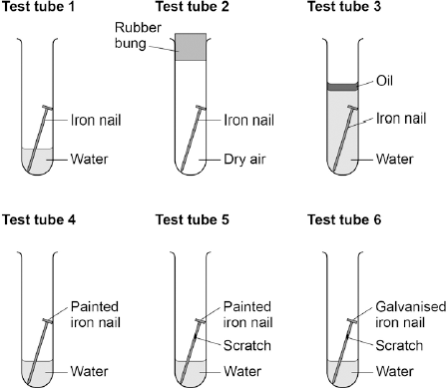
- Which nail most increased in mass?
- Which nail least increased in mass?
- Explain why nails 1 and 5 increased in mass by reference to the law of conservation of matter
- Explain why the nail in tube 2 did not increase in mass
- How does scratching the nail affect the rate of rusting? Explain your answer.
- Which other variables would need to have been controlled in order to guarantee a fair test?
- What is the purpose of the oil in test tube 3? Refer to the reactants needed for rusting to take place in your answer.
- How is iron best protected against rusting?
- Which metal could have been used to galvanise the metal in test tube 6? Explain your answer.
- Give an example of a metal that could not have been used to galvanise the metal in test tube 6.
- Explain why the scratch on the nail in tube 6 did not cause the nail to increase in mass.
Alloys
Alloys are mixtures of metal atoms with atoms of a different element (usually another metal). Most metals in use today are alloys as they have more desirable properties than pure elemental metal. Below is a table showing a number of common alloys:
Alloy | Composition | Properties | Use
Bronze | Copper and tin | Resistant to corrosion | Statues, decorative items, ship propellers  (Was first alloy invented – c.f. bronze age)
Brass | Copper and zinc | Very hard but workable | Door fittings, taps, musical instruments
Jewellery gold | Mostly gold with copper, silver and zinc added | Lustrous, corrosion resistant, hardness depends on carat | Jeweller. Note 24-carat is ~100% gold, 18- carat is 75% etc (divide carat by 24).
High carbon steel | Iron with 1-2% carbon | Strong but brittle | Cutting tools, metal presses
Low carbon steel | Iron with less than 1% carbon | Soft, easy to shape | Extensive use in manufacture: cars, machinery, ships, containers, structural steel
Stainless steel | Iron with chromium and nickel | Resistant to corrosion, hard | Cutlery, plumbing
Aluminium alloys | Over 300 alloys available | Low density, properties depend on composition | Aircraft, military uses

- Describe the structure and bonding in metals
- Describe the structure of an alloy
- Explain why alloys are usually harder than pure metals
- Why is high carbon steel not useful for building car bodies
- A shipbuilder intends to use a steel alloy as a propeller. Explain why low carbon steel would be inappropriate
- Which steel alloy would be most appropriate for this use? Explain your answer
- Using information from the previous section, how could the shipbuilder adapt their propeller for effective use?
- What is the advantage of purchasing gold jewellery with a lower carat than 24?
- Archaeologists have uncovered a large amount of bronze weaponry from the bronze age. The blades from spears have been found but the wooden handles have not. Explain this by reference to the properties of the materials involved.
- What percentage of gold is in 9-carat gold?
- What is the carat rating of gold containing 60% gold?
- Drill heads are often manufactured from high carbon steel with diamonds studded in.
  - Explain why high carbon steel is a more appropriate alloy for this use than low carbon steel
  - Making reference to its structure and bonding, explain why diamonds are used in the drill head
- Gold nanoparticles are important catalysts.
  - What is a catalyst?
  - Explain why nanoparticles are effective catalysts
- Aluminium must be extracted through electrolysis.
  - What is electrolysis?
  - Why can aluminium not be extracted using reduction with carbon?
  - Aluminium ore is called bauxite. Define an ore.
  - Aluminium oxide must first be melted before electrolysis can be carried out. Explain why this is the case.
  - The anodes from the electrolysis must be continually replaced. Explain why this is the case.
  - Show half equations for the reactions at each electrode. Specify if they are oxidation or reduction reactions.
Ceramics
Many common everyday materials are ceramics. A summary of their manufacture, properties and uses is below.
Ceramic | Manufacture | Properties | Uses
Soda-lime glass | Heat a mixture of sand, sodium carbonate, limestone | Transparent, brittle | Everyday glass objects
Borosilicate glass | Heat sand and boron trioxide | Higher melting point than soda-lime glass | Oven glassware, test tubes
Clay ceramics (pottery + bricks) | Shape wet clay then heat in a furnace | Hard, brittle, easy to shape before manufacture, resistant to corrosion | Crockery, construction, plumbing fixtures

Polymers

Polymers are made from monomers. The properties of a polymer depend on the monomer it is made from and the conditions under which it was made. For example both low and high density poly(ethene) are made from ethene but they have very different properties. This is because in LD poly(ethene) the chains have branches which prevents them packing together neatly.

Polymers can also either be thermosoftening or thermosetting. Thermosoftening polymers melt when they are heated but thermosetting polymers do not.
- Plastic and glass can be used to make milk bottles. The figure below shows the percentage of milk bottles made from glass between 1975 and 2010.

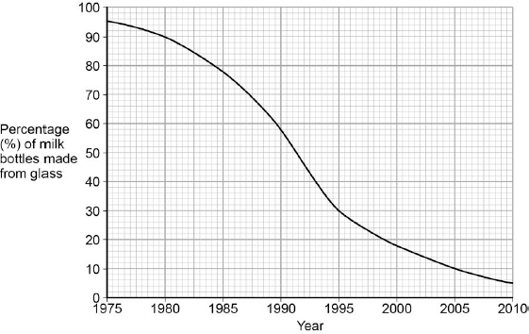

Plot the points and draw a line on the figure above to show the percentage of milk bottles made from materials other than glass between 1975 and 2010. (3)

The table below gives information about milk bottles.

 | Glass milk bottle | Plastic milk bottle
Raw materials | Sand, limestone, salt | Crude oil
Bottle material | Soda-lime glass | HD poly(ethene)
Maximum temperature  in production process | 1600 °C | 850 °C
Number of times bottle can be used for milk | 25 | 1
Size(s) of bottle | 0.5 dm³ | 0.5 dm³, 1 dm³, 2 dm³, 3 dm³
Percentage (%) of recycled material used in new bottles | 50 % | 10 %
- Are either glass bottles or plastic bottles renewable? Explain your answer.
- Why is it important to recycle materials?
- Based on which property is glass separated from steel at the recycling plant?
- How is the temperature of the production process relevant to a life cycle assessment of milk bottles?
- Express the different sizes of plastic milk bottles in cm³
- Glass is a giant covalent substance. Explain what this means in terms of its bonding.
- Glass is made from silicon dioxide. Explain why it has a higher melting and boiling point than carbon dioxide.
- Electric oven hobs have a plate of glass above a heating element. Which type of glass is most appropriate for this use?
- Explain why HD poly(ethene) is more dense than LD polyethene.
- 62g of ethane is used to form poly(ethene). How many moles is this?
- If one chain of poly(ethene) is produced, how many carbon atoms does it have in it?
- A customer is looking to purchase a saucepan. Discuss the advantages and disadvantages of choosing a saucepan made from: ceramic, low carbon steel, high carbon steel, 18-carat gold.
Composites
Composites are mixtures of materials for specific uses. The main material is called the matrix or binder. The second material is usually added as threads or fragments
Examples:
- Concrete (cement, sand and gravel)
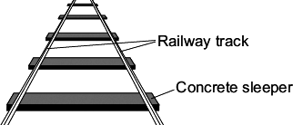
- Reinforced concrete (concrete + steel rods)
- Plywood (thin sheets of wood and glue)
- MDF (whoodchips or shavings in a polymer resin)
- Pykrete (ice and sawdust)
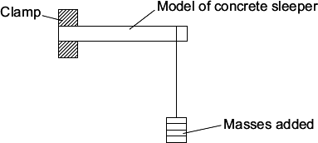
- In the UK, railway sleepers were made from wood. They are now often made from concrete. A scientist was asked to find the best concrete mixture to use so that railway sleepers would not break easily. The scientist made a mould to make small models of concrete sleepers, and concrete mixtures using crushed rock, sand, cement and water. She set it up as shown to add 0.1 kg masses until the model sleeper broke.

The scientist’s results are shown in the table.

Concrete mixture  in % by volume | Total mass added to break the model sleeper in kg
Cement | Sand | Crushed  rock | Test 1 |  | Test 2 | Test 3 | Test 4 | Mean
10 | 70 | 20 | 1.2 |  | 1.1 | 1.3 | 1.2 | 1.2
20 | 60 | 20 | 3.0 |  | 2.6 | 2.5 | 2.4
30 | 50 | 20 | 3.5 |  | 3.3 | 3.3 | 3.3 | 3.3
40 | 40 | 20 | 3.9 |  | 3.8 | 4.0 | 3.3 | 3.9
50 | 30 | 20 | 4.2 |  | 4.5 | 4.2 | 4.3 | 4.3
  - Calculate the mean total mass added to break the model sleeper that has 20 % cement by volume.
  - State one conclusion that the scientist could make from these results.
  - The scientist sent the results in a report to a company that makes full-size concrete railway sleepers. Suggest two other factors that the company should take into consideration before deciding which mixture to use to make a full-size concrete railway sleeper.
  - The scientist’s report claimed that using concrete sleepers instead of wooden sleepers would have less environmental impact. Do you agree with the scientist’s claim?
Use your knowledge and understanding to justify your answer.
- A construction engineer wants to use reinforced concrete for a tall building. The concrete must be able to bend a little without breaking. Which type of steel is appropriate to reinforce the concrete? Explain your answer.
- In the Second World War British scientists wanted to use pykrete to build an enormous aircraft carrier. Pykrete is a mixture of ice and sawdust. It takes longer to melt than pure ice, is as hard as concrete but a lot less dense.
  - Why would concrete be an ineffective material to build a ship out of?
  - Pykrete would be unsuitable to build the ship’s propellers. Explain why this might be the case.
  - Which material would the shipbuilders use instead? Explain your answer.
  - A pykrete ship would need to be built in Canada and could only go out to certain seas. Explain why this might be the case.
  - Low carbon steel is relatively strong but also easy to shape, but it is often unsuitable for use as a ship’s hull. How can low carbon steel be made suitable for use in shipbuilding?

The Haber Process

The Haber process involves the dynamic equilibrium: N₂(g) + 3H₂(g) ⇌ 2NH₃(g) where the forward direction is exothermic. The production of ammonia is vital in the manufacture of industrial fertilisers.
- Describe the effect on the position of equilibrium of:
  - Increasing the temperature
  - Increasing the pressure
- Explain your answers to 47a and b with reference to Le Chatelier’s principle
- What is the effect on the rate of reaction of increasing the temperature? Explain your answer.
- What is the effect on the rate of reaction of increasing the pressure? Explain your answer.
- What is the effect on the equilibrium position of using a catalyst?
- What is the effect on the rate of reaction of using a catalyst?
- Draw a reaction profile for the Haber process. Label the activation energy and the total energy change of the reaction.
- The graph on the next page shows the percentage yield of ammonia at different temperatures and pressures:
- Which temperature gives the greatest yield of ammonia?
- Which pressure gives the lowest yield of ammonia?
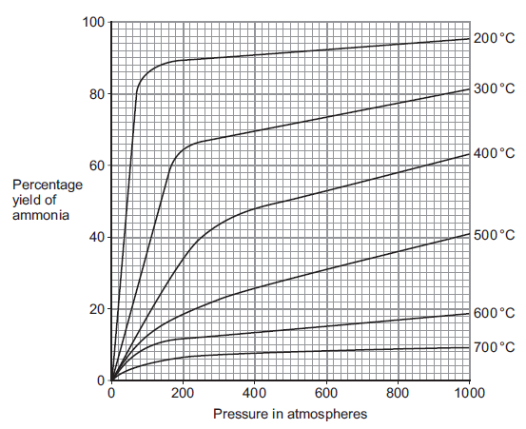
- Suggest the optimal temperature and pressure for greatest production of ammonia.
- Use the graph to suggest and explain why the conditions used to produce ammonia in the Haber process are a temperature of 450 °C and a pressure of 200 atmospheres.

NPK Fertilisers

Fertilisers are vital in industrial agriculture. NPK fertilisers are formulations containing nitrogen, phosphorous and potassium compounds.
- Nitrogen
  - From ammonia
  - Used to manufacture ammonium salts and nitric acid
- Phosphorous
  - Comes from mined phosphate rock
  - Treat the rock with nitric, phosphoric or sulphuric acid
    - With nitric acid produces phosphoric acid (H₃PO₄) and calcium nitrate
    - With phosphoric acid produces calcium phosphate
    - With sulphuric acid to produce calcium phosphate and calcium sulphate
- Potassium
  - Potassium chloride and potassium sulphate common sources
  - Obtained by mining

Many of the compounds listed above can be prepared in the laboratory. For example ammonia can be titrated with sulphuric acid and then crystallised to form ammonium sulphate.
- Give chemical formulae for each substance in bold
- Most of the substances above are ionic. State what you expect their relative melting and boiling points to be. Explain your answer with reference to their structure and bonding.
- Ammonia is a simple molecular substance. Draw a molecule of ammonia.
- Ammonia has a low melting and boiling point. Explain why.
- Ammonia solution does not conduct electricity but ammonium sulphate solution does. Explain this observation by making reference to the structure and bonding of both substances.
- Write a balanced symbol equation for the reaction between ammonia and sulphuric acid to make ammonium sulphate
- 21.3cm³ of 0.8mol/dm³ sulphuric acid is required to neutralise 20cm³ ammonia solution. Calculate the concentration of the ammonia solution.
- The experiment is repeated with a titre of 21.5cm³. Are these results concordant? What should be done next?
- Define formulation
- NPK fertilisers are solid. Explain why the salts that make them up must be water soluble for them to be effective.
- Construct an ionic equation for the reaction in question 48.
- Read the purple sections on pages 234 and 235. Summarise the differences between the laboratory and industrial methods for producing fertilisers.
- Which method is safer? Explain your answer.
- Which produces the most fertiliser? How is this relevant when choosing a manufacturing process?
- Which method has reaction conditions that require the least amount of energy? Explain your answer.
- The laboratory method is described as a “batch” process and the industrial method a “continuous” process. Explain what these terms mean and their relevance when selecting a method.

