7BC: Cells, Tissues and Organs


Name:
Class:

This unit will be about living things and what they are made up of. Before we begin studying that, we are going to spend some time looking at scientific experiments and fair tests.
What are the three types of variable? | Dependent, independent, controlled
Which variable is the one that scientists measure as a result of an experiment? | Dependent variable
Which variable is the one that scientists change during an experiment? | Independent variable
Which variables are kept the same during an experiment? | Controlled variable
What do we call an experiment where all the variables are controlled other than the independent variable? | Fair test
What do we call an experiment where lots of variables are changed? | An unfair test
Why are fair tests important? | So you know why your dependent variable is changing

Lesson 1: Variables
I am learning about different variables so I can understand the need for a fair test.
Recap questions:
You want to find out whether more solute will dissolve in hot or cold water. Answer the questions below and then your teacher will demonstrate the experiment.
- What is a solute?
- Give an example of a solute
- What key word can be used for the water in this experiment?
- Once the water and solute have been mixed, what keyword can be used to describe the mixture?
- A student dissolves 10g of solute in 100g of water. What will the mass of the mixture be?
- A student uses a solute that is a solid. Draw a particle diagram of a solid.
- What is solubility?
- Do you think more solute will dissolve in hot or cold water?
- Explain your answer.
- The student uses a solute that causes the water to change colour. By what process does the colour spread out into the water?
- Does this happen quicker in liquids or gases? Explain your answer.

During this solubility experiment, there are a number of variables. The thing you are changing in this case is the temperature of the water. This is called the independent variable. The thing you are measuring is how many spatulas of solute can dissolve. This is called the dependent variable. Anything else that might affect the experiment must be controlled, for example the solute, water source, amount of stirring and volume of water.
There are three types of variable:
- Independent variable: the variable which the scientist changes
- Dependent variable: the variable the scientist observes, counts or measures
- Controlled variables: any variable which could affect the result and is therefore kept the same

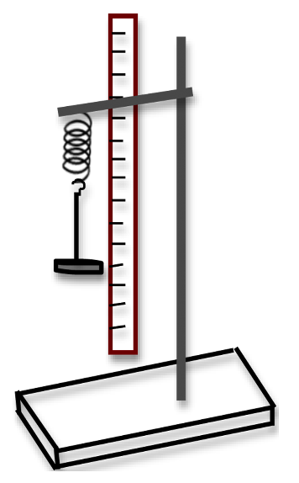
Your teacher will now add weights to a spring. We are trying to find out how the mass on the spring affects how far it stretches.
- In this experiment, what is the dependent variable?
- In this experiment, what is the independent variable?
- List as many variables that must be controlled as you can.
- The spring is a solid. Explain why it does not flow.
- Give an example of a substance that does flow and explain why it flows.
- A student tries the experiment again with a warm spring. What happens to the particles in the spring as they are warmed up?
- If it is heated enough, what will happen?
- The spring is made of steel. Steel melts at 1500°C and boils at 2750°C. What state will it be at 2000°C?
Your teacher will now demonstrate to you what happens when calcium carbonate is added to acid. Your teacher wants to know how the size of the pieces added to the acid affects the volume of gas released. Answer the questions below:
- What did you observe when the calcium carbonate was added to the acid?
- In this experiment, what is the dependent variable?
- In this experiment, what is the independent variable?
- List as many variables that must be controlled as you can.
- The gas can be collected in a syringe. Can the gas be compressed? Explain your answer.
- The gas is warmed up. What happens to the particles?
- How does warming up the gas affect the pressure within the syringe?
A student knows that when you heat a metal in the air, the mass of the metal increases. The student wishes to investigate this further so takes three different metals and prepares to heat them in the air.
- What is the student’s independent variable?
- What is the student’s dependent variable?
- What variables need to be controlled?
A student knows that when pondweed is placed under water, it releases bubbles. The student wants to know how the temperature of the water affects the number of bubbles produced.
- What is the dependent variable?
- What is the independent variable?
- Which variables need to be controlled?
A student knows that if you roll a ball down a hill and then on to a flat surface, it will eventually stop. The student wants to know how changing the height from which it is dropped affects the distance the ball travels. Below is a list of variables, for each one say if it is dependent, independent, or controlled.
- Mass of ball
- Size of ball
- Distance ball travels
- Angle of ramp
- Number of balls dropped at once
- Distance up the ramp the ball is dropped from
- Material ball is made of
- Smoothness of ramp surface
The fair test
A student has a golf ball and a tennis ball. They want to know which one bounces higher when it is dropped. The student drops the golf ball onto a wooden floor, and the tennis ball onto a piece of carpet. The golf ball bounces higher and the student says “I now know that golf balls are bouncier than tennis balls.”
The student is wrong. They are wrong because they have not controlled all the variables. Instead of changing one thing (the ball), they have changed two things (the ball and the floor). This means they have more than one independent variable and the experiment is not a fair test.
Another student wants to know the same thing: whether the golf ball or the tennis ball is bouncier. They stand on a table and drop the golf ball. They then stand on the floor and drop the tennis ball. The golf ball bounces higher and the student says “I now know that golf balls are bouncier than tennis balls.”
- The student is wrong. Use the first paragraph to write a refutation explaining why the student is wrong.
- Check your answer to question 41 by making sure you have written what the independent variables being used are.
- Write a short method explaining how a student could find out which ball is bouncier. Make sure to include a list of all the variables that need to be controlled.
A student makes parachutes out of plastic bags and toy soldiers. The student wants to know how the number of toy soldiers attached to each parachute affects the time it takes for the parachute to fall to the ground.
- What is the dependent variable?
- What is the independent variable?
- Which variables must be controlled?
- Why must these variables be controlled?
- Write a method that the student could follow to find out how the number of toy soldiers affects the time it takes for the parachute to fall to the ground.

Cells
What is an organism? | A living thing | 03 7BC Cells (cell structure)
What is a cell? | The building block of all organisms | 03 7BC Cells (cell structure)
What is an organelle? | A small part of the cell | 03 7BC Cells (cell structure)
Name five organelles that are present in animal and plant cells | Nucleus, mitochondria, ribosomes, cytoplasm, cell membrane | 03 7BC Cells (cell structure)
Name three organelles that are found in plant cells but not animal cells | Chloroplasts, cell wall, vacuole | 03 7BC Cells (cell structure)
What is the function of the nucleus? | Controls the activities of the cell | 03 7BC Cells (cell structure)
What is the function of the cell membrane? | Controls what enters and leaves the cell | 03 7BC Cells (cell structure)
What is the function of the cytoplasm? | Where the chemical reactions take place. | 03 7BC Cells (cell structure)
What is the function of the mitochondria? | Where respiration takes place. | 03 7BC Cells (cell structure)
What is the function of the ribosomes? | Where protein synthesis takes place. | 03 7BC Cells (cell structure)
What is the function of the cell wall? | It supports the cell | 03 7BC Cells (cell structure)
What is the function of the permanent vacuole? | It keeps the cell rigid. | 03 7BC Cells (cell structure)
What is the function of the chloroplasts? | Where photosynthesis takes place. | 03 7BC Cells (cell structure)
What do we use to look at things too small for the naked eye? | A microscope | 03 7BC Cells (microscopes)
What are the five steps needed for looking at something through a microscope? | 1. Start with the lowest magnification objective lens  2. Look down the eyepiece lens  3. Move the sample if you can't see it  4. Focus using the focus wheels  5. Increase the magnification (if you need to) | 03 7BC Cells (microscopes)
What happens when we focus a microscope? | The image becomes sharp enough to see (clearer) | 03 7BC Cells (microscopes)
What does magnification mean? | Making something look bigger | 03 7BC Cells (microscopes)
What word do we use to describe how big something really is? | Actual size | 03 7BC Cells (microscopes)
What word do we use to describe how big something looks through a microscope? | Image size | 03 7BC Cells (microscopes)
What equation do we use to work out image size? | Image size = magnification x actual size | 03 7BC Cells (microscopes)
In cells, what three factors affect diffusion? | Concentration gradient, temperature, cell surface area | 03 7BC Cells (diffusion)
What word do we use for the size of the difference in concentration between two places? | Concentration gradient | 03 7BC Cells (diffusion)
How does concentration gradient affect rate of diffusion? | The greater the concentration gradient, the greater the rate of diffusion | 03 7BC Cells (diffusion)
How does temperature affect the rate of diffusion? | The greater the temperature, the greater the rate of diffusion | 03 7BC Cells (diffusion)
How does cell surface area affect the rate of diffusion? | The greater the cell surface area, the greater the rate of diffusion | 03 7BC Cells (diffusion)
What is a specialised cell? | A cell which has a specific function (job) | 03 7BC Cells (specialised cells)
Name two specialised animal cells | Red blood cell, muscle cell (also: sperm cell, nerve cell, ciliated cell, white blood cell) | 03 7BC Cells (specialised cells)
What is the function of the red blood cell? | Carry oxygen round the body | 03 7BC Cells (specialised cells)
Give two adaptations of the red blood cell | No nucleus, biconcave shape | 03 7BC Cells (specialised cells)
Why does a red blood cell have no nucleus? | More space for oxygen | 03 7BC Cells (specialised cells)
Why does a red blood cell have a biconcave shape? | Easier to move through blood vessels | 03 7BC Cells (specialised cells)
What is the function of the muscle cell? | To contract and move things (e.g. bones, food) | 03 7BC Cells (specialised cells)
Give one adaptation of a muscle cell? | Lots of mitochondria | 03 7BC Cells (specialised cells)
Why do muscle cells have lots of mitochondria? | To release energy for movement | 03 7BC Cells (specialised cells)
Give two examples of specialised cells in plants | Root hair cell, palisade cell | 03 7BC Cells (specialised cells)
What is the function of a root hair cell? | Absorb water (and nutrients) from the soil | 03 7BC Cells (specialised cells)
Give two ways in which a root hair cell is specialised to its function | Large extension, no chloroplast | 03 7BC Cells (specialised cells)
Why do root hair cells have large extensions? | To increase their surface area | 03 7BC Cells (specialised cells)
Why do root hair cells not have any chloroplasts? | There is no light underground so there is no photosynthesis | 03 7BC Cells (specialised cells)
What is the function of a palisade cell? | Do lots of photosynthesis | 03 7BC Cells (specialised cells)
Name one way in which palisade cells are specialised to their function? | They have lots of chloroplasts | 03 7BC Cells (specialised cells)
Why do palisade cells have lots of chloroplasts? | To do lots of photosynthesis | 03 7BC Cells (specialised cells)
Where are palisade cells found? | At the top of leaves | 03 7BC Cells (specialised cells)
What is a tissue? | A group of similar cells working together | 03 7BC Cells (organisation)
What is an organ? | A group of different tissues working together | 03 7BC Cells (organisation)
What is an organ system? | A group of different organs working together | 03 7BC Cells (organisation)
Name two organ systems | Digestive system, respiratory system (reproductive, skeletal, nervous, circulatory) | 03 7BC Cells (organisation)
What is the function of the digestive system? | Break down food | 03 7BC Cells (organisation)
What is the function of the respiratory system? | Get gases in and out of the body | 03 7BC Cells (organisation)

Lesson 2: Animal and plant cells
I am learning about organelles to be able to identify plant and animal cells.
In biology, we call an entire living thing like a plant or an animal or a fish or a mushroom an organism. All organisms are comprised (made up of) cells. We will first look at two main categories of cells: animal and plant cells. Your teacher will draw diagrams of each type of cell, showing all the organelles and explaining what they do. You can use the core questions on the previous pages to help you learn the different organelles off by heart.
- Complete the table below with one or two ticks for each row. The first one has been done for you.
Organelle | Found in Animal cells | Found in plant cells
Nucleus | ✔ | ✔
Cell membrane
Cell wall
Permanent vacuole
Ribosome
Chloroplast
Mitochondria
Cytoplasm
- Answer the questions below in your exercise book.
- List the structures found in a human cell.
- What is the function of the nucleus and mitochondria?
- The Krebs cycle is an important part of respiration. Where do you think the Krebs cycle take place?
- What three cell structures are found only in plant cells and not in animal cells?
- What cell structure is responsible for making proteins?
- If a cell does not have mitochondria, what can it not do?
- Salivary cells produce amylase, which is a type of protein. What type of cell structure will they have a lot of?
- Use cover, write, check to start learning the names of the organelles and their functions

Lesson 3: Microscopes and Magnification
I am learning about how microscopes can be used to magnify things too small to see
Cells are too small to be seen with the naked eye. Instead microscopes have to be used. Microscopes “magnify” things, this means they make them big enough to see.
- Label the microscope below with the following words: (Objective lens, Eyepiece, Stage, Stage Clips, Fine Focus, Course Focus, Light, Base, Arm)

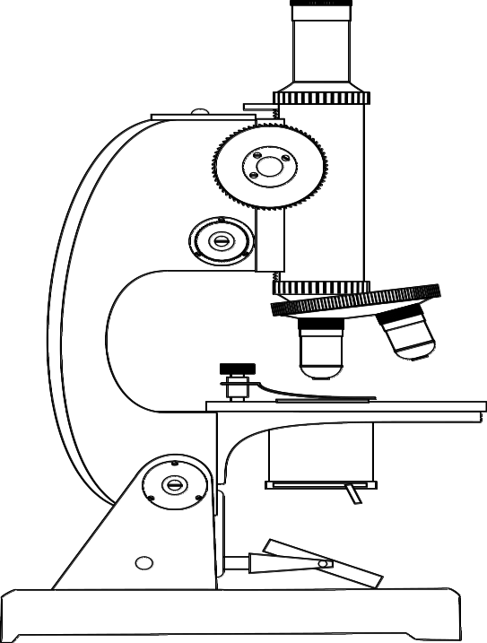
Image size
The different lenses allow us to magnify more or less – to make something look bigger or smaller. We can measure how big something looks with a ruler. We call this the image size. Your teacher will show you how to use a ruler to measure the images below, and then you should do the rest.
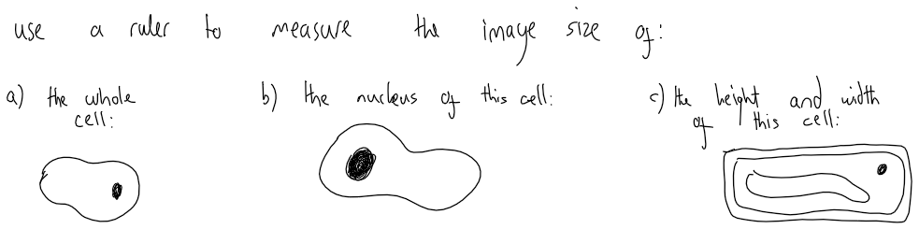

Unit conversions
Before we move on, we need to look at how we measure length and how we can use both cm and mm to do so. If you want to go from a cm to a mm measure, you need to multiply by 10, so 1 cm is 10 mm. If you want to go from mm to cm you need to divide by 10, so 1 mm is 0.1 cm.

- Convert the below into cm:
  - 10 mm
  - 1000 mm
  - 902 mm
  - 81.3 mm
  - 0.2 mm
- Convert the below into mm:
  - 5 cm
  - 28 cm
  - 1000 cm
  - 0.009 cm

Magnification

In order to make the image size bigger, we have to use a different magnification. We do this by changing the lens on the microscope. Your teacher will show you how we can easily use the magnification and the actual size of an object to work out how large an image will look.
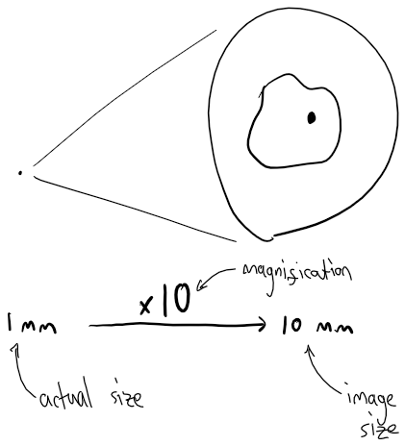
- A cell is 0.1 mm and is magnified x10. What will its image size be?
- The same cell is magnified x100. What will its image size be?
- An object is 0.02 cm and is magnified x40. What will its image size be?
- A student says that “microscopes make cells bigger.” Explain why the student is incorrect.
- A mitochondria is around 0.0005 mm in length.
  - How long is it in cm?
  - If it is viewed under a microscope with x250 magnification, what is its image size?
The magnification equation
We can combine everything we have learnt into an equation. This is like a recipe that scientists use to work things out quickly and easily. To calculate the size of a particular image in a microscope, we use the equation:
$$actual size×magnification=image size$$
- A cell has an actual size of 0.1 mm. It is viewed with a microscope with a x40 magnification. What is the image size?  D  E  S  C  U | - A cell has an actual size of 0.2 mm. It is viewed with a microscope with a x60 magnification. What is the image size?  D  E  S  C  U
- A cell has an actual size of 0.05 mm. It is viewed under a microscope with magnification x100. What is the image size?
- A microscope with magnification x50 is used to view a cell with an actual size of 0.01 mm. What is the image size?
- A cell has an actual size of 0.001 mm. What is the image size if the magnification is x60?
- A cell has an actual size of 0.01 cm. It is viewed with a microscope with a x40 magnification. What is the image size?  D  E  S  C  U | - A cell has an actual size of 0.0005 cm. It is viewed with a microscope with a x60 magnification. What is the image size?  D  E  S  C  U
- A cell has an actual size of 0.05 cm. It is viewed under a microscope with magnification x100. What is the image size?
- A microscope with magnification x75 is used to view a cell with an actual size of 0.02 mm. What is the image size?
- A cell has an actual size of 0.0003 cm. What is the image size if the magnification is x90?
- A cell has an actual size of 1 mm. Its image size when using a microscope is 10 mm. What is the magnification?  D  E  S  C  U | - A cell has an actual size of 5 mm. Its image size when using a microscope is 15 mm. What is the magnification?  D  E  S  C  U
- A cell has an image size of 1 mm. It is viewed with a microscope with a x50 magnification. What is the actual size?  D  E  S  C  U | - A cell has an image size of 0.1 mm. It is viewed with a microscope with a x100 magnification. What is the actual size?  D  E  S  C  U
- A cell has an image size of 2 mm. It is viewed with a microscope with a x80 magnification. What is the actual size?
- A cell has an actual size of 0.03 mm. It is viewed with a microscope with a x90 magnification. What is the image size?
- A cell has an actual size of 0.03 mm. Its image size when using a microscope is 15 mm. What is the magnification?
- A cell has an actual size of 0.005 cm. Its image size when using a microscope is 10 mm. What is the magnification?
- When using a microscope, a cell has an image size of 0.15 cm. Its actual size is 0.45 mm. What is the magnification?
- What are the five steps required for looking at a cell under a microscope?
More on magnification
Microscopes have two lenses, the eyepiece and the objective lens. We use both of these to calculate the total magnification of the microscope:
The magnification of a light microscope can be calculated very easily.
Total magnification = eyepiece lens magnification x objective lens magnification

- Complete the table
- Name 8 organelles
- Which organelles do plant cells have that animal cells do not?
- A student uses a microscope with an eyepiece magnification of x10 and an objective magnification of x50. What is the overall magnification?
- A student uses a microscope with the same objective magnification but an eyepiece magnification of x5. What is the overall magnification?
- A cell has an actual size of 0.001 mm. Its image size when using a microscope is 3 cm. What is the total magnification?
- A cell has an actual size of 0.1 mm. Its image size when using a microscope is 10 cm. What is the total magnification? (remember to convert cm to mm!)
- A cell has an actual size of 0.0015 cm. It is viewed with a microscope with a x4.5 objective lens and a x10 eyepiece lens magnification. What is the image size in mm?
- A cell has an image size of 0.6 cm. It is viewed with a microscope with a x20 objective lens and a x10 eyepiece lens. What is the actual size?
- A student has a cell with an actual size of 0.02 mm. They have an eyepiece lens with x25 magnification. If they want the cell to have an image size of 5mm, what objective lens will they have to use?
Lesson 4: Unicellular Organisms (AC)
I am learning about the features of unicellular organisms to be able to identify differences and similarities with multicellular organisms
A unicellular organism is a living thing that is just one cell. One type of unicellular organism that you may have heard of is bacteria. You may know bacteria as something that cause illness and infection, but bacteria can also have lots of useful functions too. For example, some bacteria live in your gut and can help you to absorb important nutrients from your food. There are many different types of unicellular organism, including: bacteria, protozoa, and unicellular fungi.
You might be tempted to think that these organisms are very simple, but in fact they can be very complex. They have adaptations that make them very well suited for life in their environment.
Bacteria (left picture) are very tiny, unicellular organisms. The structure of a bacterial cell is different to an animal or plant cell. For example, it does not have a nucleus.
Yeast Cells (right picture) are a unicellular fungi organism. Yeast have a cell wall, like plants do but do not have chloroplasts.
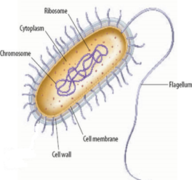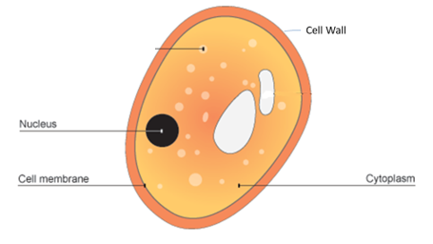
- In biology, the word “function” is similar to the word “job.” What is the function of the chromosome?
- A particular cell cannot move. What organelle could help it move?
- A particular cell has more ribosomes than the average cell. What do you think the function of that cell is?
- A yeast cell is 0.004 mm. If it is observed under a microscope with x400 magnification, how big will the image of the yeast cell be?
- The cytoplasm is mostly liquid. Explain why it can flow.
- When nutrients enter the cell, they diffuse through the cytoplasm. What is diffusion?
- Explain why diffusion through the cytoplasm is faster than diffusion through a solid.
- Draw a particle diagram of a gas
- Explain why diffusion through a gas is fast
- Name one organelle that a bacteria cell does not have that a plant and animal cell do have.
- What is the function of the flagellum?
- Name one organelle that is in both a yeast cell and a plant cell.
- What is the function of a ribosome?
- Name two unicellular organisms

- State below whether each function of unicellular organisms is a use or a danger:

____Use__ Bacteria can be added to sewage to break down harmful chemicals
__________ Bacteria live in the gut and help our digestive system
__________ Bacteria and fungi digest dead organisms releasing useful nutrients
__________ Bacteria can infect wounds on the skin after surgery causing infection
__________ Fungi such as yeast are used in brewing and baking
__________ Bacteria can reproduce in the body and release toxins causing disease
__________ Fungi can infect parts of the body causing athletes foot and thrush
__________ Fungi make antibiotics which can be used to treat bacterial infections
- The cell has an actual size of 0.01 mm and is looked at under a microscope with x100 magnification. What is the size of the image?
- The microscope is changed for one that has a x10 eyepiece lens and x40 objective lens. What is the size of the image?
Lesson 5: Diffusion
I am learning about how the rate of diffusion can be changed to explain why some cells have certain features
Recap questions:
- What is diffusion?
- In what state of matter does diffusion happen quickest?
- Explain why this is the case.
- Someone sprays deodorant in the front of a room. Is the front of the room an area of high or low concentration? Explain your answer.
- Eventually, you can smell the deodorant from the back of the classroom. Explain why, using the word particle in your answer.
- On a hot day, you can smell the deodorant at the back of the room much quicker than you can when it is cold. Explain why.
- A student wants to know how the temperature of the room affects how quickly you can smell the deodorant at the back of the room. What is the independent variable?
- What is the dependent variable?
- Which variables need to be controlled?
- Explain why it is important to control these variables.
Rate of Diffusion
The rate of diffusion is linked to how fast and easily the particles can move. This is very important in biology as particles need to move in and out of cells for organisms to be able to function.
How quickly particles move depends on three factors outlined below:
Concentration Gradient – The greater the difference in concentration, the quicker the rate of diffusion
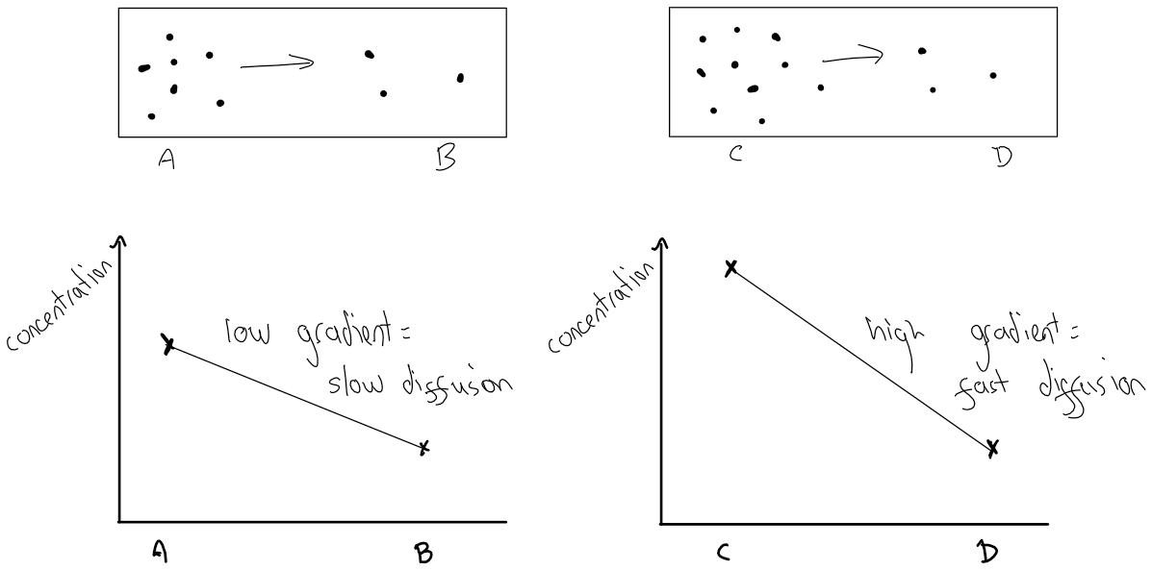

- In the diagrams on the previous page, explain why the rate of diffusion from A to B is higher than the rate from C to D.
- Look at the diagrams below:
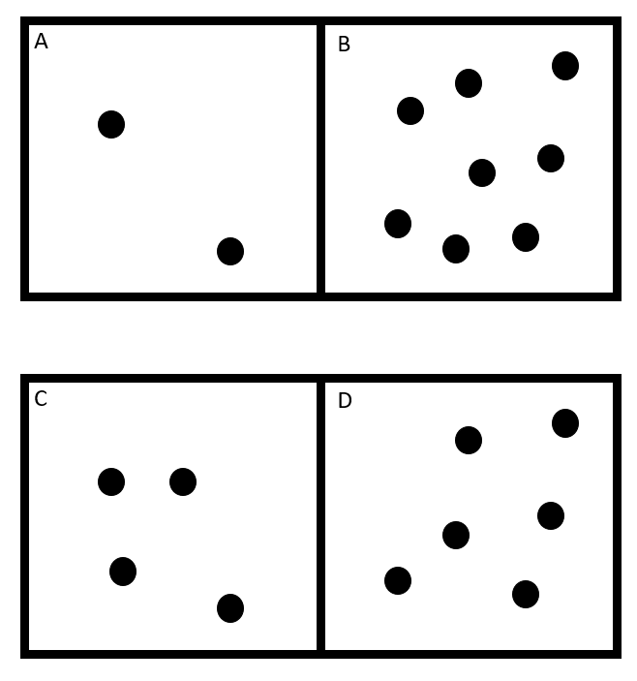
  - Will diffusion happen from A to B or from B to A?
  - Once diffusion has finished, how many particles will be in A and B?
  - Will diffusion happen from C to D or from D to C?
  - Once diffusion has finished, how many particles will be in C and D?
  - Will diffusion be quicker in A and B or in C and D? Explain your answer.
  - Draw a concentration gradient diagram to show what A and B are like after they have been left for a long time
- A student says “if the particles are all spread out evenly, diffusion has finished and the particles stop moving.” Explain why the student is wrong.
Surface area of the cell membrane- The greater the surface area, the faster the rate of diffusion
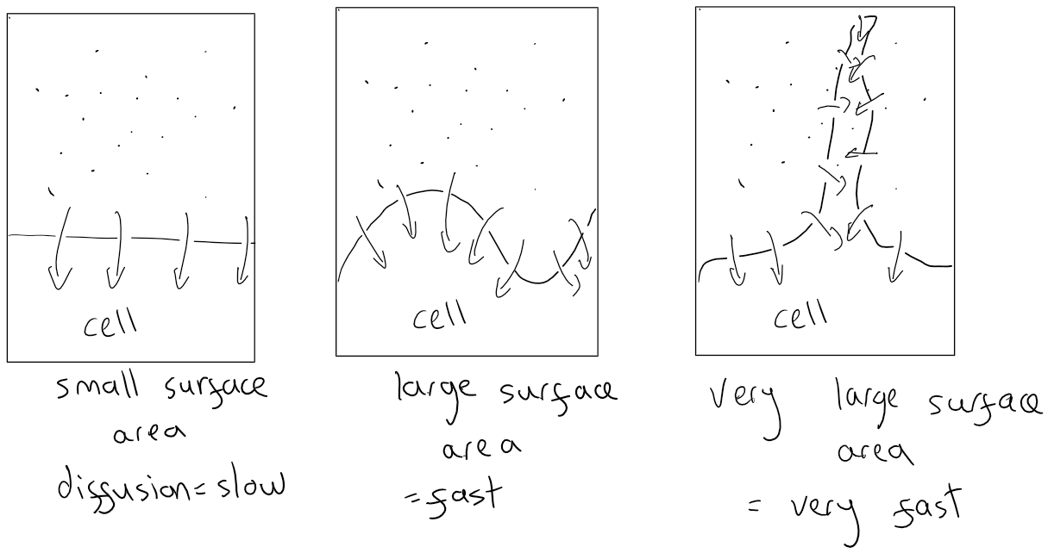
- Explain why a cell which needs to take lots of particles in from its surroundings would have a large surface area.
- What is the relationship between surface area and rate of diffusion?
- A cell has 5 particles in it, and 25 outside it. Draw a diagram of this cell, showing all the particles.
- Overall, will diffusion take place into the cell or out of the cell?
- How many particles will be in the cell at the end of diffusion?
- A student says there will be more particles in the cell at the end if it has a larger surface area. Explain why this is incorrect.
- Look at the diagram below:
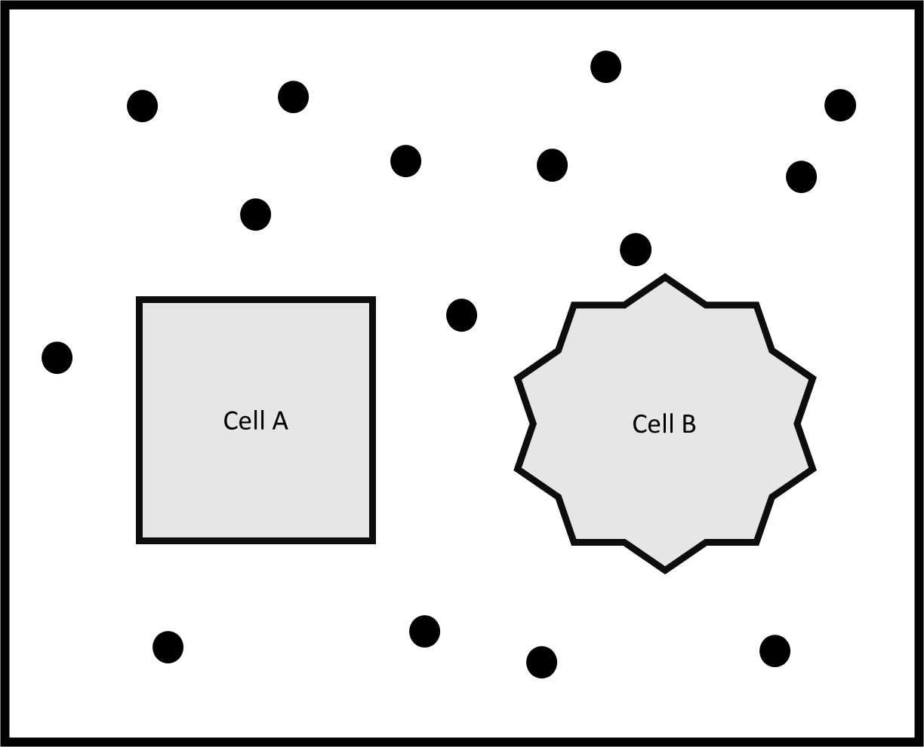
  - Will diffusion be quicker in and out of cell A or cell B?
  - Explain your answer.
Temperature – The higher the temperature, the more energy the particles will have, so they will move and mix more quickly
- A student has two beakers, one at 50°C and the other at 75°C. They put a drop of ink in each beaker. In which beaker will diffusion happen quicker?
- Explain your answer.
- Roots absorb water from the soil. Why are they more effective at this during the day than over night?
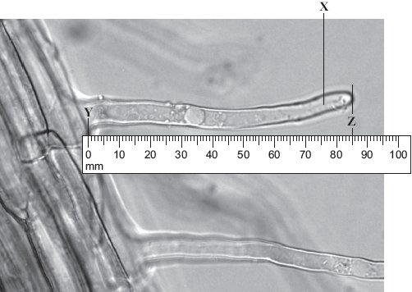
- A student wants to look at root hair cells under a microscope. What are the five steps required for looking at them under a microscope?
Pause and recap:
- The photograph shows part of the surface of a plant root. This part of the root is covered with hundreds of structures like the one labelled X. Use the scale to measure the length Y–Z on the photograph.
- The photograph shows the root magnified 100 times. Calculate the actual length Y–Z in mm.
- Why do you think the root has that shape?
- The cheek cell to the right is magnified 250 times. The width of the cell is shown by the line D to E. Use a ruler to measure the length of the line in mm.
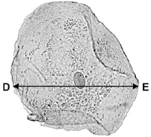
- Calculate the actual size of the cheek cell in mm.
- A microscope has an eyepiece lens with a 10x magnification and an objective lens with a 4x magnification. A student looks at a cell using it and measures the image size to be 0.2cm. What is the actual size of the cell in mm?

How does this affect that?
We know that there are three variables that affect diffusion:
How does concentration gradient affect rate of diffusion? | The greater the concentration gradient, the greater the rate of diffusion
How does temperature affect the rate of diffusion? | The greater the temperature, the greater the rate of diffusion
How does cell surface area affect the rate of diffusion? | The greater the cell surface area, the greater the rate of diffusion

In science, we call this a relationship, and say that one thing causes something else. The way we write this is always the same:
The greater/smaller the _________________, the greater/smaller the ____________________
For example, some cars have bigger engines that make them go faster. If the question is:
How does engine size affect speed?
We would write:
The greater/smaller the engine size, the greater/smaller the speed.
How would we write a similar relationship, but for the weight of the car?
The greater the weight of the car, the smaller (or lower) the speed.
As a class, we will do these ones together:
- Someone is jumping off a wall. What is the relationship between the height of the wall and how much it hurts when he falls?
- Someone is painting a ceiling. What is the relationship between the size of the brush and how quickly she can paint?
- A student is rolling small marbles down a track. What is the relationship between the height the marbles are dropped from and the speed they travel?
- When rolling the marbles, what is the:
  - Independent variable
  - Dependent variable
  - Controlled variables
  - Why is it important to have controlled variables?
- A student is investigating how quickly a drop of ink diffuses through water at different temperatures. They have one glass of water at 25 °C and one glass of water at 50 °C.
  - What is the independent variable?
  - What is the dependent variable?
  - Why does the student need to use the same volume of water in both glasses?
  - What else needs to be controlled?
  - What is the relationship between temperature and the rate of diffusion?
- What is the relationship between number of ribosomes in a cell and how much protein synthesis can take place in that cell?
- How does the number of mitochondria in a cell affect how much respiration can take place in the cell?

Lesson 6: Specialised Cells
I am learning about how the adaptations of certain cells can be used to predict their function
Humans and other animals are “multicellular” organisms meaning they are made up of multiple cells, in fact the average human is made of 37 trillion cells. The animal cell you have learnt about in the past is the general animal cell but animal cells have to be specialised for the body to function correctly. This means they look different and have different things that are unique (or special) to them. We call these differences “adaptations.”
There are over 100 specialised cells in humans, and we learn about lots of them over time, but in this unit we will only learn about two: the red blood cell and the muscle cell.
 | Function | Adaptation | Why it has that adaptation
Red blood cell | Carry oxygen around the body | No nucleus | More space for oxygen
Red blood cell | Carry oxygen around the body | Biconcave shape | Easy to move through narrow blood vessels
Muscle cell | Contract and move things (like your bones) | Lots of mitochondria | Release energy for movement

Answer the questions below in your exercise book
- What is a specialised cell?
- What is the function of the cell membrane?
- What is the function of the nucleus?
- Why don’t red blood cells have nucleuses?
- Red blood cells have a special protein which helps them carry oxygen. Which organelle do you think they have a lot of? Explain your answer.
- Muscle cells can be 1 mm in size. Red blood cells are around 0.005 mm. Why are red blood cells so small?
- There are some diseases that stop red blood cells absorbing oxygen. Why does this mean they cannot fulfil their function?
- Red blood cell’s shape also gives them a large surface area. What is the relationship between surface area and diffusion?
- What do you think diffuses in and out of red blood cells?
- How can red blood cells be viewed under a microscope? Give the five steps.
- A nerve cell is a type of specialised cell, that in parts is only 0.00007 mm wide. How big will it look when viewed under x1000 magnification?
- Complete the sentence stems:
  - Red blood cells have no nucleus because…
Red blood cells have no nucleus but…
Red blood cells have no nucleus therefore they are…
  - Muscle cells do lots of respiration because…
Muscle cells do lots of respiration but…
Muscle cells do lots of respiration therefore they are…
Specialised plant cells
Plants, like animals, are multicellular organism and as such contain many specialised cells. Just like animal specialised cells these plant cells contain certain features and adaptations that make them successful at their function.
Specialised cell | Function | Adaptations | Why it has that adaptation
Root hair cell | Absorb water and nutrients from the soil | Large extension | Increase surface area
 |  | No chloroplast | No light underground so no photosynthesis
Palisade cell | Do lots of photosynthesis | Lots of chloroplasts | To do lots of photosynthesis

Palisade cells are also found at the top of leaves, because that’s where there is the most light from the Sun. They use this light for photosynthesis.
- What is the function of a root hair cell?
- A palisade cell is viewed under x 400 magnification. The image is 1.2 cm long. How big is the cell in mm? (remember to change the image into mm!)
- What do plant cells have that stop them breaking?
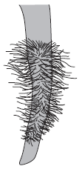
- Some root hair cells need energy in order to get as many nutrients from the soil as possible. What organelle do you think they have a lot of because of this? Explain your answer.
- Mitochondria can be seen by a normal microscope but ribosomes cannot. Why not?
- What cell structure do palisade cells have lots of?
- Suggest why a cell within the trunk of a tree cannot carry out photosynthesis
- Why don’t root hair cells contain chloroplasts?
- The image to the right shows part of a plant root. The plant root is adapted for absorbing water from the soil. Use information from the diagram to explain how this plant root is adapted for absorbing water.
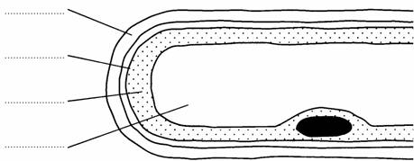
- The drawing shows part of a root hair cell.

(a) Use words from the list to label the parts of the root hair cell.

cell membrane cell wall cytoplasm nucleus vacuole

Recap Questions:
- What are the common organelles in each of the four specialised cells?
- Why is it important that red blood cells do not have a nucleus?
- Red blood cells are normally 0.006 mm in size. How big would an image of a red blood cell in a microscope with x20 magnification be?
- Which organelle is found in a large amount in a muscle cell? Why is this helpful?
- What special name does a Red Blood Cell have for its structure?
- What are the three variables that affect rate of diffusion?
- Why do root hair cells and red blood cells have high rates of diffusion?
- A student has a microscope with a magnification of x50. It has an image size of 1.5cm. What is its actual size in mm?
- Chloroplasts have a pigment (coloured chemical) in them called chlorophyll, which is made of a few different colours mixed together. How can we separate the colours in chlorophyll?
- During the separation, we use pencil not pen. Why is this?
- We also have to use a solvent. What is a solvent?
- Ethanol is a good solvent, and we can make mixtures with ethanol and other liquids to make perfumes. How can we separate those mixtures?
- Why does filtering not separate perfumes?
- From memory, name the eight organelles and give their functions.
- Which organelles do animal cells normally not have?
- Which organelles do red blood cells not have that other animal cells do have?
- What is the relationship between the size of a red blood cell and how easily it can fit through narrow blood vessels?
- What is the relationship between the size of a red blood cell and how much oxygen it can transport?
- What is the relationship between the size of the extension of a root hair cell and how quickly substances can diffuse into it?

Lesson 7: Principles of organisation and an example organ system
I am learning about how organ systems are dependent on the cells, tissues and organs that make them up
When you eat food, your body needs to break that food down into really small pieces which can easily diffuse around your body. It does this in the digestive system. We will learn about this system in more detail later, but it is a group of organs like the stomach and mouth that all work together to break down the food. The food is broken down in the stomach, mouth and small intestine. It is absorbed into the blood at the small intestine. These are all organs and are made of things called tissues. A tissue is a group of cells working together for a specific purpose.
What is a tissue? | A group of similar cells working together
What is an organ? | A group of different tissues working together
What is an organ system? | A group of different organs working together
Name two organ systems | Digestive system, respiratory system (reproductive, skeletal, nervous, circulatory)
What is the function of the digestive system? | Break down food
What is the function of the respiratory system? | Get gases in and out of the body

- Your heart is an organ. What is an organ?
- Some of the cells in the heart are muscle cells. What is the function of these cells?
- How are they adapted to that function?
- When lots of muscle cells work together, they form a tissue. What is a tissue?
- The heart and the blood vessels work together to pump blood around the body. What name is given to a group of organs like this?
Revision Recap Questions:
- What are the functions of the cell membrane?
- What is the role of the mitochondria?
- What is the function of ribosomes in a cell?
- _____________________: Controls the activities of the cell and stores genetic material.
- What do plant cells have that animal cells do not have?
- Groups of cells are known as ________________________.
- Tissues are organised into __________________________.
- What is the job of the digestive system?
- Which magnification should you start with on a microscope?
- A cell has an actual size of 0.01mm and is viewed under a microscope with an objective lens of x40 and an eyepiece lens of x10. What is its image size?
- Where is chlorophyll found in a plant cell?
- Name two types of cells that have a cell wall.
- Name the process by which particles move into and out of cells.
- Name three specialised cells.
- How is a red blood cell adapted to carry oxygen?
- List the adaptations of the root hair cell that help it to absorb water and nutrients.

