7PE Energy Name: _____________

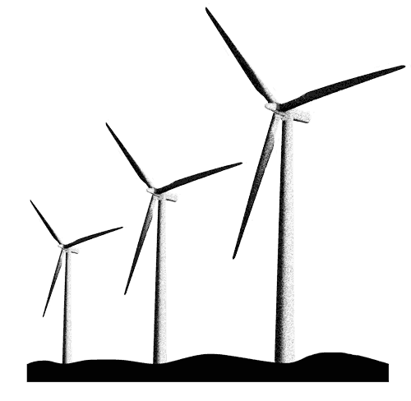

Name the five main energy stores | Thermal, kinetic, gravitational, chemical, elastic
Which energy store is involved in changes in temperature? | Thermal
Which energy store is involved in movement? | Kinetic
Which energy store is involved in objects being moving up or down? | Gravitational
Which energy store is involved in food and batteries? | Chemical
Which energy store is involved when objects are stretched or squeezed? | Elastic
Name the four energy transfers | Mechanical working, Waves, Heating, Electrical working
How is energy transferred when people or machines push or pull objects? | Mechanical working
Name two types of wave energy transfer | Light and sound
How is energy transferred through wires? | Electrical working
How is energy transferred from hot objects to cold objects? | Heating
What is the unit and unit symbol for energy? | joule, J
What is power? | How quickly energy is transferred
What is the unit and unit symbol for power? | watt, W
What is the equation that relates power, energy and time? | Power x time = energy
State the law of conservation of energy. | Energy cannot be created or destroyed
What are fossil fuels formed from? | Ancient organisms
How long does it take for fossil fuels to form? | Millions of years
What do we use fossil fuels for? | Energy
How do we get energy from fossil fuels? | By burning them
Which energy store is involved with fossil fuels? | Chemical store
What is the purpose of burning fossil fuels in a power station? | To heat water and turn it to steam.
Where does the energy generated in a power station go to? | The National Grid
Give two advantages of using fossil fuels to generate energy | Readily available, reliable
Why are fossil fuels considered reliable? | They always work
Give two disadvantages of using fossil fuels to generate energy | Non-renewable, release carbon dioxide
What is a renewable energy source? | One which won't run out
Why are fossil fuels non-renewable? | They will eventually run out
Why is releasing carbon dioxide a problem? | It causes global warming (which causes climate change)
Give two advantages of using wind power to generate energy | Renewable, doesn't release carbon dioxide
Give two disadvantages of using wind power to generate energy | Unreliable, noisy
Why is wind power considered unreliable? | The wind's strength changes
What do hydroelectric power plants use to generate energy? | Falling water
Give two advantages of using hydroelectric power to generate energy | Renewable, doesn't release carbon dioxide
Give two disadvantages of using hydroelectric power to generate energy | Can cause flooding, can damage local habitats

Lesson 1: Energy stores
I am learning about how energy stores can describe events occurring.
Energy is an incredibly difficult concept to describe. Energy cannot be seen, touched or sensed in any way. But everything that we can sense happens because of it. Whenever objects are getting hotter or colder, energy is involved. Whenever objects are moving up and down or side to side, energy is involved. Whenever your phone or TV turns on, energy is involved.
We say that objects have different energy stores. Depending on what that object happens to be doing, those stores might fill up with energy or empty out of energy. One store is called the kinetic store. If an object starts to move, its kinetic store starts to fill up. If that object slows down, its kinetic store starts to empty out.
There are eight energy stores: thermal, kinetic, gravitational, chemical, elastic, electrostatic, magnetic and nuclear. We will learn the first five in detail and you will study the last three later on in school.

- For the pictures below, state which energy store or stores is involved:

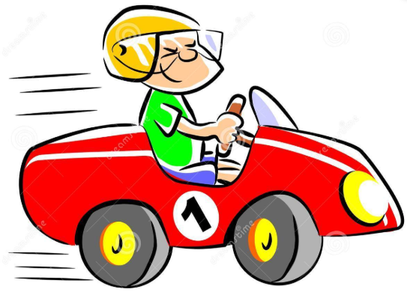 | 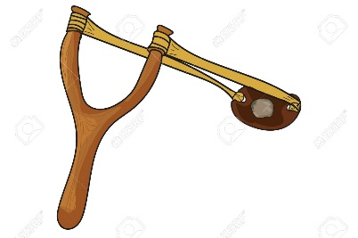 | 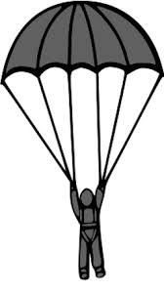
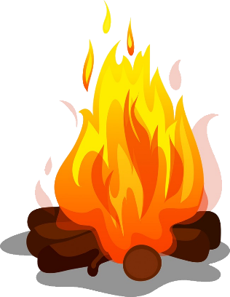 | (Rubbing hands together)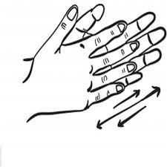 | 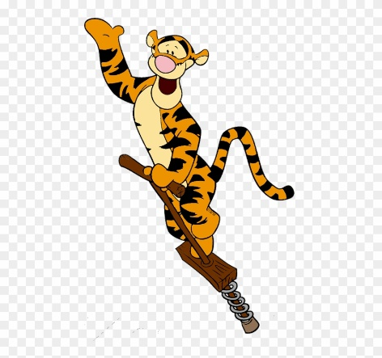
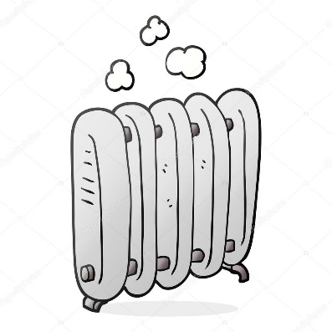 | 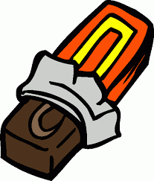 | 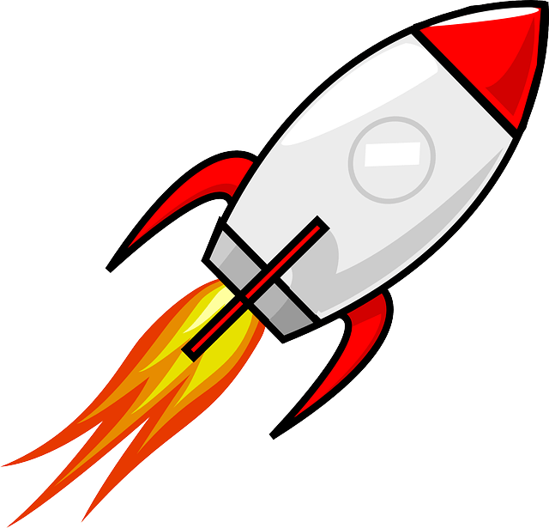
- For each of the five main energy stores, write down two objects which can be involved with those stores.

Lesson 2: Energy transfers
I am learning about how energy transfers can be used to describe the movement of energy between objects.
Energy can be transferred between objects. This means that one object loses energy from its store, and another object gains energy in its store. For example, if you hold a hot water bottle, energy is transferred from the hot water bottle’s thermal store to your thermal store. This makes you feel warmer. The way it transfers is called heating.
Your body has muscles. You can use these muscles to move objects. Your muscles have energy in their chemical store (which they release through respiration). When you move a box, energy is transferred from your chemical store to the box’s kinetic store. The way it transfers is called mechanical working.
If somebody hits a drum, it vibrates (moves up and down). When you can hear the drum, it’s because special organs in your ear also start to vibrate. Energy is transferred from the drum’s kinetic store to your ear’s kinetic store. The way it transfers is by a wave. This is when vibrations are given out in all directions. Light is another example of a wave, and its how bulbs transfer energy all around them.
Remote controlled drones can move through the air so have energy in their kinetic store. They have a battery which has energy in its chemical store. That energy is transferred by electrical working. Anything that plugs in to the mains also gets its energy from the plug by electrical working (it’s a bit more complicated than this).
- Somebody swings a tennis racket. Complete the sentences:
At first, the person has energy in their ______________ store. When they swing their hand, they transfer
energy to the racket’s ______________ store by the transfer ______________ _______________. The
racket then hits the ball and energy is transferred to the ball’s _______________ store by the transfer
_______________ _________________.
- A person lifts a cup and puts it on top of a shelf. It is now still on the shelf.
  - Which store does the energy come from?
  - Which store is the energy transferred to?
  - How is the energy transferred?
- A person buys an electric heater and uses it to heat up a room.
  - How is energy transferred to the heater from the plug?
  - How is the energy transferred to the room?
  - Which energy store receives energy from the heater?
- A light bulb lights up a room.
  - How is the energy transferred to the light bulb?
  - How is the energy transferred to the room?
  - The bulb gets hotter. What store of the bulb gains energy?
  - Someone touches the bulb and gets burned. How is the energy transferred from the bulb to their hand?
- A person is jumping on a pogo stick. As they push down on the stick, energy is transferred to the spring.
  - Which store is the energy in the spring in?
  - The spring opens and pushes the person up. Which energy stores become filled as the person is moving up?
  - How is the energy transferred from the spring to the person?
  - The person stops at a certain height. Right before they start to come down again, which energy store is full?
  - As the person falls, which energy store starts to empty and which starts to fill?
- A drummer plays on their drum kit. They transfer energy to the drum sticks, which transfer the energy to the drums, which then transfer energy to the room.
  - Which energy store does the drummer transfer energy from?
  - Which energy store does the drummer transfer energy to?
  - How is the energy transferred from the sticks to the drum skin?
  - How is the energy transferred from the drum skin to the room?
- Water is boiled in a kettle. Energy is transferred by electrical working to the kettle’s heater, then transferred from the heater to the water and to the kettle’s wall.
  - Which store of the water gains energy?
  - How is the energy transferred from the heater to the water and the kettle’s wall?

- Look at the diagrams below, showing a person falling onto a trampoline:

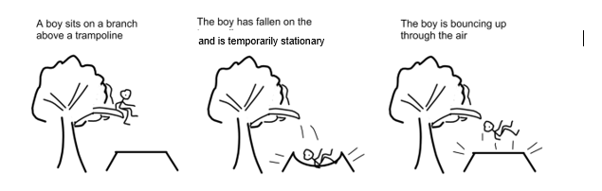
  - When the boy is sitting on the branch, what energy store is involved?
  - When the boy is falling, which energy store is emptying and which is filling?
  - When the boy is on the trampoline, which energy store of the trampoline fills up?
  - How is energy transferred from the boy to the trampoline?
  - In terms of stores and transfers, what happens when the boy bounces back up into the air?
  - Challenge: why is there no energy transfer in question b?

Pause and recap:
- From memory, name the 5 main energy stores
- From memory, name the 4 main energy transfers
- A person lifts weights. Which energy store of the weights starts to fill up as they are moving up?
- Which energy store of the person empties?
- How is the energy transferred from the person to the weights?
Making links:
- This question is about a muscle cell.
  - What is the function of a muscle cell?
  - How is the muscle cell adapted to its function? Give two ways.
  - What is the name of the process that releases energy in the muscle cell?
  - When the muscle cell contracts, which energy store becomes filled?
  - The muscle cell uses glucose to release energy in a chemical reaction. Which energy store is involved with the glucose in this process?
  - Muscle cells work together to bring about movement. What is the name for something made of many cells working together?
  - When a person moves their muscles a lot, they start to feel warm. Which energy store is filling up?
  - A person who has just exercised touches a cold object and warms it up a bit. What energy transfer is involved?
  - The object they touched was an ice cube. What will happen to it if they hold it for a long time?
  - Draw a particle diagram of an ice cube.
  - Explain why the ice cube cannot flow.

Lesson 4: Joules and power
I am learning about how energy is measured so I can calculate power
When a toaster is on, it is transferring energy by heating to the bread. It’s important that scientists know how much energy is being transferred, so the first thing we need to do is think about how energy is measured. We call energy a quantity, which just means we can measure it. This is just like measuring distance, or someone’s mass or their temperature. The unit is what we measure these things in. We measure distance in metres, mass in kilograms and temperature in degrees centigrade. We measure energy in something called joules.
Each of those units has a unit symbol. This is how scientists abbreviate (make shorter) the unit. So if something was 10 metres long, we would write 10m. If someone had a mass of 70 kilograms, we would write 70kg. If a person is ill and has a temperature of 39 degrees centigrade, we write 39°C. If the toaster has transferred 100 joules of energy we write 100J.
Quantity | Unit | Unit symbol | Example
Distance | metre | m | 10m
Mass | kilogram | kg | 70kg
Temperature | degrees centigrade | °C | 39°C
Energy | joule | J | 100J

- What measurement is shown on each of the below? Give your answer with a unit.
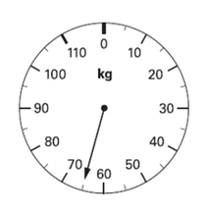 | 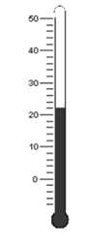 | 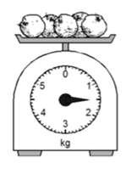
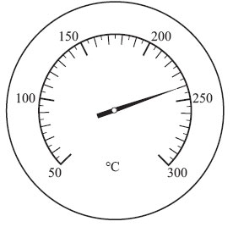 | 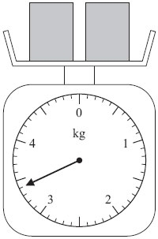

When energy is transferred, it happens in a certain amount of time. It’s no good saying that “this toaster transfers 800 J of energy” when we don’t know how long the toaster takes to transfer all that energy. This is why scientists have another quantity called power. This tells us how much energy is transferred in every second. The unit for power is watts, and the unit symbol is W.

For example, if a toaster can transfer 800 J of energy every second, it has a power of 800 W.
If it could transfer 1000 J in one second it would have a power of 1000 W.

- A toaster has a power of 1200 W.
  - How much energy does it transfer in one second?
  - How much energy does it transfer in two seconds?
  - If the toaster was turned on for five seconds, how much energy would it transfer?
  - How does the toaster transfer the energy?
  - A toaster could toast bread even in space. What does this say about the heat transfer that is involved?
- A motor uses a battery to turn.
  - Which energy stores are involved?
  - Which energy transfer is involved?
  - The motor has a power of 12 W. How much energy can it transfer in 10 seconds?
  - An object is lifted by the motor. What energy stores are involved?
  - Which energy transfer is involved?
  - The object needs 24 J of energy to be lifted to the right height. How long does this take the motor?
U
When we studied magnification, we saw that scientists like to use equations to help us work things out, and we used DESCUS to help us use the equations. There is also an equation for power, energy and time:
Power x time = energy

A device has a power of 450W. It is left on for 10 seconds. How much energy is transferred? | A device has a power of 900W. It is left on for 15 seconds. How much energy is transferred?

- Find the energy transferred by:
- A 60W bulb in 30s
- A 12W battery in 45s
For some questions, you will have to turn minutes into seconds. You do this by multiplying the number of minutes by 60.
- Find the energy transferred by:
- A 200W kettle in 2 minutes
- A 1500W microwave in 4 minutes

Sometimes we need to work out the time or the power, and the energy is provided to us:
How much time does it take for a 500W device to transfer 1500J of energy? | How much time does it take for a 500W device to transfer 750J of energy?
- What is the time taken for:
- 5000 J of energy to be transferred by a 100 W hoover
- 300 J of energy to be transferred by a 50 W speaker
- 20000 J of energy to be transferred by a 150 W radio
- 1200 J of energy to be transferred by a 40 W bulb
- Find the power of:
  - A heater transferring 420J of energy in 6 s (s is the unit symbol for seconds)
  - A heater transferring 100J of energy in 40 s
  - A battery which is left on for 15 seconds and transfers 2J
- Find the power of:
- A charger transferring 214 J of energy in 1 minute
- A TV transferring 1600 J of energy in 3 minutes
- A washing machine left on for 50 minutes and transferring 125000 J
- A person lifts an object and transfers 78 J in half a minute. What is the power of the person?
- Calculate the time in minutes in which a 3 W mobile phone transfers 2,890J of energy. (remember that there are 60 seconds in a minute)
- Mixed questions:
- A device transfers 80 J of energy in ten minutes. What is its power?
- 20 J of energy is transferred in 30 seconds. What is the power of the device?
- A device with a power of 0.8 W transfers 300 J of energy. How much time does this take?
- A device of power 5.5 W is left on for two hours. How much energy is transferred?
- A cell is viewed under a microscope. It has an actual size of 0.0028 mm and a magnification of x 240. What is its image size?
- The same cell is viewed under a different microscope and has an image size of 0.112 mm. What is the magnification of this microscope?
- How long would it take for a 12 W device to transfer 900 J?
- 88 J of energy is transferred by a device in 2 hours. What is the power of the device?

Lesson 5: Conservation of energy and efficiency
I am learning about the conservation of energy so I can calculate the efficiency of energy transfers
Recap questions
- What is the law of conservation of mass?
- A student has a glass of water with a mass of 100 g. They add 5 g of salt which dissolves and can no longer be seen. What is the mass of the glass now? Explain your answer.
- A car has a full tank of petrol. Which energy store is involved with petrol?
- As the car is driving, which energy store fills up?
- The car makes the road underneath it very hot. Which energy store of the road is filling up?
- How is energy transferred from the wheels of the car to the road?
- The car drives into a bin which bounces off the car. How was energy transferred to the bin from the car?
In the particles unit, we learnt the law of conservation of mass: that atoms cannot be created or destroyed, only rearranged. The same is true of energy: it cannot be created or destroyed, just transferred from store to store. If a car has petrol in it, and the petrol has 1200 J in its chemical energy store, a maximum of 1200 J could be transferred to the car’s kinetic store. Once that energy has run out, the car will stop.
- An apple in a tree has a gravitational store of 8 J. As it falls, what is the apple’s maximum kinetic store? Explain your answer.
- A child at the top of a slide has a gravitational store of 1800 J. What is the child’s maximum kinetic store as he slides down? Explain your answer.
- A bouncing ball has 50 J of kinetic energy as it leaves the ground. What is its maximum gravitational store when it reaches its highest point? Explain your answer.
- What is the maximum amount of energy in its kinetic store as it falls?
- When will the energy in its kinetic store be 0 J?
- A cannonball is shot straight up from a cannon with an initial kinetic store of 7000 J. What is its maximum gravitational energy store when it reaches its highest point? Explain your answer.
- Challenge: A small car has a tank of petrol, storing 15000000 J of energy. The engine of the car has a power of 2500 W. How long can the car drive for?
Unfortunately, just because energy can’t be destroyed, doesn’t mean it is always useful to us. When a car drives it transfers energy from the chemical store of the petrol to the kinetic store of the car. But there are other energy transfers that are not useful. For example, the engine itself gets very hot, and some of that energy is transferred to the air around the car by heating. But the driver of the car doesn’t want to use their petrol to heat up the air – they want to use it to drive the car. This is called wasted energy. The energy that is transferred to the kinetic store is called useful energy.
- A light bulb transfers energy by heating and by light waves. Which energy transfer is useful and which is wasted?
- As a car moves it makes a sound. Is this a useful energy transfer? Explain your answer.
- A block of wood stores 100 000 J of energy.
  - Which energy store is that energy in?
  - When the wood is burned, in which two ways is the energy transferred to the area around it?
  - Which transfer is useful and which is wasted?
  - A student says it can only transfer a maximum of 95 000 J because the fire is so hot it destroys some energy. Explain why the student is wrong.
(AC) Some cars waste more energy than others. How much energy is wasted is called the efficiency. Efficient cars waste little energy, non-efficient cars waste lots of energy.
- There are two remote controlled cars: car A and car B. They both have batteries which store 2000 J of energy which can be transferred to their motor. They both waste energy by heating the air and the road underneath the car. In a straight line, car A wastes 150 J and car B wastes 200 J.
  - Which car is more efficient? Explain your answer.
  - Which car could travel further? Explain your answer.
- Two new cars, C and D, store 2500 J in their batteries.
  - Car C transfers all the energy from its battery. 1800 J is transferred to the kinetic store of the car. How much energy is wasted?
  - Car D transfers all the energy from its battery. 300 J is wasted. How much energy is useful?
  - Which car is more efficient? Explain your answer.
- One car stores 1000 J and wastes 200 J. Another car stores 1200 J and wastes 400 J. Which one is more efficient? Explain your answer.
(AC) We have an equation to help us answer the question above. It allows us to calculate the efficiency of a device if we have data on the energy that goes in (input) and the energy that goes out (output).

$$Efficiency= \frac{Useful energy output}{Total energy input}$$
Your teacher will do the question above about cars as worked examples using DESCUS.
- A lightbulb uses 470J of energy and produces 180J of heat and 290J of light.
  - What is the total energy input?
  - What is the total energy output?
  - How much of that is useful?
  - Use DESCUS to calculate the efficiency
- A power station uses 1900J of fuel and produces 1250J of electricity. Use DESCUS to calculate the efficiency of the power station.
- A loudspeaker uses 400J of energy and produces 325J of sound, wasting 75J. Find the efficiency of the loudspeaker.
- Find the efficiency of a car that uses 3890J of fuel to generate 2650J in the kinetic store.
- What is the efficiency of a lorry that produces 5780J of kinetic energy store by burning 7850J of fuel?

Lesson 6: Fossil fuels

I am learning how fossil fuels are used to generate energy

Wood comes from trees, and has a large amount of energy in its chemical store. We can transfer that energy by heating if we burn the wood. We call the wood a fuel: something that stores a lot of energy.
If a tree dies and nobody burns it, that energy stays where it is: stored in the dead tree. If that tree becomes buried, over millions of years lots of soil and rock can form above it, pushing it further underground. As it goes underground it gets compressed (squeezed) and often heated as well. Sometimes, this can result in the tree turning into a substance called coal. That coal stores all the energy that the original tree was storing, and humans can dig into the ground, pull out the coal, and burn it for energy just like they could have done with the original tree.
Coal is a type of fossil fuel. These are fuels that come from organisms that died millions of years ago. When plants die, they can form coal. When animals and other organisms die, they can form natural gas and oil. Humans use all there of these as fuels.
- Where do fossil fuels come from?
- How do humans release the energy from fossil fuels?
- Which energy store is associated with fossil fuels before we use them?
- How long do fossil fuels take to form?
- Which energy transfers are involved when a person uses a wood fire for warmth?
- A fire releases 145000 J of energy in 30 seconds. What is its power?
Many power stations use fossil fuels to generate electricity. They burn the coal and use the energy released to heat water and turn a special machine called a turbine. This special machine can transfer that energy to the cables and pylons that run across the country providing electricity.
- This question is about a coal power plant.
  - From memory, name the three fossil fuels
  - How are the fossil fuels formed?
  - What energy store is involved with the fuels?
  - Explain why wood is considered a fuel, but not a fossil fuel.
  - In one minute, the power plant uses fuel that stores 15000000 J of energy. What is the power plant’s power?
  - When the fuel is burned, 145000000 J of energy is transferred to the water. What is the energy transfer involved?
  - How much energy is wasted?
Fossil fuels are, in many ways, excellent sources of energy. The developed world has relied on them for many years for all sorts of purposes. They are very reliable and they are also readily available (easy to get hold of). However, they have two major disadvantages.
- Because they take so long to form, if we take too much of the fossil fuels out of the Earth, they will eventually run out. We say that they are non-renewable resources: ones that will run out or cannot be easily replaced
- When you burn a fossil fuel, you release carbon dioxide. This is a particle which causes global warming.
For these reasons, it is important to look for other sources of energy. We will look at these next lesson.
- What are the two main advantages of fossil fuels?
- Name the three fossil fuels
- What are the two main disadvantages of fossil fuels?
- What does carbon dioxide cause?
- A person chops down a tree for fuel. Is this renewable or non-renewable?
- Complete the sentence stems below:
Fossil fuels are used a lot as fuels because…
Fossil fuels are used a lot as fuels but…
Fossil fuels are used a lot as fuels therefore…
- What does non-renewable mean?
- How do we release energy from fossil fuels?
- How is energy transferred away from fossil fuels?
Lesson 7: Renewables
I am learning about renewable resources so I can discuss alternatives to fossil fuels
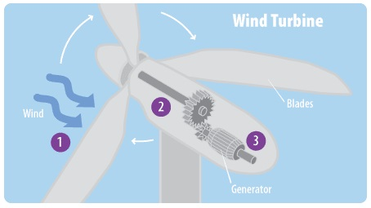
Lots of scientists are trying to find alternatives to fossil fuels from renewable sources. There are many different ways to do this, including using the Sun, the sea and even the heat from deep inside Earth. We are going to learn in detail about two: wind and hydroelectric.
When the wind blows, there is energy in its kinetic store. A wind turbine has blades that turn when the wind blows on it. Those blades can turn a turbine just like a coal power plant does.
Wind turbines do not release any carbon dioxide. The wind also doesn’t run out, so is a renewable resource. Also, once built they are quite cheap to run. However, there are some disadvantages. Because the wind’s strength changes we don’t always get the same amount of energy from them, and there will be times when we get very little energy from them. We therefore say that they are unreliable. They are also expensive to make and install, even if they are cheap to run once built. Some wind turbines can be noisy, and some people think that they look ugly and spoil the view.
- The wind causes the blades to spin. How is energy transferred from the wind to the blades?
- Where does the energy produced by a wind turbine go?
- Why is wind power considered renewable?
- Why are wind turbines considered unreliable?
- What is the relationship between wind strength and the amount of energy produced?
- List the advantages and disadvantages of wind turbines.
- Why is it an advantage that wind turbines do not release carbon dioxide?
- Why is it an advantage that wind turbines are renewable?
- Why are wind turbines often built out at sea?
- Give as many similarities and differences between coal power plants and wind turbines as you can.

Hydroelectric power is generated from falling water. First, you find a river and build a dam (a big wall) across it. The water behind the wall cannot go anywhere so starts to form a reservoir (like a big man-made lake). You can put holes in the dam and when you open them water will rush through. If you put a turbine in front of the water, the water will push the turbine round and generate electricity. You can open and close the holes depending on how much energy you need.
Hydroelectric energy relies on rivers which generally don’t dry up permanently, so it is renewable. They are quite cheap to run once built and don’t produce any carbon dioxide. The reservoir they create can be used for many different purposes and the dam itself can be used as a bridge to help people move from place to place. However, they are expensive to build and install, and can cause flooding. In 2019 a dam in Derbyshire burst causing hundreds of people to have to evacuate their homes.

- Why is hydroelectric power considered renewable?
- List the advantages and disadvantages of hydroelectric power.
- What is more reliable, hydroelectric power or wind power? Explain your answer.
- What are the similarities between hydroelectric power and wind power in how they generate electricity?
- What are the differences between hydroelectric power and wind power in how they generate electricity?
- On a particular day, a wind turbine generates 12000 J of energy in ten minutes. Calculate its power.
- On a different day, its power was a lot higher. Explain why this could be the case.

Careers spotlight: mechanical engineer

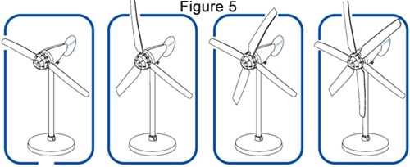
Mechanical engineers combine a knowledge of physics, maths and materials in order to build new and exciting devices. Mechanical engineers are deeply involved in the manufacture and maintenance of power plants like the ones we have learnt about. When the first wind turbines were being built, mechanical engineers had to run experiments to figure out how many blades the turbines should have. In order to do this, miniature wind turbines are built and the amount of energy produced recorded.

- In this experiment, what is the independent variable?
- What is the dependent variable?
- List as many variables that will need to be controlled as possible.
- Explain why it is important to control these variables.
- As a source of wind, do you think it is better for the engineer to put the miniature wind turbines outside or to use a desk fan?

A table of results from this experiment looks a bit like this:

 | Two blades | Three blades | Four blades | Five blades
Energy produced in one minute (J) | 40J | 80J | 70J | 45J
Power (W)

- Use DESCUS to calculate the power of each wind turbine. Do your working in your exercise book.
- What energy stores and transfers are involved when the wind turns the turbine?

The repeatability of an experiment is whether if you repeated the experiment you would get the same results. The reproducibility is whether someone else did the experiment and got the same results. To improve the reproducibility, the engineer asked a colleague to do the experiment, and got the results below:

 |  | Two blades | Three blades | Four blades | Five blades
Engineer 1 | Energy produced in one minute (J) | 40 | 80 | 70 | 45
Engineer 2 | Energy produced in one minute (J) | 38 | 82 | 95 | 43

- Was this experiment reproducible? Explain your answer.
- What do you think could account for (have caused) the differences?

The engineer then attempted the experiment herself another two times and got the results below:

 |  | Two blades | Three blades | Four blades | Five blades
Experiment 1 | Energy produced in one minute (J) | 40 | 80 | 70 | 45
Experiment 2 | Energy produced in one minute (J) | 42 | 81 | 70 | 43
Experiment 3 | Energy produced in one minute (J) | 41 | 83 | 67 | 45
Mean | Energy produced in one minute (J)

- We these results repeatable?
- Explain your answer
- Calculate a mean for every turbine. Do this by adding the three numbers together and dividing by three.
- Based on all the data you have seen so far, how many blades is best for a wind turbine? Justify your answer.
- Challenge: what else would you need to know about wind turbines before you could tell for sure what the best number of blades is?

