8BE – Ecology
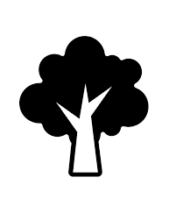

What is a feeding relationship? | How different organisms feed on (eat) each other | Feeding relationships
Why do organisms eat each other? | To get energy and nutrients | Feeding relationships
What diagram do scientists use to show feeding relationships? | Food chains and food webs | Feeding relationships
What name is given to organisms that make their own food? | Producer | Feeding relationships
Where do producers get their energy from? | The Sun | Feeding relationships
In a food chain or web, what name is given to an organism that eats another organism? | A consumer | Feeding relationships
In a food chain or web, what name is given to the organism that eats the producer? | Primary consumer | Feeding relationships
In a food chain or web, what name is given to the organism that eats the primary consumer? | Secondary consumer | Feeding relationships
In a food chain or web, what name is given to the organism that eats the secondary consumer? | Tertiary consumer | Feeding relationships
What name is given to organisms that eat animals? | Predators | Feeding relationships
What name is given to animals that are eaten by other organisms? | Prey | Feeding relationships
What is a herbivore? | An animal that eats plants | Feeding relationships
What is a carnivore? | An animal that eats other animals | Feeding relationships
What is an omnivore? | An animal that eats plants and animals | Feeding relationships
In a food chain or web, which direction are the arrows drawn in? | From the organism being eaten to the organism eating it | Feeding relationships
In a food chain or web, why are the arrows drawn from the organism being eaten to the organism eating it? | To show the flow of energy | Feeding relationships
What is decay? | The breakdown of dead organisms | Decay
What name is given to organisms that cause decay? | Decomposer | Decay
What are the two main types of decomposer? | Detritivores and microbes | Decay
Give an example of a detritivore | Maggots, woodlice | Decay
Give an example of a microbe decomposer | Bacteria, fungi | Decay
Why is decay important? | It releases waste products that plants can use | Decay
What conditions are best for decay? | Lots of oxygen, warm temperatures, moisture | Decay
What is the “population” of an organism? | The number of that organism in a particular area | Interdependence
What is interdependence? | How organisms depend on each other for survival | Interdependence
What is bioaccumulation? | How toxic materials can build up in a food chain | Interdependence
What is an adaptation? | A way in which an organism suits its environment | Interdependence
Name two types of adaptation | Physical and behavioural | Evolution
Give an example of a physical adaptation | Sharp teeth, camouflage, foot surface area, spikes | Evolution
Give an example of a behavioural adaptation | Making nests to shelter offspring (children), huddling for warmth, rolling into a ball, courtship displays | Evolution
What is competition? | Where organisms have to struggle against each other for resources | Evolution
What resources do organisms often compete over? | Food, water, space, light, mates | Evolution
What is a species? | A group of organisms that can breed and produce fertile offspring | Evolution
What is a mutation? | A change to an organism’s DNA | Evolution
What can mutations result in? | Slight changes to an organism’s adaptations | Evolution
What is natural selection? | How organisms with the most useful adaptations are more likely to survive and reproduce | Evolution
What are the four main stages in evolution by natural selection? | An organism is born with a mutation  The mutation helps it survive longer  It has more offspring  It passes the mutation on to its offspring | Evolution
Give two sources of evidence for evolution | The fossil record, bacterial resistance | Evolution
What does the fossil record show? | That over time species have changed physically | Evolution
What is bacterial resistance? | How bacteria become resistant to antibiotics | Evolution
What is extinction? | When an entire species dies out | Evolution
Name two things that can cause extinction | New predators, new diseases, changes to habitat, more successful competitors, catastrophic events (like volcanoes or asteroid impacts) | Evolution
How can scientists estimate population size? | Using quadrats (sampling from a larger area) | Evolution
What word is used when scientists put organisms into groups? | Classification | Classification
What are the seven classification levels? | Kingdom, phylum, class, order, family, genus, species | Classification
What are the five chordate groups? | Mammals, fish, birds, reptiles, amphibians | Classification
What word is used to describe the variety of species in an area? | Biodiversity | Biodiversity
Give two reasons why biodiversity is important. | Moral reasons, species may be useful to us, protects food supply, limits large changes to food chains and webs | Biodiversity
Name two ways in which scientists try to maintain biodiversity | Gene banks, protection of habitats, breeding programmes | Biodiversity

Lesson 1: food chains and webs
I am learning about feeding relationships so I can construct and understand food chains and webs
Warm up
- What is an organism?
- What is photosynthesis?
- What types of organisms do photosynthesis?
- Where does photosynthesis take place?
- Why do some organisms do photosynthesis?
Food chains
In spring and summer, the fields around the school will fill up with different types of caterpillar. These caterpillars will eat leaves from grass, bushes and trees. A common food for caterpillars is cabbage. They need to eat in order to get energy and nutrients to grow. Scientists say that there is a feeding relationship between the caterpillars and the things they eat. There is also a feeding relationship between caterpillars and robins, which will eat caterpillars in order to get energy and nutrients for themselves. Scientists will draw this out as a food chain:
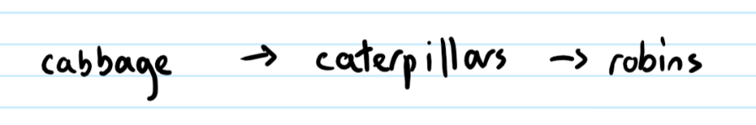
The arrows in the food chain represent the transfer of energy from one organism (living thing) to the next. The cabbage at the start gets its energy from the Sun and uses that to grow by doing photosynthesis. It is called a producer, because it produces food for itself, which other organisms then eat. The other organisms are called consumers, and the first consumer is called the primary consumer, then the secondary consumer. In England, sparrowhawks can eat robins, so sparrowhawks are called tertiary consumers.
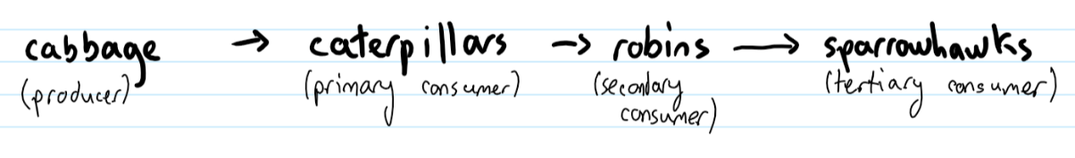
We also use words like predator and prey. Caterpillars are prey for robins, which are caterpillars’ predators. Robins are prey for sparrowhawks, which are robins’ predators.
We also use the words below:
Herbivore – animal that eats plants
Carnivore – animal that eats animals
Omnivore – animal that eats plants and animals
Carnivores are normally predators and vice versa but not always. For example, vultures are a type of bird that eat dead animals, but they haven’t killed them themselves. Some plants are considered carnivorous too, but we wouldn’t normally call them predators.
- A gardener grows some rose bushes. A small green insect called an aphid eats the rose bush leaves. Ladybirds are red beetles that like to eat aphids, so they land on the bush and start eating them. Swifts are a type of bird that can catch and eat ladybirds.
  - Construct a food chain for these organisms (living things)
  - Identify all predators in the food chain
  - Identify all prey in the food chain
  - Identify the herbivore in the food chain
  - Identify two carnivores in the food chain
  - Add labels for which organisms are producers and consumers
  - Using the word energy transfer in your answer, what does the direction of the arrow tell us?
  - The gardener sprays a special chemical on the roses that kills the aphids. What do you think this will do to the number of ladybirds in the garden?
  - Explain your answer.
  - A student says that we draw an arrow going from a predator to its prey because the predator goes to the prey to eat it. Explain why this is incorrect.
- Plankton is a tiny organism that lives in water. Plant plankton are producers, and are eaten by animal plankton. Animal plankton have lots of predators, including herring. Herring are eaten by cod.
  - Draw a food chain for these feeding relationships
  - Identify all producers, consumers, predators and prey
  - Where does the energy in the food chain come from?
  - In some areas of the ocean, there is a lot of litter on top of the water that blocks the Sun’s light. What effect does this have on all the organisms in the food chain?
Food webs
As we saw earlier, caterpillars are prey for robins. However, they are also prey for blue tits. Blue tits and robins also eat seeds, so we can change the food chain to look like this:
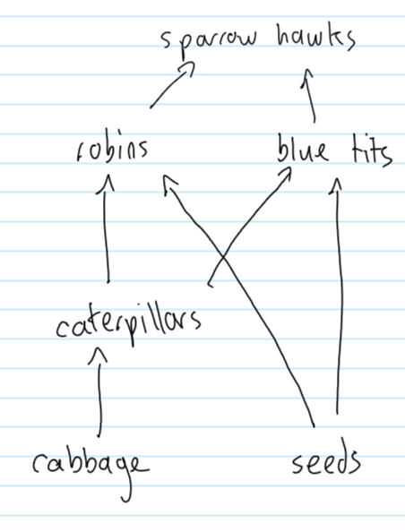
This is called a food web, and it shows more than just one chain.
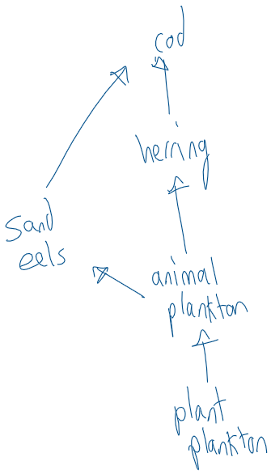
- Look at the food chain from the previous question involving cod. Capelin is a type of fish that eats plant plankton. Capelin is also eaten by cod. Add capelin to the food web.
- Sand eels eat animal plankton and capelin. Add sand eels to your food web.
- A farmer has a number of plants. Grasshoppers and snails eat her plants. A partridge is a small bird which eats grasshoppers and snails, but is prey for foxes and stoats. Construct a food web showing this information.
- Look at the food chains below. Use a pencil to make a food web which includes all of the organisms in the chains
plants à aphid à ladybird à blue tit à owl
plants à moth larva à blue tit à owl
plants à mmoth larva àspider àchiffchaff àowl
plants à vole à stoat
plants à vole à owl
- Identify all carnivores and herbivores in the food web.
- Blue tits also eat seeds. Are they carnivores, herbivores or omnivores? Explain your answer.
Lesson 2: decay
I am learning about decomposers and decay so I can explain how nutrients are recycled in the soil
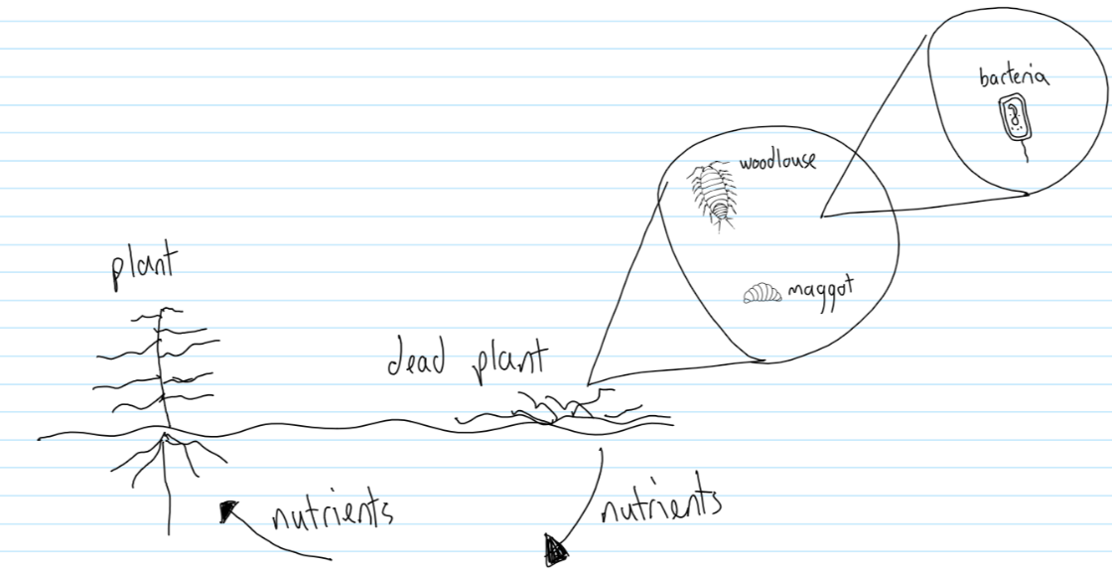
In the winter, many trees and plants will lose their leaves. These leaves fall to the ground at the base of the tree. Insects living on the ground like woodlice and maggots start to break these leaves down into smaller pieces as they eat them. These insects are called detritovores. Microbes in the soil like bacteria and fungi then further break down the smaller pieces. Detritovores and the microbes are called decomposers: they decompose all the leaves and other organic matter (the remains of living things). This is an important process as it releases a lot of nutrients into the soil, which plants can then use to help themselves grow.
- Bacteria are unicellular organisms. What is a unicellular organism?
- Name two decomposers
- Scientists call leaves that have fallen to the ground “leaf litter.” Woodlice eat leaf litter. Shrews eat woodlice. Draw a food chain for these feeding relationships.
- Shrews also eat slugs, which are also eaten by blackbirds. Slugs eat lettuce. Add this information to your food chain to make a food web
- Identify all producers, consumers, predators and prey in your food web
- Identify all herbivores and carnivores in your food web.
Decay conditions
Many decomposers work best when the environment is:
- Warm
- Moist
- Oxygen rich
A lot of gardeners and farmers will make their own compost, which they can put on their plants. They do this by taking organic matter and putting it in a special compost bin. Over time, decomposers will turn it into compost.
- Explain why compost bins are best left in a sunny spot
- Explain why gardeners will often add a little bit of water to the compost bin
- Compost bins should be placed on a muddy area, rather than on concrete. Suggest why you think this is.
- Why do gardeners and farmers add compost to their gardens and farms?
We are going to spend some time with GROW looking at decomposers and decay in more detail.
Lesson 3: interdependence
I am learning about interdependence so I can explain how changes in an environment can affect all organisms in that environment
In our first lesson of this unit, we looked at how caterpillars can eat cabbage. Farmers growing cabbage will often put an insecticide (a special chemical) on the cabbage which stops caterpillars eating it. This helps the cabbage grow, but can have negative effects further down the food chain. Robins that would have eaten the caterpillars now have less food to eat. They may not be able to get enough food to support themselves or their chicks, and as a result the total number of robins in the area may decrease.
Scientists call the number of a particular organism its population. Food chains and webs allow us to see what effect there will be on the different organisms when we change something in the environment. We call this interdependence: how the organisms in a particular area depend on each other for survival.
- This question is about the food web you drew with the foxes, stoats, partridges, grasshoppers, snails and plants.
  - A farmer uses insecticide on her plants. What effect could this have on the grasshopper population?
  - What effect could this have on the partridge population?
  - The insecticide does not affect snails. What effect does using the insecticide have on the snail population?
  - A relative of the farmer comes to live on the farm, and loves to shoot partridges. What effect will this have on the fox population?
  - If they need to, stoats will eat earthworms when they cannot find any other food. How could the relative shooting partridges cause the stoats to eat earthworms?
  - Earthworms are detritivores. What do they eat?
  - Why do farmers like having earthworms in their farms?
  - When it is very hot, the soil can dry out. What effect can this have on earthworms?
- This question is about the food web you drew involving herring and cod.
  - Herring lay their eggs in the seabed. Humans remove sand and stones from the seabed to help make roads. What effect does this have on the population of herring?
  - What effect does this have on the population of cod? Explain your answer.
  - What effect could it have on the population of sand eels? Explain your answer.
  - Sand eels live on the seabed. How does this change your answer?
  - A student says that because cod eat herring, the arrow should go from cod to herring: cod à herring. Explain why the student is wrong.
Lesson 4: bioaccumulation
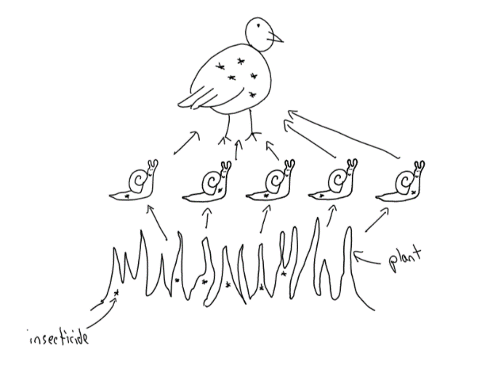
I am learning about bioaccumulation so I can explain why predators can have a large amount of toxic chemicals in their bodies
Let’s think back to the plants on a farm. The farmer sprays insecticide on the plants. This doesn’t kill the snails, but they still eat the plants and the insecticide goes into their bodies. They might only have a tiny amount of the insecticide in them – what scientists might call 1 ppm (ppm means “parts per million”). If a partridge ate that snail, the insecticide would then go into the partridge.
A partridge might eat 5 snails and they would then have 5 ppm. If a fox then eats 5 partridges, it could end up with 25 ppm. It is often difficult for these chemicals to leave the body, so predators can get more and more of them in their body and if they have enough of the chemical it can start to make them very ill. We call this bioaccumulation.
It can often take a long time for scientists to figure out that there is a problem as the toxic chemicals are only harmful in large quantities, so predators can be absolutely fine for a very long time.
- Explain how a stoat could end up with insecticide in their body.
- Robins do not eat leaves. A farmer sprays insecticide on some leaves. Explain how the insecticide can end up in the robin’s body.
- A farmer finds a dead robin on their field and passes it to a scientist, who finds out that it has a lot of toxic chemicals in its body. Explain how the robin came to have so much of the chemical in its body.
- There was a long delay between the farmer using the insecticide and the robin dying. Explain why there was this delay.
- A scientist develops a new insecticide that can be digested and excreted by robins. What effect will this have on the population of robins?
- The following are food chains found on the shore.
Algae à barnacle à sea bird
Algae à limpet à dog whelk à crab à sea bird
Algae à mussel à starfish
Algae à mussel à dog whelk à crab à sea bird
  - Construct a food web for this information.
  - Identify all carnivores in the food web.
  - How could an increase in the number of mussels cause an increase in the number of dog whelk?
  - How could an increase in the number of crabs cause an increase in the number of barnacles?
  - A new sea bird comes to the area which eats only starfish.
    - What effect will this have on the number of mussels?
    - What effect will this have on the number of dog whelks?
    - What effect will this have on the number of crabs?
    - What effect will this have on the first sea bird?
  - A new crab comes to the area which is bigger and stronger than the first type of crab.
    - What effect will this have on the number of dog whelks?
    - What effect will this have on the number of the original type of crab?
    - This new crab’s shell is too hard for seabirds to eat it. What effect will this have on the total number of sea birds?
    - What effect will this have on the number of barnacles?
  - Burning coal can release mercury into the oceans. How could mercury end up in the sea birds?
  - Explain why sea birds are found with more mercury in their bodies than barnacles
Lesson 5: adaptations
I am learning about different adaptations so I can explain why organisms have certain physical structures and behaviours.
We now know that snails are eaten by partridges. Snails have shells, which can help protect them from partridges. This is called an adaptation – and it is a way that the organism suits its environment. If the snail did not have any predators, it would not need a shell. Some caterpillars that eat cabbage are greenish-white in colour. This helps them camouflage (blend in) to the colour of the cabbage they eat, and it makes it harder for robins to spot them. Other caterpillars have spikes to protect them, and others have very bright colours to warn predators that they have a very bad taste.
These are all examples of physical adaptations – things to do with the structure of the organism. Organisms can have hundreds of physical adaptations to help them succeed. Other examples include:
- Hedgehogs, holly and roses have spikes to protect them
- Polar bears have wide feet to help them move on snow
- Horses have smaller feet to help them run on hard ground
- Predators have sharp teeth to help them catch, kill and eat their prey
- Underwater plants have long stems so their leaves can get to the top of the water

The questions below are about different organisms and their adaptations
- Look at the food chains below:
cabbage à caterpillars à hedgehogs à foxes
cabbage à snails à hedgehogs
cabbage à snails à robins
seeds à robins
robins à red kites
cabbage à rabbits à red kites
cabbage à rabbits à foxes
  - Construct a food web for these food chains
  - How could an increase in the number of rabbits cause an increase in the number of hedgehogs?
  - What physical adaptations do snails have?
  - Explain why this is useful to them
  - A student says “robins are herbivores because they eat seeds.” Explain why the student is wrong.
  - Rabbits have very strong legs which help them move quickly. Explain why this is a physical adaptation
  - Explain why this is useful to them
  - Rabbits have very large ears. Explain why this is useful to them
  - What physical adaptations do hedgehogs have? Why is this useful to them?
  - A farmer buys a dog to chase rabbits away from his fields. What effect will this have on the population of foxes?
  - What effect could this have on the population of hedgehogs?
  - Cabbage plants make food by photosynthesis. Which part of the plant makes food?
  - What will the plant use that food for?
- Bearded dragons are a type of lizard that live in the desert. Anolis lizards are a type of lizard that live in jungles.
  - Explain why bearded dragons are a brown/yellow colour
  - Explain why anolis lizards are a green colour
  - Bearded dragons eat small insects like locusts. Locusts eat plants. Draw a food chain for this feeding relationship.
  - A dingo is a type of dog that is one of the bearded dragon’s predators. Add dingoes to your food chain.
  - Label all producers and consumers on your food chain.
  - Dingoes have brown fur. Explain why.
  - Dingoes have very sharp teeth. Explain why.
  - A farmer sprays insecticide on his plants to stop locusts eating them. Explain the effect this can have on the dingo population.
  - Explain why dingoes can be found with insecticide in their bodies even though they don’t eat plants.
  - Explain why it could be a long time before the farmer realises that the dingoes are being affected by the insecticide.
When hedgehogs feel threatened, they curl up into a ball to protect themselves. This is called a behavioural adaptation – something about the way an organism behaves which helps it survive and succeed. There are many different types of behavioural adaptations, for example robins tend to look for food on the ground underneath bushes. This makes it harder for birds like red kites to spot them. Like most other birds, they build nests to protect and shelter their offspring (children), and they also sing to attract mates. Lots of animals fight over land or mates. Male walruses for example will fight extremely hard to see which of them has access to the female walruses in a certain area.
Robins tend to work by themselves (or in pairs) but many animals work together as a team. For example, dingoes will work together to bring down a kangaroo – something none of them could do by themselves. Penguins huddle for warmth, which allows more of them to be protected from the cold.
- For each of the below, state whether it is a physical or behavioural adaptation:
  - Red kites flying high up to spot prey
  - Red kites have large wings to help them glide
  - Red kites have strong claws
  - Plants have brightly coloured flowers to attract insects
  - Caterpillars have spikes
  - Caterpillars are the same colour as plants
  - Woodlice stay in dark, moist areas
  - Earthworms avoid coming up to the top of the soil
  - Male kangaroos fight each other
  - Male robins have red breasts which grown in size as they get older to show their age and strength
  - Bowerbirds sing and dance to attract females
  - Bowerbirds have bright colours to attract females
  - Cactuses have tiny leaves to stop them losing water
  - Roses have thorns to protect themselves from being eaten
Lesson 6: competition
I am learning about how animals compete for resources so I can describe the importance of their adaptations
In the previous lesson, we looked at several different species and their adaptations. A species is a group of organisms that can produce fertile offspring. This means that their offspring can have more offspring. Because dogs can mate and produce dogs that can produce more dogs, they are called one species. But a dog cannot mate with a cat and produce offspring that could produce more offspring, so they are different species.
Some adaptations work between species – so they help one species (e.g. snails) be protected from another species (e.g. hedgehogs). Some adaptations are about each organism trying to get limited resources. A resource is something you need to survive. We call this competition.
Trees are all competing for light (as well as other things), so growing tall is a physical adaptation that helps them in this competition with members of their own species or other species of trees.
Robins will have a territory – an area which is “theirs” for food. If another robin comes to their territory, they will become very aggressive and will chase it away. This is a behavioural adaptation that helps them compete for food. Male peacocks grow large and colourful tails to help them attract females. The males with the biggest, most colourful tails are best able to compete for mates.
- This question is about horses
  - Wild horses run away from predators, and narrow hooves are better for this than wide feet. Explain why this is a useful adaptation.
  - Male horses fight for mates. Explain why having strong teeth is a useful adaptation.
  - Explain why strong teeth is also a useful adaptation when competing for food.
  - Some horses live in cold areas and have very thick fur. Explain why this is a useful adaptation.
  - Some of the food horses eat is quite high up. Explain why tall horses can live longer than short ones.
- This question is about red and grey squirrels
  - Red squirrels live in trees with brown barks. Explain why their colour is a useful adaptation.
  - Is their colour a behavioural or physical adaptation?
  - Pine martens eat red squirrels. Explain why pine martens have sharp teeth.
  - Red squirrels eat acorns. Draw a food chain for red squirrels.
  - Red squirrels tend to live alone, with large distances between them. Explain why this is a useful adaptation.
  - Red squirrels have big ears. Explain what type of adaptation this is and why it is useful
  - Grey squirrels were introduced to the UK over the last few hundred years. They carry a disease that does not affect them but can kill red squirrels. What effect would this have on the population of red squirrels and why?
  - The population of red squirrels has declined massively. Part of the reason is because both grey and red squirrels eat acorns, but grey squirrels can eat them before they are ripe. In this case, what are the squirrels competing for?
  - Grey squirrels are larger than red squirrels and better able to survive cold winters. Explain the effect this has on the population of red squirrels.
  - When red squirrels have little food they will not breed as much. What effect does the introduction of grey squirrels to the UK have on red squirrels’ mating?
  - Red and grey squirrels cannot mate with each other and produce fertile offspring. Are they one or two species?
  - Red squirrels can smell pine martens. Is this a physical or behavioural adaptation?
  - When red squirrels smell pine martens, they run away from the smell and are very careful in going to get food. Is this a physical or behavioural adaptation?
  - Explain why this is helpful for the red squirrel
  - Grey squirrels do not run away when the scent of pine martens is present. Explain why pine martens find it easier to eat grey squirrels than red squirrels.
  - Draw a food web showing acorns, red squirrels, grey squirrels and pine martens
  - The population of red squirrels in an area has become close to zero due to grey squirrel competition. A scientist introduces a pine marten to the area. What effect could this have on the red squirrel population? Explain your answer.
  - Foxes also eat squirrels, but cannot climb trees like pine martens can. Explain why pine martens out-compete (are better at competing for) food like squirrels than foxes are.
Lesson 7: evolution
I am learning about how natural selection leads to evolution
Many thousands of years ago, squirrels will may not have been very good at smelling pine martens. Whenever a new squirrel is born, it takes DNA from both its parents. Normally, the DNA is copied straight across with no changes. Sometimes, it changes a little bit – this is called a mutation. Often, those mutations make no difference, but sometimes they can make a small difference. For example, a squirrel may have been born that could smell pine martens a little bit better than its parents and other squirrels. This squirrel was more likely to be better at hiding from predators than the other squirrels. It was then more likely to live for longer and have more offspring than other squirrels. Each of these offspring could also smell the pine marten better than other squirrels, and they more likely to live longer and have more offspring and pass on their improved sense of smell. Over thousands of years, the number of these squirrels increased until nowadays all red squirrels can smell pine martens very well.
This is called evolution by natural selection. Natural selection means that the most successful organisms (in this case the super-smelling squirrels) live the longest and pass on their characteristics to the most offspring. Over time, this leads to large changes within a species. It can even result in new species coming about. Many hundreds of thousands of years ago, there probably were no grey or red squirrels, but a different type of squirrel completely. Some of these squirrels may have ended up in America, and others in the UK. The ones in America adapted for that environment, and got bigger and took on a grey colour. The ones in the UK adapted for that environment, and became red in colour and could smell pine martens. Eventually the differences became so large that they could not interbreed and therefore became different species completely.
- Modern horses are descended from a small animal that lived 55 million years ago called hyracotherium.
  - The hyracotherium lived in very muddy swamps and had wide feet. Why do you think it had wide feet?
  - Over time, the hyracotherium’s environment changed and became less muddy. Offspring with a mutation for narrower feet could compete better. Is narrow feet a physical or behavioural adaptation?
  - Why were narrow-footed animals better at competing?
  - Why did narrow-footed animals have more offspring?
  - Over time, the number of narrow-footed animals increased. What word is given for this process?
  - Having narrow feet was a mutation. What is a mutation?
  - Why are modern horses and hyracotherium considered different species?
  - In swamps, a lot of the food is low down in small bushes. In fields and forests a lot of the food is higher up. Explain why horses nowadays are taller than the hyracotherium was.
Sometimes natural selection can result in big changes very quickly. For example in 1915 there was a disease of oysters in Canada that killed almost all the oysters. The only oysters left were immune to the disease, and now almost all oysters in Canada are also immune to the disease. They aren’t a different species, but natural selection has still caused a change in them.
- If almost all the oysters died, why could the surviving oysters have lots of offspring?
- What caused some oysters to be immune to the disease?
- If a grey squirrel was born that could smell pine martens, would it be better or worse at competing than other grey squirrels?
- Would it be better or worse at competing than red squirrels?
- Climate change is causing a reduction in the amount of ice in the Arctic. Explain why a polar bear which is better at swimming than other polar bears would be more successful.
- What caused the polar bear to be better at swimming?
- Most plants have large leaves to get lots of sunlight. Large leaves also means the plant loses lots of water.
  - A plant in the desert has a mutation for smaller leaves. Explain why this is an advantage
  - What is a mutation?
  - Why does that plant live for longer?
  - Why does that plant have more offspring?
  - That plant also grew bigger than all the plants around it. What were the plants competing for?
  - Why was the big plant better at competing?
  - Over millions of years, the leaves became smaller and smaller. What is the name for this process?
  - Eventually the big-leaved and small-leaved plants became so different to each other they could no longer reproduce. What name is given to the different plants?
- Hedgehogs curl up into a ball when threatened. What kind of adaptation is this?
- Why do they do this?
- Hedgehogs often feel threatened by cars. Why has curling up into a ball become a bad thing?
- A hedgehog is born that runs away from bright lights. Explain why this is a useful adaptation.
- Explain how over time more and more hedgehogs run away from bright lights.
- On the island of Sark, there are very few cars. Explain why over time hedgehogs on Sark could become a different species to hedgehogs in England.
Scientists are very sure the process of evolution by natural selection has taken place. They use lots of evidence, and one main source of evidence is the fossil record. We can look at fossils of different organisms (like horses) and see how over millions of years there are slight changes (like to the horses’ foot size and height).
They also look at bacterial resistance. They use special drugs called antibiotics to kill bacteria, but some bacteria have mutations which make them immune to the drugs. Eventually, these are the only bacteria that survive, and bacteria without the resistance completely die out.
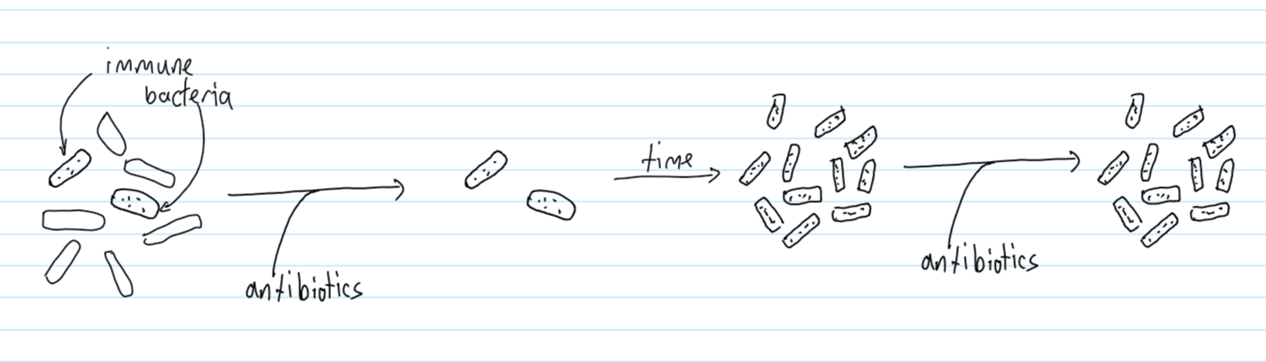
- Fossils from America show that grey squirrels used to be a lot smaller than they are now. Bigger squirrels are more likely to survive a difficult winter. How did grey squirrels get bigger over time?
- What two sources of evidence to scientists have for evolution by natural selection?
- Bearded dragons can vary (be different) in their colour. How could scientists find out if they were the same species?
- Some bearded dragons are very light yellow but others are dark brown. On what kind of ground would the light yellow ones be best adapted?
- On what type of ground would the dark brown ones be best adapted? Explain your answer.
- Some bearded dragons are a greenish colour. A farmer plants grass in the desert. Explain why the greenish bearded dragons would live longest on the farm.
- What would you expect to happen to the population size of the brown bearded dragons?
- A bacteria called E. Coli can be killed by piperacillin (a type of drug). How could E. Coli become resistant to piperacillin?

Lesson 8: Extinction
I am learning about the causes of extinction so I can explain why some organisms have gone extinct
As we have seen, the population of different species can change with time. If the population of a species goes to zero, then it is called “extinct.” Extinction is often a natural and normal part of evolution, but it is often caused by human activity. Below are a few examples of where extinction has occurred or almost occurred:
New predators | The Galapagos islands has a population of giant tortoises. About 200 years ago, whalers (people who hunted whales) started taking the tortoises onto their ships to serve as food. They took so many that 4 species of tortoise are now completely extinct, and the population of tortoises is about 10% of where it was only 200 years ago.  The kakapo is a large green bird that lives in New Zealand. When British colonists arrived in New Zealand, they brought ferrets and stoats to protect their farms from rabbits. The ferrets and stoats also hunted the kakapo, and in 1995 there were only 51 kakapo left. Thanks to scientists and conservationists, there are now over 200 and the population should increase over time.
New diseases | Chytridiomycosis is a fungal disease that affects frogs. In some species of frogs, most frogs can survive it. In other species of frogs it kills 100% of the frogs, and has resulted in the extinction of a number of frog species and a massive population decline (drop) in many others.  Ash dieback is a disease affecting ash trees. There is currently no known way to control it, and it has had a devastating impact on ash trees, and could lead to their extinction. Hopefully resistant trees or an effective control will be found.
Changes to habitat | The axolotl is an amphibian that lives in rivers and lakes near Mexico City. As the city has grown, water has been taken from the lakes which have also been polluted with toxic chemicals. Mexicans also like to catch and eat axolotl. As a result, axolotls are on the verge of becoming extinct in the wild.  Most of England used to be forest, but now it is mostly fields or cities. This has led to a large reduction in the space available for wild animals. Wolves are a good example of an animal that has suffered because of this. Due to hunting and loss of space to live, wolves are now extinct from the UK. This is a very common pattern with large predators. For example, over the last 100 years, the number of tigers in the wild has decreased from over 100000 to around 3000. This is due to habitat loss and poaching (like hunting).
More successful competitors | As we have seen, the introduction of grey squirrels has led to large declines in red squirrel populations. Though they are not extinct, there is a danger that this could occur.
Catastrophic events | Most scientists believe that the dinosaurs became extinct when an asteroid hit Earth. It will have led to large changes in the climate and the dinosaurs will not have been able to easily find food.

As you can see, humans have had a large impact on the living things that surround us, and even though extinction often happens naturally, this generally takes place over millions of years and at a relatively slow rate. Most scientists believe the current extinction rate is hundreds – if not thousands – of times higher than it is “naturally.” Scientists recently estimated that on average animal, many species of animal have reduced their populations by 60% in the last 50 years.
Human activities are good for some species. The changing climate in the ocean favours jellyfish, which can respond more quickly to changes than other species. There is now a massive increase in the jellyfish population, which in turn produces more competition for other organisms in the oceans.
Use all the information in the table and text above to answer the questions.
- Explain why the number of giant tortoises in the Galapagos Islands have decreased over time.
- Many millions of years ago, there was only one species of tortoise on the Galapagos Islands. A volcano erupted and separated the tortoises into two groups. The first group found themselves in an area with lots of grass to eat. The second group found themselves in an area with tall bushes. These tortoises evolved to have long necks.
  - What kind of adaptation are long necks?
  - Why is having a long neck an advantage?
  - What caused the first tortoises to have slightly longer necks?
  - In future generations of tortoise, why were there more of them with longer necks?
  - As time went on, their necks became longer and longer, until they could no longer mate successfully with the first group. What has taken place here?
  - What evidence would you expect to find if you went digging in the Galapagos Islands?
  - Humans came and started to eat the tortoises. Draw a food chain for this feeding relationship.
  - Label all organisms on the food chain as consumers or producers.
  - Explain why many species of giant tortoises eventually became extinct.
- Some scientists think that the best way to stop ash dieback spreading is by burning all the trees in a forest where it is found.
  - Why would this stop the disease spreading?
  - Some ash trees could develop resistance to ash dieback. Why would this make some scientists worried about burning forests?
  - A certain type of finch (a bird) only eats seeds from ash trees. Why could this bird become extinct?
  - A random mutation causes a finch to be born which can eat seeds from other types of tree. Why is this advantageous?
  - Over time, predict what could happen to the finch population.
Lesson 9: Population
I am learning about quadrats and pyramids of number so I can explain how scientists calculate population sizes
In order to understand more about the world around them and how different activities can affect different organisms, scientists need to be able to calculate the population of certain species. This isn’t as easy as just counting them. Even though there are only around 200 kakapo still living, there are 415,000 elephants and over 10000000000000000 ants. Scientists can’t count them all, so instead estimate.
There are a number of different ways to estimate, but one uses something called a quadrat. Your teacher will show you a quadrat. You throw the quadrat onto a field, and count the number of organisms inside the quadrat. You then work out how many quadrats would fit in the field in total, and from there estimate the number of organisms on the field.
Your teacher will take you out to the fields to show you how to use quadrats and complete 8BE – Required Practical.
Pyramids of numbers
A pyramid of numbers shows you the populations of the species in a particular food chain. Take the food chain below for example:
Grass à snails à hedgehogs
In one field, there could be hundreds of thousands of grass plants, hundreds of snails, but only a few hedgehogs. The pyramid of number would look like this:
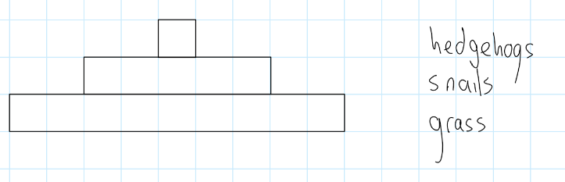
The pyramids aren’t always that simple. Take the food chain below:
Oak tree à aphid (a type of bug) à blue tits à sparrowhawk
Here, the producer is one organism, and there are thousands of primary consumers, so the pyramid looks like this:
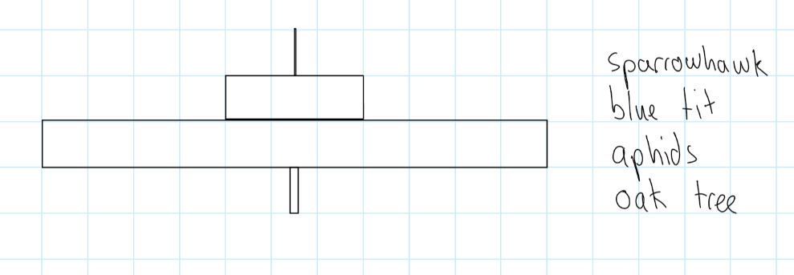
- Four pyramids of number are shown below:
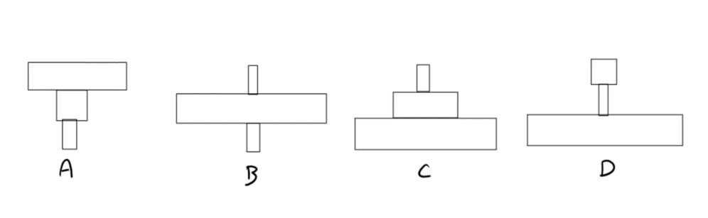
Choose which pyramid relates to which situation below. Pyramids can be used more than once.
- Grass à grasshoppers à sparrows
- Seeds à chickens à humans
- Pine tree à squirrels à pine marten
- A farmer has a cow which eats grass. The farmer decides to slaughter (kill) the cow, and feeds 30 people from the cow
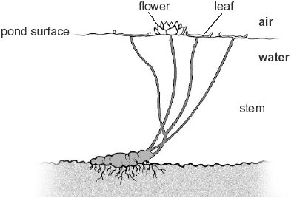
- Acacia trees are very large, and can feed a small family of 4 giraffes. A pack of 20 lions hunts and kills the giraffes.
- The picture shows a water lily – a plant that lives in water.
  - How is the lily adapted to living in water?
  - Why are the lily’s leaves at the top of the water?
  - Lots of insects live on lily leaves. The insects are eaten by cod. Draw a food chain for this feeding relationship.
  - Draw a pyramid of numbers for the food chain.
  - Identify any predators and prey on your food chain.
  - Explain why the lily doesn’t grow much in the winter.
- The Antarctic Ocean is very cold. Tiny organisms called phytoplankton live there and do photosynthesis. They are eaten by shrimp, which are prey for penguins, cod and squid. Seals are predators of penguins, cod and squid. Penguins also eat cod and squid.
  - Draw a food web for these feeding relationships
  - Sketch a pyramid of numbers for the food chain involving phytoplankton, shrimp, penguins and seals
  - Where does the energy in the food web come from?
  - Penguins huddle together for warmth. What kind of adaptation is this?
  - Penguins have a special coating on their feathers which keeps them dry. What kind of adaptation is this?
  - One year, the winter is particularly cold and a lot of penguin chicks do not survive. What could happen to the population of penguins?
  - What could happen to the population of cod?
  - Explain why the penguins that survive have less competition for food.
  - Penguins cannot fly, but use their wings for swimming. What kind of adaptation is this?
  - Explain why penguins with stronger wings are better adapted than ones with weaker wings.
  - Explain how over time penguins’ wings have become stronger.
  - A penguin is born and has a much longer beak than either of its parents. How could this have happened?
  - There is mercury (a toxic element) in the oceans due to human activity. Explain how penguins can come to have mercury in their bodies.
  - Explain why seals can have more mercury in their bodies than penguins.
  - When a penguin dies, its body decays. Explain why decay is very slow in the Antarctic Ocean.
  - Due to human activity, the Antarctic Ocean is slowly warming up. Antarctic phytoplankton are not well adapted to warm water. Explain why the temperature increasing could cause the population of shrimp to decrease.
  - The Saimaa ringed seal lives in the arctic. There are only around 300 Saimaa ringed seals left. What could happen to this seal if its numbers keep decreasing?
  - Saimaa ringed seals build ice dens to protect their offspring. What kind of adaptation is this?
  - Explain why warmer winters can cause problems for the Saimaa ringed seal.
  - There are lots of different types of ringed seal. How could scientists decide if two different ringed seals should count as two different species?
  - Humans fish in the lake that the Saimaa ringed seal lives in. Explain why this could be a problem for the seals.

Lesson 10: classification
I am learning about classification so I can group organisms together
For thousands of years, scientists have been trying to find ways to group different organisms together. Some groupings are obvious, like animals and plants or dogs and cats. Some are less obvious, like worms and snails and others can only be done with the aid of microscopes, like bacteria and protists. Putting these organisms into groups is called classification. Carl Linnaeus was a Swedish scientist living in the 18th century who is responsible for one of the most common classifications used today. It is divided as below:
Classification level | Example
Kingdom | Animals, plants, fungi, protists, prokaryotes (like bacteria)
Phylum | Chordata (have backbones), arthropods (most insects), annelids (worms)
Class | The chordata phylum is made of five classes: mammals, birds, amphibians, fish, reptiles
Order | The mammal class has an order called primates in it
Family | The primate order has a family in it called hominids
Genus | The family called hominids has a genus called homo in it
Species | The genus called homo has a species called sapiens in it
(Kids prefer candy over fresh green salad)
The scientific name for humans is homo sapiens, and the name is taken from the genus and species. In primary school, you will have learnt about the five chordata classes:
Class | Common features
Mammals | Have body hair or fur  Produce milk to feed their young  Warm blooded  Have four limbs  Breathe using lungs  Give birth to live young
Birds | Have feathers and wings  Lay eggs with hard shells  Breathe with lungs  Warm blooded
Amphibians | Smooth moist skin  Lay their eggs in water  Larvae have gills and live in water  Adults have lungs and live on land  Cold blooded
Fish | Live in water  Breathe with gills  Streamlined bodies  Cold blooded  Mostly lay eggs
Reptiles | Have dry, scaly skins  Lay eggs  Breathe with lungs  Cold blooded
You are not expected to memorise all of the features in the table, but you should be able to use the information to help you classify different organisms.

- Below is a list of organisms we have discussed so far in this booklet. For each one
  - Identify if it is a chordate (from the phylum chordata)
  - State which chordate it is and how you know
  - If it isn’t a chordate see if you can identify which kingdom or phylum it could be.
The first two have been done for you:
Grey squirrels:
- Grey squirrels are chordates
- They are mammals because they have fur and four limbs
Earthworms:
- Not a chordate
- They are annelids
List of organisms:

  - Bearded dragons
  - Penguins
  - Seals
  - Toads
  - Snails
  - Robins
  - Woodlice
  - Ants
  - Decomposer microbes
  - Trout
  - Hedgehogs
  - Bats

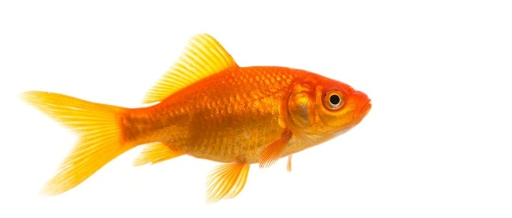
- Look at the picture of a fish. In what ways is the fish adapted for swimming? Give as many adaptations as you can.
- What kind of adaptations are these?
- People used to think that dolphins were fish, but we now know they are mammals. Give two ways in which you would expect dolphins to be different to fish.
- Blue whales are also mammals that live in the water. Over time, their population has decreased from around 350,000 to around 10,000. Suggest as many reasons as you can why this may have happened.
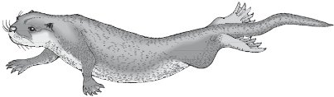
- The picture shows an otter. Otters are mammals.
  - How is the otter adapted for swimming?
  - The otter has very sharp teeth. Do otters eat fish or plants?
  - In what ways would you expect the otter to be different to a fish?
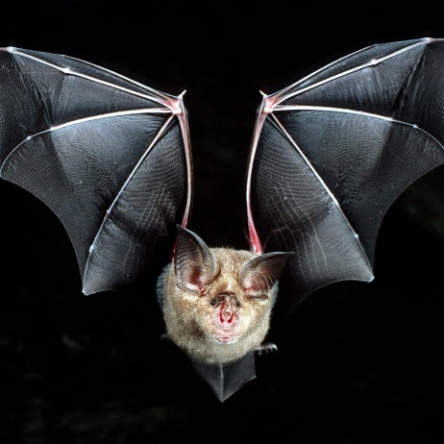
  - Otters dig burrows (big holes) underground where their cubs (babies) are born. What kind of adaptation is this?
  - How does this adaptation help otter cubs to survive?
  - Millions of years ago, some otters dug small burrows. Explain why otters that dug bigger, stronger burrows were more successful than the other otters.
  - Explain how over time the burrows dug by otters became stronger.
- The picture shows a bat. Bats are classified as mammals.
  - In what way is the bat similar to a bird?
  - How are bats adapted for flying?
  - In what ways would you expect the bat to be different to birds?
  - Bats have very large ears. Suggest why this is a useful adaptation.
  - Millions of years ago, bat ears were smaller than they are now. Explain how bat ears have changed over time.
Not all organisms can be easily classified. Your teacher will play this video about platypuses.
http://www.youtube.com/watch?v=9FTft5kxjsE
- Some people think that platypuses are mammals. Explain why.
- Some people think that platypuses are birds. Explain why.
- Some people think that platypuses are reptiles. Explain why.
- What other adaptations do platypuses have?
- Explain which class you think platypuses should belong to.
Extension - research any of the animals below and explain why it is hard to classify them: Mole rat, Pangolin, Blob fish, Jackson’s chameleon
Lesson 11: Biodiversity
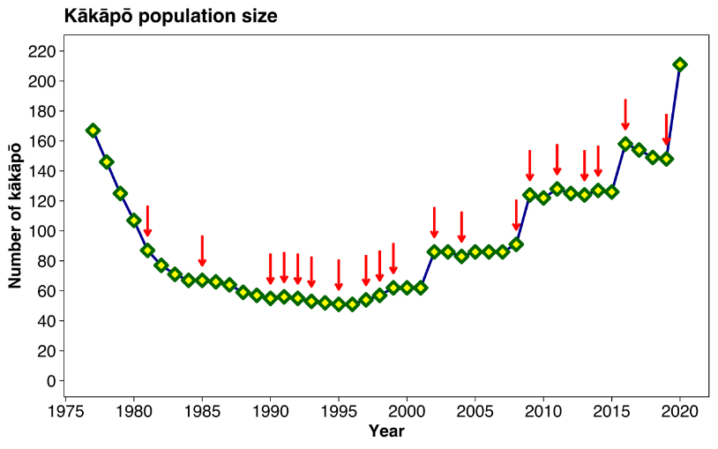
I am learning about biodiversity so I can explain why it is important
We saw earlier that the kakapo was driven to the edge of extinction due to human activities. As time has gone on, human scientists and conservationists have made great efforts to try and help the kakapo numbers increase. They tag every kakapo, so they know where it is and how to find it. If a kakapo gets sick, they will find it and fly it to special hospitals. Often once kakapos have laid eggs they will take the eggs and incubate them (help them grow) in environments where they will definitely have enough warmth to survive and there are no predators. They also make special habitats for them where there are no predators so they can live and mate without predators killing them. Because of this, kakapo numbers have been increasing over the last 20 years or so.
Humans could have decided to just let kakapo go extinct, and to not worry about their survival. This would cause a decrease in what scientists call biodiversity: the number of different types of organisms that there are in an area. Most people think it is important to keep biodiversity high, for a number of reasons:
- It is morally the right thing to do: we have a responsibility to protect the planet and the life that is on it
- Some species may be useful to us in the future (like plants in the rainforest could have medicinal properties [ used for medicine])
- Keeps up our food supply
- Food webs with lots of different species and connections can survive changes better than ones without
- In the rainforest there are millions of different species. In the arctic, there are very few. Which one has a greater biodiversity?
- Scientists are looking for plants with new medicinal uses. Should they look in the rainforest or the arctic? Explain your answer.
- Where do you think it is more likely that scientists would discover a brand new species, the rainforest or the arctic? Explain your answer.
- In India, tigers living close to cities were hunted and killed. Does this increase or decrease biodiversity? Explain your answer.
- Snail kites are animals with feathers, wings and warm blood. Which chordate class do they belong to?
- Snail kites eat apple snails, and normally don’t eat other types of food. Apple snails eat plants. Draw a food chain for apple snails, plants and snail kites.
- The apple snail has a hard shell. What kind of adaptation is this and why is it useful?
- When the weather is very dry, apple snails can dry out and die. To stop this happening, they bury themselves in mud and go into their shell. What kind of adaptation is this?
- A disease in a part of Central America affects the apple snail and causes them to dry out faster. How will this affect the population of apple snails?
- Some species of turtle eat apple snails. Add the food chains below to the food chain you made earlier to make a food web:
Plants à apple snail à turtle
Algae à shrimp à turtle
Algae à shrimp à small fish à turtle
- When the disease affects the apple snails, why are turtles better able to survive than snail kites?
- A person has a pet turtle which eats snails. The person takes snails from their garden to feed the turtle. Explain how insecticide can end up in the turtle.
- Explain why the turtle could have more insecticide in their body than any individual snail.
- Explain why the turtle owner might not realise the turtle is taking in insecticide for a long time.
- Snails that live on rocks underwater often have black shells. Snails that live in forests are usually brown or red. Explain why snails have this difference.

There are lots of things scientists can do to help maintain (keep high) biodiversity:
What scientists can do | What that means | Example
Gene banks | A special laboratory is built which protects DNA from many different organisms. Scientists can later use this DNA for research or to reintroduce organisms to the wild | The Svalbard Global Seed Bank stores 1,074,537 seeds. If ever a disease wipes out crops that we use for food, we can take the seeds from the seed bank and grow the crops again. There are lots of seed banks around the world, including the Millennium Seed Bank in Sussex.
Protection of habitat | Areas with threatened diversity can be physically and legally protected. Sometimes this means building a fence around them to stop predators and other times it means making laws stopping humans from going there. | Beavers used to be common across the UK, but about 500 years ago were hunted to extinction (people used their fur for clothes). Some beavers were recently discovered in the wild and it is likely they had escaped from captivity (like zoos). Conservationists have brought more beavers to the UK, but they live in special enclosed areas to protect them. Conservationists are also trying to get laws to be passed (made) which will stop farmers from killing beavers that may threaten their crops.
Breeding programmes | There are many species that have a very low population in the wild. Conservationists will often try to breed them in captivity (often zoos) in order to build up a large population which can then be released back into the wild. | In the 1970s, the Arabian Oryx was officially extinct in the wild. However, there were 9 oryxes in the Phoenix Zoo in America. Conservationists bred the oryxes and sent them to other zoos to build up big herds. There are now over 1200 Arabian oryxes in the wild, with thousands more in large zoos and enclosures around the world. Many zoos in the UK are involved in breeding programmes, and our local zoo (Paradise Wildlife Park in Hertfordshire) works with other local sanctuaries as part of a big cat breeding programme and has been very successful.  https://www.youtube.com/watch?v=-zABPunSGjg

- Seeds in seed banks are stored at very low temperatures. Explain why the Svalbard Global Seed Bank was built 1500 miles North of Scotland.
- A certain crop goes extinct in the wild due to disease. Explain how conservationists could reintroduce the crop.
- When crops die, they are broken down by detritivores. What is a detritivore?
- Give two examples of detritivores.
- What other organisms are involved in decay?
- Explain why the process of decay is important.
- Explain why decay can often be slower in deserts than forests.
- Explain why beavers need to be protected from farmers.
- Explain why beavers need to be protected, but pigeons do not.
- Beavers eat plants, and foxes will eat beavers. Draw a food chain for this feeding relationship.
- If there were no beavers, foxes would not be endangered. Explain why.
- Explain why conservationists build fences around large areas where beavers live.
- Beavers have fur, warm blood and give birth to live young. They also live in the water. What class of chordata are they? Explain your answer.
- Beaver fur is very thick and waterproof. Explain why this is a useful adaptation.
- Beavers use logs and sticks to build dams and block rivers. What kind of adaptation is this?
- When scientists release animals from captivity (like zoos) into the wild, they often release them in pairs with one male and one female. Explain why they do this.
- In breeding programmes, it is important that conservationists do not use animals from the same family (like cousins) to breed. Explain why it is important for zoos to work together on breeding programmes.
- A scientist uses a seed from a seed bank to grow a small plant on a field. They come back in a while and lots of the plant have now grown. How can they use a quadrat to estimate the total number of the plant on the field?
- Why is this only an estimation?

