8PE Electricity

Name:

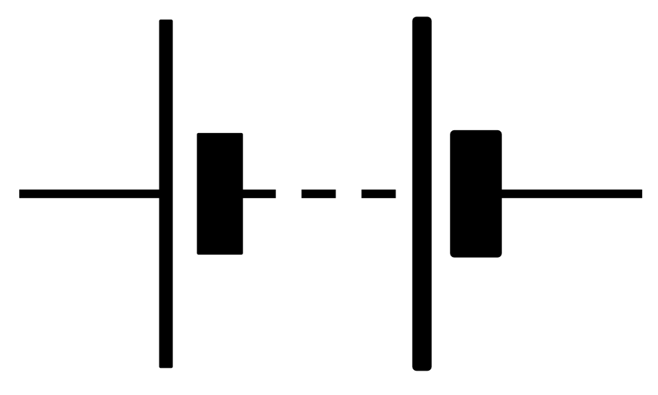

What do we call a closed loop which can carry electricity? | A circuit
How do we count electrons? | In coulombs
What is current? | How quickly coulombs of electrons are flowing through a circuit
What is the unit and unit symbol for current? | Amps (A)
What does 1 A represent? | One coulomb passing a point per second
Which particle transfers energy around a circuit? | Electrons
Where do electrons in a circuit get energy from? | A power supply
Name two power supplies | Electrical cell/battery, mains power
What is a battery? | Two or more cells connected together (in series)
What is potential difference? | The amount of energy each coulomb of charge transfers
What is the unit and unit symbol for potential difference? | Volts (V)
What happens to the current when potential difference increases? | It increases
What is resistance? | How electrons can be slowed down by the circuit
What is the unit and unit symbol for resistance? | Ohms (Ω)
What causes resistance? | Electrical devices
What is a device? | Something which transfers energy from the circuit to the surroundings
What is a switch? | A place in the circuit where it can be broken
Name 3 electrical devices that transfer energy in a circuit | Lamp, motor, resistor
How do lamps transfer energy to the surroundings? | Waves (and heating)
How do motors transfer energy to the surroundings? | Mechanical working (and heating)
How do resistors transfer energy to the surroundings? | Heating
What equation links potential difference, resistance and current? | V/R = I
How do we measure the current in a circuit? | With an ammeter
How are ammeters connected to a circuit? | As part of the circuit (in series)
How do we measure the potential difference across a device? | With a voltmeter
How are voltmeters connected to a circuit? | Across (on the back of) specific devices (in parallel)
What are the two main types of circuit? | Series and parallel
What are series circuits made of? | A single loop
How does current change in a series circuit change? | It doesn’t
How does potential difference in a series circuit change? | It is shared between devices (It drops across each device)
What are parallel circuits made of? | Different loops and junctions
How does current in a parallel circuit change? | Splits at junctions
How does potential difference in a parallel circuit change? | Same across each loop
Give an example of a conductor of electricity | Copper, graphite (any metal)
Give an example of an insulator of electricity | Plastic, wood, rubber (most non-metals)

Lesson 1: Charge

I am learning about the charge on different particles so I can explain what causes electricity.

Recap quiz on properties:

- What is a property?
- Name three typical properties of metals
- A material is a gas at room temperature. What can you say about its boiling point?
- Name the three subatomic (smaller than an atom) particles
- Challenge: why do metals conduct electricity? If you need to, go back to your notes from the last unit

Different substances have different properties. One property is called charge. It is a little difficult to fully explain what charge is, but some substances have positive charge, others have negative charge, and some have no charge at all.

When discussing electricity, we are most interested in the charge of subatomic particles:
Protons: +1
Neutrons: 0 (no charge)
Electrons: -1

In some materials, like metals, electrons are free to move around. Any material like this is called a conductor of electricity. If we take the conductor (like a metal), turn it into a wire, and then make a closed loop, we say an electrical circuit has been made. This is what we commonly call “electricity.”

Comprehension questions:
- What is charge?
- What are the three options for charge?
- From memory, what is the charge on a proton, neutron and electron?
- What needs to be done to a wire before we call it a circuit?
- Why do we use metals to make circuits?

Electrons are incredibly tiny. If you took a small piece of metal, there would be billions and billions of electrons in it. It’s important to scientists to talk about how many electrons there are in a particular circuit, but because there are so many of them we use a different word. Scientists use the word coulomb to describe an enormous number of electrons (about 6 quintillion). You can think really simply that the word “coulomb” just means “massive group of” so “one coulomb of electrons” just means “a massive group of electrons.” Technically, the word coulomb can refer to any charged particle but we will just use it for electrons.

Comprehension questions:
- A piece of wire has 6000000000000000000 electrons in it. Why is it easier for scientists to use the word coulomb when describing that piece of wire?
- If one coulomb is approximately 6 quintillion electrons, how many electrons are in:
  - Two coulombs
  - Half a coulomb
  - A sixth of a coulomb
- Explain why metals conduct electricity.
- A student says:
“this piece of wire has 6 coulombs of electrons moving through it, which means it has 6 electrons moving through it”
Explain why the student is wrong.

The final ingredient for an electrical circuit is a power supply. The power supply pushes the electrons round the circuit and allows them to transfer energy. When the electrons pass a certain point in the circuit, we can measure how quickly they are going past. We call this the current and it is measured in amps (A). One amp (1 A) means “one coulomb of charge every second.”

Comprehension questions:
- What is an electrical conductor?
- Give an example of an electrical conductor
- What is a coulomb?
- What is current?
- What is the unit for current?
- If two coulombs of charge are passing a point every second, what is the current?

Electrical circuits can transfer energy from the power supply to the surroundings. The electrons receive energy from the power supply and transfer it around the circuit. There are two common types of power supply: mains and cells.

Mains: this refers to the electricity that comes from a plug. This originally comes from the National Grid, which is a large network of cables and power plants all around the country.

Cells: these are often called “batteries,” but technically batteries are made of two or more cells. A cell is something which has lots of energy in its chemical store which it can release by a chemical reaction.

The amount of energy that coulombs can transfer is called the potential difference. It is measured in volts (V). A high potential difference means lots of energy is being transferred. Because the electrons are given more energy, they also move faster. This means the current increases.

A low potential difference means very little energy is being transferred. This means the electrons move slower and the current is therefore lower.

Increasing the potential difference increases the current.

Comprehension questions
- Name the two most common power supplies
- What is the difference between a battery and a cell?
- What is potential difference?
- What is potential difference measured in?
- Why are metals good conductors of electricity?
- What is one amp?
- How do we count electrons?
- Why do we not count them by number?

There is no point in energy just being transferred within the circuit. We use circuits because they can transfer energy out of the circuit. For example, an electric heater will transfer energy out of the circuit and into the area around it. We call the area around it the surroundings.

Circuits do this by having electrical devices in them like lamps or motors. These devices slow down the electrons, which lose energy. That energy is then transferred to the surroundings. This is called resistance: when electrons are slowed down by a device in the circuit. Resistance is measured in ohms (Ω).
- What is resistance?
- In an electrical device, what happens to the electrons?
- Why do we use circuits?
- When electrons slow down, they lose energy. Where does that energy go?
- A circuit has a very high potential difference. Do you think it will have a high or low current?
- Explain your answer.
- If that circuit had a very high resistance, how do you think that would affect the current?
- Explain your answer.
- What is charge?
- What is a coulomb?
- How is current measured?
- What is current?
- How do we measure potential difference?
- A student attaches a battery to a long piece of wire. What do they need to do to the wire before it is considered an electrical circuit?

Drawing circuits

I am learning how to use symbols to quickly and easily draw circuits.

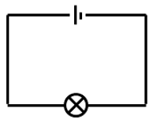
Scientists use special symbols in order to draw out circuits as diagrams. You can find the symbols that we will be using in the front of this booklet. You are going to be using diagrams to construct circuits. First, your teacher will show you a simple circuit set up like this:

Often, you will find that your circuit is not working. Before you ask for help, you must follow the steps below to “troubleshoot” your circuit and attempt to fix it for yourself. Your teacher will show you how to do each of the steps.
- If you are using a mains power pack, check that it is plugged in and switched on at the mains (the switch by the plug is on)
- If you are using a mains power pack, check that it the power pack itself is switched on (there is a switch on the pack itself)
- If you are using a mains power pack, check that you have two wires connected to the power pack, both in different holes
- If you are using a cell, make sure that the cell is in the base properly and the + and – sides on the cell match the + and – on the plastic
- If you are using a cell, check that you have two wires connected to the cell, both in different holes
- Check that your wires are all in one straight loop with no breaks
- Check that one wire goes into one side of the bulb, and the other wire goes into the other side of the bulb
- Check that the bulb is screwed into the base properly
- Look at the filament in the bulb – if it is broken return the bulb to the teacher and get a new one
- There is a small red plastic button on the power pack. Press this button.

Once you have constructed that circuit, construct the circuits below. For each one, describe what happens to the brightness of the bulb.

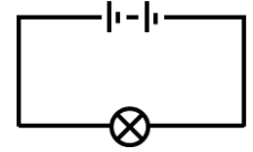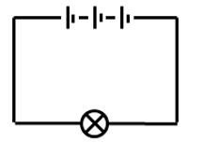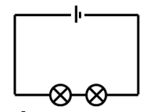
Questions for when you have set up the circuits:
- Which particle is transferring the energy around the circuit?
- How do we count those particles?
- What kind of charge do those particles have?
- What are the other two types of charge?
- How do we measure the amount of energy being transferred round the circuit?
- What unit do we use?
- What causes the electrons to slow down in a circuit?
- In terms of energy, what happens when the electrons slow down?
- Name two types of power supply.
- Draw a circuit with three cells and two lamps
- Add a switch to your diagram between the cells and the lamps.
- Draw a new circuit with one cell and two lamps
- Add a switch between the two lamps.
- If that switch is opened, do both lamps turn off or just one? Explain your answer.

Electrical devices

I am learning about how lamps, motors and resistors transfer energy to the surroundings

When electrons pass through an electrical device, they slow down due to its resistance. They therefore lose energy. This energy has to go somewhere, and is transferred to the surroundings. There are many different types of device, but we will only cover 3: lamps, motors and resistors.

When electrons pass through a lamp, it lights up and energy is transferred to the surroundings by waves.

When electrons pass through a motor, it starts to spin round and energy is transferred to the surroundings by mechanical working.

When electrons pass through a resistor, it starts to get hot and energy is transferred to the surroundings by heating.

- Complete the sentence stems below:
  - When electrons enter a device, they…
  - When electrons enter a device, energy is…
  - When electrons enter a lamp, energy is…
  - When electrons enter a motor, energy is…
  - When electrons enter a resistor, energy is…
  - When there is high resistance, the current is…
  - When there is high potential difference, the current is…
- Draw a circuit with:
  - Two cells, a lamp, and a resistor
  - Three cells, a switch and a resistor
  - Two cells and a motor
  - Two cells and a motor which can be turned on and off. When the motor is on, a light also comes on.
- Toasters transfer energy by heating. Which electrical device are they most like?
- What are the units for potential difference and current?
- Which of the below will have the highest current?
  - A circuit with high potential difference and high resistance
  - A circuit with high potential difference and low resistance
  - A circuit with low potential difference and high resistance
  - A circuit with low potential difference and low resistance

Making links
- A circuit has a lamp in it. The lamp gives off light as a wave. What kind of wave is light?
- In what direction does the light travel?
- If the light passes into a glass block at an angle, what happens?
- Draw a ray diagram to show this process.
- Some of the light going into the block is absorbed. What does this mean?
- Some of the light going into the block is reflected. What does this mean?
- What is the law of reflection?
- A lamp produces green and blue light. The light is passed through a green filter. What colour light comes out of the filter?
- The lamp shines on a red ball. What colour does the ball appear?
- The lamp gets its energy from a cell. The cell has lithium in it. What group is lithium in?
- What is observed when lithium is dropped in water?
- How many protons, neutrons and electrons does an atom of lithium have in it?
- Draw the full structure of lithium, showing all electrons.
- Lithium is an alkali metal. Why is it an alkali metal?
- What is the trend in the reactivities of the alkali metals?
- When lithium oxide reacts with sodium, sodium oxide and lithium are produced. Write a word equation for this reaction.
- Identify reactants and products.
- The formula for lithium oxide is Li₂O. Which atoms does it have in it?
- When lithium reacts with acid, bubbles can be seen. What happens to the mass?

Measuring potential difference and current

I am learning how to use ammeters and voltmeters in a circuit to measure potential difference and current

Your teacher will demonstrate to you how ammeters and voltmeters are connected in circuits.

- Construct this circuit:
- If it doesn’t work, go back to your troubleshooting guide.
- Measure the current before the first bulb
- Measure the current after the second bulb
- Measure the current between the bulbs
- Measure the potential difference across the cell
- Measure the potential difference across each bulb individually
- Measure the potential difference across both bulbs
- Clear away your equipment, and work through the questions below.
- Draw a circuit with two cells and two bulbs
- Add a voltmeter to each bulb
- Add a switch
- Draw a circuit with a resistor, a motor and a switch.
- On the circuit, show how you would measure the current in that circuit.
- If another device were added to the circuit, how would the current change?
- Explain your answer.
- On the circuit, show how you would measure the potential difference across the motor?
- Name three devices and how they transfer energy to the surroundings.
- An electrician uses a resistor to heat a room. The resistor has a light on it that says when it is on. How would removing the light affect the amount of energy transferred to the room? Explain your answer.

Ohm’s law

I am using experimental data to look at the relationship between potential difference, current and resistance

We already know that increasing resistance decreases current. We also know that increasing potential difference increases current. We are going to do an experiment to prove that this is the case. First we will build a circuit with one lamp. We will slowly change the potential difference and then measure the current.

- What is the independent variable in this experiment?
- What is the dependent variable in this experiment?
- Which variables need to be controlled?
- Explain why they need to be controlled
- What do you predict will happen in this experiment?
- Explain your answer.

Your teacher will show you how to set this experiment up and how to take your readings.
- Set up your circuit and complete the table:

Potential difference (V) | Current (A)
- Describe the relationship between potential difference and current.
- Explain the relationship between potential difference and current.

Once you have completed the table, add another lamp to your circuit.
- How do you predict this will affect your results?
- Explain your answer.
- Use the same potential differences as you did before to complete the table for your second experiment:
Potential difference (V) | Current (A)

- You should see that the current in the two experiments is different. Describe the differences between the two experiments
- Explain why they are different

Ohm’s law turns what you already know about resistance, potential difference and current into an equation:

$Current= \frac{potential difference}{resistance}$ $I= \frac{V}{R}$

This shows that if potential difference is increased, current is increased. If resistance is increased, current is decreased.

 | I do: Calculate the current flowing when a 45 Ω resistor has 20 V of potential difference across it. | We do: Calculate the current flowing when a 90 Ω resistor has 15 V of potential difference across it.
Data

Equation

Substitute

Calculate

Units

You do:
- A battery gives a potential difference of 4 V. Find the current through a resistor of 20 Ω connected directly to the battery.
- A battery gives a potential difference of 12 V. Find the current through a resistor of 30 Ω connected directly to the battery.
- Calculate the current flowing through a 10 Ω resistor when a potential difference of 3.3 V is applied

 | I do: What is the potential difference needed to create 14 A of current through a 12 Ω resistor? | We do: What is the potential difference needed to create 25 A of current through a 300 Ω resistor?
D

E

S

C

U

You do:
- Calculate the potential difference if a 10 Ω resistor has 0.5 amp of current flowing
- What potential difference will let 5 amps flow through a 0.5 Ω resistor?
- A 2.5 Ω resistor is connected to a circuit that has 0.25 amps flowing. Calculate the p.d. (potential difference) of the resistor.
- What is the current across a lamp with a potential difference of 2 V and a resistance of 0.1 Ω?
- Describe the relationship between current and potential difference.
- Describe the relationship between current and resistance.
- What potential difference is required for a current of 200 A in a resistor of 10000 Ω?

 | I do: Find the resistance of a component which allows 25 A of current to flow when 100 V of potential difference is put across it. | We do: Find the resistance of a component which allows 16 A of current to flow when 84 V of potential difference is put across it.
D

E

S

C

U

- Find the resistance of a component which allows 5 A of current to flow when 25 V of potential difference is put across it.
- What is the resistance of a resistor with 680 V of potential difference across it if 46 A of current are flowing?
- What resistance will be caused by a lamp that has 3 amps flowing when a voltage of 9 volts is applied
- Calculate the resistance of a circuit which has a potential difference of 4.5 V and a current of 3 amps
- A resistor has a potential difference of 5.5 V and a current of 0.5 A what is its resistance in ohms?
- Find the potential difference that will push 2.4 A of current through a 90 Ω resistor.
- Find the potential difference that will push 5.2 A of current through a 40 Ω resistor.
- A 50 Ω resistor has a voltage of 25 V. What is the current flowing?

Mixed practice (AC)
Note on units. When numbers are very big or small we change the units to make them easier to read. In order to use them in the equation, you need to change them in the data step.
Unit | Change to the number
M (mega) | X 1,000,000
K (kilo) | X 1000
m (milli) | ÷ 1000
µ (micro) | ÷ 1,000,000

- I do: How many A are in:

  - 2MA
  - 3kA
  - 7mA
  - 4 µ
  - 1.5MA

- We do: How many V are in:

  - 1.7kV
  - 200mV
  - 0.08MV
  - 74µV

- You do: How many Ω are in:

  - 100kΩ
  - 0.89mΩ
  - 70034µ
  - 1.1MΩ

When using these values with the equation, make any changes in the D step

- The voltage across a lamp is 0.08 kV and the current through the lamp is 2 mA. Calculate the resistance of the lamp
- The current through an iPad is 11 mA and the voltage of its power supply is 12 V. Calculate the resistance of the ipad?
- The resistance of a resistor is 340µΩ and the current through it is 0.3 A. What is the voltage across the resistor?
- The voltage across a 50 MΩ resistor is 6 V. What is the current through the resistor?
- The resistance of an iPhone is 3 kΩ and the current through it is 4 mA. What is the potential difference of its power source?
- The voltage across a woman when she is struck by lightning is 33 MV and the resistance of a human being is around 1 kΩ. What is the current?
- The voltage across a 50 mΩ resistor is 6 MV. What is the current through the resistor?

Series and parallel circuits

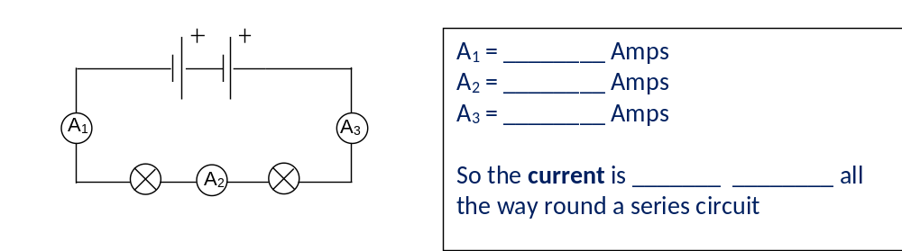
I am learning about the differences between series and parallel circuits to explain how potential difference and current can vary

The circuits we have used till now are called series circuits. In a series circuit, the current is the same across the entire circuit.

In the circuit to the right, the current in all three ameters would be exactly the same.

However, the potential difference is “shared” between the different devices in the circuit. So if there are 12V coming from the battery, those 12V will be shared between the lamps. One might take 6V and the other would take 6V, one might take 10V and the other 2V. It all depends on the actual devices as different devices take different amounts of volts.

- Draw a circuit with one cell and two lamps
- The cell has a potential difference of 10V. One of the lamps has a potential difference of 6V. What is the potential difference across the other lamp?
- The first lamp has a potential difference of 6V, and a resistance of 2.4Ω. What is the current through that lamp?
- What is the current through the other lamp?
- Two new lamps are used. One has a resistance of 3Ω and the other has a resistance of 7Ω. If the current across both is 1.3A, what is the potential difference across each one?
- What is the total potential difference from the power supply?
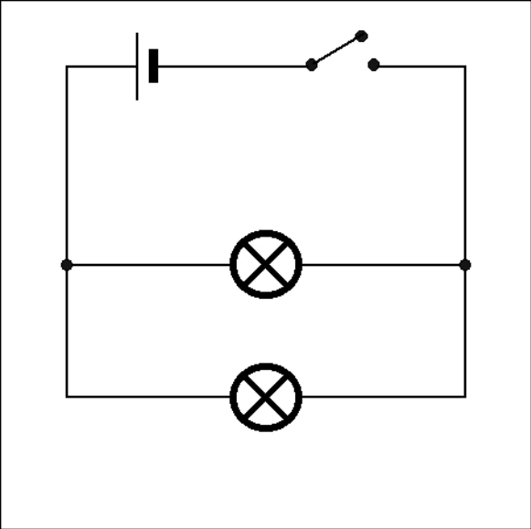
12V
In a series circuit, if there is a break at any point in the circuit the whole circuit stops working. This means that if you had a series circuit at home, if one bulb died or you flicked one switch, all the lights in the house would go off. However, there is a different kind of circuit which can get around this problem called a parallel circuit. This circuit has different loops and junctions, which allows for lots of mini-circuits to be connected.
12V
3A
5A

The circuit to the right is a parallel circuit. If one bulb breaks, the other one can still work because the electrons still have a complete circuit to flow through.
12V
2A

Because some electrons go through the first bulb and others go through the second, the current splits up too. It might be that there are so many coulombs in the main loop, but they must split up at the junction, with some going one way and others going another way.

However, the potential difference across both branches stays the same. This is because potential difference is about how much energy each coulomb is transferring, and whether the coulombs go through the top branch or the bottom branch doesn’t really matter – they still transfer the same amount of energy.

The rules:

How does current in a series circuit change? | It doesn’t
How does potential difference in a series circuit change? | It is shared between devices (It drops across each device)
How does current in a parallel circuit change? | Splits at junctions
How does potential difference in a parallel circuit change? | Same across each loop

Your teacher will do a number of worked examples with you.
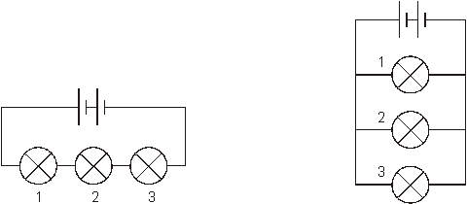
- In the circuit to the right, all the lamps are identical. The potential difference at 1 is 2 V. What is the potential difference at 2?
- What is the potential difference at 3?
- What is the overall potential difference from the battery?
- If bulb 1 breaks, what happens to bulb 2 and 3?
- The current coming from the power supply is 12 A. What is the current at 1, 2 and 3?
- What is the resistance of each lamp?
- New lamps are used, and each one has a resistance of 2 Ω. The power supply is the same – what is the current at 1, 2 and 3? You may want to sketch the diagram again so you can write the numbers onto it.
- What is the current coming from the power supply?

- What is the potential difference V₂ in the following circuit? Give a reason for your answer.
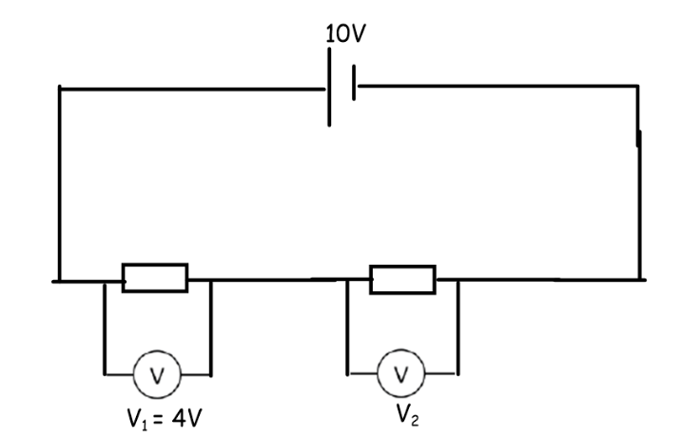
- If the current coming out of the cell was 5 A, what would it be between the two resistors? Explain your answer.
- If one of the resistors broke, what would happen to the other one?
- How are the resistors transferring energy to the surroundings?
- If another resistor is added, what will that do to the current?

- What is the potential difference V₁ in the following circuit? Give a reason for your answer. 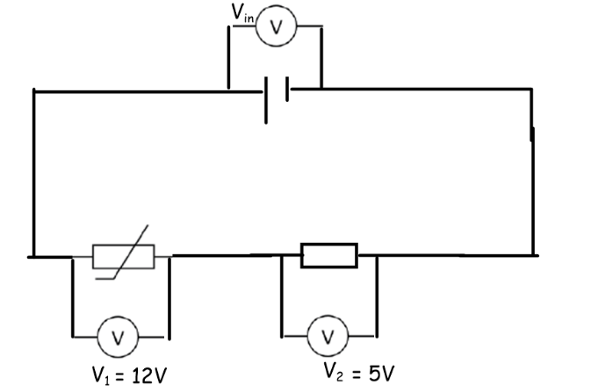
- Find the input voltage V_{in}. Give a reason for your answer.
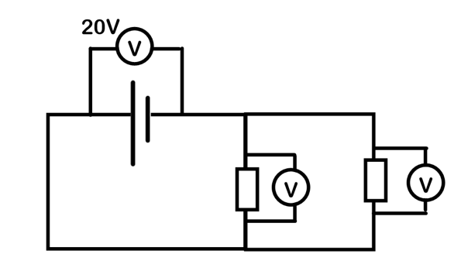
- What are the missing values below? How do you know? 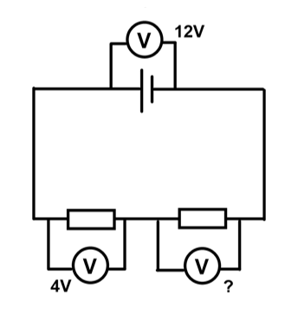
- Assuming that the two resistors are the same, what are the missing values? Give a reason

- Find all missing readings:
