8PL: Light
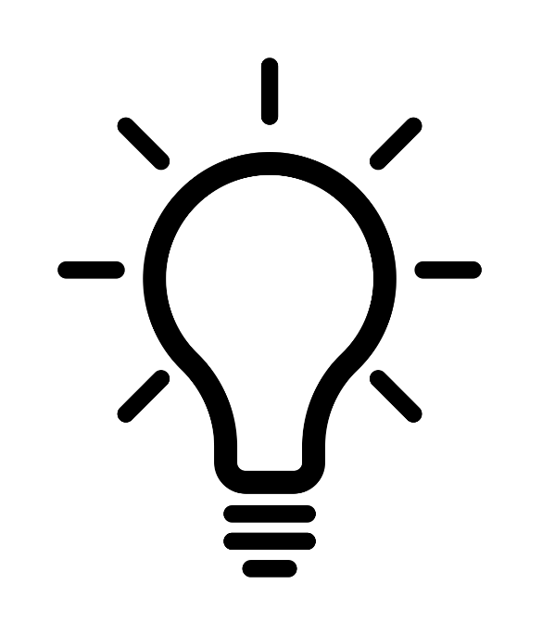
Name:
Class:
Energy recap questions
- Name the five main energy stores
- Name the four energy transfers
- What energy store is associated with a battery?
- How is that energy transferred around a circuit
- If the battery is attached to a motor, which energy store of the motor fills up as the motor starts to spin?
- If the battery is attached to a heater, which energy store of the heater fills up?
- If the battery is attached to a motor which lifts an object, which energy store of the object fills up?
- If the battery is attached to a light bulb, how is the energy transferred to the room?
Lesson 1: Light Waves
I am learning about waves so I can describe what light waves are and how they travel.
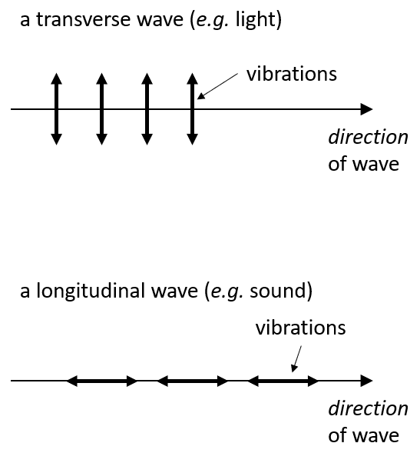
As we have learnt, energy can be transferred in four different ways. One of the energy transfers is called waves, and we have seen that there are two main types of wave: sound and light. We sense these waves through our ears (sound) or our eyes (light). Objects which transfer energy as a light wave are called light sources.
Waves are energy transfers, and they work by causing vibrations, which is a movement up and down or from side to side. An object vibrating doesn’t change position though, the movement is always around one point.
In a sound wave, it is the particles in the air (or whatever the sound is travelling through) that vibrate. In a light wave, something called the electromagnetic field vibrates. We will learn more about fields later, but they are areas which aren’t made of particles, we can’t always see or feel them, but things can still happen in them.
In a sound wave, the vibrations are backwards and forwards in the same direction as the wave (parallel). This is called a longitudinal wave. In a light wave, the vibrations are up and down, so at 90 degrees to the direction of the wave (perpendicular). This is called a transverse wave.
 | Light | Sound
What is vibrating? | The electromagnetic field | Particles
What direction is the vibration | Perpendicular | Parallel
Name of type of wave | Transverse | Longitudinal
How we sense them | Eyes | Ears
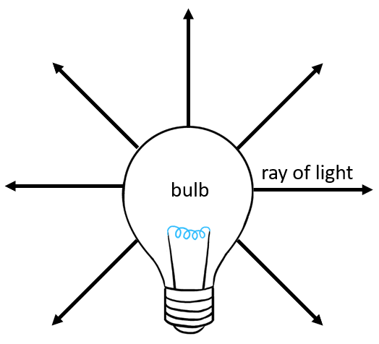
- An object gives off light waves. What word can be used to describe the object?
- What direction are the vibrations in a sound wave?
- What is the difference between a vibration and a normal type of movement?
- A person stands at the front of a room, and walks all around the edge of the room until they are back where they started. Is this a vibration? Explain your answer.
- A student says that light needs particles. Explain why the student is wrong.
- Which energy transfer do light sources use?
- Without looking in your notes, give three light sources.
- Magnesium is added to some acid. It starts to feel hot. How can you tell a chemical reaction has taken place?
- How is the reaction transferring energy?
- Is the magnesium a light source?
- A student burns a piece of magnesium and it glows very brightly. Is the magnesium a light source?
- Without looking in your notes, write as many similarities and differences between light and sound as you can.

Light always starts at a light source. From there, it travels in straight lines in all directions away from the source.
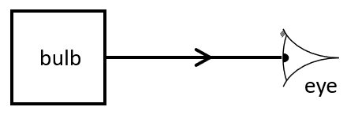
Scientists use a ray diagram to show how light travels. A ray is like a small part of the light. In a ray diagram:
- Light rays always comes from the light source -use an arrow to show this
- Light rays always travels in a straight line (with a ruler)
- The ray has no gaps in it

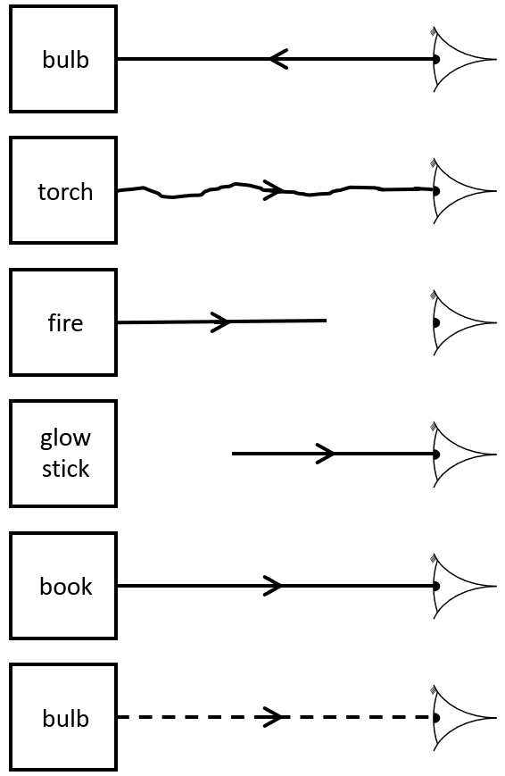
- Look at the ray diagrams below. In each one, there is at least one mistake. Explain what the mistake is.

- A person is looking at a phone screen. How does the phone screen transfer energy to the person’s eyes?
- Draw a ray diagram for the person looking at a phone screen.
- How is energy transferred from the phone’s battery to the screen?
- If the phone was turned off, why would it be wrong to draw a ray diagram with light coming from the phone?
Lesson 2: Reflection
I am learning about reflection so I can explain how we see things that are not light sources.
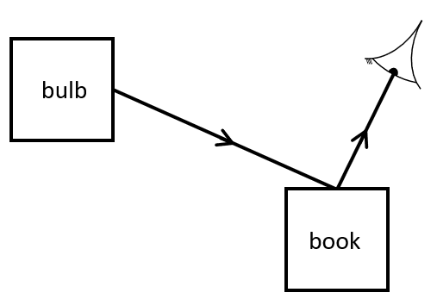
Of course, we can still see things that aren’t light sources. In the question above, the brick is not a light source, so does not give off light. The only way we could see the brick would be if there were a light source near the brick. The light source would release light and it would hit the brick. It would bounce off the brick and into our eyes. This is called reflection.
In the diagram above, you can see that the light moves in the same way that a tennis ball would if you threw it against a wall. The angle the light comes in at is the same as the angle it goes out at. This diagram is what it would not look like:
You can see it just doesn’t look right – you don’t expect the reflection to work like that in the same way you wouldn’t expect a bouncing ball to behave like that. We call this the law of reflection.

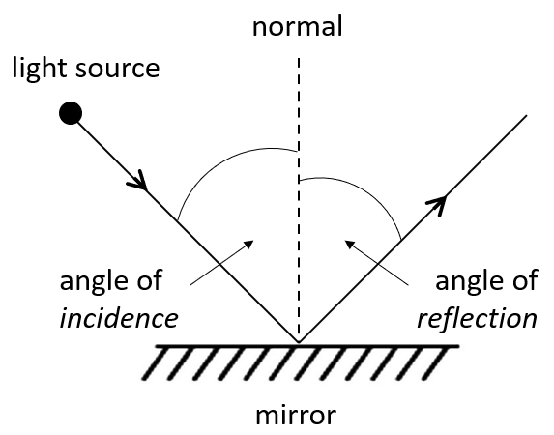
Mathematically, we draw the angles a bit like this:
The angle of incidence and the angle of reflection are equal (or at least as close to equal as you can get when doing diagrams by hand!). Get a protractor out and measure the angles.
Our light ray rules list can now get longer:
- Light rays always comes from the light source -use an arrow to show this
- Light rays always travels in a straight line (with a ruler)
- The ray has no gaps in it
- The ray can be reflected off objects which are not light sources
- A normal is drawn perpendicular (90°) to the object where the ray hits it
- The angle of incidence and the angle of reflection should be equal
Questions:
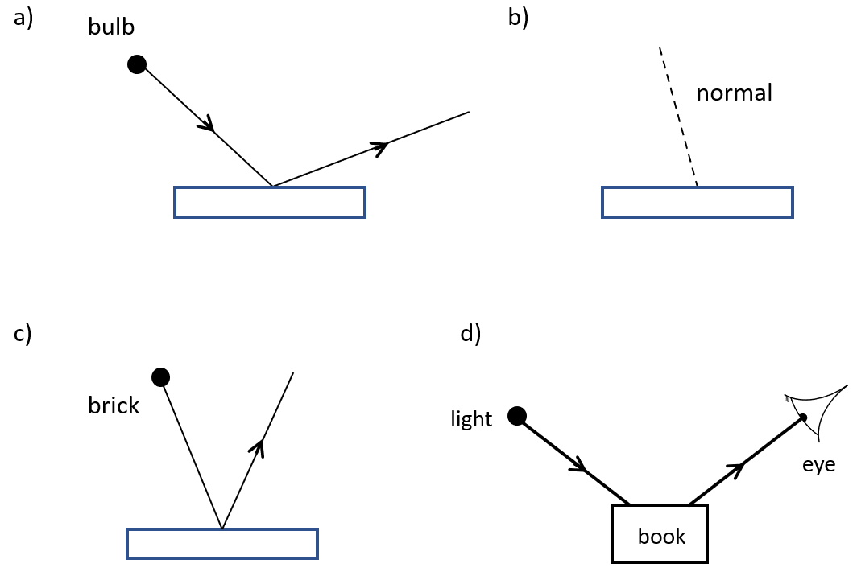
- In each of the diagrams below there is a mistake. Explain what the mistake is
- On the squares below, draw a ray diagram for light reflecting off an object with an angle of incidence of 30°. Make sure to use a pencil and a protractor.
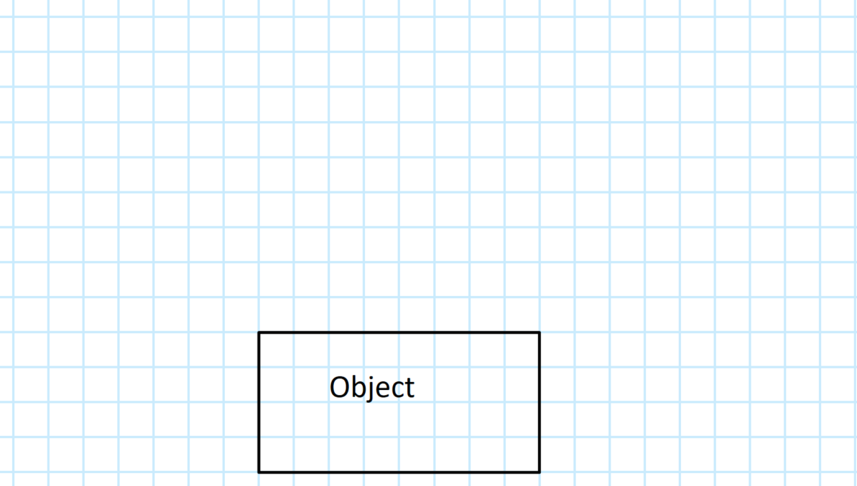
- A student is reading a book by the light from a bulb. Use the keywords to describe how the student can see the book.
light source, light, reflect, eyes
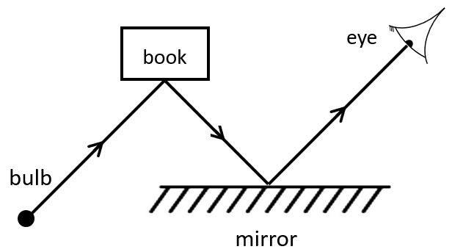
- The student turns the light bulb off. There are no windows in the room or other light sources. Explain why the student can no longer see the book.
- What would a ray diagram for the student and the book look like now?
- Each of the diagrams below has light approaching a surface. On each surface draw a normal and the reflected ray. Make sure to use a protractor. The first one has been done for you.
  - 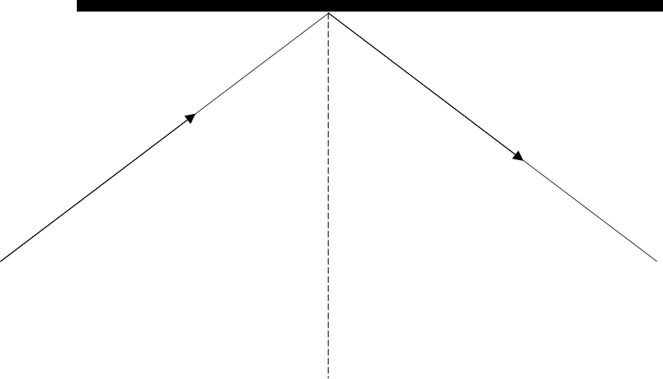
  - 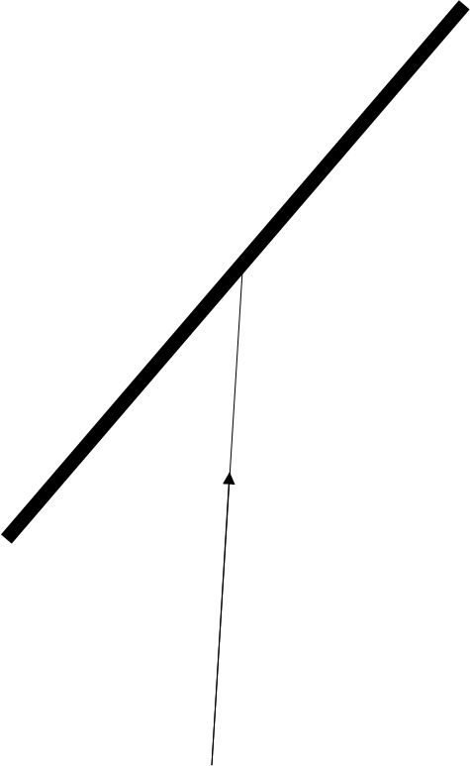
  - 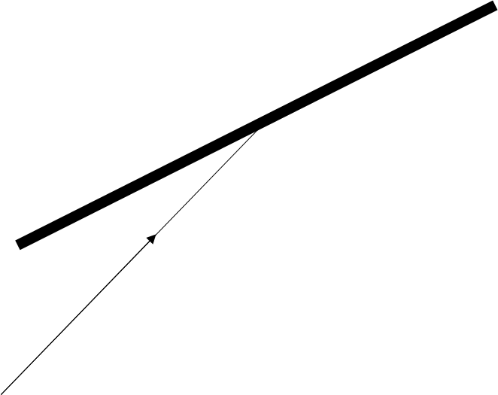
  - 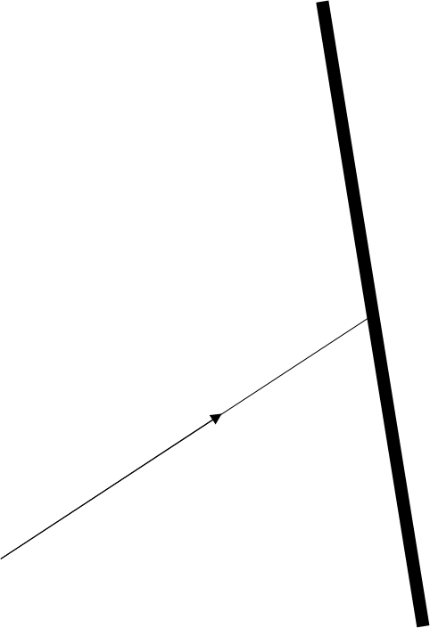
  - 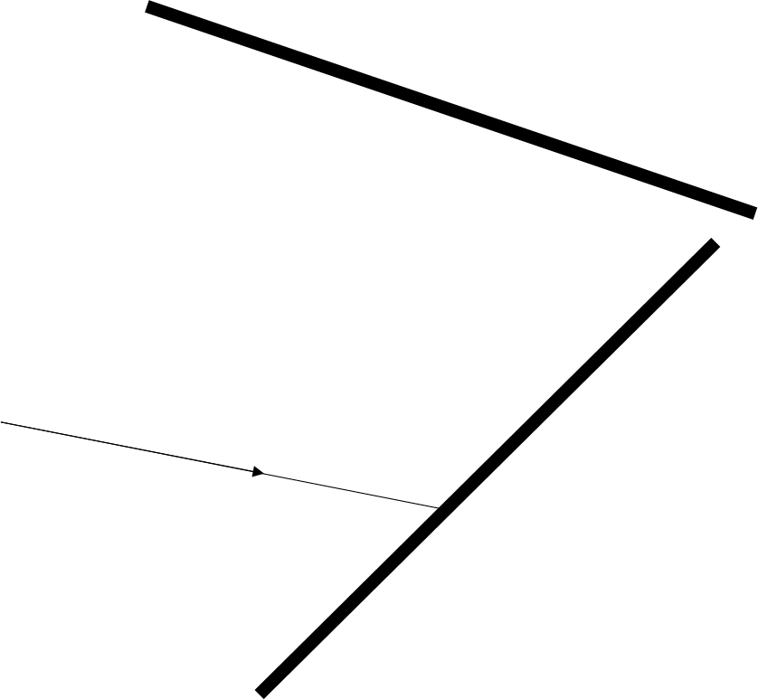
  - 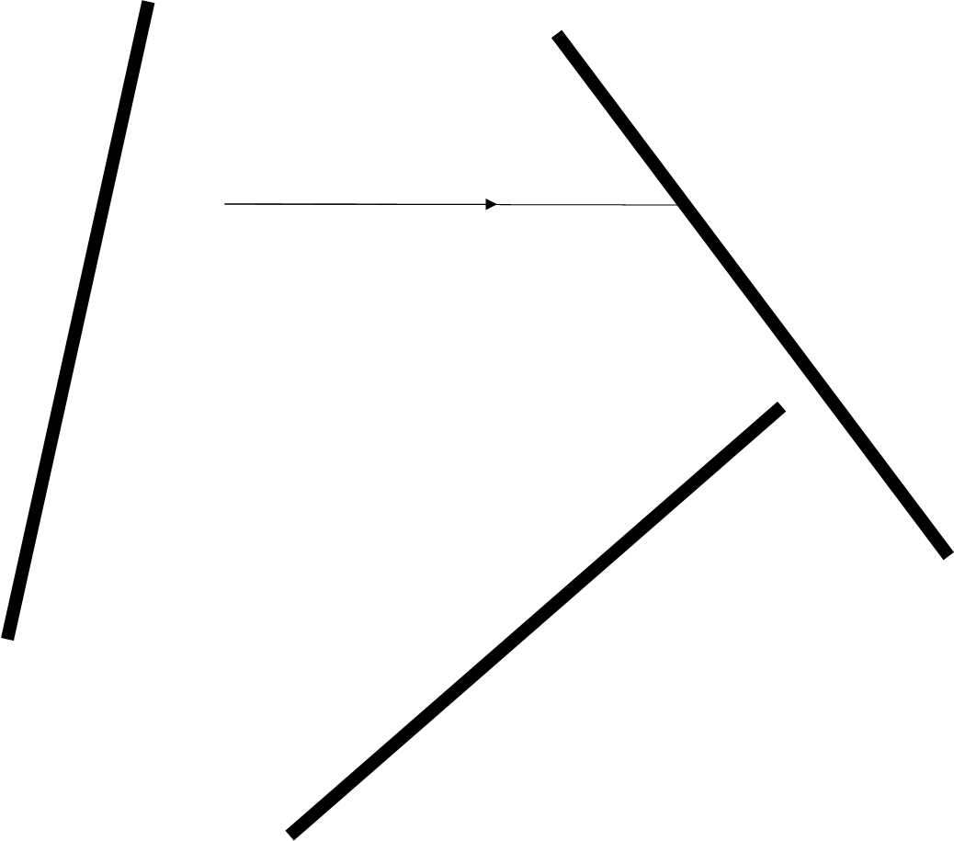
  - 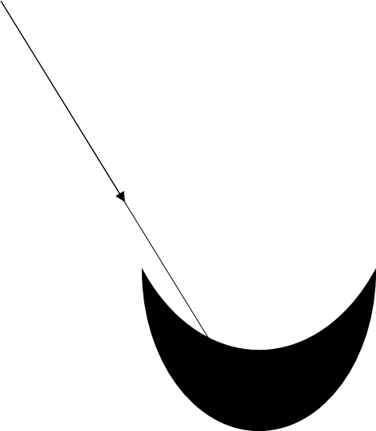

Reflection practical
Your teacher will now show you how we can use ray boxes, mirrors and protractors to measure angles of incidence and angles of reflection.
Lesson 3: Transmission
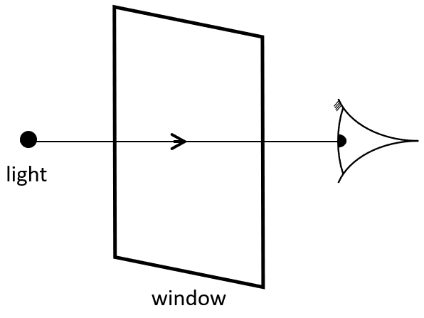
I am learning about transmission so I can explain what happens when light meets transparent objects
Light does not always reflect off objects. There are some objects which allow the light to easily pass through, like windows. When this happens, we say that transmission has occurred.
Some objects transmit a lot of light. We call these objects transparent. If they only transmit some of the light, we call them translucent. If they do not transmit any of the light, we call them opaque.
- Name two transparent objects
- A light ray travels into a block of glass and is transmitted. Draw a ray diagram to show this process.
- A person is looking at a book which is in a cabinet behind a piece of glass. There is a bulb in the room. Complete the ray diagram to show how the person can see the book.
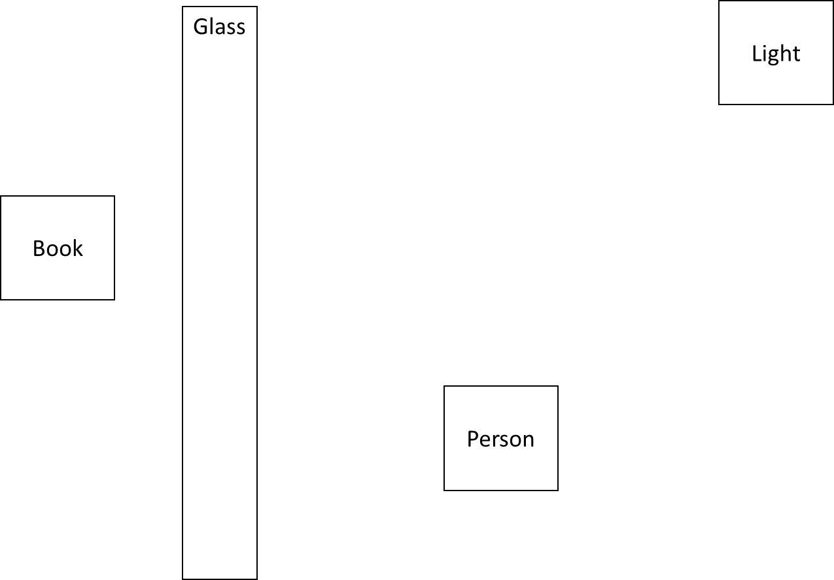
- Describe how the person can see the book. Use the keywords below in your answer:
Glass, light, light source, transmit, reflect, person, transparent
- What kind of wave is a light wave?
- In what direction are the vibrations in a light wave?
- When a light wave travels, what is vibrating?

Lesson 4: Absorption
Recap questions:
- Name a transparent object.
- Name a translucent object.
- Name an opaque object.
- How do light sources transfer energy?
- What is the law of conservation of energy?
- If a light bulb transfers 40 J of energy towards a piece of glass, but only 35 J is transmitted through the glass, how much is not transmitted by the glass?
- The transfer takes place in 120 seconds. What is the power of the bulb?
Use the equation: power x time = energy
- A different bulb has a power of 20 W and is left on for 5 minutes. How much energy does it transfer? Use the same equation as above.
When light hits a translucent object, only some of the light is transmitted through it. The rest of the light is absorbed by the object. This process transfers the energy into the thermal store of the object, so it gets a little bit hotter.
This also happens when objects reflect light. Not all the light gets reflected, and any light that doesn’t transfers energy to the object’s thermal store.
- A student says “I saw a book in the mirror because light came from my eyes and reflected off the mirror and onto the book.” Explain why the student is wrong.
- What two things happen to light when it hits a block of wood?
- A student has a block of wood, a block of glass and a pair of sunglasses. State which one is transparent, which one is translucent and which one is opaque. Explain your answer.
- A student shines a torch on a chair. After a little while, the temperature of the chair has gone up a tiny bit. Explain why this has occurred.
- A student is in the garden, and notices that the temperature of the fence increases when it is in the sun. Explain why this has occurred.
- A student uses a battery powered torch to view a brick. The temperature of the brick increases. The student says “the temperature has gone up because the light energy store is now full.” Explain why the student is wrong.
- A person is looking in a bathroom mirror, and the light in the room is above their head. Explain how they can see themselves in the mirror. It may help to draw a sketch diagram here.
So far we have seen that light can be reflected, transmitted or absorbed when it hits a surface. However, more than one thing could happen to it, and almost all of the time there will be a combination of the three happening. For example, most windows aren’t perfect and will absorb a little bit of the light, even if they transmit most of it. Also, if you look at a window and the conditions are right you can normally see that there is a bit of reflection taking place in them as well.
- Light is shone on a mirror. Not all the light is reflected. What happens to the rest of the light?
- Some glass transmits 98 % of light. Other glass transmits 93 %. Which glass is better for windows? Explain your answer.
- Which glass is better for sunglasses? Explain your answer.
- If a window doesn’t transmit all the light that hits it, what happens to the rest of it?
- A student leaves a brick and a mirror in front of a light bulb. Which one would you expect to heat up more? Explain your answer.
- Define the words transparent, translucent and opaque.
- Uses a ruler and a protractor to complete the ray diagram below.
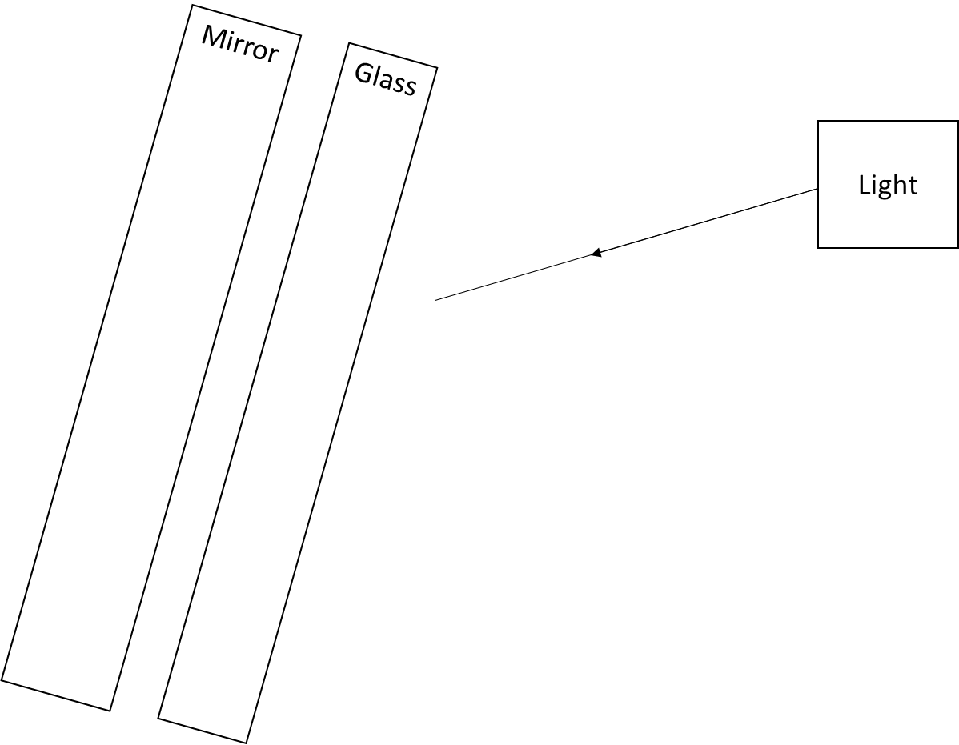
- Draw a ray diagram for a person looking at a light in a mirror. The mirror is not perfect and transmits some light. Show the light which is transmitted as a dotted line.
Lesson 5: Colour
I am learning about the composition of white light so I can explain why some objects are coloured.
Over 300 years ago, Isaac Newton published a book called Opticks. Newton had taken some white light from a light source and passed it into something special called a prism. The white light separated out into a number of different colours. He used this to explain that what we think of as white light is actually made up of many different colours: red, orange, yellow, green, blue, indigo and violet (we will learn later how he did this). Your teacher will show you how this works using a simulation https://phet.colorado.edu/en/simulation/bending-light
We know that light waves are ways of transferring energy, but we have not looked at how much energy they transfer and in fact different coloured light rays transfer different amounts of energy. Violet light transfers the most energy, and red light transfers the least, with orange, yellow, green, blue and indigo in the middle (in order of less to more).
The reason why we see things with different colours is because of transmission, reflection and absorption. Different objects reflect different colours. For example, if I shine red and blue light on an object that absorbs red light, the blue light will be reflected, and the object will look blue to me. So if I have a blue Lego brick, the reason it looks blue is because it absorbs all colours other than blue, which it reflects into my eyes.
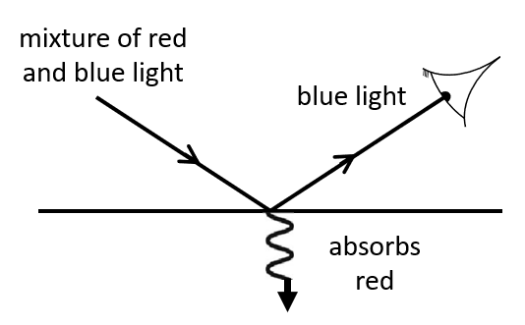
If something reflects all the light, it will look white. If it absorbs all the light and reflects no light at all, it will look black.
- Complete the table below. The first two have been done for you.
Incident light (the light coming in) | Colours absorbed | Colours reflected | What it looks like to me
Blue and red | Red | Blue | Blue
Blue and red | None | Blue and red | A mix of blue and red – purple
Blue, green and orange | Blue and orange
Indigo and violet | Indigo and violet
Red, yellow and green |  | Red
 | Red and indigo |  | A mix of yellow and blue
- A student looks at a tennis ball in white light. Explain why the tennis ball looks green to them.
- The student takes the tennis ball into a room with only red light. What colour will the tennis ball look? Explain your answer.
- A student shines green and orange light on an object which absorbs the orange light. What happens to the temperature of the object? Explain your answer.
- Identify as many errors in the diagram below as you can.
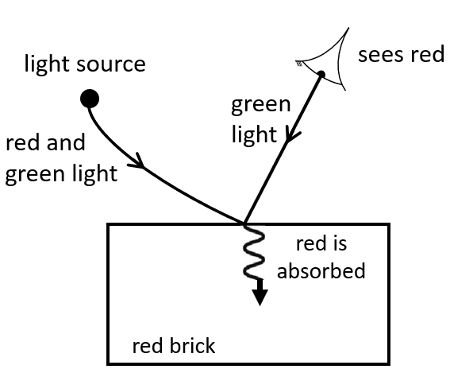
67. Redraw the diagram to show what happens when a person looks at a red brick. Label all arrows.
Filters
A filter is an object that is designed to absorb some light and transmit other light. Coloured filters absorb some colours and transmit others. A red filter for example, absorbs all colours except red.
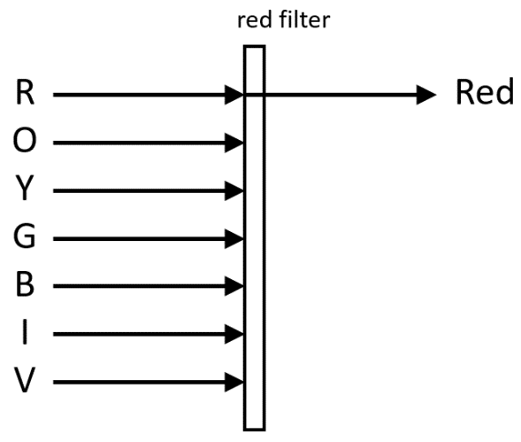
This can change the colour of objects you see. If we pass white light through a red filter onto some white paper, it will look red to us.
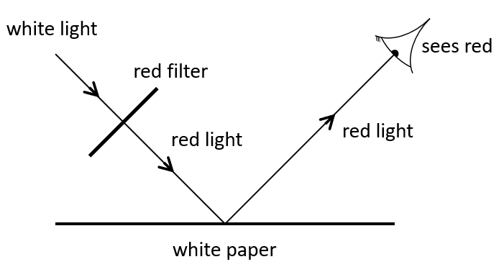
If we pass it onto some blue paper, it will look black. Blue paper absorbs red light, so if the only light coming onto the paper is red, none will be reflected.
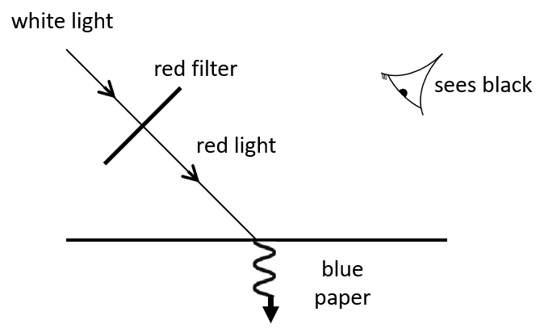
- White light is passed through a blue filter onto a white piece of paper. What colour will the paper look?
- It is then passed onto a green piece of paper. What colour will the paper look?
- It is then passed onto a blue piece of paper. What colour will the paper look?
- White light is passed through a red filter and then a purple filter and then onto a white piece of paper. What colour will the paper look?
- Explain why an orange does not look orange when in green light.

Looking back at plants
Last year when we studied plants and plant cells, we saw that they have chloroplasts in them which perform photosynthesis. The chloroplasts have a substance in them called chlorophyll which makes them look green.
- Which colours are absorbed by chlorophyll?
- Which colours are reflected by chlorophyll?
- Why do plants need to absorb light?
- What is the energy transferred to the plant used for?
- Why do root hair cells not have any chloroplasts?
- Plant cells absorb light from the Sun because…
Plant cells absorb light from the Sun but…
Plant cells absorb light from the Sun therefore…
- Are plants producers or consumers?
- Mice eat wheat. Foxes eat mice. Draw a food chain for this feeding relationship.
- Label all producers and consumers.
- Mice also eat snails, which eat lettuce. Add these organisms to your food chain to make a food web.
- Identify all carnivores, omnivores and herbivores.
- A farmer uses a chemical on their lettuce which stops the slugs eating it. What effect will this have on the number of foxes? Explain your answer.
- Mice have large ears which help them hear foxes. What kind of adaptation is this?
- When they hear a fox, mice try and find a very dark spot. What kind of adaptation is this?
- When mice are growing and getting bigger, where do they get the energy to grow from?
- Explain why over time the size of mice ears has increased.
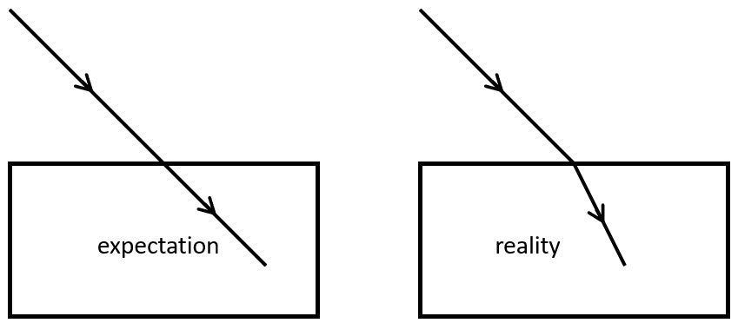
Lesson 6: Refraction
I am learning about refraction so I can explain how light changes direction.
We have now seen that light can be absorbed, transmitted and reflected when it hits a surface. It can also be refracted, which is where it changes direction. When light is passed into a glass block at an angle, instead of it carrying on straight, it actually changes direction
This works because light changes speed in different mediums. A medium is whatever the light is passing through. So the medium before the light hits the block is the air. When it hits the block, the medium is glass. Before it gets to our atmosphere, the medium that the Sun’s light is travelling through is space (or a vacuum).
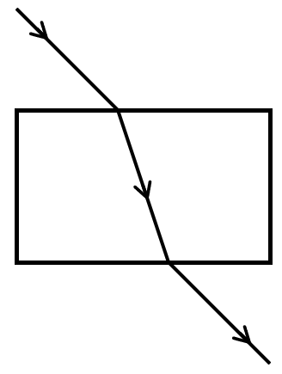
When light moves into the glass block, it slows down. But the beam of light has a width, and the bit of the beam closest to the block slows down first, with the bit furthest from the block carrying on at the same speed. This causes the beam’s direction to bend. Your teacher will explain how this works using cars driving on a road or on mud.
When light leaves the glass, it speeds up and goes back to its original direction.
- Explain why light passing between two glass blocks does not refract.
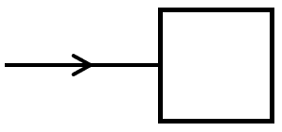
- A student shines light onto a glass block as below. Explain why the light does not refract.
- When light passes from air into water it slows down and refracts. Add a line to the diagram to show the refracted light
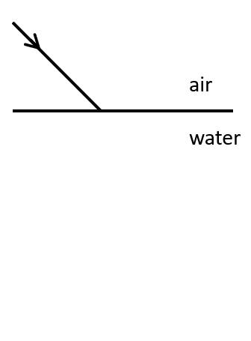
- A beam of light passes out of water and into air. Draw a sketch in your exercise book like in the previous question to show how it refracts
- For each of the sentences below, state whether it is referring to absorption, reflection, transmission or refraction. Sometimes it can be more than one.
  - A student looks at themself brushing teeth in a mirror
  - A student looks at a bird through a window
  - A student on the ground looks at fish under water
  - A student on the ground looks at fish under water through a red prism
  - A student is underwater and looking at fish
  - A student on the ground looks at fish under water but also sees an image of themself on the surface of the water
  - A student looks at a black chair through a window. The black chair is underneath a white light.
Refraction can result in some odd effects. It sometimes looks like an object is in one place, when really it is somewhere else. In the diagram below, someone is looking at a brick through a glass block:
The brick looks like it is at position Y, but in reality it is at position X. Our brain assumes that the light comes straight from the brick to our eyes, when in reality it has changed direction. This is why when you put things like straws in water it looks like they are bending.
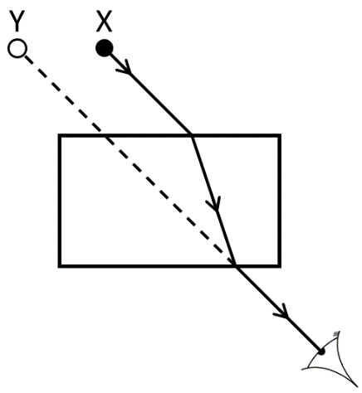

In the past in some places in the world, people used to catch fish from rivers using a spear. This was called spear fishing. When you are spear fishing, you don’t throw your spear at where you can see the fish. You throw it where the fish really is:
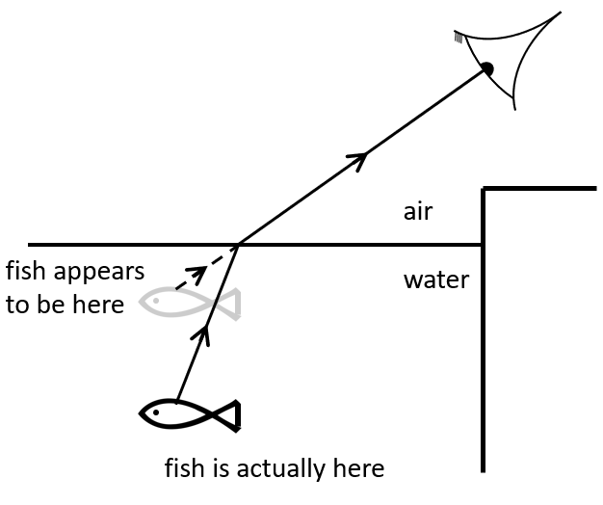

- A person is throwing spears at fish in a river. Explain why they should not throw the spear at where they can see the fish

- A person is looking at the water and can see the fish as below. Towards which letter should they throw the spear?
Explain your answer.
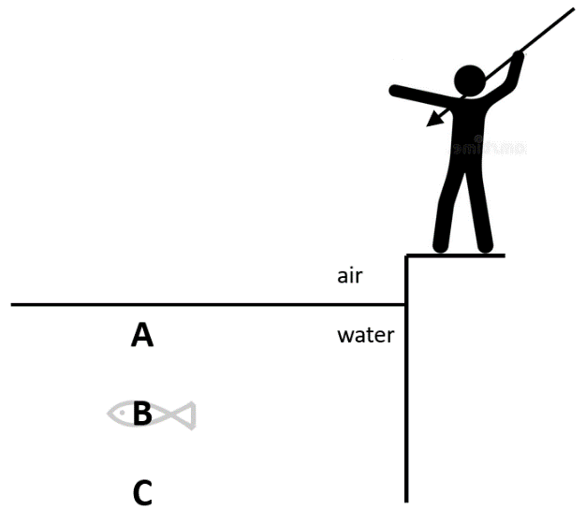

- Archer fish are fish which can shoot jets of water at bugs which are flying above the water.
This fish is looking at a bug and sees it at position X. Draw a Y on the diagram to show where the fish should shoot its water jet.
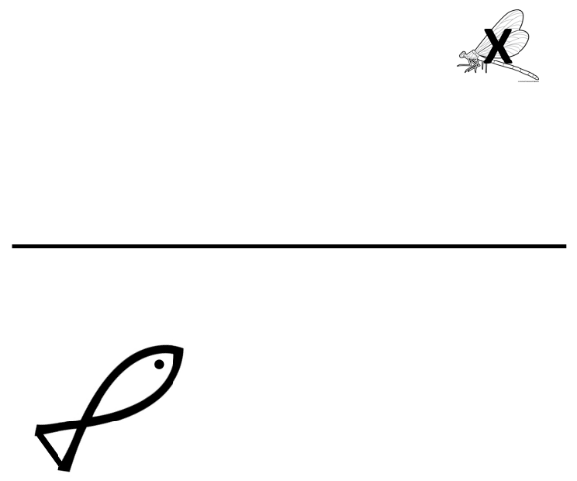

Lesson 7: The speed of light
I am learning about the speed of light so I can calculate the distance it can travel in a certain amount of time.
Our final point in this unit is about how fast light travels. We know that light travels from light sources, and we also know that it travels at different speeds in different mediums:
In a vacuum (space): 300,000,000 m/s
In air: 299,700,000 m/s
In water: 226,000,000 m/s
In glass: 197,000,000 m/s
We can use the speed equation from year 7 to answer questions about the speed of light:
speed x time = distance
- What does a speed of 300,000,000 m/s mean?
- How far does light travel in a vacuum in 6.2 s?
- Earth is 152 000 000 000 m away from the Sun. How long does it take light from the Sun to reach us?
- The air around Earth is about 97000 m thick. How long does it take for light to travel through the air to the surface of Earth?
- What is the difference in speed between light travelling in a vacuum to light travelling in water?
- Will light moving from water to glass slow down or speed up?
- Draw a diagram showing how light refracts when it moves from water to a vacuum
- Explain why the refraction takes place
- Complete the ray diagram showing how a person can see a book using a light from a lamp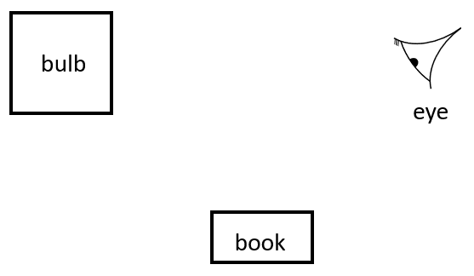
- If the book has white paper, and the lamp gives off red light, what colour will the paper appear?
- If the lamp gives off white light which is then passed through a green filter, what could will the paper appear?
- The person turns the page to a new page which is yellow. What colour will that page appear if the green filter is still there?
- At what speed does the light travel from the lamp to the book?
- What type of wave is light?
- In what direction are the vibrations in the light wave?
- What is actually vibrating?
- What are the four things that could happen when light hits a surface?
- Give an example of each one.
- How far does light travel in a year?

