8PL2 Space
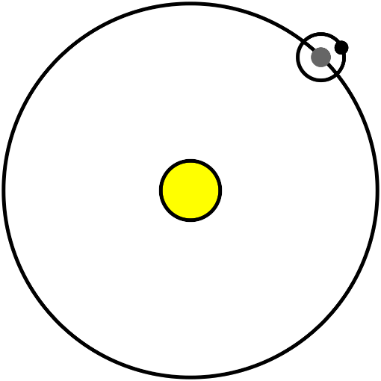

What word is used to describe the path an object takes around another object in space? | An orbit | 10 8PL Space
What name is given to the planets and other objects that orbit the Sun? | The solar system | 10 8PL Space
What is a galaxy? | A group of billions of stars. | 10 8PL Space
Name the planets in our solar system in order of distance from the Sun. | Mercury, Venus, Earth, Mars, Jupiter, Saturn, Uranus, Neptune | 10 8PL Space
What word is used to describe the amount of material in an object? | Mass | 10 8PL Space (weight)
What is the unit and unit symbol for mass? | Kilograms, kg. | 10 8PL Space (weight)
What is a field? | The area around an object where a non-contact force acts | 10 8PL Space (weight)
What kind of field causes weight? | Gravitational field | 10 8PL Space (weight)
What is gravitational field strength? | How strong a gravitational field is | 10 8PL Space (weight)
What is the gravitational field strength on Earth? | 9.8 N/kg | 10 8PL Space (weight)
What is the unit and unit symbol for gravitational field strength? | Newtons per kilogram, N/kg. | 10 8PL Space (weight)
What is the symbol for weight? | W | 10 8PL Space (weight)
What is the unit and unit symbol for weight? | Newtons, N. | 10 8PL Space (weight)
What is the equation that relates weight, mass and gravitational field strength? | W = m x g | 10 8PL Space (weight)
What is the name given to the imaginary line running through the centre of Earth? | The axis | 10 8PL Space (Earth)
What causes day and night? | Earth spinning on its axis. | 10 8PL Space (Earth)
How long does it take for Earth to spin round once on its axis? | 24 hours | 10 8PL Space (Earth)
What causes seasons? | Earth’s tilted axis and its orbit around the Sun. | 10 8PL Space (Earth)
How long does it take for Earth to orbit once round the Sun? | 365 days | 10 8PL Space (Earth)
What is the name given to the imaginary line running round the middle of Earth on the surface? | The equator | 10 8PL Space (Earth)
Give two things that are affected by the seasons | Average temperature, length of the day, height of the Sun in the sky | 10 8PL Space (Earth)
If the North pole is tilted towards the Sun, what season will it be in the Northern Hemisphere? | Summer | 10 8PL Space (Earth)
If the North pole is tilted towards the Sun, what season will it be in the Southern Hemisphere? | Winter | 10 8PL Space (Earth)
Why is it hotter in the hemisphere which is pointed to the Sun? | The sunlight is more concentrated | 10 8PL Space (Earth)
What is a light year? | The distance travelled by light in a year | 10 8PL Space (Earth)

Lesson 1: The Solar System
I am learning about the Solar System so I can understand Earth’s movements
We live on a planet called Earth. It’s called a planet because it’s a huge sphere that travels around a star. A star is also a huge sphere, but while Earth is made of rock, stars are made of burning gas. There are planets made of gas too like Jupiter, but they aren’t burning and don’t give off huge amounts of energy like a star does.
The star that Earth travels round is called the Sun and it provides us with light and with heat. Earth follows a specific path called an orbit. This path is elliptical (a bit like an oval or squashed circle) and doesn’t exist like a road does. The orbit takes Earth through space which is a vacuum. This means that there are no particles there at all, so as Earth travels it isn’t moving through air or water – it is moving through nothing at all.
Earth isn’t the only planet orbiting the Sun. Mercury, Venus, Mars, Jupiter, Saturn and Neptune are all planets that orbit the Sun. There are also comets (big balls of rock and ice) and asteroids (big lumps of rock) orbiting the Sun. We call the collection of objects orbiting the Sun the solar system.
We aren’t the only planets, and the Sun isn’t the only star. There are countless billions of stars, and each of them has their own objects – planets, comets, asteroids and the like. Some of these stars are grouped relatively closely together. We call a grouping of stars a galaxy. We are part of a galaxy called the Milky Way, which has over 250 billion stars: that’s 250000000000 stars. It’s also huge – and is about 1000000000000000000km wide. Our closest star, Proxima Centauri, is about 30000000000000km away from us.
There are plenty of other types of objects out there in space like nebulae and black holes, but taken together the whole thing is called the universe.
- Put these terms in order of size: Earth, galaxy, Sun, universe, TTA
- Unjumble the sentence:
Planet orbits the that called Sun is Earth the a star
- What does Earth pass through as it orbits the Sun?
- Without the Sun, why would it be dark the whole time?
- How is energy transferred from the Sun to Earth?
- In the text above it says that the planets are relatively close together. What does this mean?
- A student says that if you go into space without a helmet you will die because there is no air to breathe. Is the student correct? Explain your answer.
- Why do you think space is black?
- Pluto isn’t called a planet any more. Part of the reason for this is that it isn’t big enough. A student says “if it isn’t a planet or a star, then it also isn’t part of the solar system.” Explain why the student is wrong.
Lightyears (AC)
Earlier, we said that our closest star, Proxima Centauri, is about 30000000000000 km away from us. This is a very large number and not particularly helpful. For this reason, scientists use “lightyears” to measure big distances. This is how far light can travel in one year. We know that light travels very fast (from our last unit), and in one year it can travel 9500000000000 km. Using light years, Proxima Centauri is 4.2 lightyears.
- How far away from us is Proxima Centauri in metres?
- A student asks a teacher “how much time is a lightyear?” Why is this a bad question?
- What should they have asked?
- It takes light about 8 minutes to get from the Sun to Earth. What medium is it passing through in this time?
- How far can light travel in:

  - Two years
  - Ten years
  - Six months
  - One month
  - One hundred and fifty years
  - Challenge: one minute

- The speed of light in a vacuum is 299 792 458 m/s.
  - Calculate the number of seconds in a year.
  - Calculate the number of metres travelled by light in a year.
  - How long does it take for light from Proxima Centauri to reach us?
- Why is it important to specify the speed of light “in a vacuum”?
- What happens to light when it enters the atmosphere?
Lesson 2: Weight
I am learning about gravitational fields so I can explain the difference between mass and weight
Recap questions from year 7:
- Draw a free body diagram for a person standing on a chair.
- What is the name of the force pulling them down?
- What is the name of the force stopping them falling through the chair?
- Draw a free body diagram for a plan flying through the air, labelling all four forces.
- Which forces are contact forces and which ones are non-contact forces?
- How would the free body diagram change if the plane was flying in space?
Many forces need contact to work. For example, friction needs contact between two surfaces before it will work. The same is true for a normal push or pull on an object. There are some forces that work at a distance, like magnets. “Gravity” is one of those forces and it’s what keeps us stuck to the ground. You can tell it works without contact, because if you jump out a plane, you aren’t in contact with Earth at all, but it’s still pulling you down.
When we studied light, we looked at the electromagnetic field, which is what light travels through. A gravitational field is the area around an object in which gravity works (it’s a bit more complicated than that in reality). Gravity causes objects with mass to be attracted to each other. Objects with mass are ones made of particles. Atoms, people, water, air – all of these have mass. The more particles, the more mass.
Light is an example of something not made of particles – it is a way for energy to be transferred. It therefore has no mass and we say that it isn’t affected by gravity (again, it’s a bit more complicated than that in reality!).
- Which of the below have mass?

  - Earth
  - The vacuum of space
  - Clouds
  - Oxygen
  - Length
  - Time

The more mass something has, the stronger its gravitational field. This means it pulls at other objects with mass harder. The gravitational field around Earth is 10 N/kg. This means that objects are pulled to Earth with 10 N for every kg of mass they have. The objects in the diagram show how this works.
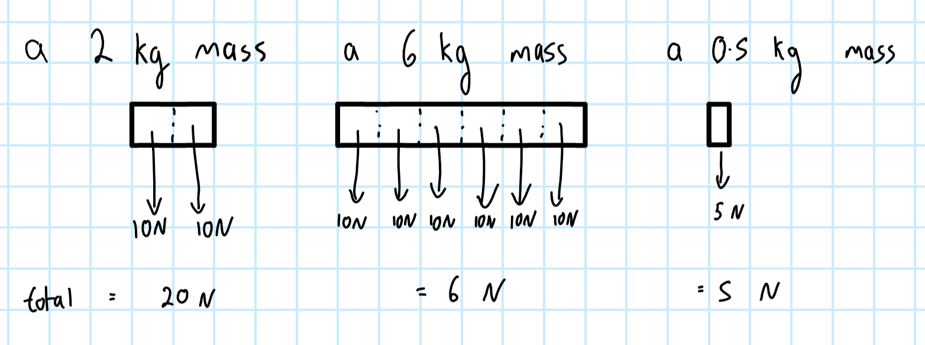
- What is the total force acting on a 10 kg object on Earth?
- What is the total force acting on a 200 kg object on Earth?
- What is the total force acting on a 15.5 kg object on Earth?
- What is the total force acting on a 0.1 kg object on Earth?

Jupiter has a lot more mass than Earth, so its gravitational field is a lot stronger: 26 N/kg. The Moon has a lot less mass than Earth, so its gravitational field is a lot weaker: 1.6 N/kg.
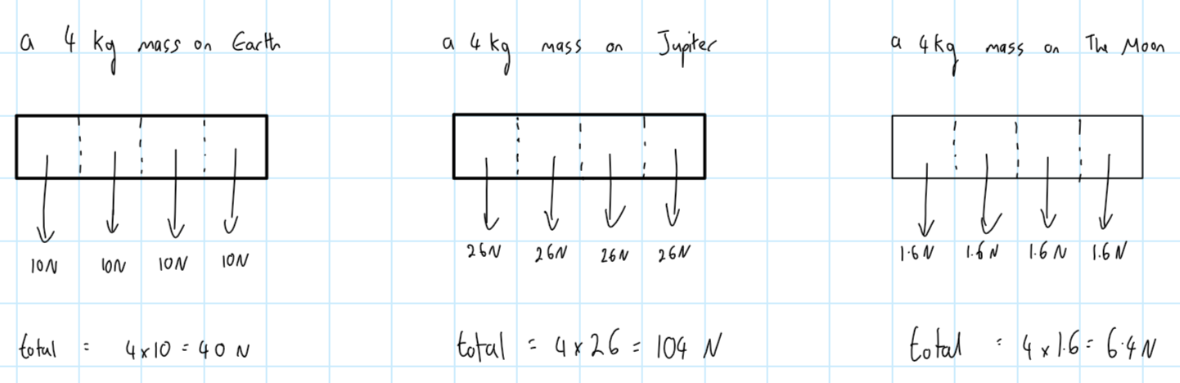
- What is the total force acting on a 6 kg object on the Moon?
- What is the total force acting on a 6 kg object on Jupiter?
- What is the total force acting on a 55 kg object on Earth, the Moon and Jupiter?
- What is the total force acting on a 450.5 kg object on Earth, the Moon and Jupiter?
- How much more force is acting on a 25 kg object on Jupiter than if it were on Earth?
- An object has a mass of 150 kg and a total force acting on it of 3900 N. Where is it?
The total force here has a special name: weight. Now this is a bit confusing, because in day to day life the word “weight” means “how heavy something is,” not “how much force is being acted on it due to gravity.” But in science, that’s exactly what weight means. If you go back to those diagrams, you can see that an object with exactly the same mass (number of particles) has different weights depending on where it is.
A person on the Moon has less weight (force pulling them down) than they do on Earth. That’s why they can jump so high on the Moon – because there is less force pulling them down. But, their mass has not changed. They are the same person as they were on Earth, but on the Moon they can jump higher.
- A 1kg object is taken from Earth to the Moon. Where does it have more weight?
- Where does the object have more mass?
- A 5kg object is moved from Earth to Jupiter, and a small piece breaks off. What has happened to the mass?
- What is the weight acting on a 10 kg object on Jupiter? Show how you worked this out. Go back to the questions in the previous section or the diagrams if you can’t remember how to do this.
- In words, what calculation did you do? Remember that the words involved are mass, weight and gravitational field strength.
- A person is on Earth and has a mass of 70 kg. They travel to the moon and can now jump a lot higher. A student says this is because their mass has decreased. Explain why this is incorrect.
- Why can they jump a lot higher on the Moon?
- Would they be able to jump less high or more high on Jupiter?

You may have worked out an equation by now. To work out weight, we multiply the mass and the gravitational field strength together:
weight = mass x gravitational field strength
W = m x g
Units: W = N, m = kg, g = N/kg
Here are some example gravitational field strengths (note the more precise values than before):
Place | g (N/kg)
Mercury | 3.6
Venus | 8.9
Earth | 9.8
The Moon | 1.6
Mars | 3.8
Jupiter | 26.0
Saturn | 11.1
Uranus | 10.7
Neptune | 14.1

Question set 1:
The first question will be done by your teacher following DESCUS. The second question will be done as a class, and from then on you will work by yourself until the next section.
- What is the weight of a 50 kg object on Earth?
- What is the weight of the same object on Saturn?
- What is the weight of a 100 kg object on Neptune?
- What is the weight of a 75.2 kg object on Mars?
- An object has a mass of 50 kg. Where will its weight be greatest?
- What change in weight will an object with a mass of 65 kg experience if it moves from Saturn to Venus?
- Which planet has the weakest gravitational field strength?
- An object has a mass of 170 kg and is cut in half. One half is moved to Mercury, the other half to Neptune. Without doing any calculations, which half has the greater weight?
- By doing a calculation, show that your previous answer is correct.
Question set 2: unit conversions
Your teacher will remind you how to convert:
kg g
kN N

- Express 3 kg in g
- Express 12.8 kg in g
- Express 100 g in kg
- Express 15,670 kg in g
- Express 72 N in kN
- Express 0.02 kN in N
- Which is larger 12000 N or 12.05 kN?
- An object has a mass of 567 g. What is its mass in kg?
- An object has a weight of 3.2 kN. What is its weight in N?
- An object has a mass of 1200 g and is on Earth. What is its weight?
- An object has a mass of 45 kg and is on Saturn. What is its weight in kN?
- What would its weight in kN be?

Question set 3:
The first question will be done by your teacher following DESCUS. The second question will be done as a class, and from then on you will work by yourself until the next section. Give all your answers to one decimal place.
- An object on Earth has a weight of 50 N. What is its mass?
- An object on Earth has a weight of 20 kN. What is its mass?
- Give the mass in g of an object on the Moon with a weight of 10 N.
- Give the mass of an object on Jupiter with a weight of 20000 kN.
- An object on Neptune has a weight of 100000 N. What is its mass in g?
- What is the weight of an object on Saturn with a mass of 267 kg?
- A 400,050 g mass is placed on Mars. What is its weight in N?
- What is the mass in kg of an object on Venus with a weight of 1.334 kN?
Question set 4:
The first question will be done by your teacher following DESCUS. The second question will be done as a class, and from then on you will work by yourself until the next section. Give all your answers to one decimal place.
- An object has a weight of 300 N and a mass of 15000 g. What is the gravitational field strength?
- An object has a weight of 85 kN and a mass of 7.5k g. What is the gravitational field strength?
- What is the gravitational field strength of a 11.2 kg object with a weight of 0.9 kN?
- For an object with a mass of 500 g, what would the gravitational field strength have to be to give it a weight of 7500 N?
- What is the weight of a 7 kg object on the Moon?
- If an object has a mass of 43 kg and a weight of 203 N, is the gravitational field strength stronger or weaker than Earth’s?
- A 45 kg object has a weight of 1.17 kN. Where is it?
- What is the mass of an object with a 0.002 kN weight on Saturn?
- Challenge: A 10 kg object is cut into two small pieces. One piece is taken to Venus, and the other is taken to Mars. They have the same weight. What is the mass of each piece?
Gravity always works towards the centre of objects. This is why people in Australia don’t fall off Earth – gravity is pulling them to the centre of Earth.
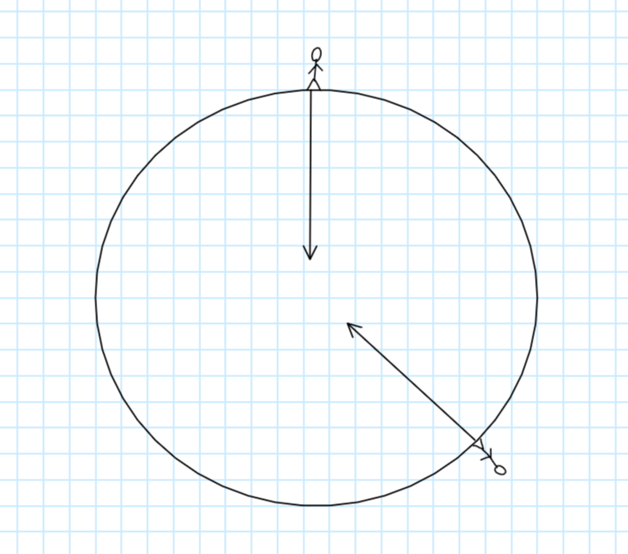
- A 75 kg man is in England. What is his weight?
- What would his weight be if he moved to Australia?
- What would his mass be if he moved to Australia?
- Why does he not fall off the bottom of Earth if he lives in Australia?
- A student says that weight is a contact force because you have to be standing on the surface for it to work. Explain why this is wrong.
- What are the three forces that can oppose weight?

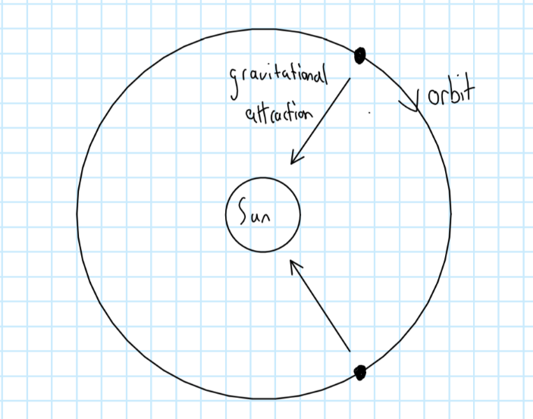
Gravity doesn’t just keep us stuck to the ground. It is gravity that causes Earth and all the other planets to orbit the Sun. Again, the gravity always works towards the centre of the different objects, so wherever Earth is in its orbit, the force is pulling it towards the Sun.

- The Moon orbits Earth. Draw a diagram showing this orbit and draw an arrow to show the direction of the pull of Earth on the Moon.
- A student says that “gravity pulls objects in the direction of their orbit.” Explain why this is incorrect.
Some objects (like comets) have orbits that aren’t quite the same distance the whole way around. They feel a really strong force from the Sun the closer they get to them:
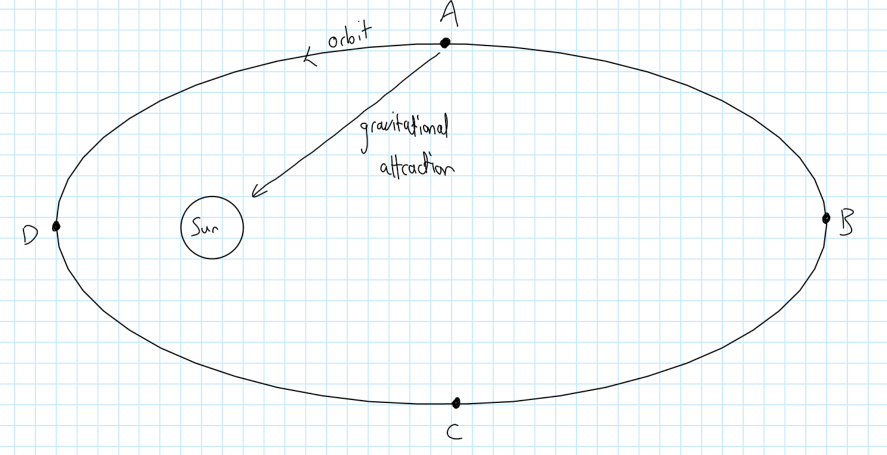
- Draw the comet at B, C and D. Draw an arrow at each point to show its direction of travel.
- Draw an arrow at each point to show the direction of the gravitational attraction.
- As the comet gets closer to the Sun, it travels faster. At which point will its speed be greatest?
- At which point will its speed be lowest?
- Why does the comet slow down as it moves from D to C?
- A comet has a 500000000000000 kg mass. At point A, the gravitational field strength of the Sun is 12.8N/kg. What is the weight of the comet?
- How can something have weight if it is not on the surface of a planet?
- Look at the diagram below, showing a planet shaped like a disk:
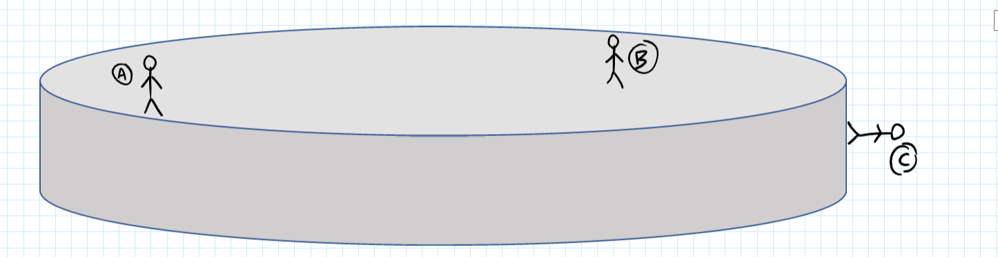
  - Explain why the person at A does not fall off the planet.
  - Draw lines for the person at A and B to show the direction of their weight.
  - Describe what will happen to person A.

Lesson 3: Days, years and seasons
I am learning about the movements and rotation of Earth to explain how the conditions on Earth change over time
There are two movements of Earth that we need to know about. The first is how long it takes to complete an orbit (travel once around the sun). This takes 365¼ days and is called a year.
There is also an imaginary line going vertically through the middle of Earth. This is called Earth’s axis. Earth rotates on this axis, which means it spins on it. It takes 24 hours for one spin to be complete. If you are standing in one place on Earth and the Sun is directly above you, 12 hours later you will not be able to see the Sun, because Earth is pointing in the wrong direction. We call this day and night. As you spin towards the Sun, you will start to see it just above the horizon. Then as time passes it will climb in the sky, go over you, and sink back below the opposite horizon. But the Sun isn’t moving: you are.
- What does rotate mean?
- On what does Earth rotate?
- How long is one year in days?
- How long is one year in hours?
- Scientists used to think the Sun travelled around Earth. Why did they think this?
- What do we know now?
- What causes Earth to orbit around the Sun?
The axis isn’t the only “imaginary” line we are interested in. The equator is also important: it is a line that goes around the middle of Earth and separates Earth into two hemispheres (half a sphere): North and South.
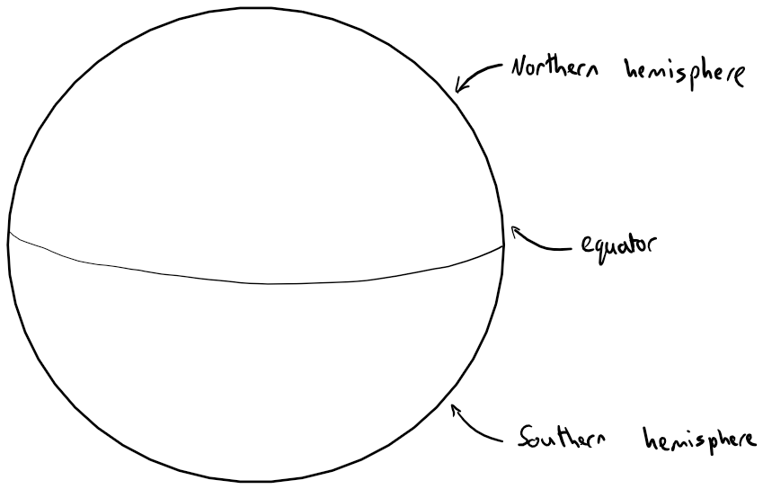

- A student says that he wants to go and see the equator. Explain why this is impossible.
- List as many similarities and differences between the equator and Earth’s axis as you can.
- Kenya is a country on the equator. If you stood in Kenya and the Sun was directly overhead, how long would you have to wait for the Sun to be directly overhead again?
- Would this be different if you were in England?

Looking back at Earth’s axis, it’s important to realise that it doesn’t point straight up relative to the Sun. It is actually tilted:
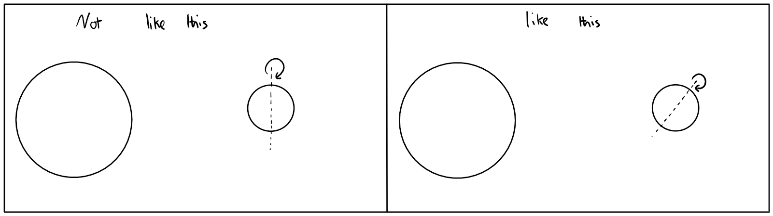

You might think that this doesn’t make a difference, but it actually explains why we have the seasons: summer, autumn, winter and spring.
First, imagine beams of light hitting a flat, vertical surface:
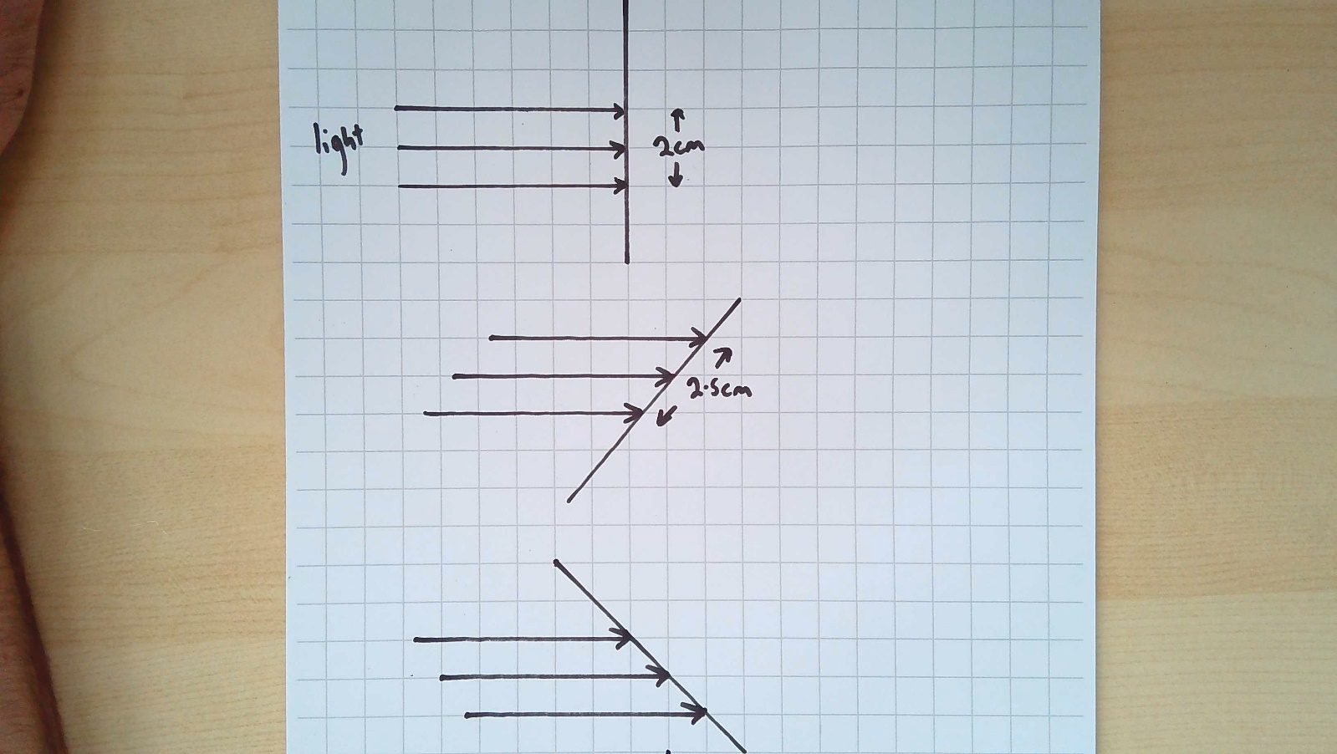
You can see that there are three rays of light for about 2cm worth of length. Now let’s tilt the line away from the light a bit:
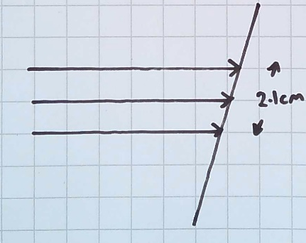
You can see that the three lines are now spread out a bit more. It’s the same amount of light, but it goes to a bigger area. If we tilt it even more you can see how much more that same light gets spread out:
This is like taking a small piece of butter and spreading it on a large slice of bread. It gets thinner and thinner and harder to taste. The same is true of the rays from the Sun. If the land is tilted away from the Sun, the light is spread out more. This makes it hotter on average.

The diagram shows three countries: A, B and C:
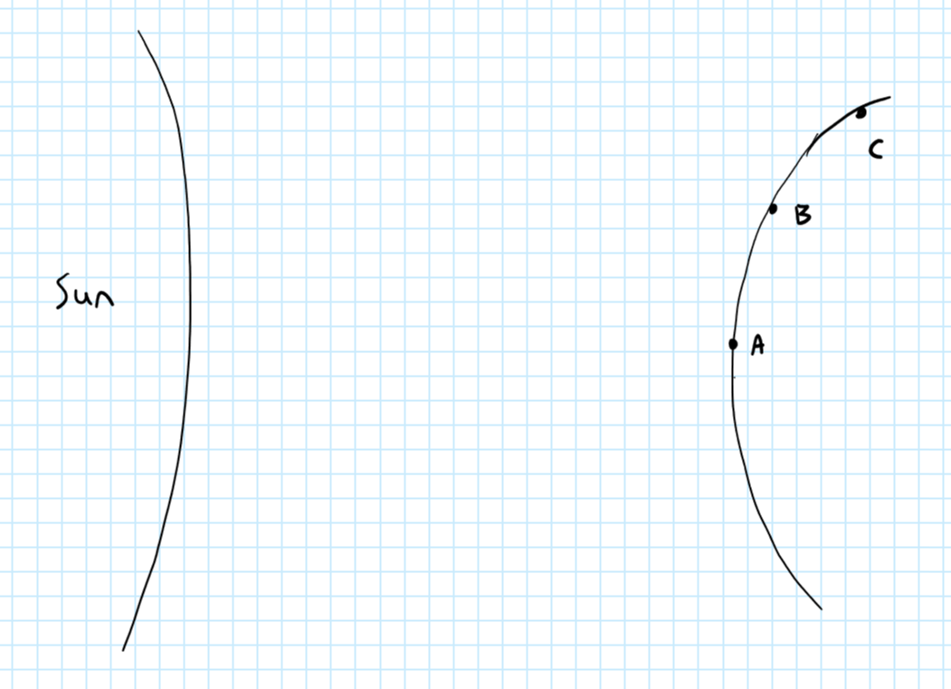
- A student says that country A is hotter than country C because it is closer to the Sun. Explain why this is wrong
- A student says that country C is colder than country B because it is further from the Sun. Explain why this is wrong.
- Explain why C is is colder than A and B.
It’s really important to know that the temperature isn’t about the distance from the Sun. If the countries in the picture above were on Earth, A is closer to the Sun than C, but only by a really tiny amount. The Sun is so far away from us that that tiny difference in distance cannot explain differences in temperature.
At different points in the year, different hemispheres are tilted towards or away from the Sun:
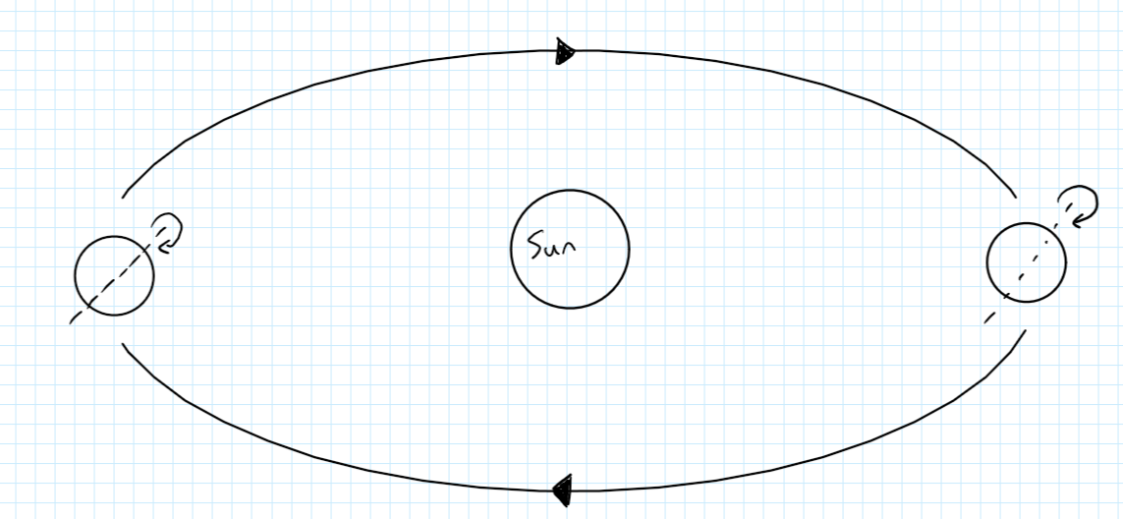

Whichever hemisphere is tilted towards the Sun is in summer. Whichever one is tilted away from the Sun is in winter. Again, this is not because they are closer or further, but because the light spreads out more or less.
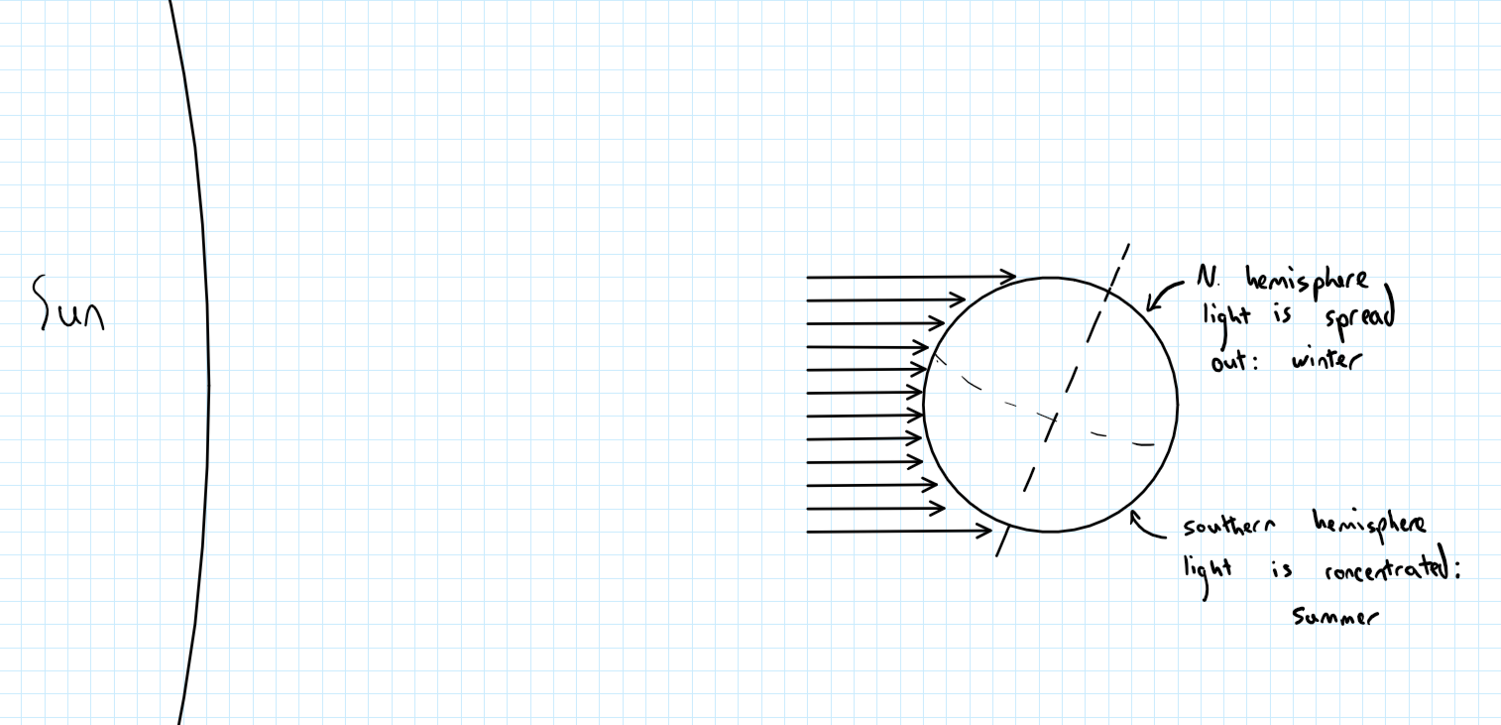
The Sun also appears higher in the sky when it is summer than when it is winter:
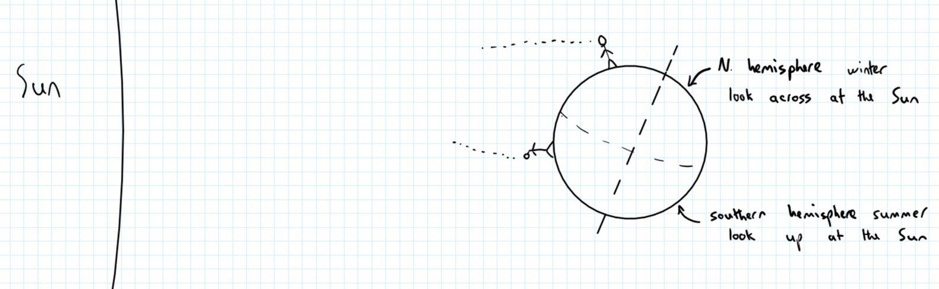
The days are also longer in summer for the same reason. If you are tilted away from the Sun, you are in its light for less time. Your teacher will demonstrate this using a globe.
Season | Summer | Winter
Average temperature | High | Low
Height of Sun in the sky | High | Low
Length of days | Long | Short
- It is summer in the northern hemisphere. What season is it in the southern hemisphere?
- If England is in summer, what will be different to if it were in winter?
- Why is it colder on average in the winter?
- In summer, the average temperature is high because…
In summer, the average temperature is high but…
- A student says it is hot in the summer because Earth is closer to the Sun. Explain why she is wrong.
- Mercury’s axis is not tilted. Explain why Mercury does not have seasons.
- Saturn’s axis is tilted more than Earth’s. In what ways will seasons on Saturn be different to Seasons on Earth?
- What is the weight of a 150kg object on Saturn?
- What is the mass of a 1467N object on Saturn? Give your answer to one decimal place.
- What is the difference between a galaxy and a solar system?
- What are the main differences between planets and stars?
- Is our solar system made up of the Sun and planets only? Explain your answer.
- An object is taken from the Moon to Earth in a sealed box. Does its mass change? Explain your answer.
- Does its weight change? Explain your answer.
- Explain why people in the southern hemisphere do not fall off the bottom of Earth
- If someone is in the southern hemisphere, why does the Sun appear higher in the sky?

