8BD Digestion Booklet
Name: ___________

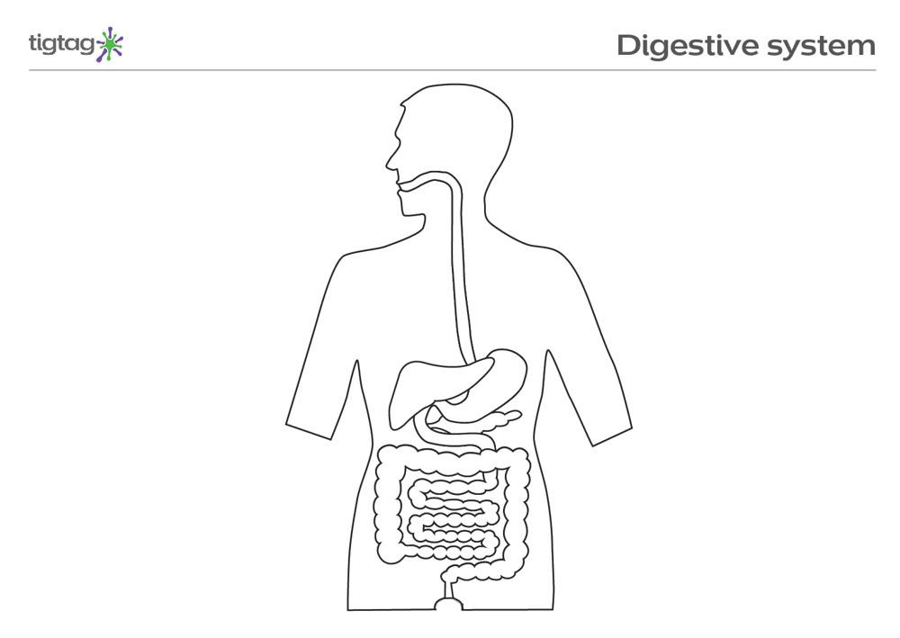
Oesophagus
Mouth
Liver
Stomach
Pancreas
Small intestine
Large intestine
Anus

What is digestion? | The breakdown of food into small molecules | Food
Name 4 food groups | Carbohydrates, proteins, fats, vitamins and minerals | Food
Give an example of a food containing carbohydrates | Potato, rice, bread, pasta | Food
Give an example of a food containing protein | Meat, fish, eggs, milk, cheese | Food
Give an example of a food containing fats | Meat, milk, yogurt, oil | Food
Give an example of a food containing vitamins and minerals | Fruit, vegetables, | Food
What are carbohydrates broken down into? | Simple sugars | Food
Give an example of a simple sugar | Glucose (sucrose, fructose) | Food
What is glucose used for? | Respiration | Food
What are proteins broken down into? | Amino acids | Food
What are amino acids used for? | Growth and repair | Food
What are fats broken down into? | Fatty acids and glycerol | Food
What are fatty acids and glycerol used for? | Energy storage | Food
What are vitamins and minerals used for? | Contribute to all aspects of health | Food
What happens to the small molecules at the end of digestion? | They are absorbed into the blood | Food
Name the organs in the digestive system in the order food passes through them | Mouth, oesophagus, stomach, small intestine, large intestine, anus | Organs
Where is food digested? | The mouth, the stomach and the small intestine | Organs
What happens in the small intestine? | Digested food is absorbed into the blood | Organs
What happens in the large intestine? | Excess water is absorbed (from undigested food) | Organs
What does the liver do? | Produce bile | Organs
What does bile do? | Helps digest fats | Organs
What is an enzyme? | A biological catalyst | Organs
What is a catalyst? | Something that makes a chemical reaction faster | Organs
What do enzymes do? | Speed up digestion | Organs
What does the pancreas do? | Produce enzymes | Organs
Give four adaptation of the small intestine | Very long, contains villi, rich blood supply, has microvilli | Organs
Why is the small intestine long? | To increase surface area | Organs
Why does the small intestine have villi? | To increase surface area | Organs
Why does the small intestine have a rich blood supply? | To keep a high concentration gradient | Organs
Why does the small intestine have microvilli? | To increase surface area | Organs
What are gut bacteria? | Bacteria found in the large intestines | Health
What do gut bacteria do? | Help digest food | Health
What is obesity? | Having too much body fat | Health
What causes obesity? | Eating too much sugary or fatty foods | Health
What are the risks of obesity? | Coronary heart disease | Health
What does coronary heart disease cause? | The heart to function worse | Health
What is a deficiency disease? | A disease caused by not getting enough of one food group | Health

Lesson 1: Digestion
I am learning about the different food groups so I can understand the purpose of digestion.
All humans need food in order to live. For example, our cells do respiration which releases energy. They use this energy for growth, repair, movement, making useful chemicals for the body or reproducing. In order for respiration to happen, the cell needs glucose. Glucose is an example of a simple sugar, but we do not eat glucose directly. Instead, we eat food that contains carbohydrates. These are long molecules that our body breaks down to make smaller molecules, like glucose. This process of breaking down is called digestion and it’s important because our body cannot use them as long molecules, but only as short ones.
Carbohydrate glucose respiration in cells energy released to body
There are four main food groups, and the food in each one is made of long molecules. Our body digests them into smaller molecules which it then uses for many different purposes. The first three are summarised below:
Food group | Examples | Broken down into | Used for in the body
Carbohydrates | Potato, rice, bread, pasta | Simple sugars (glucose is an example) | Glucose is used for respiration.
Proteins | Meat, fish, eggs, dairy | Amino acids | Growth and repair
Fats | Meat, dairy, oil | Fatty acids and glycerol | Energy storage

We also eat the food group vitamins and minerals, with our main sources being fruit and vegetables. These contribute to all aspects of our health.
Comprehension questions: answer in groups of five from memory, then use your purple pen and the information above to correct your answers
- Why do we need glucose?
- What is digestion?
- What is glucose an example of?
- What food group contains glucose?
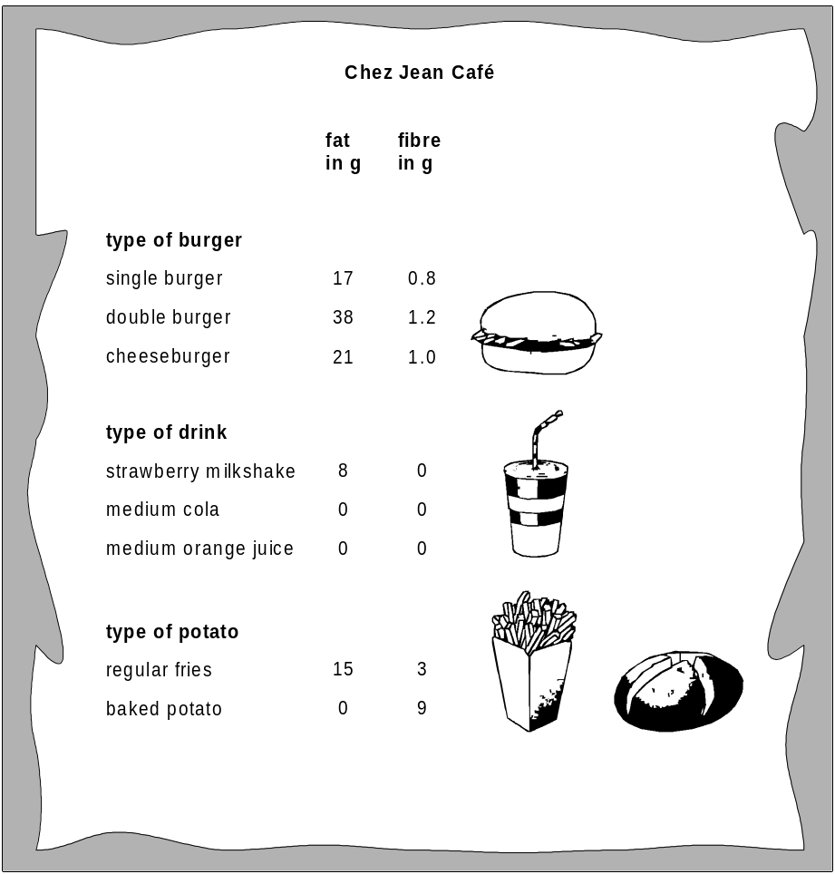
- Give an example of a food which could contain glucose
- What food group contains meat, fish, eggs and dairy?
- Why do we need this food group?
- What are foods in this group broken down into?
- What are fats broken down into?
- A person does not get enough carbohydrate in their diet. Explain why they feel very tired a lot of the time.
Application questions: you can use your notes to help you
- Complete the following sentences:
Fats are needed in the diet because…
Fats are needed in the diet but…
Fats are needed in the diet therefore…
- The card shows the amounts of fat and fibre in some types of food and drink from a café. From the card, choose a meal consisting of a burger, a drink and some potato, to give:
  - the least fat
  - the most fibre
- A person orders a double burger, fries and a strawberry milkshake. Calculate the fat content of this meal. Give the unit.
Additional content: The text below has been taken from the NHS website and is to do with fat:
Too much fat in your diet, especially saturated fats, can raise your cholesterol, which increases the risk of heart disease. Current UK government guidelines advise cutting down on all fats and replacing saturated fat with some unsaturated fat.
A small amount of fat is an essential part of a healthy, balanced diet. Fat is a source of essential fatty acids, which the body cannot make itself. Fat helps the body absorb vitamin A, vitamin D and vitamin E. These vitamins are fat-soluble, meaning they can only be absorbed with the help of fats.
Any fat not used by your body's cells or to create energy is converted into body fat. Likewise, unused carbohydrate and protein are also converted into body fat. All types of fat are high in energy. A gram of fat, whether saturated or unsaturated, provides 9kcal (37kJ) of energy compared with 4kcal (17kJ) for carbohydrate and protein.
The main types of fat found in food are:
saturated fats
unsaturated fats
Most fats and oils contain both saturated and unsaturated fats in different proportions. As part of a healthy diet, we should try to cut down on foods and drinks high in saturated fats and trans fats, and replace some of them with unsaturated fats.
In the text below, some of the words have been removed:
Fat in your diet can raise your cholesterol, which increases the risk of heart disease. Current UK government guidelines advise cutting down on fats and replacing saturated fat.
Fat is an essential part of a healthy, balanced diet. Fat is a source of fatty acids, which the body cannot make itself. Fat helps the body absorb vitamin A, vitamin D and vitamin E.
Any fat is converted into body fat. All types of fat are high in energy. A gram of fat provides 9kcal (37kJ) of energy compared with 4kcal (17kJ) for carbohydrate and protein.
Types of fat found in food are:
saturated fats
unsaturated fats
Most fats and oils contain both saturated and unsaturated fats. As part of a healthy diet, we should try to cut down on foods and drinks high in fats, and replace some of them.
- Highlight any words in the first text that do not come up in the second. The first one has been done for you in grey.
- For each of the words, explain what difference it makes having them. For example, the first one is about the phrase “too much fat” and you might write something like:
“It is important to know that for a healthy diet you do need to eat a bit of fat. The problem is if you eat too much fat.”
- Discuss the difference between the two texts, explaining why the first one gives better advice than the second one.

Lesson 2: The digestive system

I am learning about the digestive system so I can understand how and where food is digested

The food that we eat contains long molecules. These are too long to be absorbed into our bodies, so we need to do digestion to break them down. There are lots of organs that help with the process of breaking them down and absorbing them into our blood to travel round the body. These organs make up the digestive system.
Your teacher will describe to you how food travels through your digestive system and what each part does. There will be a lot of information, so it is summarised below:
Name the organs in the digestive system in the order food passes through them | Mouth, oesophagus, stomach, small intestine, large intestine, anus
Where is food digested? | The mouth, the stomach and the small intestine
What happens in the small intestine? | Digested food is absorbed into the blood
What happens in the large intestine? | Excess water is absorbed (from undigested food)
What does the liver do? | Produce bile
What does bile do? | Helps digest fats
What is an enzyme? | A biological catalyst
What is a catalyst? | Something that makes a chemical reaction faster
What do enzymes do? | Speed up digestion
What does the pancreas do? | Produce enzymes

- Label the digestive system with each organ and their function.
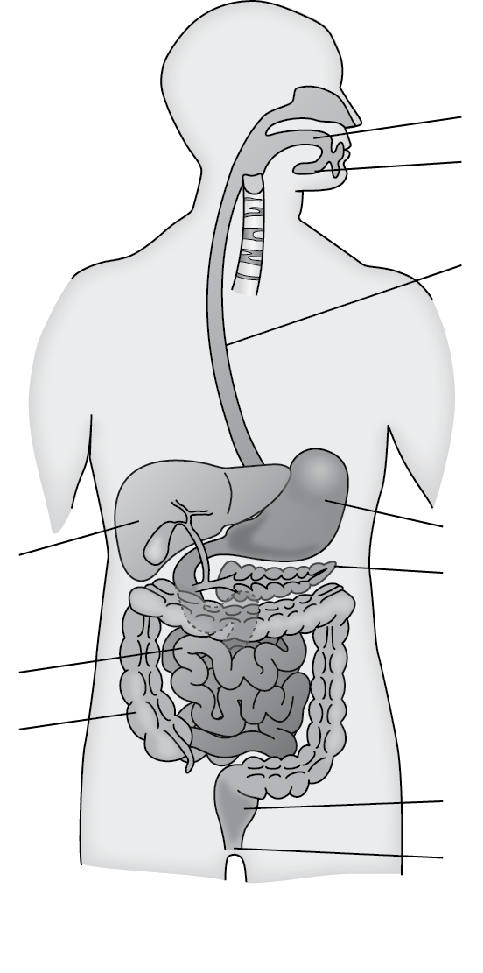
Comprehension Questions – answer five at a time from memory, then use your purple pen and the notes to make corrections.

- Name as many organs from the digestive system as you can
- Give the functions of as many of the organs as you can
- What is digestion?
- Why is digestion important to us?
- State the functional difference (the difference in their functions) between the small and large intestines.
(You have now done five questions from memory – go back with your purple pen and make corrections)
- Name the organs from the digestive system, but in the order food passes through them.
- How is the liver important in helping digestion?
- What is the role of saliva in the mouth?
- What is the role of bile?
- Where is bile produced?
- Name the parts of the digestive system that produce enzyme?
- Why does food need to be digested?
Application questions – you can use your notes to help you answer
- Adam says, “Digestion is linked to respiration”. Is Adam right? Explain your answer
- Some enzymes only work well in acid. Where in the body do you think these enzymes are found?
- Some people struggle to chew food. Why do these people often have to have their food blended and given to them as a liquid?
- Are there any organs in your digestive system that you think you could live without? Explain your choice.
- Jenny says that “The liver is a part of the digestive system, even though food doesn’t pass directly through it” Explain why Jenny is correct
- Paul says “Most of the process of Digestion place in the stomach.” explain why Paul is wrong. Refer to specific parts of the digestive system in your answer
- A gastric band is a band that goes around the stomach. It means that a person’s stomach has a smaller volume and they feel full more quickly. Explain why this could cause a person to lose weight.
Making links
- There is acid in your stomach. What could we add to acid to tell what pH it has?
- What is the pH of acids?
- The acid is hydrochloric acid. If it reacted with a piece of iron, what two products would be formed?
- We can add an alkali to stomach acid. What kind of reaction is this?
- A student adds an indigestion tablet to some acid. It starts to fizz and bubble. Has a chemical reaction taken place? Explain how you know.
- In this reaction, calcium carbonate reacts with hydrochloric acid to form calcium chloride, carbon dioxide and water. Write a word equation for this reaction, and identify all reactants and products.
- There are no elements in this reaction. What is an element?
- The substances in the reaction are compounds. What are compounds?
- Calcium carbonate contains atoms of calcium, carbon and oxygen. Draw an atom of calcium, showing all the electrons.
- Calculate the number of protons, neutrons and electrons in calcium.
- Draw atoms of carbon and oxygen, showing all the electrons.
- What group and period are each of these three elements in?
- Calcium is a metal. Suggest two properties of calcium.
- Oxygen is a gas at room temperature. Does it have a high or low boiling point?
- Oxygen is a non-metal. Suggest two properties of oxygen.
- Oxygen gas is cooled down until it is a liquid. What is the name of this process?
- Draw a particle diagram of oxygen as a liquid.
- Give two properties of liquids.
- The carbon dioxide produced in the reaction can be stored in a balloon. There is gas pressure in the balloon. Explain why increasing the temperature increases the gas pressure.
- What is the relationship between gas pressure and temperature?
- Give two other variables we could change to affect the gas pressure of the balloon.
- Explain why gases can flow but solids cannot.
- Calculation: a gas exerts (causes) a force of 4096 N on a surface area of 3.2 m². Calculate the pressure.
Use the equation: pressure x area = force
- A student has two glass boxes, and in each box is a different type of gas. What could happen to light as it passes from one box to the other? Explain your answer.
- Some gases have colour. Chlorine is a green gas. Explain why chlorine looks green when placed under white light.
- What colour would chlorine look if it were placed under blue light? Explain your answer.

Lesson 3 - Careers spotlight: dietitians
I am learning about how dietitians give advice for people’s general diets and for people with specific illnesses and conditions
Dietitians are health professionals (like doctors or nurses) who specifically deal with people’s diets. Part of their role is to give general dietary advice, like in the text above about reducing fat in the diet. Another part of their role is to work with people who have specific illnesses or conditions that affect what they can and cannot eat.
Watch the video of a dietitian describing the importance of eating five portions of fruit and vegetables a day then answer the questions https://www.nhs.uk/video/Pages/Fiveaday.aspx
The transcript from the video is here:
Fruit and veg are so rich in vitamins, minerals, fibre and they're low in fat, but what's really interesting is that there's worldwide research to show that eating five portions of fruit and veg a day can help to reduce the incidence of diseases such as cardiovascular disease and some cancers.
It's really important because what we have in our bodies are free radicals. These are substances that cause inflammatory reactions in our body. Fruit and vegetables are rich in what we call antioxidants and research is showing that if you have 400g a day, which is equivalent roughly to five portions of fruit and veg a day, then you are protecting yourself against that free radical damage. Each portion represents one serving or one portion of your five a day.
For example, one portion of your five a day could be a banana or a pear, an apple, an orange, roughly a handful of grapes or cherries or strawberries. When it comes to vegetables, beans and pulses count once a day, so three tablespoons of any beans, such as baked beans or chickpeas or kidney beans. No matter how much you have, they will count once a day. The reason for that is that they don't have quite the same range of nutrients as the other fruits and vegetables.
A bowl of salad, for example, or in terms of salad vegetables, something like a five-centimetre stick of cucumber, not quite a whole carrot there, an average tomato. Other vegetables, around three tablespoons of any type of vegetable will count towards your five a day, that would be one portion each, and an average-sized glass of unsweetened fruit juice again will count just once a day, no matter how much you drink, because you have stripped the fruit of its natural fibre.
In terms of dried fruit also, about a heaped tablespoon of any dried fruit counts, and even canned fruit will count, three tablespoons. So look at what you're eating, add one more and gradually add another one. It could be as simple as just taking a piece of fruit to work or having some dried fruit in your desk next to you or having some salad with your sandwich at lunchtime.
- What do fruit and vegetables contain that is good for your general health and wellbeing?
- What are fruit and vegetables generally low in?
- Worldwide research shows that eating five portions a day could reduce your chances of which diseases?
- How many portions of your five a day is in:
  - One banana
  - Two apples
  - Half a handful of grapes
- However many beans you have in a day, more than three tablespoons only counts as one portion.
  - Why is this?
  - How many portions are in one and a half tablespoons?
  - How many portions are in 6 tablespoons?
- Why can you not have your five a day through just drinking fruit juice?
- How could you get more fruit and vegetables into your diet?
- In one day, a person has an apple, half a cucumber, two glasses of fruit juice and a big bowl full of baked beans. Have they had their five a day? Explain your answer.
As above, dietitians also deal with people who have illnesses and conditions that mean they have trouble with eating. There are many different conditions like this. One common condition is called Crohn’s disease. This affects the whole digestive system and causes areas of it to become inflamed. This means they become very sore and puffy and it causes people a lot of pain. Different foods can often make people feel even worse and digestion becomes less effective because inflamed areas are not good at absorbing food. A dietitian would help someone with Crohn’s find a diet that gives them enough nutrients but also does not cause them pain. Sometimes, those with Crohn’s will have to go onto an enteral diet. This involves a special type of food called an enteral which is in liquid form. It contains all the nutrients a person needs, causes less pain in the digestive system and is absorbed much better.
- What is Crohn’s disease?
- Who can help a person with Crohn’s disease?
- People with Crohn’s can get tired very easily. Use your knowledge of food groups, absorption and respiration to explain why.
- Anaemia is a condition that means people have fewer red blood cells. This is very common in people with Crohn’s. Explain why people with anaemia feel very tired a lot of the time.
- Crohn’s affects roughly one in 650 people. In the UK there are around 65 million people. How many will be affected by Crohn’s?
Lesson 4: The small intestine
I am learning about the adaptations of the small intestine so I can explain its function within the digestive system
Recap questions:
- What is diffusion?
- The relationship between temperature and rate (speed) of diffusion is:
As temperature increases, rate of diffusion increases
Explain why this is true.
- What is the relationship between surface area and rate (speed) of diffusion?
- What is the relationship between concentration gradient and rate (speed) of diffusion?
- Explain why a cell which needs to take lots of particles in from its surroundings would have a large surface area.
- A cell has 5 particles in it, and 25 outside it. Draw a diagram of this cell, showing all the particles.
- Overall, will diffusion take place into the cell or out of the cell?
- How many particles will be in the cell at the end of diffusion?
- A student says there will be more particles in the cell at the end if it has a larger surface area. Explain why this is incorrect.
- Look at the diagram below:
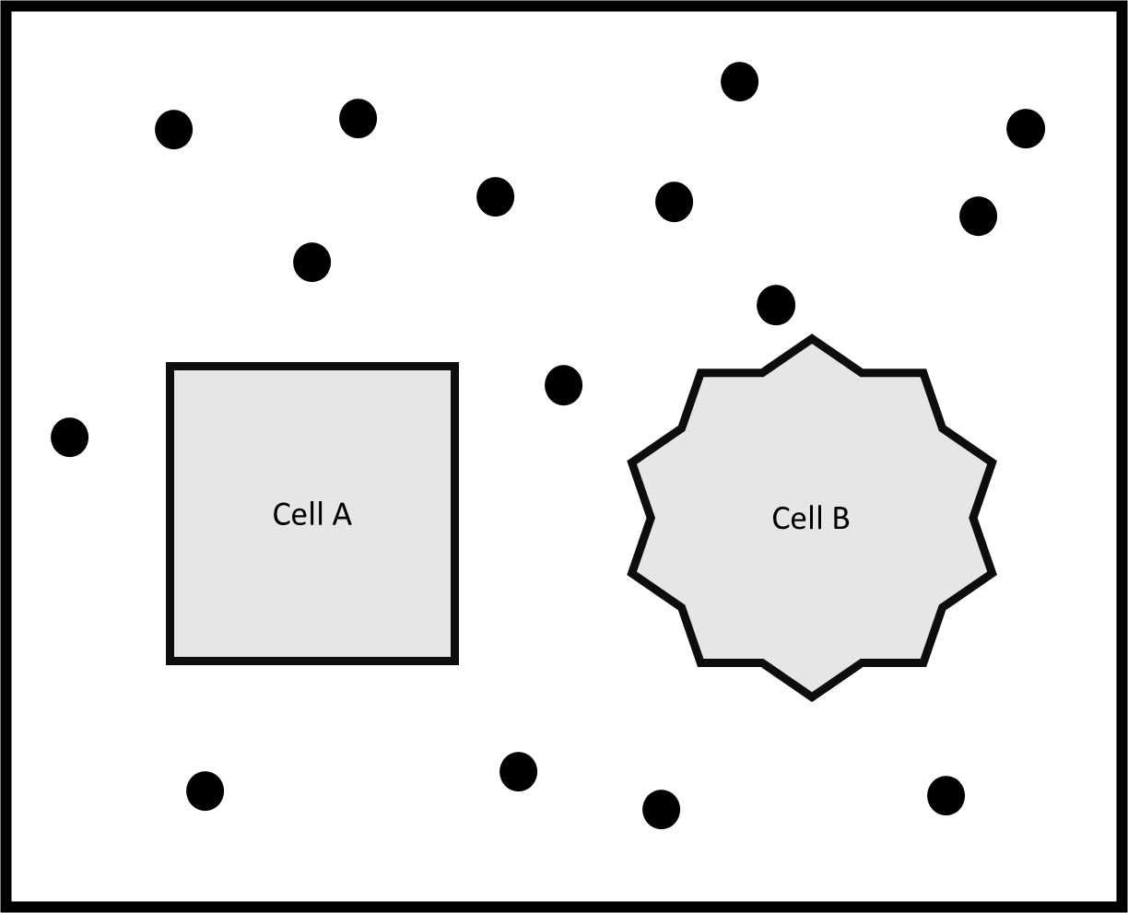
  - Will diffusion be quicker in and out of cell A or cell B?
  - Explain your answer.
- Someone sprays deodorant in the front of a room. Is the front of the room an area of high or low concentration? Explain your answer.
- Eventually, you can smell the deodorant from the back of the classroom. Explain why, using the word particle in your answer.
- On a hot day, you can smell the deodorant at the back of the room much quicker than you can when it is cold. Explain why.
- A student wants to know how the temperature of the room affects how quickly you can smell the deodorant at the back of the room. What is the independent variable?
- What is the dependent variable?
- Which variables need to be controlled?
- Explain why it is important to control these variables

Rate of Diffusion
After food is digested, most of it is absorbed in the small intestine by diffusion. After reviewing the questions above, your teacher will remind you about the different ways to increase the rate of diffusion. This is really important because the small intestine is adapted to make sure it can do diffusion really quickly (have a high rate of diffusion). The Core Questions we used in year 7 were:
In cells, what three factors affect diffusion? | Concentration gradient, temperature, cell surface area
What word do we use for the size of the difference in concentration between two places? | Concentration gradient
How does concentration gradient affect rate of diffusion? | The greater the concentration gradient, the greater the rate of diffusion
How does temperature affect the rate of diffusion? | The greater the temperature, the greater the rate of diffusion
How does cell surface area affect the rate of diffusion? | The greater the cell surface area, the greater the rate of diffusion

- A cell is absorbing particles from outside it. There is a very high concentration outside the cell, and a very low concentration inside the cell. Will diffusion be fast or slow? Explain your answer.
- A cell is absorbing particles by diffusion. The cell is put in a fridge. What will this do to the rate of diffusion?
- The cell is then put in a warm cupboard. What will this do to the rate of diffusion? Explain your answer.
- Cell A has a surface area of 0.01mm². Cell B has a surface area of 0.02mm². Which one will have a higher rate of diffusion? Explain your answer.
- Root hair cells absorb water and minerals from the soil. They have a large surface area. Explain why.
- Why is it important for the water and minerals to be moved out of the root hair cell quickly?
- Why does increasing the temperature increase the rate of diffusion?
- Why does a cell absorb particles from a solution quicker if the solution is highly concentrated?

The small intestine has four adaptations, each of which make it better at absorbing the small molecules:

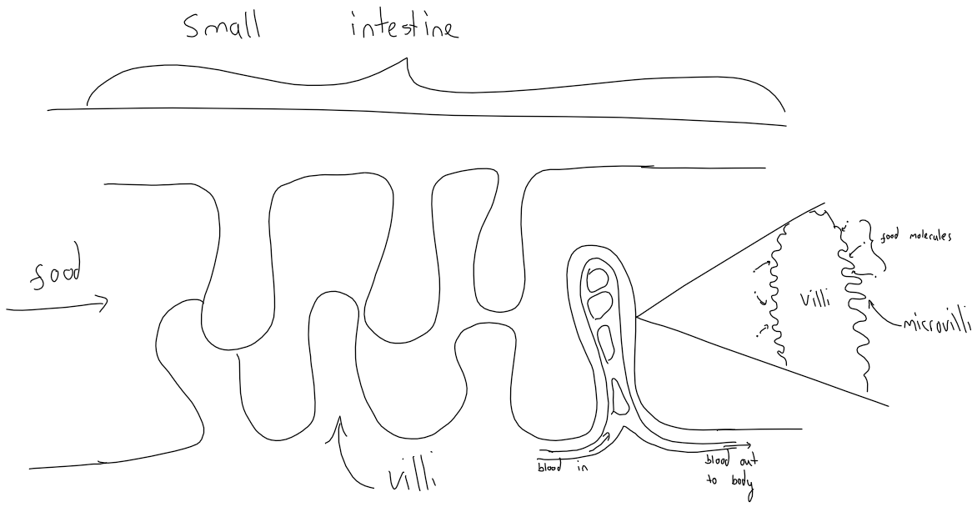
Give four adaptation of the small intestine | Very long, contains villi, rich blood supply, has microvilli
Why is the small intestine long? | To increase surface area
Why does the small intestine have villi? | To increase surface area
Why does the small intestine have a rich blood supply? | To keep a high concentration gradient
Why does the small intestine have microvilli? | To increase surface area
Comprehension questions
- What happens in the small intestine?
- List the four adaptations of the small intestine from memory
- Go back into your notes and see if you forgot any. Use your purple pen to make corrections
- Repeat until you get them all correct
- Answer from memory:
  - Why does the small intestine have microvilli?
  - Why is the small intestine long?
  - Why does the small intestine have a rich blood supply?
  - Why does the small intestine have villi?
- Go back into your notes and correct your answers for a-d.
- Why is a large surface area beneficial (a good thing) for the small intestine?
Application questions – use your notes to help you answer
- What would happen if a person did not have villi in their small intestine?
- The concentration (a bit like amount) of glucose in the intestine is high, and the concentration in the blood is low. Explain why this is good for the rate of diffusion.
- Explain why the small intestines need to be kept warm by the rest of the body.
- When a person exercises, they need more glucose. Their blood is moved through the small intestines more quickly. Why do you think this is?
- A person with Crohn’s disease can have worse absorption in the small intestine. What causes this? (use the lesson on dietitians to help if you can’t remember)
- What is the result of this?
- Why does the small intestine need a rich blood supply?
- The products of digestion are absorbed in the small intestine. From memory, what are the below broken down into?
  - Carbohydrates
  - Proteins
  - Fats
- Why are people with bad absorption in their intestines more likely to have worse health generally?
- In some surgeries a person’s intestine can be shortened by a section being removed. What is the effect of this on absorption? Explain your answer.
- From memory draw a diagram of the villi to show how they help absorption.
Gut bacteria
Gut bacteria are special bacteria that live mostly in the large intestine. They contribute to the digestion of food and other aspects of general health. Scientists are still researching how they do this, but we know that they are important. Some diseases and medications can affect your gut bacteria negatively, as can having a poor diet without enough fruit and vegetables.
Application questions:
- A student says that all bacteria are harmful. Explain why they are wrong.
- Some bacteria help prevent inflammation of the digestive system. Go back to your notes on Crohn’s disease and explain why this is helpful.
- Complete the sentence stems:
Gut bacteria are helpful because…
Gut bacteria are helpful but…
Gut bacteria are helpful therefore…
- Probiotics are foods which contain bacteria that can add to your gut bacteria. Some yogurts are probiotics. Explain why eating yogurt might have a positive effect on a person’s health.
- Many yogurts contain lots of sugar and fat. What could the effects of eating these types of yogurt be on a person?
- In a scientific study, some people changed their diet to include more burgers, pizzas and chips. The scientists found that this had a negative effect on the gut bacteria. What conclusion can be made from this about digestion and diet?

Lesson 5 – diet and disease
I am learning about how a person’s diet can affect their health and cause disease
The term obesity describes someone who is very overweight and has a high percentage of body fat. Obesity is generally caused by consuming more calories, particularly those in fatty and sugary foods, than you burn off through physical activity. The excess energy is stored by the body as fat. The best way to treat obesity is to eat a healthy, reduced-calorie diet and exercise regularly.

Obesity can lead to Coronary heart disease (CHD). CHD is a major cause of death both in the UK and worldwide. Coronary heart disease is the term that describes what happens when your heart’s blood supply is blocked or interrupted by a build up of fatty substances in the coronary arteries (arteries that provide the heart with glucose and oxygen). Over time, the walls of your arteries can become furred up with fatty deposits. Heart disease can be caused by lifestyle factors and other conditions such as: smoking, high cholesterol, high blood pressure, diabetes. Treatment can include lifestyle changes such as regular exercise and stopping smoking, medication and surgery.
Comprehension questions – answer from memory then check your notes and make corrections with a purple pen
- What is obesity?
- What causes obesity?
- What can obesity lead to?
- How can obesity be prevented or treated?
- What is CHD?
- What can cause CHD?

Obesity is caused by eating too much of a particular food (sugary and fatty ones). There are diseases called deficiency diseases which are caused by not eating enough of a particular food. For example, sailors used to get a disease called scurvy which was caused by them not eating enough fresh fruit and vegetables. When they were out at sea for a long time they could not get these foods (fridges had not been invented yet).

Scurvy results from a lack of vitamin C (ascorbic acid). Early symptoms of deficiency include weakness, feeling tired, and sore arms and legs. Without treatment, decreased red blood cells, gum disease, changes to hair, and bleeding from the skin may occur. Scurvy is easily treated by adding some vitamin C to your diet, such as fresh fruit and vegetables. Nowadays, a GP may also recommend taking vitamin C supplements until you feel better

Comprehension questions – answer from memory then check your notes and make corrections with a purple pen

- What caused scurvy?
- Why do sailors nowadays not get scurvy?
- What is a deficiency disease?

Lesson 6 – Food tests
I am learning about how chemical tests can be used to identify different food groups
Food Tests – Testing for Sugar and Starch
Starch is a carbohydrate which is made of long chains of identical small sugar molecules. Long chains of repeating molecules are known as polymers. The small molecules from carbohydrates are used by the body to release energy to allow muscle contraction. The test for starch is always to add iodine solution. Iodine solution is normally orange-brown. It will turn blue-black if starch is present

Sugars react with Benedicts reagent to turn it from blue to orange-red. But it is a slow reaction, so needs speeding up by placing in a water bath.

You will use the table to record results from testing a series of different foods.

Food | Does it contain?
Food | Starch | Sugar | Fat | Protein

- Starch and sugar questions:
- State some examples of foods that contain starch
- State some examples of foods that contain sugar
- State the foods that you tested containing starch
- Describe what carbohydrates are used for in the body
- What are carbohydrates broken down into?
- State the liquid you added to the foods to test for starch
- What colour did that liquid turn when starch was present?
- Name the liquid you added to the foods to test for sugar
- What colour did that liquid turn when sugar was present?
- Describe why might a water bath used when testing for sugar
- What colour is iodine normally (before a reaction)?

Food tests – Testing for Proteins and Fat
To test for protein, add some food to a test tube and add a few drops of biuret reagent. If the biuret reagent changes from blue to lilac/purple, that is a positive result, meaning there is protein present in the food. If the biuret reagent stays blue, there is no protein present.

To test for fats, add ground food to a test tube, add 2cm3 of ethanol and shake gently, covering the end of the test tube with your thumb, then add 2cm³ of water and gently shake again. Fats will make the clear ethanol turn a cloudy, milky white if they are present.

Complete the table we started last time once you have done all the food tests.

- Food test questions:
- State some examples of foods that contain fats
- State some examples of foods that contain protein
- Describe what fats are used for in the body
- Name the liquid you added to the foods to test for Protein
- Name the liquid you added to the foods to test for Fats
- What do fat molecules contain?
- What colour does biuret reagent turn in the presence of protein?
- Describe how ethanol changes in the presence of fats
- Name the small molecules used to make up proteins
- What can result from eating too many fats?
- What disease can this result in?
- Describe how someone could avoid getting this disease
- What is a deficiency disease?
- What are proteins used for in the body
- Babies and infants are given lots of milk as part of their diet, why do you think this is? Explain your answer.
- Jake is 3 years old and allergic to milk, what foods could Jake be given to avoid becoming deficient in protein?
- As you get older, the amount of drink you are suggested to drink each day decreases – Why do you think this is? Explain your answer.
Summary questions:
- Read the magazine cutting about research into heart disease.
More heart disease in older women: Heart disease amongst British women in the 60-79 age group is more common than previous research suggested. A recent study of 4,286 British women in that age group indicated that one in five showed signs of heart disease.
- Why can the results of this research not be used to draw any conclusions about
heart disease amongst women across the world?
- How can people reduce their risk of heart disease?
- Explain the possible effects of a diet that does not contain enough calcium for a child.
- What is protein needed for in the diet?
- Why is there hydrochloric acid in the stomach?
- Name two diseases linked with unbalanced energy or fat intake.
- Name two places in the body where enzymes are produced
- State all of the parts of the digestive system in the correct order
- Describe the role of bile in digestion
- What products are fats broken down into
- Name a deficiency diseases
- Write a definition of an enzyme
- Give four ways in which the intestines are adapted for digestion
- Each statement below is incorrect. Write a correct version of each statement.
  - People that need to lose weight need a balanced diet
  - The nutrient groups are carbohydrates, fats, protein, dairy, vitamins, minerals and water
  - Digestion starts in the stomach
  - All bacteria are dangerous and can cause disease

- Some information about a packet of biscuits is shown below:
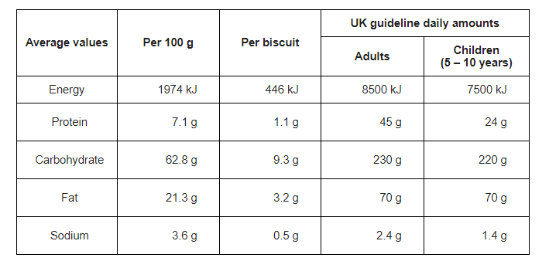
  - One day a ten-year-old child ate a whole packet of the biscuits. The biscuits in the pack had a mass of 400 g. How many grams of carbohydrate did the child eat?
  - The amount of carbohydrate you calculated in part (a) was more than the UK guideline daily amount for the child. How much more?
  - How many biscuits would an adult need to eat to get all the protein they need?
  - How much energy would that number of biscuits give them?
  - Is eating biscuits a good way to get protein? Explain your answer.
  - An adult gets 10,000 kJ of energy every day from their food. They exercise and use 9,200 kJ of energy. What could happen to that person?
  - A person eats 3 biscuits. What percentage of their daily amount of fat is that?

