Organic Chemistry Mastery Booklet
Use your class notes to help you answer the below.
- Complete the below:
Over millions of years, crude oil forms from the remains of ancient b_____________. Crude oil is a mixture of compounds called hydrocarbons, which contain carbon and hydrogen only. One type of hydrocarbon is called an alkane, which only has single bonds between the atoms. There are many different types of alkane, and they all have different numbers of carbon and hydrogen atoms. Because it takes so long for crude oil to form it is called a finite resource.
- Draw out and name the first four alkanes
Methane 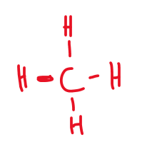 | Ethane 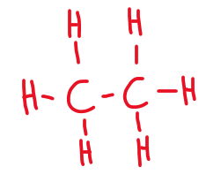
Propane 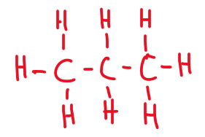 | Butane 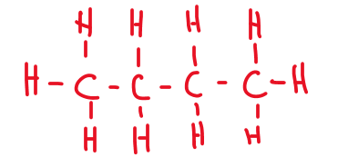

- To work out the chemical formula of an alkane, use the general formula C_{n}H_{2n+2}. This means that if there are 4 carbons, there will be (2x4)+2 hydrogens. If there are 6, there will be (2x6)+2. Write the formula for an alkane containing
  - 4 carbons C₄H₁₀
  - 6 carbons C₆H₁₄
  - 8 carbons C₈H₁₈
  - 25 carbons C₂₅H₅₂
  - 100 carbons C₁₀₀H₂₀₂
  - 90 hydrogens C₄₄H₉₀
  - 82 hydrogens C₄₀H₈₂
- Draw a molecule of nonane, which has 9 carbon atoms
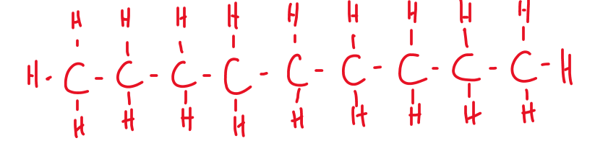
- Alkanes are simple molecular substances. What properties would you expect them to have?
Low melting and boiling points, poor conductor of heat and electricity
- Explain why methane does not conduct electricity.
Methane does not have free electrons or ions that could carry a charge
- How many moles of methane are present in 100g of methane?
M_{r}(CH₄)=1x12+4x1=16 n(CH₄)=m(CH₄)/M_{r}(CH₄)=100/16=6.25mol
- How many atoms are present in 2 moles of methane?
5 atoms in one molecule => number of atoms=5x2x6.02x10²³=6.02x10²⁴ atoms
- Challenge: nonane (see question 4) reacts with oxygen to form carbon dioxide and water. Construct and balance a symbol equation for this reaction
C₉H₂₀ + 14O₂ 9CO₂ + 10H₂O

The different alkanes all have different properties depending on the length of the chain (how many carbon atoms there are). Use the table to answer the questions
 | Short chain | Long chain
Boiling point | Low | High
Viscosity (how thick it is) | Low (so very runny) | High (so very thick)
Flammability (how easy it is to set on fire) | High | Low
- Alkane X and alkane Y are tested against each other. Alkane X is a lot easier to set on fire than alkane Y. Which one has a longer chain? Y
- Alkane X and alkane Y are tested against each other. Alkane X is a lot easier to turn into a gas than alkane Y. Which one has a longer chain? X
- Below are the boiling points of a number of alkanes. Put them in order of increasing chain length:
Alkane | A | B | C | D | E
Boiling point (°C) | 91 | -28 | 430 | 65 | 23
B<E<D<A<C
- Two students are investigating the viscosity of alkane X and Y. They pour a sample of each alkane at the top of a ramp and see how long it takes to flow down. How would you expect the amount of time taken to flow down to relate to the length of the chain? The longer the chain the longer it takes the alkane to flow down.
- Explain your answer to 13. Viscosity increases with the length of the chain
- A mixture of alkane D and alkane E from the table above is heated to 30°C. Explain why alkane E turns into a gas but alkane D does not. E has a boiling point of 23°C, it will turn into a gas at 23°C (so is a gas at 30°C) whereas D has a boiling point of 65°C, so is still a liquid at 30°C.
The boiling point of a substance is the temperature which a liquid will turn into a gas. So water has a boiling point of 100°C so will boil into steam at that temperature.
It is also the temperature at which a gas will turn back into a liquid. So if steam is cooled down to 100°C it will condense back into a liquid.

Use the alkane data from the table above to answer the questions below.
- Which alkane (from question 12) has the highest boiling point? C
- The alkanes are all heated to 500°C. Explain why they will all turn into a gas. They all have a boiling point lower than 500°C.
- From the temperature of 500°C they are all cooled down. Which one will condense first? C
- Explain your answer to 13. It is the first alkane to reach its boiling point when the temperature decreases.
- Which one will condense last? B
- Explain your answer to 15. It is the last alkane to reach its boiling point when temperature decreases.
- Compared to D, predict the viscosity of A. A is more viscous than D. (A has a higher boiling point than D, so A has a longer chain than D, Viscosity increases with the chain length)
- Compared to B, predict the viscosity of C. C is a lot more viscous than B.
- A mixture of A and D are heated up until they turn into a gas. Predict a temperature at which this might happen. D will turn into a gas first when the temperature reaches 65°C, and A will turn into a gas when the temperature reaches 90°C.
- A and D are cooled down to a temperature of 80°C. Which one will condense? Explain your answer. A will condense at it turns into a liquid when the temperature is less than 91°C.
- A mixture of all the alkanes is cooled down to 0°C. Which one is still a gas? B
- Alkane C has 15 carbons. How many hydrogens does it have? 32
- Write out its chemical formula. C₁₅H₃₂
- Alkane A has 11 carbons and E has 5. Predict how many carbons D has. 8
- At what temperature does gaseous D condense? 65°C
- Explain how you can use the boiling points of D and E to separate a mixture of them. Distillation can be used to separate D and E.

- Alkane C has an M_{r} of 120. How many moles of C are in 25g? n(C)=m(C)/M_{r}(C)=25/120=0.21mol
- What is the mass of 10 moles of C? m(C)=n(C)xM_{r}(C)=10x120=1200g
- In the reaction below, methane reacts with chlorine:
CH₄ + Cl₂ CH₂Cl₂ + H₂
If 40g of methane are used, how many moles of methane are used?
n(CH₄)=m(CH₄)/M_{r}(CH₄)=40/16=2.5mol
- How many moles of H₂ will be produced?
n(H₂)=2.5mol
- What is the mass of the H₂ produced?
m(H₂)=n(H₂)xM_{r}(H₂)=2.5x2=5g
- If 10g of methane are used, what mass of H₂ will be produced? m(H₂)=1.25g
- What mass of CH₂Cl₂ will be produced?
M_{r}(CH₂Cl₂)=1x12+2x1+2x35.5=85 n(CH₂Cl₂)=2.5/4=0.625mol
m(CH₂Cl₂)=0.625x85= 53.1g
- CH₂Cl₂ can dissolve in water. If 30g are dissolved in 120cm³ of water, what is the concentration in g/dm³? (triple only: what is the concentration in mol/dm³?)
C(CH₂Cl₂)=m(CH₂Cl₂)/V=30/0.120=250g/dm³
- If 15g of methane and 15g of chlorine are used, which is in excess and which is limiting?
n(CH₄)=15/16=0.94mol n(Cl₂)=15/71=0.21mol => Cl₂ is the limiting reactant
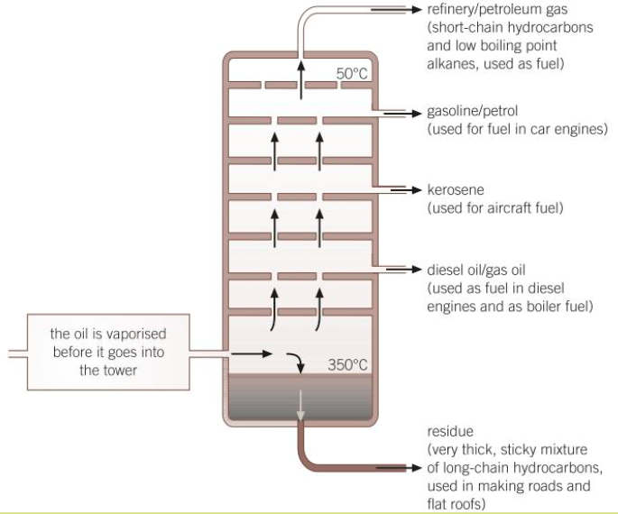
Fractional distillation
Fractional distillation is how we separate the different alkanes in crude oil. First, the oil is heated up enough so that all the alkanes turn into a gas (boil). Next they are sent into a fractionating column, which is hot at the bottom and cool at the top.
As they are gases, they rise up the column. As they rise up the column they cool down. When they reach their boiling point they condense back into a liquid and can be collected. Because they all have different boiling points they are collected at different points on the column.
Use the data from the table on the first page to answer the questions:
- Where will the alkanes with the lowest boiling points be collected? At the top of the column
- Where will the alkanes with the highest boiling points be collected? At the bottom of the column
- Which of the alkanes (from the table) will condense first? C
- Where will that alkane be collected from the column? At the bottom of the column
- Which alkanes will not condense in the column? B
- Which alkane will condense highest up the column? D
- Where will the most flammable alkanes be collected? At the top of the column
- Where will the most viscous alkanes be collected? At the bottom of the column
- An alkane with 10 carbons is collected halfway up the column. One with 3 carbons is collected at the top, and one with 30 is collected at the bottom.
  - Where would one with 20 carbons be collected? Between the bottom and halfway up the column
  - Where would one with 5 carbons be collected? Between the top and halfway up the column
  - Where would one with two carbons be collected? At the top of the column
- Icosane has a boiling point of 343.1°C and has 20 carbons in its chain. Complete the sentence kernels below:
Icosane has a high boiling point because… it has a long chain of carbon
Icosane has a high boiling point but… hydrocarbons with more carbon have a higher boiling point
Icosane has a high boiling point therefore… it is not as good a fuel as octane
- Octane has a boiling point of 125.6°C. Describe how it can be separated using fractional distillation (normally 4 marks).
- Octane has 8 carbon atoms. How many moles of octane are in 30g of octane?
Octane: C₈H₁₈ =>M_{r}(C₈H₁₈)=8x12+18x1=114 => n(C₈H₁₈)=30/114=0.26mol
Complete Combustion
Combustion reactions are when a hydrocarbon reacts with oxygen (O₂). Complete combustion always produces carbon dioxide (CO₂) and water (H₂O). The reaction releases energy which can be used.
Example: the combustion of methane:
Word equation:
Methane + oxygen carbon dioxide + water
Symbol equation:
CH₄(g) + O₂(g) CO₂(g) + H₂O(g)
Balance the equation:
CH₄(g) + 2O₂(g) CO₂(g) + 2H₂O(g)
- Write word and balanced symbol equations for the combustion of:
  - Ethane Ethane + oxygen carbon dioxide + water C₂H₆ + 3.5O₂ 2CO₂ + 3H₂O
  - Propane Propane + oxygen carbon dioxide + water C₃H₈ + 5O₂ 3CO₂ + 4H₂O
  - Butane Butane + oxygen carbon dioxide + water C₄H₁₀ + 6.5O₂ 4CO₂ + 5H₂O
  - An alkane with 10 carbons (decane)
Decane + oxygen carbon dioxide + water C₁₀H₂₂ + 15.5O₂ 10CO₂ + 11H₂O
  - An alkane with 20 hydrogens (nonane)
Nonane + oxygen carbon dioxide + water C₉H₂₀ + 14O₂ 9CO₂ + 10H₂O
- Combustion reactions are exothermic. Draw a reaction profile for a combustion reaction.
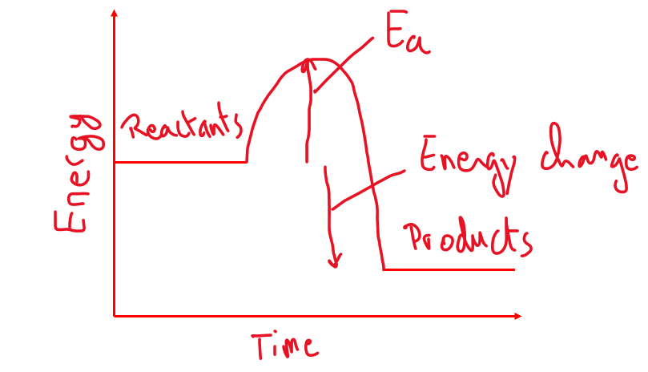
- 10g of ethane is completely combusted in oxygen. What mass of carbon dioxide is produced?
Triple only: if the reaction is conducted at room temperature, what volume of carbon dioxide is produced?
M_{r}(ethane)=2x12+6x1=30 n(ethane)=m(ethane)/M_{r}(ethane)=10/30=1/3 From equation, 1 mole of ethane makes 2 moles of CO₂. n(CO₂)=2/3mol m(CO₂)=n(CO₂)xM_{r}(CO₂)=2/3x(1x12+2x16)=29.3g

Incomplete Combustion
Incomplete combustion occurs when there is not enough oxygen. It can result in a range of products including carbon monoxide (which is a toxic gas) and soot. It also releases less energy. So for methane:
Methane + oxygen carbon monoxide + water
2CH₄(g) + 3O₂(g) 2CO(g) + 4H₂O(g)
Notice that the ratio of carbon atoms to oxygen atoms here is 1:3 but for complete combustion was 1:4
- For ethane and propane write symbol equations for reactions where the products are CO and H₂O
Ethane: C₂H₆ + 2.5O₂ 2CO + 3H₂O
Propane: C₃H₈ + 3.5O₂ 3CO + 4H₂O
- Explain why a blue flame in a Bunsen burner boils water quicker than a yellow flame
A blue flame indicates complete combustion. More energy is released during complete combustion (because more bonds are formed during complete combustion).
- Challenge: 10g of ethane is combusted in 15g of oxygen. Will this be complete or incomplete combustion?
M_{r}(ethane)=2x12+6x1=30 n(ethane)=m(ethane)/M_{r}(ethane)=10/30=1/3mol
M_{r}(oxygen)=2x16=32 n(oxygen)=15/32=0.47mol
C₂H₆ + 3.5O₂ 2CO₂ + 3H₂O
For the combustion to be complete, the number of moles of oxygen must be at least 3.5 higher than the number of moles of ethane. This is not the case, so the combustion will be incomplete.
Cracking
- There are long hydrocarbons and short ones
  - The shorter ones are more useful
  - Used as fuels and to help make polymers and other useful chemicals
- Cracking turns the long ones into shorter ones
  - One way is to pass over a hot catalyst
  - Another way is to mix with steam and heat to a high temperature
- Cracking produces shorter alkanes and alkenes
  - Alkenes are useful substances that are more reactive than alkanes
  - Alkenes are more reactive than alkanes
  - Alkenes turn bromine water colourless
Questions:
- Why do chemical plant owners commonly crack long hydrocarbons? To get more useful short hydrocarbons
- Balance the equation: C₂₀H₄₂ C₁₀H₂₂ + 2C₃H₆ + 2C₂H₄
- A student has three bottles. Two have alkanes and one has an alkene. How could they tell which is which? When adding a small volume of each bottle in bromine water, only the alkene will make the bromine water go from orange to colourless. The alkanes will not decolourise bromine water.
- What are the two main types of cracking? Thermal cracking (high temperature) and catalytic cracking (Heat and catalyst)
- How can alkanes be separated based on their boiling points? Fractional distillation
- Use your glossary to write a definition for thermal decomposition Thermal decomposition is a chemical reaction where a compound decompose into smaller compounds because of the high temperature
- How is cracking an example of thermal decomposition? A long hydrocarbon decomposes into smaller hydrocarbons when heated.
- Dodecane (alkane with 12 carbon atoms) can be cracked into octane (eight carbons) and ethene (C₂H₄). Write a word and balanced symbol equation for this reaction.
Dodecane octane + ethene
C₁₂H₂₆ C₈H₁₈ + 2C₂H₄
- Write a word and balanced symbol equation for the complete combustion of octane.
Octane + oxygen carbon dioxide + water
C₈H₁₈ + 12.5O₂ 8CO₂ + 9H₂O
- In what way would you expect dodecane and octane to be different? (think about their properties)
Octane has a shorter chain than dodecane so octane is more volatile, has a lower boiling point, is more flammable and less viscous than dodecane.
- Write a word and symbol equation for the combustion of methane. Use page 118 from the textbook or your energy changes booklet to work out the energy change of this reaction. The bond energy in C=O from CO₂ is 799kJ/mol
- Repeat this process for propane.
Summary problem
Look at this equation: C₁₀H₂₂ C₄H₁₀ ₊ C₃H₆
- Balance the equation C₁₀H₂₂ C₄H₁₀ ₊ 2C₃H₆
- Explain how you know that cracking has occurred Same number of C and H on both side of the equation, only one reactant
- Why is cracking carried out? Cracking is carried out to form more of more useful small hydrocarbons
- What are the two types of cracking? Thermal and catalytic
- Cracking is an endothermic reaction. Draw a reaction profile for cracking, and label the activation energy
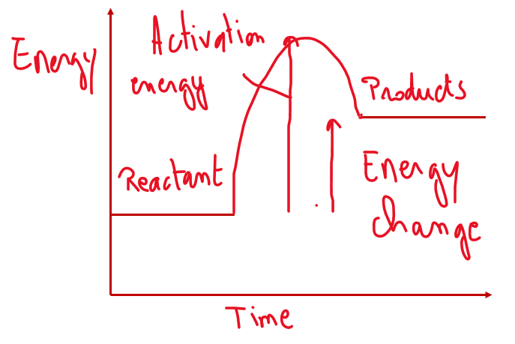
- A catalyst is often used for cracking. What is a catalyst? A chemical that speeds up a reaction without being used up.
- How do catalysts increase the rate of a reaction? Catalysts provide a different reaction pathway with a lower activation energy
- All substances in the reaction are gases. How could the rate of the reaction be increased? Increasing the temperature, decreasing the pressure, increasing the number of moles of reactant could increase the rate of reaction.
- This is a reversible reaction. What is a reversible reaction? A reaction where the products can react with each other to re-form the reactants.
- The reaction is allowed to reach dynamic equilibrium. What is dynamic equilibrium? When the rate of the forward reaction is the same as the rate of the backward reaction.
- What will the effect of increasing the temperature be on the position of the equilibrium? Explain your answer. The forward reaction is endothermic, so the forward reaction is favoured by a higher temperature. Increasing the temperature will shift the equilibrium to the right.
- What will the effect of increasing the pressure be on the position of the equilibrium? Explain your answer. Increasing the pressure would shift the equilibrium to the left. The equilibrium shift to minimise the change in conditions. The side with the least amount of gas will be favoured.
- Are all three substances in the equation hydrocarbons? Explain your answer. The reactants and products are hydrocarbons because they are made of hydrogen and carbon atoms only.
- The reactant is called decane, and is found in crude oil. What is crude oil? Crude oil is a mixture of hydrocarbons.
- Why is crude oil considered a finite resource? It take millions of years for crude oil to form.
- Decane has a boiling point of 174°C. At 200°what state will it be? Gaseous
- Describe how fractional distillation is used to separate decane from crude oil. Decane has a different boiling points than other compounds in crude oil. Decane will condense at a different temperature than other hydrocarbons.
- What are the products of the complete combustion of decane? Water and carbon dioxide
- Construct a symbol equation for this reaction C₁₀H₂₂ + 15.5O₂ 10CO₂ + 11H₂O
- Decane has covalent bonds. What are covalent bonds? Covalent bond are formed when two atoms share a pair of electrons
- Explain why decane does not conduct electricity. Decane doesn’t have free electrons or ions able to carry a charge
- In the reaction at the start of the problem, if 250g of C₁₀H₂₂ are used, what mass of C₃H₆ will be produced?
M_{r}(decane)=10x12+22x1=142 n(decane)=m(decane)/M_{r}(decane)=250/142 mol
1 mole of decane forms 2 moles of propene. n(propene)=2x250/142 mol
M_{r}(propene)=3x12+6x1=42 m(propene)=n(propene)xM_{r}(propene)=42x2x250/142=148g
- Triple only: when 250g are used by a student, they obtain a percentage yield of 72%. What mass of C₃H₆ did they actually obtain?

Additional questions

- What state is fluorine at room temperature? gas
- What is a base? A chemical that neutralises an acid
- What charge will an ion of beryllium take? 2+
- Define inert A chemical that does not react
- Why is sodium not produced in the electrolysis of sodium chloride solution? Sodium is more reactive than hydrogen, so hydrogen will be formed during the electrolysis of sodium chloride solution, not sodium.
- What are intermolecular forces? The forces of attraction between molecules
- How can you measure the quantity of a reactant or product? Measure its mass (if a solid or liquid) or its volume if it is a gas.
- Is making bonds endothermic or exothermic? Exothermic
- Show two half equations for the reaction below: Al³⁺ + Fe → Fe³⁺ + Al
Al³⁺ + 3e⁻ Al
Fe Fe³⁺ + 3e⁻
- For the extraction of which metals is electrolysis needed? Any metal more reactive than carbon
- What is the formula of magnesium fluoride? MgF₂
- State the effect of increasing the concentration on the rate of reaction Increasing the concentration increases the rate of reaction as the chances of successful collisions increases with the concentration of reactants.
- In terms of electrons, what do group 7 elements have in common? All the elements of group 7 have 7 electrons in their outer shell
- Give two examples of exothermic reactions. Respiration, Combustion, neutralisation
- Explain why increasing the pressure of a gas increases the rate of a reaction The particles of gas are closer to each other so there is a higher chance of successful collisions between particles of gas.
- Which ions do the common acids form in solution? H⁺
- How many electrons can go in the first shell? 2
- How do you test for an alkene? Put a small volume of sample in bromine water. If the bromine water goes from orange to colourless, the sample is an alkene.
- What is a base? A chemical that neutralises an acid
- Is this process oxidation or reduction? Fe²⁺ → Fe³⁺ + e⁻ Oxidation (loss of electron(s))
- In terms of electrons, what do group 1 elements have in common? All the elements of group1 have 1 electron in their outer shell
- What is the name given to the structure of diamond, graphite and silicon dioxide? Giant covalent lattice
- What is an alkane? A hydrocarbon with the general formula C_{n}H_{2n+2} where all the bonds are single covalent.
- Is this process oxidation or reduction? Na⁺ + e⁻ → Na Reduction (gain of electron(s))
- Which ions are in CaCO₃? Ca²⁺ and CO₃²⁻

