7x/Sc1 FOF 5
Name _____________________________________________________________________________________
 | Question | Answer
 | Give two properties of solids
 | What causes gas pressure?
 | Name three organelles that are found in plant cells but not animal cells
 | How do the particles in a solid move?
 | What is the function of the nucleus?
 | Explain why solids cannot be compressed
 | What is the function of the ribosomes?
 | What is the function of the cell wall?
 | In what three ways can you increase gas pressure?
 | What are the three states of matter?
11. Figure 2 shows a different human embryo.
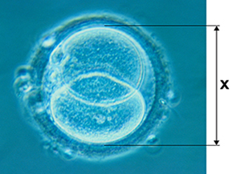
(a) Measure image length X on Figure 2.
Give your answer in millimetres (mm).
(1)
(b) The image in Figure 2 has been magnified × 500
Calculate the real length of the embryo.
You may use your calculator
Give your answer in millimetres (mm).

(2)
Mark scheme
Year 7 FOF 5
Name _____________________________________________________________________________________
 | Question | Answer
 | Give two properties of solids
 | What causes gas pressure?
 | Name three organelles that are found in plant cells but not animal cells
 | How do the particles in a solid move?
 | What is the function of the nucleus?
 | Explain why solids cannot be compressed
 | What is the function of the ribosomes?
 | What is the function of the cell wall?
 | In what three ways can you increase gas pressure?
 | What are the three states of matter?
(a)

