Extent of reaction (reversible reactions and Le Chatelier’s principle)

⇌

Name:

What is a reversible reaction? | A reaction which can go from reactants to products but also from products to reactants
What chemical symbol represents a reversible reaction? | ⇌ (Double headed arrow)
If a reaction is exothermic in the forward direction what will it be in the reverse direction? | Endothermic
What is dynamic equilibrium? | The point in a reversible reaction in a closed system when the forward and reverse reactions are occurring at the same rate
What kind of equipment is necessary for a reaction to reach dynamic equilibrium? | A closed system
If a reaction is at dynamic equilibrium, how is the amount of reactant changing? | It is not changing
If a reaction is at dynamic equilibrium, how is the amount of product changing? | It is not changing
What is Le Chatelier's principle? | If a system is at equilibrium and a change is made to any of the conditions, then the system responds to counteract the change
What are the three main ways we can change a reaction at equilibrium? | Changing concentration, changing temperature, changing pressure
What is the effect of decreasing the concentration of products in a reaction at equilibrium? | Equilibrium moves/shifts to the right
What is the effect of decreasing the concentration of reactants in a reaction at equilibrium? | Equilibrium moves/shifts to the left
What is the effect of increasing the concentration of reactants in a reaction at equilibrium? | Equilibrium moves/shifts to the right
What is the effect of increasing the concentration of reactants in a reaction at equilibrium? | Equilibrium moves/shifts to the left
A reaction is exothermic in the forward direction and reaches equilibrium. What will the effect on the equilibrium be if the temperature is increased? | Equilibrium moves/shifts to the left
A reaction is exothermic in the forward direction and reaches equilibrium. What will the effect on the equilibrium be if the temperature is decreased? | Equilibrium moves/shifts to the right
A reaction is endothermic in the forward direction and reaches equilibrium. What will the effect on the equilibrium be if the temperature is increased? | Equilibrium moves/shifts to the right
A reaction is endothermic in the forward direction and reaches equilibrium. What will the effect on the equilibrium be if the temperature is decreased? | Equilibrium moves/shifts to the left
In the reaction below, explain the effect of increasing the pressure. N₂ (g) + 3H₂ (g) ⇌ 2NH₃ (g) | Equilibrium shifts to the right to favour the side with fewer gas particles
In the reaction below, explain the effect of decreasing the pressure. N₂ (g) + 3H₂ (g) ⇌ 2NH₃ (g) | Equilibrium shifts to the left to favour the side with more gas particles
In the reaction below, explain the effect of increasing the pressure H₂ (g) + I₂ (g) ⇌ 2HI (g) | No effect, equal numbers of gas particles on each side
In the reaction below, explain the effect of increasing the pressure 2H₂O₂ (g) ⇌ 2H₂O (g) + O₂ (g) | Equilibrium shifts to the left to favour the side with fewer gas particles
In the reaction below, explain the effect of decreasing the pressure 2H₂O₂ (g) ⇌ 2H₂O (g) + O₂ (g) | Equilibrium shifts to the right to favour the side with more gas particles

Reversible reactions
I am learning about reversible reactions so I can explain how their direction can be changed
Many reactions can only easily progress in one direction, from reactants to products. However, there are some reactions that can be reversed. For example, ammonium chloride can break down to form ammonia and hydrogen chloride. Hydrogen chloride and ammonia can also react together to form ammonium chloride. This is called a reversible reaction, and it has a special symbol:
ammonium chloride ⇌ ammonia + hydrogen chloride
Reversible reactions are always exothermic in one direction and endothermic in the other direction. For example, when anhydrous copper sulfate is mixed with water, there is an exothermic reaction and it turns into hydrated copper sulfate. Hydrated copper sulfate itself can react endothermically to form anhydrous copper sulfate and water.
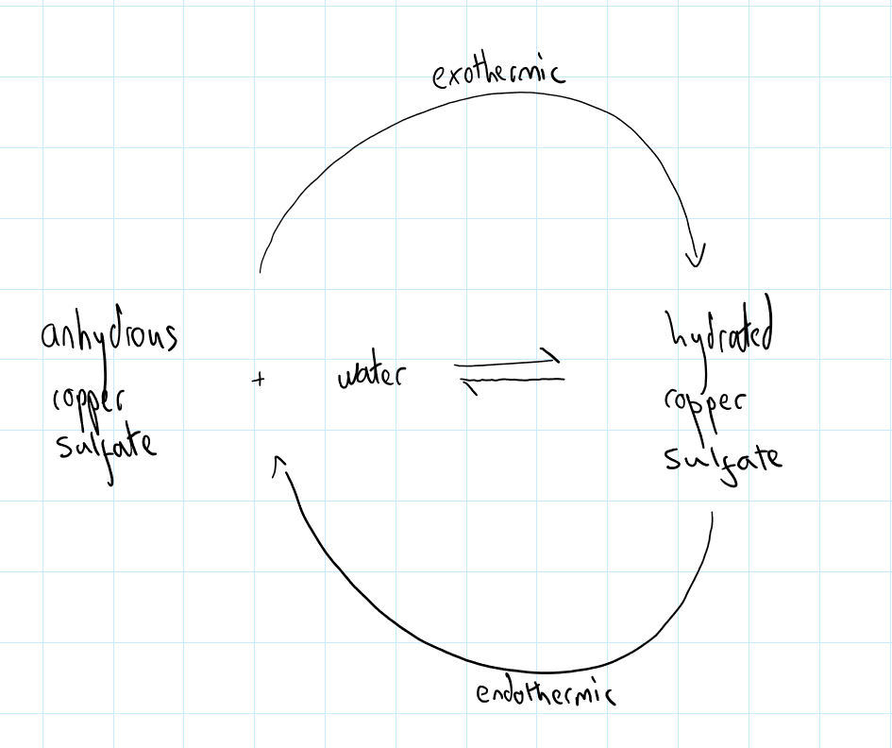
- When nitrogen and oxygen react together, they form nitric oxide. This reaction is reversible. Write a word equation for the reaction.
- Nitric oxide is NO. Construct a balanced symbol equation for the reaction.
- All the substances in the reaction are simple molecular. Explain why they are gases at room temperature.
- Draw a covalent bonding diagram for oxygen.
- The reaction in the forward direction is endothermic. What is it in the reverse direction?
- What happens to the temperature of the surroundings whilst the forward reaction is occurring?
- Draw a reaction profile for the conversion of nitrogen and oxygen to nitric oxide.
- (H) Calculate the mass of nitric oxide that can be formed when 78 g of oxygen completely reacts with nitrogen.
- (H) Calculate the % by mass of nitrogen in nitric oxide.

Dynamic equilibrium
I am learning about closed systems so I can explain how a reaction can reach equilibrium
Consider the reaction below:
A(g) + B(g) ⇌ C(g) + D(g)
If we start with just A and B, as soon as the reaction starts they will begin colliding to form C and D. The rate will be high at the start, but it will decrease as C and D start to be formed. Once C and D start to form, they can also collide and turn back into A and B. At the start, this rate (the reverse reaction) is 0 g/s, because there is no C and D. As time goes on the rate starts to increase as there is more and more C and D so more and more collisions between C and D. However, the rate of A and B’s reaction will decrease, because there is less and less A and B so fewer collisions.

Therefore, at the start, the forward reaction rate is high, and the reverse rate is low. As time goes on, the forward rate decreases and the reverse rate decreases. Eventually, they will meet and be identical. A and B are forming C and D as quickly as C and D are forming A and B. The rates are the same. The total amount of A, B, C and D is also not changing. We might be making 5 g of C and D every second, but we are also making 5 g of A and B in the same second, so overall there is no change:
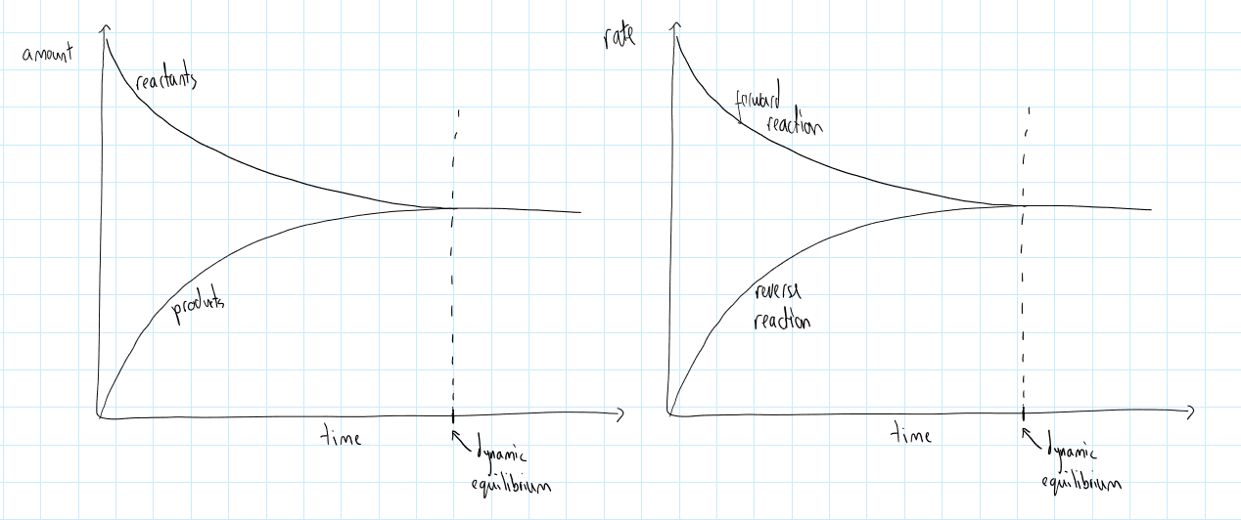The point in time at which the forward and reverse rates are equal is called dynamic equilibrium.
- A student conducts a reaction between W(aq) and X(aq) to form Y(aq) and Z(aq). The reaction is reversible. Write an equation for the reaction.
- Explain what it means that the reaction is reversible.
- The forward reaction decreases the temperature of the surroundings. Is the reverse reaction endothermic or exothermic? Explain your answer in terms of energy transfers.
- When W and X are first added together, what is the rate of the reverse reaction?
- As time goes on, the rate of the forward reaction decreases. Explain why, making reference to the particles in the solution.
- As time goes on, the rate of the reverse reaction decreases. Explain why, making reference to the particles in the solution.
- Eventually, what happens to the rates of the reverse and forward reaction?
- At dynamic equilibrium, there is 10 g of W and X, and 8 g of Y and Z. If the student waits for another 10 seconds, how will those masses change?
- The student repeats the reaction. In the first 5 seconds, 8 g of Y and Z are formed. Calculate the rate of formation of Y and Z.
- In the next 5 seconds, 3 g of Y and Z are formed. Calculate the rate of formation of Y and Z.
- Once dynamic equilibrium is reached, the student says “the rate of formation of Y and Z is now 0 g/s.” Explain why the student is wrong.
- Overall, describe the changes in the reaction that lead to it reaching dynamic equilibrium.

Earlier, we looked at this reaction:
A(g) + B(g) ⇌ C(g) + D(g)
We can change it a little to look like this:
A(aq) + B(aq) ⇌ C(aq) + D(g)
If we conduct the reaction in an open beaker, D will escape:
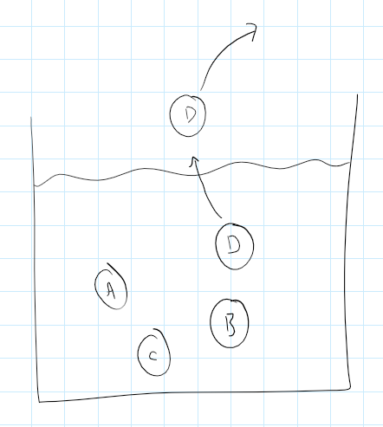
This means that D and C can no longer collide, and the reverse reaction will not occur. Dynamic equilibrium cannot be met under these conditions.
In order to reach dynamic equilibrium, we need a “closed system” – a situation where nothing can escape. In our example, we could achieve this by completing the reaction in a sealed vessel.
- A student reacts iodine (I₂) with hydrogen (H₂) to form hydrogen iodide (HI). The reaction is reversible. Construct a word and balanced symbol equation for the reaction.
- Iodine is a solid at room temperature, the other two substances are gases. Add state symbols to your equation.
- A student conducts the reaction in a beaker. Explain why it will never reach dynamic equilibrium.
- At the start of the reaction, is the forward rate high, low or zero? Explain your answer.
- The reaction is exothermic in the forward direction. Draw a reaction profile for the reverse reaction.
- The boiling points of the three substances are below:
Hydrogen: -252.9 °C
Iodine: 184.3 °C
Hydrogen iodide: -35.1 °C
All three substances are simple molecular. Explain the differences in their boiling points.
- Why would it not be correct to talk about the boiling point of one molecule of hydrogen?

(H from here on) The effect of changing conditions on equilibrium
I am learning about Le Chatelier’s principle so I can predict the effect of changing conditions on the position of an equilibrium
Your teacher will use the immigration model to explain how external changes can affect the position of a reaction at equilibrium.
Le Chatelier’s principle is summarised as: If a system is at equilibrium and a change is made to any of the conditions, then the system responds to counteract the change.
There are three main conditions that we can change.
The first is concentration:
- If the concentration of reactants is increased, the equilibrium moves to the right
- If the concentration of reactants is decreased, the equilibrium moves to the left
- If the concentration of products is increased, the equilibrium moves to the left
- If the concentration of products is decreased, the equilibrium moves to the right

- The reaction below is set up in a sealed vessel and allowed to reach dynamic equilibrium:
A(aq) + B(aq) ⇌ C(aq) + D(g)
What is the meaning of the ⇌ symbol?
- Explain why it is necessary to conduct the reaction in a sealed vessel.
- What is the effect on the equilibrium if the concentration of A and B is increased?
- What will the effect on the equilibrium be if D is removed from the vessel?
- If A and B are completely removed from the reaction, what will the effect on C and D be? Explain your answer.
- At equilibrium, the rate of reaction for A with B is 0.65 g/s. What is the rate of reaction for C and D?
- The reaction vessel weighs 4kg at the beginning of the reaction. Remembering that it is completely sealed, what will its mass be at the end of the reaction? Explain your answer.

The second condition is temperature:
- If the forward reaction is exothermic and the temperature is increased, the equilibrium shifts to the left
- If the forward reaction is exothermic and the temperature is decreased, the equilibrium shifts to the right
- If the forward reaction is endothermic and the temperature is increased, the equilibrium shifts to the right
- If the forward reaction is endothermic and the temperature is decreased, the equilibrium shifts to the left

- A student reacts Substance X(s) with Substance Y(s) to form Substance Z(g) in a sealed vessel in order to reach dynamic equilibrium.
  - What is meant by “dynamic equilibrium”?
  - Explain why a sealed vessel is necessary to reach dynamic equilibrium
  - Write a word equation for this reaction.
  - At the start of the reaction, the temperature of the vessel is 21°C, and after one minute the temperature was 38°C. Is the forward reaction exothermic or endothermic? How do you know?
  - Calculate the rate of temperature change in the reaction.
  - Suggest and explain whether the rate of temperature change is highest at the start of the reaction or after one minute.
  - Once the reaction hits equilibrium, the student heats up the vessel in an oven. What effect does this have on the amount of product?
  - Once the reaction hits the student cools down the vessel in a fridge. What effect does this have on the amount of reactant?

The final effect is that of gas pressure. First, we will examine what is meant by gas pressure and what causes it:
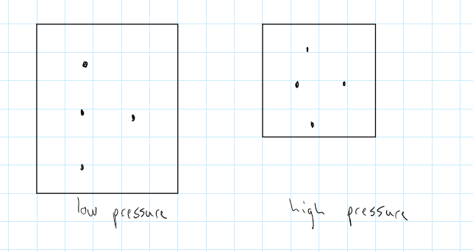
Gas pressure is about the frequency of collisions that gas particles make with the walls of the container they are in. More frequent collisions = higher gas pressure. Decreasing the volume of the container as above will increase the pressure, but also increasing the number of particles will increase the pressure:
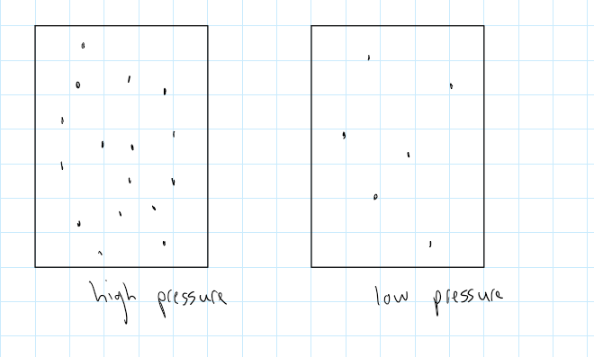
Note that temperature also affects the pressure, but when discussing equilibrium we try to separate these out because temperature also affects equilibrium.
- A student has two identical balloons filled with gas. One has 2 moles of gas in it, and the other has 1.8 moles. Which balloon has a higher pressure and why?
- Why is it important that the balloons are identical?
- What causes the pressure inside the balloons?
- A student has a sealed box with Ca(s) and O₂(g) in it. Explain why adding more Ca(s) to the box will not affect the pressure in the box.
- A student has two cuboid boxes. Cuboid A has dimensions 92 cm x 118 cm x 14 cm and Cuboid B has dimensions 0.81 m x 0.74 m x 1.01 m. Each cuboid has 3 moles of gas in. Calculate which Cuboid has a higher pressure (assume that both cuboids are at the same temperature).
- Use the box method to establish what amount of gas would need to be added to the lower pressure cuboid in order to give the two cuboids the same pressure (at the same temperature).
- Explain why the temperature must remain constant when comparing the pressure in both Cuboids.

When it comes to equilibrium, we need to consider the number of gas particles on either side of a reaction:
2A(g) + B(g) A₂B(g)
In this case, there are three particles of gas on the left and two particles on the right. That means that the more product you form, the lower the pressure. As the reaction progresses, the pressure will decrease:
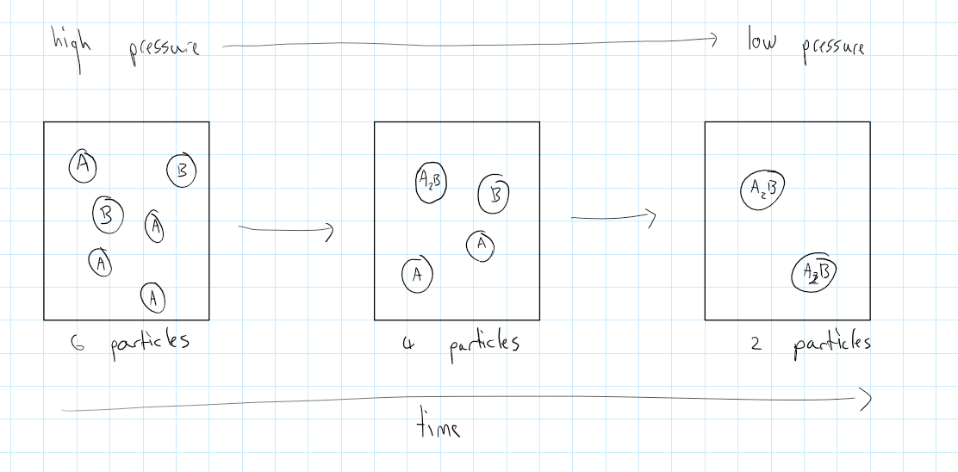
If the reaction was reversible, you would never get to the “end of a reaction”, and would hit equilibrium:
2A(g) + B(g) ⇌ A₂B(g)
If at the point of equilibrium you then increased the pressure, the system would counteract the change by shifting to the right. This would increase the amount of product, which decreases the total number of particles. If you decrease the pressure, it would shift to the left and increase the amount of reactant, which increases the total number of particles.
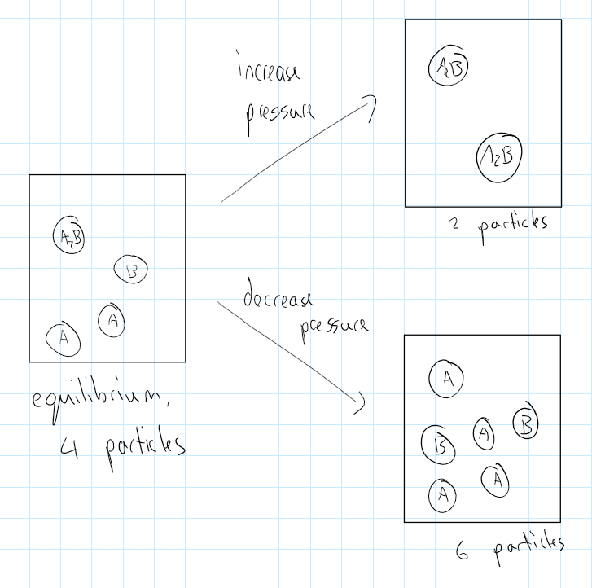
Changing the pressure only makes a difference when we are dealing with gases, and when the number of particles on either side is the same, there is also no effect on the equilibrium if you change the pressure.
Summary:
- If there are more gas particles on the product side and the pressure is increased, the equilibrium shifts to the left
- If there are more gas particles on the product side and the pressure is decreased, the equilibrium shifts to the right
- If there are fewer gas particles on the product side and the pressure is increased, the equilibrium shifts to the right
- If there are fewer gas particles on the product side and the pressure is decreased, the equilibrium shifts to the left

- This question is about the reaction below:
N₂(g) + 3H₂(g) ⇌ 2NH₃(g)
  - Which side has a greater number of particles?
  - What is the effect on the position of equilibrium if the pressure is increased?
  - What is the effect on the position of equilibrium if the pressure is decreased?
- The reaction below is allowed to reach equilibrium:
2SO₂(g) + O₂(g) ⇌ 2SO₃(g)
Which side of the equation has more gas molecules?
  - If the pressure is increased. The amount of SO₃ increases. Explain this result.
  - A small amount of O₂ is allowed to escape. What effect will this have on the amount of SO₃? Explain your answer.
  - The forward reaction is exothermic. What effect will decreasing the temperature have on the product?
  - What conditions (temperature and pressure) would be best for the production of SO₃?
- Explain the effect of increasing the pressure on the equilibrium mixture:
H₂(g) + I₂(g) ⇌ 2HI(g)
- Look at the reaction below:
H₂O(g) + C(s) ⇌ CO(g) +H₂(g)
  - Explain why the reaction must take place in a sealed vessel.
  - What effect will increasing the pressure have on the amount of hydrogen produced?
  - What effect will decreasing the pressure have on the amount of hydrogen produced?
  - The reaction is carried out in a sealed vessel. Explain how the mass of the vessel will change throughout the reaction.
- Look at the reaction below:
NO₂(g) ⇌ N₂O₄(g)
  - Balance the equation.
  - The reactant is a brown gas and the product is a yellow gas. How will the colour change if the pressure of the reaction is increased?
  - How will the colour change if the pressure of the reaction is decreased?

Summary question:
When heated, ammonium sulfate reacts to form ammonia and hydrogen sulfate:
(NH₄)₂SO₄(s) ⇌ 2NH₃(g) + H₂SO₄(g)
- Calculate the Mr of every substance in the equation
- If 20g of ammonium sulfate is completely reacted, what mass of ammonia will be produced?
- The reaction is conducted in an open beaker. Explain why the mass decreases over time.
- The temperature of the reaction is increased. State the effect this will have on the rate of reaction.
- Explain your answer.
- Ammonia is a simple molecular substance. Explain why it does not conduct electricity.
- H₂SO₄ can be dissolved in water to give sulphuric acid. Which ions will be present in the sulphuric acid?
- How is the pH of the acid related to the ions in the solution?
- A sample of sulphuric acid has a concentration of 10g/dm³ and a pH of 2. What concentration would it need to have a pH of 1?
- What are the products from a reaction between sulphuric acid and calcium carbonate?
- What charge does a calcium ion take?
- In the reaction above, the ammonium sulfate needs to be heated before it forms ammonia and hydrogen sulfate. Does this mean that the reaction is endothermic or exothermic?
- A student wants the reaction to reach dynamic equilibrium. Why must they put a tight lid on the beaker?
- The reaction above is allowed to reach dynamic equilibrium. What can be said about the rate of the forward and reverse reactions at dynamic equilibrium?
- The student increases the pressure of the reaction. What effect does this have on the position of the equilibrium? Explain your answer.
- The student adds a catalyst. What is the effect of adding a catalyst on the position of the equilibrium?

