Rates of reaction
Name:

 | What is meant by the rate of a reaction? | How fast a reaction is
 | What are the two possible units for rate of reaction? | g/s or cm³/s
 | State how the rate of a reaction changes with time | As time increases, the rate decreases
 | Explain why a reaction’s rate decreases with time | As reactant gets used up, so there are fewer particles of reactant and less frequent collisions
 | What factors can affect the rate of a reaction? | Temperature, surface area of a solid, concentration of reactants in solution, pressure of gases, use of a catalyst
 | State the effect of increasing the surface area on the rate of a reaction | Increases the rate
 | How can the surface area of a solid be increased? | Cutting it up/using smaller pieces
 | Explain why increasing the surface area of a solid increases the rate of a reaction | More particles are available to collide, there are therefore more frequent collisions between reactants.
 | State the effect of increasing the concentration of a solution on the rate of reaction | Increases
 | Explain why increasing the concentration of a solution increases the rate of reaction | More concentrated means more particles in solution, therefore more frequent collisions between reactants.
 | State the effect on increasing the pressure of a gas on the rate of reaction | Increases
 | Explain why increasing the pressure of a gas increases the rate of a reaction | Less space between the particles, therefore more frequent collisions
 | State the effect of increasing the temperature on the rate of reaction | Increases
 | What is the activation energy? | The amount of energy a particle needs before it will be able to react when it collides with another particle
 | Explain why increasing the temperature increases the rate of reaction | Increases the speed at which particles move therefore there are more frequent collisions. Increases the number of particles which have the activation energy, therefore more collisions result in a reaction.
 | What is a catalyst? | A substance which increases the rate of a reaction but is not used up in that reaction
 | How do catalysts speed up reactions? | They allow the reaction to progress with a lower activation energy.

Calculating the rate of a reaction
I am learning about changes in mass and volume so I can calculate the rate of a reaction
Some chemical reactions are very fast. Explosions are a good example of reactions like this. Some reactions are a lot slower, like rusting. We can measure the rate of a reaction by looking at the change in mass or the change in volume. E.g.:
- If I heat up a metal and its mass increases a lot in a short amount of time, it has a high rate.
- If I put some metal in an acid and a small volume of gas is given off in a large amount of time, it has a low rate.
We use two equations to calculate the rate:
$$rate of reaction= \frac{change in mass (g)}{time (s)}$$  Unit: g/s | $$rate of reaction= \frac{change in volume ({cm}^{3})}{time (s)}$$  Unit: cm³/s

Worked examples:
In a reaction, a volume of 80 cm³ of gas is released in 640 seconds. What is the rate of the reaction?
D: change in volume = 80 cm³ time = 640 s
E: rate of reaction = change in volume/time
S: rate of reaction = 80 / 640
C: = 0.125
U: = 0.125 cm³/s
In a reaction, a metal increases from a mass of 6 g to a mass of 20 g. This takes 350 seconds. What is the rate of the reaction?
D: change in mass = 20 – 6 = 14 g time = 350s
E: rate of reaction = change in mass/time
S: rate of reaction = 14 / 350
C: = 0.04
U: = 0.04 g/s
- In a reaction, a metal decreases in mass by 0.5 g in 25 s. What is the rate of the reaction?
- In a reaction a volume of 72 cm³ of gas is released in 6 minutes. What is the rate of the reaction? Make sure to convert minutes to seconds.
- In a reaction, a substance changes in mass from 180 g to 210 g. This takes five minutes. What is the rate of the reaction?
- A student does two reactions.
In reaction A, 25 cm³ of gas is produced in one minute.
In reaction B, 60 cm³ of gas is produced in two minutes.
Which reaction is quicker? Use a calculation to prove your answer.
- A student does a reaction using magnesium carbonate and some acid.
  - Complete the equation for the reaction:
magnesium carbonate + sulfuric acid ________________ + _______________ + ___________
  - Which product is a gas?
  - None of the products are elements. What are they?
  - Explain how you know.
  - The formula for magnesium carbonate is MgCO₃. Calculate its Mr.
  - Draw an ion of magnesium, showing all electrons and the charge.
  - Explain why Mendeleev put magnesium in the same group as calcium.
  - In Mendeleev’s first periodic table, there was a gap below calcium. Why did he leave this gap?
  - In the student’s reaction, 7 cm³ of gas is produced. Look at the equation in a. What is the gas?
  - It takes 3.5 seconds to produce this volume of gas. What is the rate of the reaction?
  - Sulfuric acid has a state symbol of (aq). What does this mean?
  - What colour would sulfuric acid be if universal indicator was added to it?
  - At the end of the reaction, there is no acid left and all the products are neutral. What pH would the products have and what colour would they be if universal indicator were added to them?
  - Magnesium cannot be extracted from magnesium carbonate by reduction with carbon. Explain why.
  - Magnesium carbonate has a giant ionic structure, and sulfuric acid gas a simple molecular structure. Compare the two substances.

Rate graphs
I am learning about plotting rate data so I can interpret gradients
Imagine we have conducted a reaction, and we collect the data below:
Time (seconds) | Cumulative Volume of Gas Produced (cm³)
0 | 35.0
20 | 43.0
40 | 47.5
60 | 49.5
80 | 50.0
100 | 50
120 | 50

We can plot that data on a graph that looks like this:
GRAPH 1
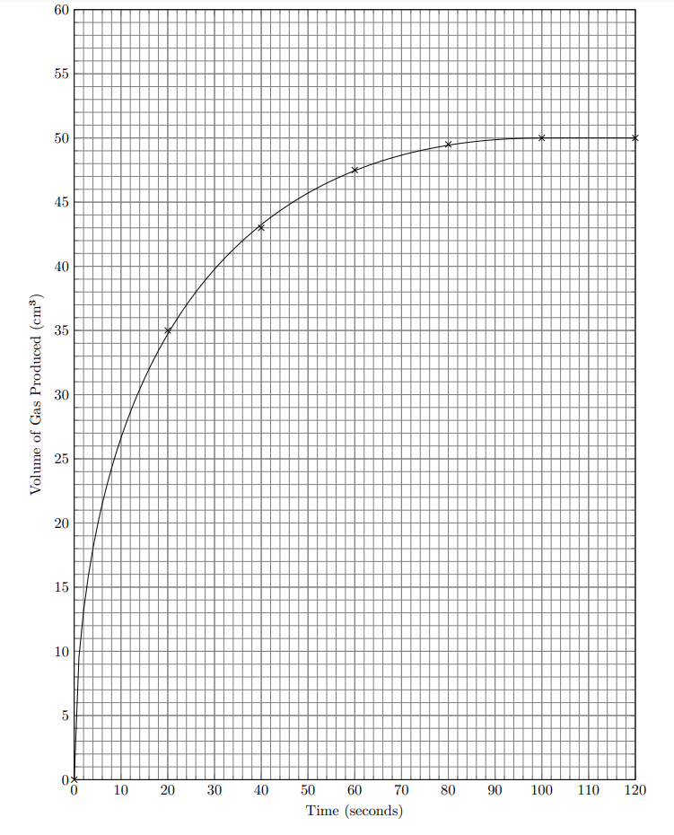
We can use this graph to make calculations.
Worked example: use the graph to calculate the rate for the first ten seconds
At 10 seconds on the graph, the volume of gas produced is 26.5 cm³.
D: change in volume = 26.5 cm³ time = 10 s
E: rate of reaction = change in volume/time
S: rate of reaction = 26.5 / 10
C: = 2.65
U: = 2.65 cm³/s
- With your teacher, calculate the rate:
  - Across the first 30 seconds
  - Across the first 64 seconds
- What is the volume of gas produced at 52 seconds?
- How long does it take for 45 cm³ of gas to be produced?
- In a different reaction, 50 cm³ of gas is produced in 40 s. Will that reaction have a higher or lower rate than the reaction in GRAPH 1?

Look at the graph below:
GRAPH 2
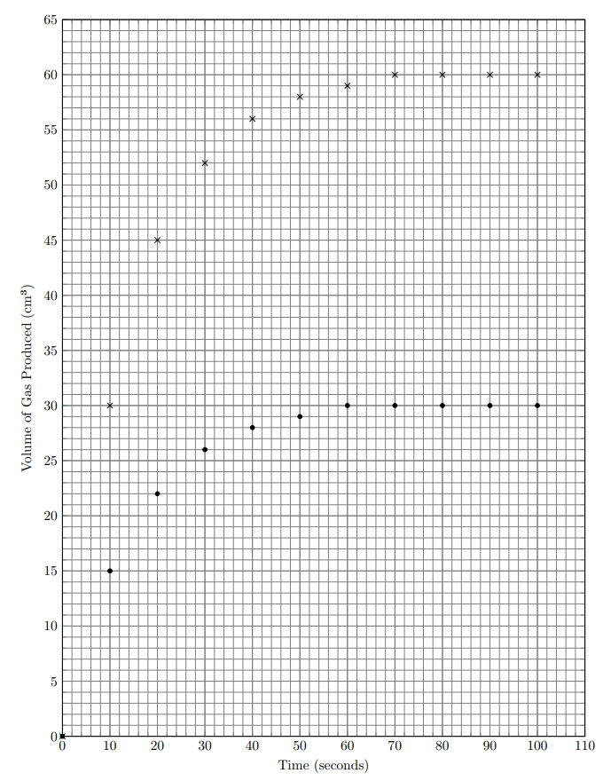

The graph shows data for two different reaction, the cross reaction and the dot reaction.
- Draw two separate lines of best fit on the graph, one for each reaction
- For the cross and dot line:
  - Calculate the rate over the first 24 seconds (you should get one answer for the cross line, and one for the dot line)
  - Calculate the rate over the first 56 seconds
- Which reaction has a greater rate?
- How can you tell from your calculations?
- At what point in time does the dot reaction stop?
- At what point in time does the cross reaction stop?
We can also calculate the rate between two points on the graph. The worked example below uses GRAPH 1:
Worked example: calculate the rate of reaction between 28 and 64 seconds
Volume at 28 seconds = 36 cm³
Volume at 64 seconds = 47 cm³
Change in time = 64 – 28 = 36 s
Change in volume = 47 – 36 = 11 cm³
D: change in volume = 11 cm³ time = 36 s
E: rate of reaction = change in volume/time
S: rate of reaction = 11 / 36
C: = 0.31
U: = 0.31 cm³/s
Use GRAPH 1 with your teacher to calculate the rate:
- Between 8 and 24 seconds
- Between 52 and 100 seconds
- Between 100 and 120 seconds
The questions below rely on GRAPH 2
- For the dot line, calculate the rate between 20 and 44 seconds
- For the cross line, calculate the rate between 40 and 76 seconds
- For both lines, calculate the rate between 4 and 32 seconds
You will have noticed that the rate decrease as the reaction progresses. We will look at this more later, but the main point is that the rate at the start of a reaction is highest, and it decreases as the reaction goes on.
GRAPH 3
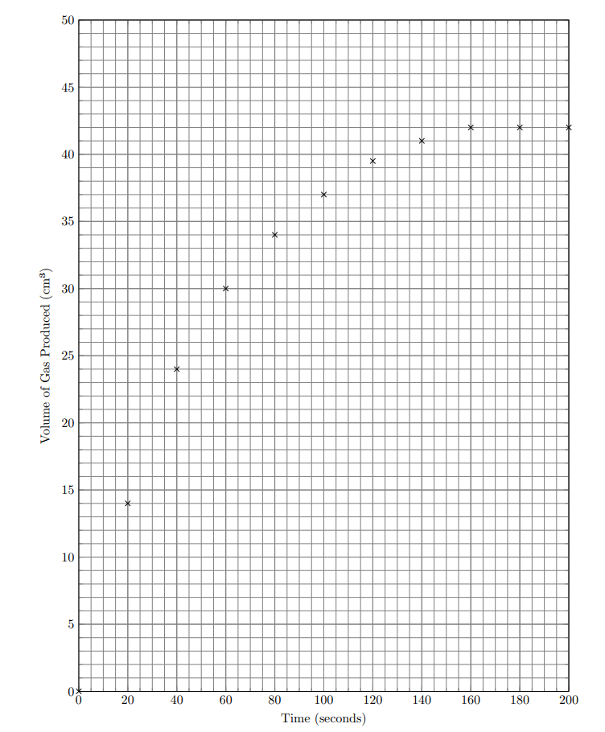
- Draw a line of best fit for the data on the GRAPH 3
- Where is the rate of the reaction highest?
- At what point does the reaction stop? How do you know?
- Calculate the rate across the first 50 seconds
- Calculate the rate across the first 115 seconds
- Calculate the rate between 60 and 100 seconds
- Calculate the rate between 105 and 135 seconds
GRAPH 4
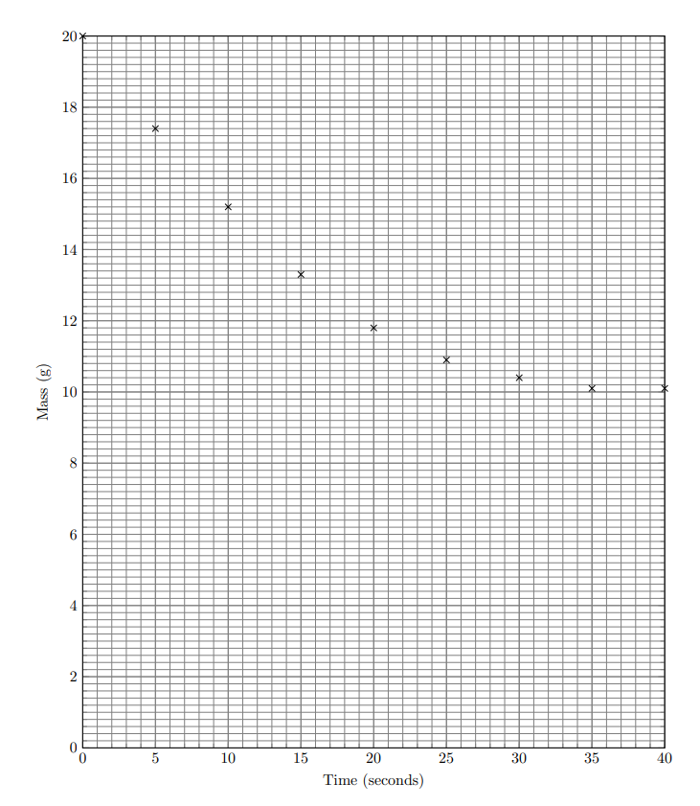
- Draw a line of best fit for GRAPH 4
- Calculate the rate over the first 5 seconds
- Calculate the rate between 5 and 10 seconds
- At what point in time does the reaction stop?
- The graph shows data for the reaction below:
CaCO₃ (s) + HCl (aq) CaCl₂ (aq) + H₂O (l) + CO₂ (g)
Balance the equation
- Explain why the mass decreases over time
- What mass in total is lost?
- Calculate the number of moles in 4 g of CaCO₃
- Calculate the number of moles of HCl that would be required to react fully with the CaCO₃
- If that number of moles were dissolved in 850 cm³ of water, what would the concentration be in g/dm³?
- The reaction is exothermic. Would the temperature of the reaction increase or decrease? Explain your answer.
- Write an ionic equation for the reaction.
- Two substances in the reaction have high melting and boiling points, and three substances have low melting and boiling points. Establish which is which, and justify your choices.
- CaCO₃ (s) does not conduct electricity but CaCl₂ (aq) does. Explain why.
- Explain why calcium cannot be extracted by reduction with carbon.
- How is it extracted?
- A 4067 kg sample of CaCO₃ is heated, and its mass slowly decreases. At the end of two days, its mass is 3490 kg. What is the rate of reaction across those two days?
- How many moles of CaCO₃ have reacted?
- Suggest the rate of reaction in mol/s
- The student repeats the CaCO₃ + HCl reaction with 8.6 g of CaCO₃ and 250 cm³ of 13.9 g/dm³ HCl. Calculate which is excess and which is limiting.

(H ONLY) The rates that we have calculated till now are mean rates, but we can also calculate the rate at a specific point by drawing a tangent. Here is another copy of GRAPH 1, and your teacher will show you how to use it to calculate the rate at a specific point:
- With your teacher, calculate the rate at:
  - 10 s
  - 40 s
  - 60 s
- Calculate the mean rate between 50 and 70 s
- Compare the mean rate you calculated with the rate at 60 s you calculated above.
- Use the copy of GRAPH 2 below to calculate the rate of reaction at 30 s for the dotted and cross reactions.
- Looking at GRAPH 2, how can you tell that the rate of the cross reaction is larger than the rate of the dot reaction?

- A student does electrolysis on a sample of CuCl₂(aq).
  - What will the product at the anode be?
  - Draw a half equation to show this reaction.
  - What will the product at the cathode be?
  - Draw a half equation to show this reaction.
  - Explain what has been oxidised and what has been reduced.
  - Explain why if the student used NaCl(aq) some of the products would be different.
  - The student measures the volume of gas produced by the electrolysis:
Time (s) | Volume produced (cm³)
0 | 0
20 | 1.6
40 | 2.4
80 | 2.8
100 | 3.0
120 | 3.1
140 | 3.1
160 | 3.1
Plot this data onto GRAPH 5 and draw a line of best fit:
GRAPH 5
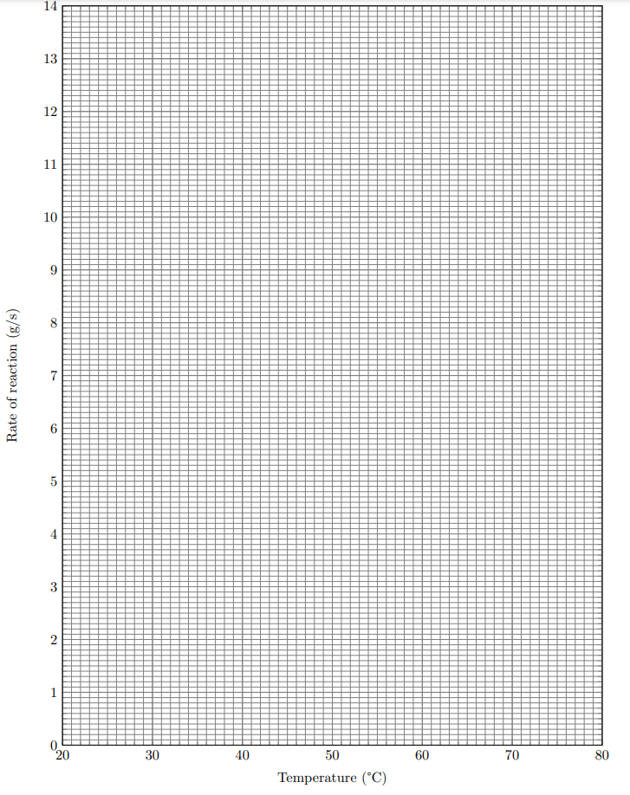
  - Calculate the rate for the first 40 seconds
  - Calculate the rate between 40 and 80 seconds
  - (H ONLY) Using a tangent to the graph, calculate the precise rate at 70 seconds
  - At what point in time does the reaction finish?
  - What volume of gas in total is produced by the end of the reaction?
  - In the electrolysis, the eloctodes used are made of graphite. Explain why graphite conducts electricity.
  - Explain why the CuCl₂ must be (aq) or (l) before the electrolysis will work.
  - Cu exists as two isotopes. Explain how Chadwick’s discoveries led to a greater understanding of isotopes.
  - Chadwick is not the only scientist who did experiments and discovered new things about atoms. Explain how the gold foil experiment proved that the plum pudding model of the atom was incorrect.
  - Cu exists as Cu-63 and Cu-65. Cl exists as Cl-35 and Cl-37. What is the maximum Mr of CuCl₂?
  - The abundance of each isotope are shown below:
Cu-63 | 69%
Cu-65 | 31%
Cl-35 | 75%
Cl-37 | 25%
Use this information to calculate the relative atomic mass of copper.
  - Calculate the relative atomic mass of chlorine.
  - Calculate the probability that a “molecule” of CuCl₂ has an Mr of 133.
  - A student has 10 g of CuCl₂. Within that sample, how many of the Cu⁻ ions will have a mass of 37?

Measuring the rate + practicals
I am learning how the rate of a reaction can be measured in a lab so I can describe the process for doing so
There are three main ways to measure the rate of a reaction:
- Conduct the experiment on a balance. This enables you to watch the mass changing as the reaction proceeds. Only suitable for reactions where a gas is produced – the gas escapes the vessel and the mass decreases.
- Collect gas in a syringe or cylinder. You can use a stopwatch to see how much gas is produced with time. Only suitable for reactions where a gas is produced.
- The “Disappearing Cross” method is where you start with clear reactants which become cloudy as the reaction goes on. This occurs because the reaction produces a solid (precipitate). You can time how long it takes for a cross underneath the reaction vessel (the flask) to become completely blocked by the precipitate. Only suitable for reactions which start with solutions and produce a solid.

- Mg(s) + HCl(aq) MgCl₂(aq) + H₂(g)
  - Balance the equation above.
Mg(s) + 2HCl(aq) MgCl₂(aq) + H₂(g)

  - Suggest two methods for measuring the rate of this reaction, and justify your choice.
gas syringe/delivery under water, mass balance – as a gas is produced
  - Explain why the third method would not be appropriate.
disappearing cross only works when a solid is formed in the products
  - In the reaction, 0.02 moles of hydrogen are produced. Calculate the mass of this hydrogen.
mass = moles x Mr
mass = 0.02 x 2
mass = 0.04
  - Suggest why this mass would be hard to measure.
it is extremely small
- Na₂S₂O₃(aq)+ 2HCl(aq) 2NaCl(aq) + H₂O(l) + SO₂(g) + S(s)
  - Balance the equation above.
  - Explain why the disappearing cross method would be appropriate for this reaction.
a solid is produced (sulfur)
- Complete each of the equations below:
  - Calcium carbonate + sulphuric acid calcium sulfate + carbon dioxide + water
  - Sodium + nitric acid sodium nitrate + hydrogen
  - Explain why the disappearing cross method would not be appropriate for these two reactions.
no solids are produced
- Write a balanced symbol equation for each of these reactions:
  - Potassium oxide + hydrochloric acid potassium chloride + water
K₂O + 2HCl 2KCl + H₂O
  - Magnesium + nitric acid magnesium nitrate + hydrogen
Mg + 2HNO₃ Mg(NO₃)₂ + H₂
- PbNO₃(aq) + KI(aq) KNO₃(aq) + PbI(s)
  - In the reaction, 5.6 g of PbI is produced in 3.8 minutes. Calculate the rate of the reaction.
rate = mass/time
rate = 5.6/228 = 0.00246 g/s
  - Calculate the Mr of every substance in the reaction
PbNO₃ = 269
KI = 166
KNO₃ = 101
PbI = 334
  - KNO₃ conducts electricity in solution, but not when solid. Explain why.
it is a giant ionic substance/has a giant ionic structure
when solid, the ions are not free to move and carry charge
when in solution, the ions are free to move and carry charge
  - Pb conducts electricity when solid. Explain why
it is a metal
it has delocalised electrons
which can move through the metal and carry charge
  - KI is made from reacting K with I₂. Construct a balanced symbol equation for this reaction.
2K + I₂ 2KI
  - I₂ has a very low melting point and does not conduct electricity. What type of substance is it?
simple molecular
  - Explain why it has a low melting point.
weak forces BETWEEN MOLECULES (not bonds)/weak intermolecular forces
require little energy to break
  - KI cannot be reacted back to form K by reduction with carbon. Explain why.
K is more reactive than C so cannot be displaced by it
  - KI can be separated into its elements by electrolysis of KI(l). State which element forms at which electrode.
Anode: iodine
Cathode: potassium
  - Give half equations for the reactions at each electrode
K⁺(l) + e⁻ K(s) (or K(l))
2I⁻ I₂ + 2e⁻
  - When KI(aq) is electrolysed, different products are formed. What are they?
iodine, and hydrogen gas
  - Construct an ionic equation for the reaction at the start of the question
PbNO₃(aq) + KI(aq) KNO₃(aq) + PbI(s)
Pb⁺ + NO₃⁻ + K⁺ + I⁻ K⁺ + NO₃⁻ + PbI
Pb⁺ + I⁻ PbI
Why the rate changes over time
I am learning about collisions so I can explain how the rate of a reaction changes throughout the reaction
In all of the graphs above, the rate decreases as the reaction goes on. It is greatest at the start, then gets slower and then zero at the end. It is zero at the end because all the reactant is used up, but why does it change throughout the reaction?
In order for particles to react, they need to collide (bump into each other). At the start of a reaction, there are lots of reactant particles, and because they move randomly there is potential for lots of collisions. If there are lots of collisions in a same amount of time, we say there are more frequent collisions. As a reaction goes on, there are fewer and fewer particles of reactant, so fewer collisions in the same amount of time, so less frequent collisions. The greater the frequency of collision, the greater the rate, so as the reaction progresses the rate decreases.

- A student mixes an acid with a metal, and a gas is produced. After 2 minutes, no more gas is being produced.
  - Will the reaction have the greatest rate at the start or the end?
  - When will the rate be higher, after 30 seconds or after 90 seconds?
  - In 2 minutes, 45 cm³ of gas is produced. What is the mean rate for the full 2 minutes.
  - What is the rate after 2 minutes have passed?
  - Between 10 s and 20 s, 10 cm³ of gas is produced. Would you expect more or less gas to be produced between 30 s and 40 s? Explain your answer.
  - Complete the blanks:
As the reaction progresses, the rate _____________. This is because there are _____________ reactant particles able to react, so there are ____________ _______________ collisions.
- A student says: “reactions have a high rate when there are lots of collisions.” Explain why the student isn’t completely correct.
- A student says: “reactions stop when there are no more collisions between products.” Suggest what mistake the student has made, and rewrite their sentence so it is correct.
- In a reaction, 2 moles of atoms collide in 7.8 s. What is the rate of collision in atoms/s?

Effect of surface area on the rate of reaction
I am learning about the surface area of solids so I can explain their effect on the rate of reaction
When solids are broken up, their surface area increases. This increases the number of particles available to collide, so the rate of reaction increases.

- A student crushes up a rock into a powder.
  - Explain why the powder reacts more quickly with acid than the rock would.
  - The rock produces 5 cm³ of gas in 30 s. The powder produces the same volume in 10 s. Calculate the rate of reaction for the rock and the powder.
  - By how many times is the powder more reactive than the rock?
- A student has a square, with sides of 4 cm each.
  - Calculate the perimeter of the square.
  - The student cuts the square in half to form two rectangles. Calculate the perimeter of each rectangle.
  - Use your calculations to explain why cutting the square into smaller pieces gives it a greater surface area.
  - If the square was a chemical, explain why it would react more slowly than the two rectangles.
- A substance reacts with acid, and its mass decreases by 0.8 kg in 4 minutes. Calculate the rate of the reaction.

- A student conducts a reaction between a solid and an acid. They plot the data on the graph below using crosses. They then take some more solid and smash it up, and repeat the reaction. They plot the data on the graph below using dots.
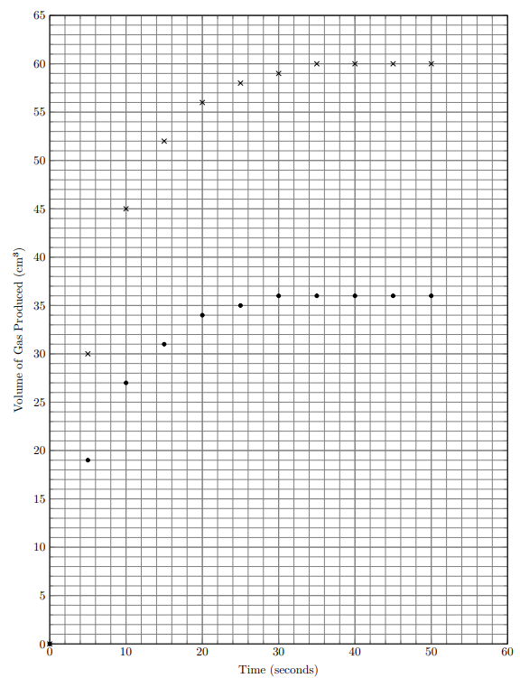
- Draw a line of best fit for each reaction
- In the experiment, what is the independent variable?
- What is the dependent variable?
- What variables should have been controlled?
- Which reaction has the higher rate, and how can you tell by looking at the graph?
- Explain why that reaction has a higher rate.
- (H ONLY) Calculate the rate of each reaction at 20 s exactly.
- Calculate the mean rate between 10 and 20 s for each reaction.
- How does the rate of each reaction change with time? Explain this change.
- In this experiment, the student collected the gas in a syringe. Suggest another way they could have conducted the experiment.
- At what point in time does each reaction finish?
- What is the maximum volume of gas produced in each reaction?
- The maximum volume in each reaction should be the same, but it isn’t. Suggest what mistake has been made to result in different volumes produced.
Effect of concentration on the rate of reaction
I am learning about concentration so I can explain its effect on the rate of reaction
Using a solution with a higher concentration in a reaction has two effects. First, it increases the rate of the reaction because there are more particles in the solution, so more frequent collisions. Secondly, it can increase the total amount of product, because there is now more reactant.

- A student has two acids, A and B.
Acid A has a low concentration.
Acid B has a high concentration.
  - Explain why acid A has a lower rate of reaction than acid B.
it has a lower concentration
there are fewer reactant particles
there are less frequent collisions
  - The student reacts a lump of metal with acid A. Suggest a way they could increase the rate without changing the acid.
turn the lump into smaller pieces which will increase the surface area
  - Explain your answer.
increase surface area, increase particles available to react, more frequent collisions
  - When they use acid A, they produce 12 cm³ of gas. Predict whether a larger or smaller volume of gas would be produced from acid B.
Larger if B
  - Explain your answer.
Higher concentration, so more reactant, so more product formed
- A student conducts a reaction between sulfuric acid and calcium carbonate pieces.
- They repeat the experiment with smaller pieces of calcium carbonate, but the same mass. What effect will this have on the rate of reaction?
- Explain your answer.
- What effect will this have on the volume of gas produced? Explain your answer.
- Explain why it is important to use the same concentration of acid both times.
- In the reaction, the mass changes from 113.8 g to 94.2 g in three minutes. Calculate the rate of the reaction.
- A student conducts a reaction between HCl(aq) of two different concentrations and a sample of Na₂O(s).
Reaction 1: 200 cm³ of 12 g/dm³ acid, 4.5 g of NaO
Reaction 2: 50 cm³ of 16 g/dm³ acid, 4.5 g of NaO
- Suggest and explain which reaction will have a greater rate
- (S only) Use an excess and limiting calculation to first establish what is excess and what is limiting, and then predict the volume of gas produced in each reaction.
Effect of temperature on the rate of reaction
I am learning about temperature so I can explain its effect on the rate of reaction
Increasing temperature increases rate for two separate reasons:
- Particles at a higher temperature move faster, meaning they collide more frequently.
- When particles collide they need to have enough energy to react. This is called the activation energy. Increasing the temperature increases the number of particles with the activation energy required to react.
In sum then, there are more frequent collisions, and more of those collisions result in a successful reaction.

- A student reacts a metal with some acid and calculates the rate. They change the temperature of the acid and calculate the rate again. The repeat this at a series of temperatures, and get the data below:
Temperature (°C) | Rate of reaction (g/s)
20 | 3.4
30 | 3.6
40 | 4.0
50 | 4.8
60 | 3.6
70 | 9.2
80 | 12.6
- One of the results is anomalous. Identify which result.
- Use the other results to describe the trend shown in the table.
as the temperature increases, the rate of reaction increases
- Explain the trend, making full reference to particles and collisions.
the higher the temperature, the reactant particles move faster
colliding more frequently
AND ALSO
more particles have the activation energy
and therefore more collisions are successful/result in a reaction
- Plot the data on the graph below and draw a line of best fit. Ignore the anomalous result.

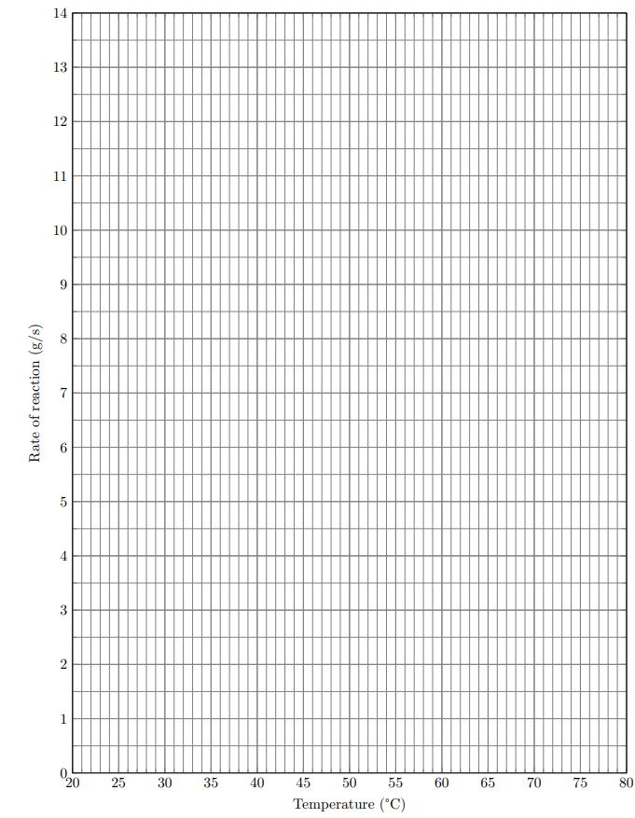
- Explain why you do not need to draw a tangent to the line to calculate the rate at a given temperature.
because the y axis gives you rate (and not volume or mass)
- Predict the rate of this reaction at 55 °C
about 5.6 g/s
- In this experiment, what was the dependent variable?
rate of reaction
- What was the independent variable?
temperature
- Which variables should have been controlled?
concentration of acid, mass of solid, stirring, volume of acid, type of acid, type of metal, surface area of the metal (initial temperature of metal)
- Suggest why the reaction was not carried out at 0 °C
the rate would be really low
- At 60 °C, by how much would the mass change in 17 s?
rate at 60 is about 6.5 g/s
6.5 x 17 = 110.5 g (approx.)
- A student is asked to explain why reactions at lower temperatures have a lower rate of reaction. They write:
At lower temperatures, the particles move less. They collide less, and when they collide, they have less activation energy.
- Identify as many errors as you can in their answer.
- Rewrite the student’s answer correctly.
Effect of gas pressure on the rate of reaction
I am learning about gas pressure so I can explain its effect on the rate of reaction
If a reaction involves a gas, increasing the pressure increases the rate. This is normally because there is less space between the particles, so they collide more frequently. Note that this only works with gases, it isn’t relevant when discussing reactions without gases.

- A student conducts a reaction between gas A and gas B. They do it twice. The first time, they do it in a vessel that is 10 dm³ in volume. The second time is done in a vessel of 20 dm³.
- Which reaction will have a greater rate?
the 10 dm³ one
- Explain your answer.
volume decreases
higher pressure
less space between particles
more frequent collisions
- Explain why the temperature of each vessel should be the same.
the temperature could affect the rate (fair test)
- Calculate the volume of each vessel in cm³
20,000 cm³
10,000 cm³
- The student gets a new vessel, which is a perfect cube with side lengths of 3 dm³. Calculate the surface area to volume ratio of the vessel.
each side has an area of 3x3 = 9, there are 6 faces so total area = 54 dm²
volume = 3x3x3 = 27dm³
SA:V
54:27
2:1
- Methane (CH₄) reacts with oxygen (O₂) to produce carbon dioxide (CO₂) and steam (H₂O).
- Write a balanced symbol equation for this reaction.
- Calculate the enthalpy (energy) change for this reaction. You may need to look back in your notes. The bond energies have been provided for you.
C-H 413kJ/mol
H-O 464kJ/mol
O=O 498kJ/mol
C=O 532kJ/mol
- Is this reaction endo or exothermic?
exothermic (more energy is released breaking the bonds than is used making them)
- The pressure under which the reaction is conducted is decreased. State the effect this has on the rate of reaction.
decreases
- Justify your answer.
lower pressure
more space between the particles
less frequent collisions
- A student reacts a metal with an acid, which produces a gas.
- They say that because a gas is produced, increasing the pressure will increase the rate. Explain why the student is wrong.
it’s the reactant that needs to be a gas, not the product
- In the reaction, 40 cm³ of gas are produced in two minutes. Calculate the rate in cm³/s
40/120 = 0.33 cm³/s
- Will the rate increase or decrease after two minutes? Explain your answer.
decrease
reactant particles are used up
less frequent collisions
- The student wants to repeat the experiment with magnesium, iron and copper. Write a method for carrying out this experiment, and name the dependent and independent variables involved. State which variables need to be controlled.
- add each metal to acid
- collect gas produced in a gas syringe
- record the volume of gas produced over time
- dependent variable: volume of gas produced over time OR rate of reaction
- independent variable: type of metal
- controlled variables: temperature of acid, mass of metal, volume and concentration of acid, surface area of metal, stirring, type of acid
Effect of catalysts on the rate of reaction
I am learning about catalysts so I can explain their effect on the rate of reaction
Some reactions are very slow, but can be sped up when you add a special chemical called a catalyst. Catalysts increase the rate of a reaction, but they aren’t used up in that reaction. They reduce the activation energy required for the reaction, meaning that more of the collisions result in a reaction.
- The reaction below uses hydrogen and nitrogen to make ammonia:
3H₂(g) + N₂(g) 2NH₃(g)
- Balance the equation
- At room temperature and pressure, the reaction is very slow. When iron is added to the reaction, it speeds up. What can iron be described as?
a catalyst
- Why is iron not included in the equation for the reaction?
it’s not used up/it’s not a reactant
- At the start of the reaction, the mass of iron used is 40 g. Suggest and explain the mass of iron at the end of the reaction.
40 g, it is not used up in the reaction
- When lumps of iron are used, the reaction has a rate of 10 g/s. Suggest and explain what happens to the rate if iron powder is used instead of iron lumps.
the rate of reaction increases
higher surface area
more particles exposed/available to react
more frequent collisions
- The reaction profiles below show this reaction with and without a catalyst.
    - Label the axes
    - Identify a and b
    - Is this reaction exothermic or endothermic?
exothermic
    - How do you know?
reactants have more energy than products/(more energy at the start than the end)
energy is lost to the surroundings
    - Which profile shows the reaction with a catalyst?
the first one
    - How do you know?
activation energy is lower
    - Suggest why increasing the temperature of the reaction does not change the reaction profile.
the temperature affects the rate, it does not affect how much energy the reactants or products store
- State and explain the effect of increasing the temperature on the rate of this reaction.
rate increases
particles have more energy/move faster
more frequent collisions
AND ALSO
more particles have the activation energy
more successful collisions
- State and explain the effect of increasing the pressure on the rate of this reaction.
the rate of reaction increases
there is less space between particles
more frequent collisions
- Suggest why using a catalyst is a preferred method of increasing the rate of a reaction.
increasing pressure is very expensive
OR only need to buy catalysts once
- A mass of 40 g of hydrogen and 75 g of nitrogen are used in the reaction. Use a calculation to identify which is excess and which is limiting.
- Calculate the percentage by mass of hydrogen in ammonia (NH₃).
- Draw a covalent bonding diagram to show how the atoms in ammonia are joined together.

- Ammonia has a low boiling point. Predict one other property of ammonia.
does not conduct electricity
- Explain why ammonia has a higher boiling point than hydrogen.
it’s a larger molecule
stronger intermolecular forces
requires more energy to break those bonds
- A student is investigating the rate of reaction of an electrolysis experiment, where they are electrolysing NaCl(aq)
- What does the (aq) stand for?
aqueous
- Explain why NaCl(s) cannot be electrolysed
it does not conduct electricity
- The student uses graphite electrodes. Making full reference to its structure and bonding, explain why graphite conducts electricity.
made of carbon atoms
each carbon atom has three bonds
there is one delocalised electron per carbon atom
the delocalised electrons carry charge through the graphite
- The student dissolves 12g of NaCl in 200cm³ of water. What is the concentration of this solution in g/dm³? (separate science only: work out the concentration in mol/dm³ too)
12/0.2 = 60 g/dm³
12/58.5 = 0.2051
0.2051/0.2 = 1.026 mol/dm³
- Two gases are produced in this electrolysis. Which gases are they?
hydrogen and chlorine
- Explain why solid sodium is not produced.
it is more reactive than hydrogen (and it is in solution)
- Give a half equation for the reaction at the anode.
2Cl⁻ Cl₂ + 2e⁻
- Give a half equation for the reaction at the cathode.
2H⁺ + 2e⁻ H₂
- When the student first performs the reaction, 20cm³ of gas is produced in 41s. What is the rate of this reaction?
20/41 = 0.49
- The student increases the temperature of the solution. State and explain the effect this will have on the rate of reaction.
increases the rate
particles gain energy/move faster
more frequent collisions
AND ALSO
more particles have the activation energy
more collisions result in a reaction/are successful
- Sodium chloride has sodium and chlorine in it.
    - Give a word and symbol equation for the reaction of sodium with water
sodium + water sodium hydroxide + hydrogen
2Na + 2H₂O 2NaOH + H₂
    - Explain why sodium is called an “alkali metal”
it is a metal
it reacts with water to form an alkali
    - Explain why chlorine has a low melting point
simple molecular
weak intermolecular forces of attraction
require little energy to break
    - Explain why chlorine is less reactive than fluorine
it is a larger atom/outer shell electron is further from the nucleus
weaker attraction from the nucleus to the outer shell
harder to gain an electron
    - What is the mass of 5 moles of sodium chloride?
5 x (35.5+23) = 292.5 g

